2024 MFP-AC Marketing Toolkit
Below please find content that you are welcome and encouraged to share with your contacts regarding the 2024 Minority Fellowship Program for Addiction Professions. If you have any questions, please do not hesitate to contact NAADAC Programs Manager Jennifer Velotta at jvelotta@naadac.org.
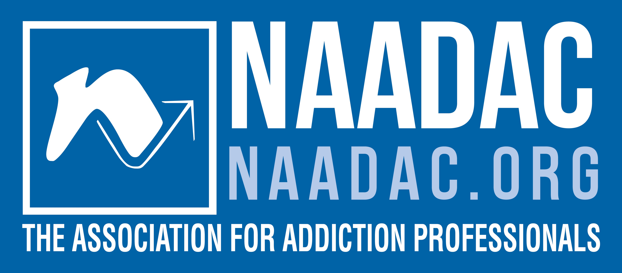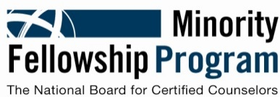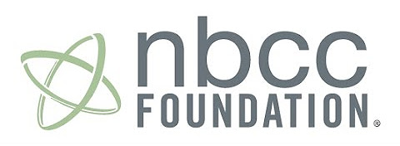

Email Subject Line: Spread the Word: Addiction Counseling Student Fellowships Available

Email Content:
Are you or someone you know a Master’s-level addiction counseling student who plans on working with underserved communities? Apply today for the 2024 MFP-AC!
Master’s-level addiction counseling students can earn $15,000 towards their educational journey through the Minority Fellowship Program for Addiction Counselors (MFP-AC)! Fellows also receive:
- A designated mentor
- NAADAC Membership
- Travel and registration for the NAADAC 2024 Annual Conference
- And more!
The 2024 program year will award up to 40 master’s-level fellowships for addiction counseling students in the amount of $15,000 each. Awardees are also paired with a mentor in the field and receive additional professional development resources, including travel to the NAADAC Annual Conference.
The National Board for Certified Counselors (NBCC) Minority Fellowship Program for Addictions Counselors (MFP-AC) is a program made possible by a grant awarded to the NBCC Foundation in collaboration with NAADAC from the Substance Abuse and Mental Health Services Administration (SAMHSA).
Visit www.naadac.org/MFP to view eligibility requirements and apply. Contact NAADAC Programs Manager Jennifer Velotta at jvelotta@naadac.org with any questions.
Application Deadline: September 30, 2023.

Social Media Posts:

Are you or someone you know a Master’s-level addiction counseling student who plans on working with underserved communities? Become a Fellow with 2024 MFP-AC and earn $15,000! Learn more at www.naadac.org/mfp.

Master’s-level addiction counseling students can earn $15,000 towards their educational journey through the Minority Fellowship Program for Addiction Counselors (MFP-AC)! Learn more at www.naadac.org/mfp.

Master’s-level addiction counseling students who plan on working with underserved communities can earn $15,000. Learn more at www.naadac.org/mfp.

