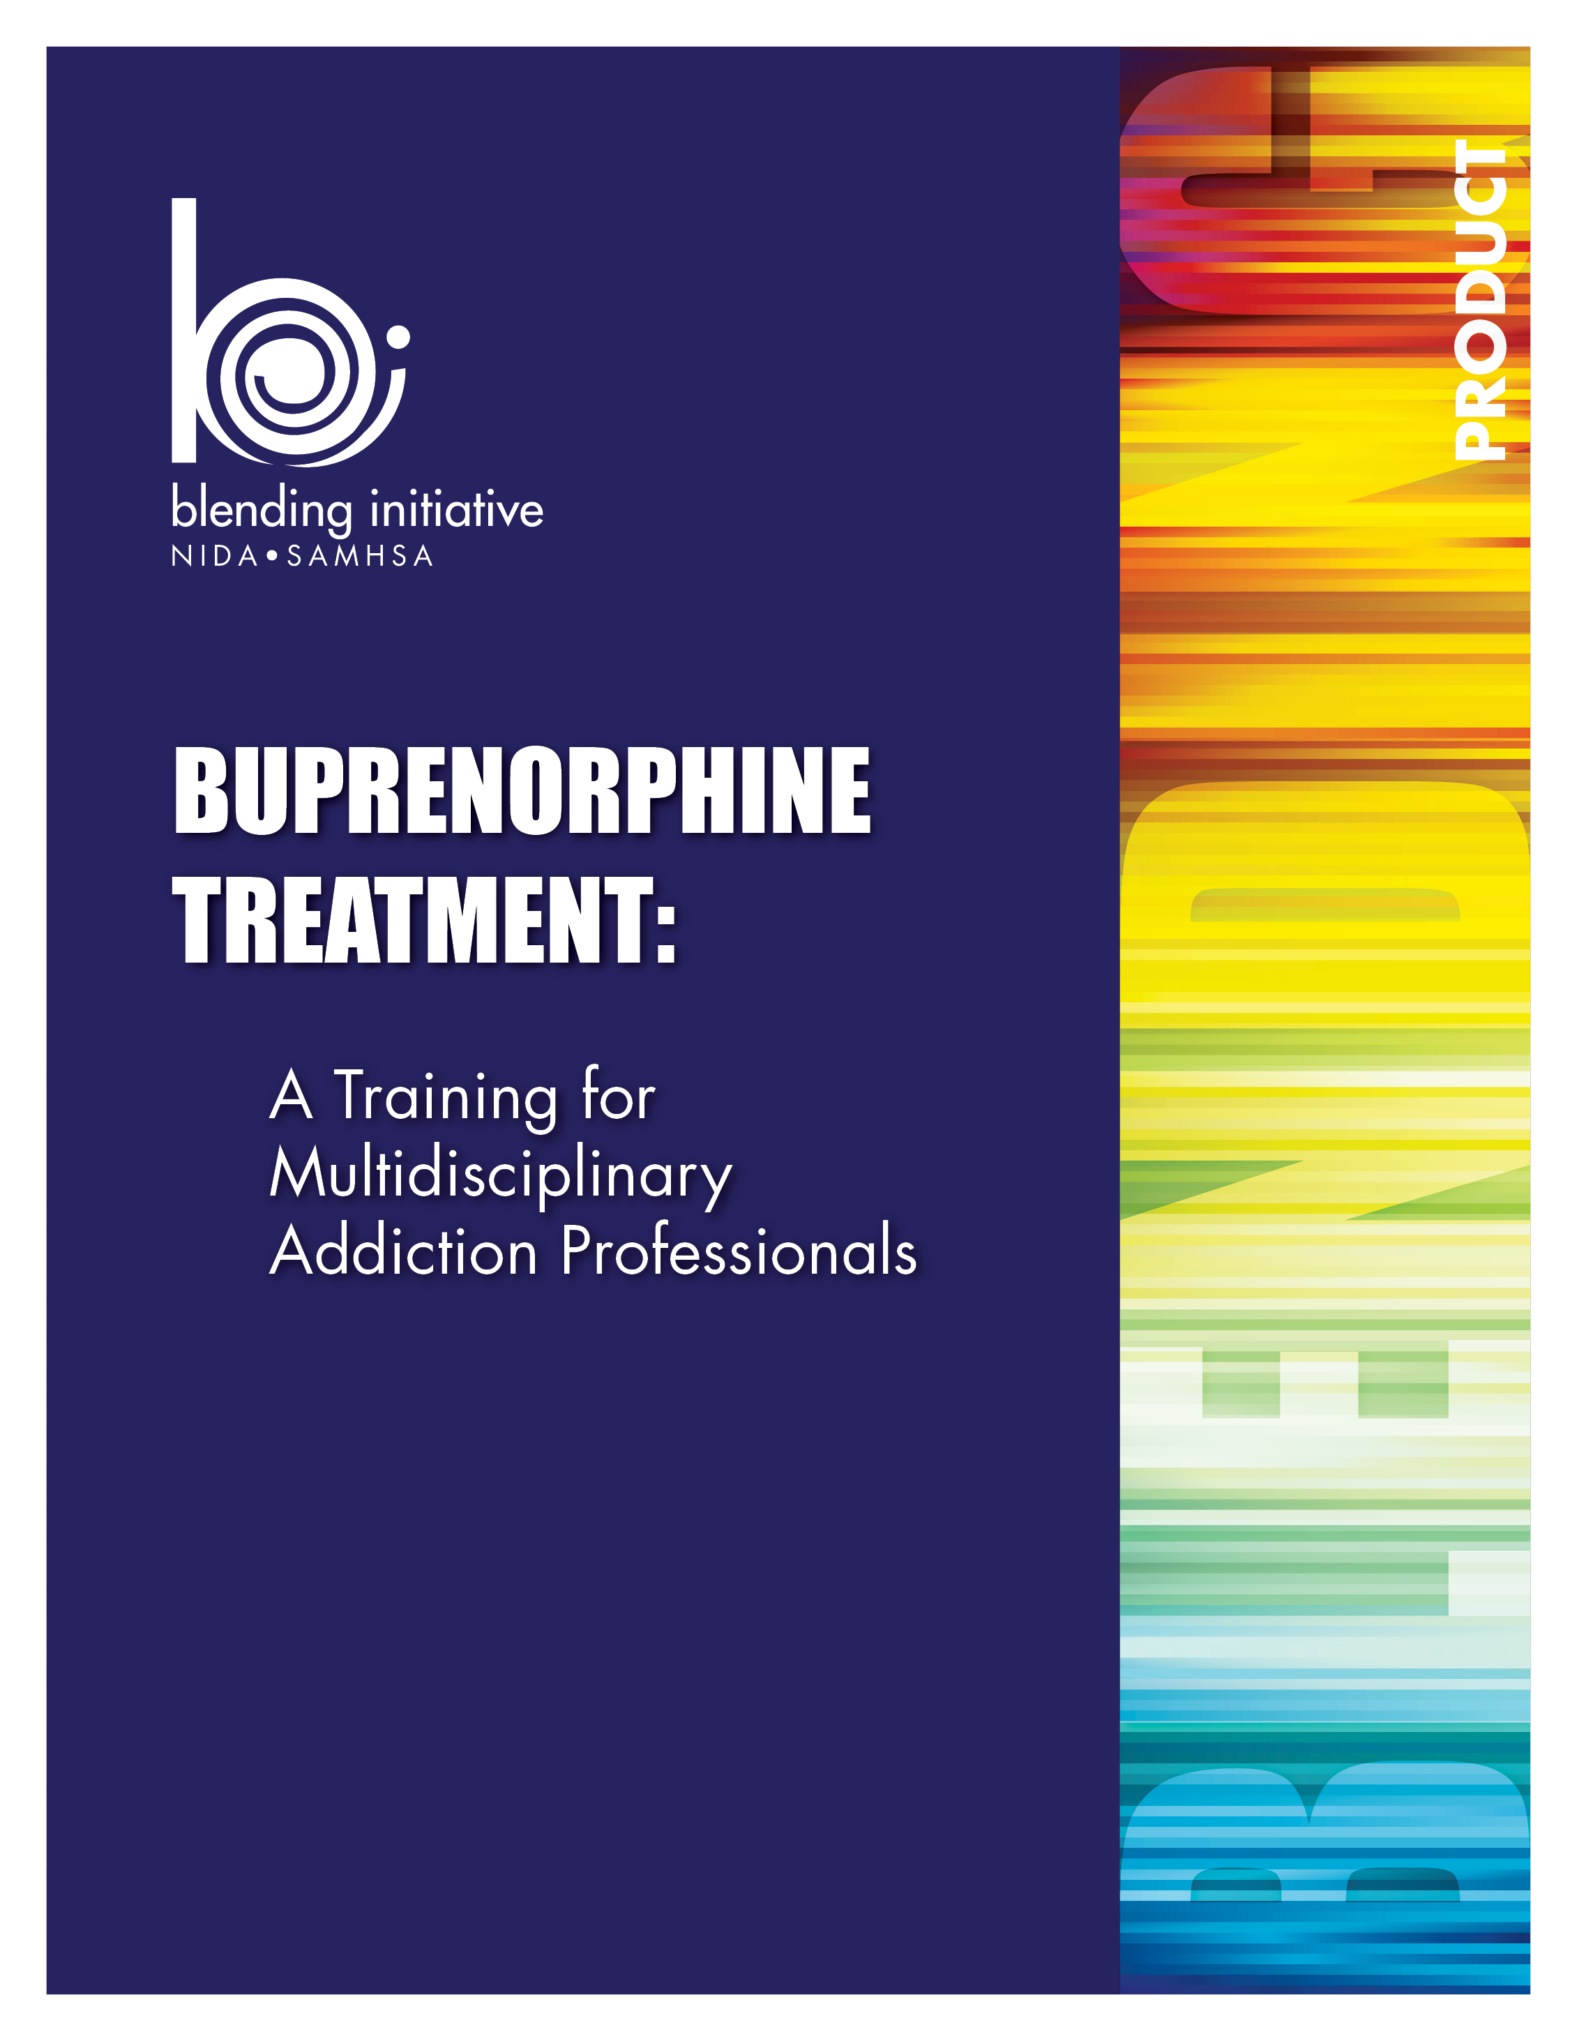



Buprenorphine Treatment:
A Training for Multidisciplinary Addiction Professionals

Table of Contents

Introduction to the Training 1
Background Information: NIDA/SAMHSA Blending Initiative 1
Focus on Buprenorphine 1
Blending Team Members 1
Additional Contributors 2
What Does the Training Package Contain? 2
What Does This Trainer’s Manual Contain? 2
How Are the PowerPoint Training Slides Organized? 2
General Information About Conducting the Training 3
Materials Needed to Conduct the Training 3
Overall Training Notes 3
Combining the Presentations 5
PowerPoint 2007 5
PowerPoint 1997-2003 9
Module I: Introduction 15
Module II: Opioids 101 59
Module III: Buprenorphine 101 81
Module IV: Identification of Patients for Buprenorphine Treatment 105
Module V: Coordinated Care 121
Module VI: Counseling Buprenorphine Patients 131

Buprenorphine Treatment:
A Training for Multidisciplinary Addiction Professionals

Background Information: NIDA/SAMHSA Blending Initiative
The National Institute on Drug Abuse (NIDA) and the Substance Abuse and Mental Health Services Administration (SAMHSA) has created a partnership to disseminate information to the addiction treatment field. Through the NIDA/SAMHSA Blending Initiative, special groups called Blending Teams meet to design dissemination strategies and develop research-based products. Members of these Blending Teams come from the NIDA-funded National Drug Abuse Treatment Clinical Trials Network (CTN) and the SAMHSA-funded Addiction Technology Transfer Center (ATTC) Network.

In the year 2000, NIDA created the National Drug Abuse Treatment CTN. The CTN conducts studies of behavioral, pharmacological, and integrated behavioral and pharmacological treatment interventions in rigorous, multi-site clinical trials to determine effectiveness across a broad range of community-based treatment settings and diverse patient populations. As the CTN research is completed, NIDA-funded researchers work with representatives from the ATTC network to provide the results and strategies for implementing these findings in clinical settings. This will decrease the time it takes for research to be incorporated into treatment settings and will thereby improve the quality of drug abuse treatment throughout the country.

Focus on Buprenorphine
In 2002, tablet formulations of buprenorphine were approved by the Food and Drug Administration (FDA) for the treatment of opiate addiction. Additionally, the CTN completed several clinical trials related to specific uses of this medication. The results of these trials strongly supported this method of using buprenorphine in the treatment of opioid dependence. Information from these studies is incorporated in the following materials.

In order to prepare the field to effectively integrate this treatment, NIDA formed a Blending Team to develop an awareness training for multidisciplinary addiction professionals to educate them about buprenorphine and its use in the treatment of opioid addiction. This training was designed to provide a broad overview of the medication, its effects, and the roles of multi-disciplinary addiction professionals in providing and supporting the treatment of individuals receiving this medication.

Blending Team Members
Thomas E. Freese, Ph.D. – Pacific Southwest ATTC – Blending Team Chair
Leslie Amass, Ph.D. – Friends Research Institute, Inc.
Greg Brigham, Ph.D. – CTN Ohio Valley Node
Glenda Clare, M.A. – Central East ATTC
Gail Dixon, M.A. – Southern Coast ATTC
Beth Finnerty, M.P.H. – Pacific Southwest ATTC
Eric Strain, M.D. – Johns Hopkins University

Additional Contributors
Judith Martin, M.D. – 14th Street Clinic, Oakland, CA
Michael McCann, M.A. – Matrix Institute on Addictions
Jeanne Obert, MFT, MSM – Matrix Institute on Addictions
Donald Wesson, M.D. – Independent Consultant
The ATTC National Office
The O.A.S.I.S. Clinic

What Does the Training Package Contain?
- PowerPoint Training Slides
- CD-ROM – “Put Your Smack Down! A Video About Buprenorphine”
- Trainer’s Manual

What Does This Trainer’s Manual Contain?
This training manual, Buprenorphine Treatment: A Training for Multidisciplinary Addiction Professionals, is the product of the NIDA/SAMHSA Blending Team. The training guide is designed to support a one-day face-to-face training to introduce multidisciplinary addiction treatment providers to the basics of buprenorphine treatment. The training is designed as a guide that will be customized by ATTC and CTN trainers across the country to meet the needs of their local region.

The notes below contain information that can be presented with each slide. This information is designed as a guidepost and can be adapted to meet the needs of the local training situation. Information can be added or deleted at the discretion of the trainer(s).

How Are the PowerPoint Training Slides Organized?
The primary goal of this Blending product is to create a package of training materials that can be used to create awareness about buprenorphine among multidisciplinary addiction professionals. The materials include information designed to increase motivation for bringing buprenorphine to local communities, as well as information about what to expect when someone is treated with this medication.
It is important to note that this training is introductory and is focused on building awareness and encouraging multidisciplinary addiction professionals to enhance their knowledge about buprenorphine treatment. It is not designed to provide an expert level of competency in utilizing buprenorphine for opioid addiction. This course provides valuable information about legislation that permits office-based buprenorphine treatment, the science of addiction, the mechanism of buprenorphine, patient selection issues, and various patient, counseling, and therapeutic issues.
This course, Buprenorphine Treatment: A Training for Multidisciplinary Addiction Professionals, is divided into six core modules. The training package is designed to provide information and content for a four to six hour training. Additionally, the introductory module (Module I) is designed so that it can be presented as a stand-alone introduction to buprenorphine. This shorter presentation could be used as a keynote address at conferences or as a marketing tool to expose people to the benefits of buprenorphine and the advantages of including it as a treatment within local communities. It is integral to the success of the training to be cognizant of the audience’s needs and past experience.
In addition to the awareness package described above, this training contains two optional modules that cover topics specifically related to the use of buprenorphine that have been evaluated by the CTN.
We recommend that you begin with Module I and work your way through each module, since each module builds on the previous one. If the training audience has extensive experience with opioid treatment, Modules I and II can be abbreviated or omitted. In this case, the trainer(s) would begin with Module III and proceed through the remaining modules. Module VI (Counseling Buprenorphine Patients) is the largest module, and contains a lot of important information. It is critical that the trainer allow enough time to adequately cover the information contained within Module VI, without having to rush through earlier content.
Optional modules provide more in-depth information about tapering patients off of the medication, and about use of the medication with adolescents and young adults. The optional modules can be used as stand alone trainings, or may be seamlessly incorporated into the training as indicated in the guide and are designed to expand on brief information presented in the core training.

It is important to note that many of the slides in this training contain some animation. Animations are used to call attention to particular aspects of the information or to present the information in a stepwise fashion to facilitate both the presentation of information and participant understanding. Because of this, some information is hidden when slides first appear on the screen and then comes in as the slide is advanced. No special notes are made if the animation simply causes the next row of text to appear. However, when the animations are complex, step by step instructions are provided.

General Information About Conducting the Training
The training is designed to be conducted in small- to medium-sized groups (10-25 people). It is possible to use these materials with larger groups, but the trainer will have to adapt the small group exercises to ensure that there is adequate time to cover all of the material.

Materials Needed to Conduct the Training
- Computer with PowerPoint software installed (2003 or higher version) and LCD projector to project the PowerPoint training slides
- Flip chart paper and easel/white board, and pens to write down relevant information
- Computer (with speakers) to play the optional CD-ROM of “Put Your Smack Down! A Video About Buprenorphine” that appears in Module IV

Overall Training Notes
It is important that every attempt be made to find as much out about the trainees as possible prior to the training. This will help the trainer(s) to customize the six-module presentation and avoid reviewing information that will seem elementary or redundant to the participants. It is also critical that, prior to conducting an actual training, the trainer practice using this guide while showing the slide presentation in Slideshow Mode in order to be prepared to use the slides in the most effective manner.

Throughout this training the term buprenorphine will be used as a generic term to refer to both formulations of the product available (buprenorphine alone and the combined buprenorphine/naloxone tablet). Where it is important to distinguish between the two formulations, the specific formulation will be emphasized.

It is also important to note that throughout the training, the term “patient” is used to refer to the individual seeking treatment. This terminology reflects the medical nature of buprenorphine treatment and underscores the fact that the treatment is largely physician-driven. The use of this term may be inconsistent with the vocabulary in common usage in addiction treatment settings. Trainers are encouraged to address this issue with participants and make adaptations to the materials as needed.

Additionally, the term “medication” is used to refer to buprenorphine and buprenorphine/naloxone. This terminology again reflects the medical nature of buprenorphine treatment and underscores the difference between a drug of abuse and medication used for the treatment of opioid treatment and medically-assisted withdrawal.

Note to speaker  Activity

References



Buprenorphine Treatment:
A Training for Multidisciplinary Addiction Professionals

Combining the Presentations
The NIDA/SAMHSA Blending Initiative has developed a suite of products on buprenorphine. The Buprenorphine Suite includes the following training curricula:
- Buprenorphine Treatment: A Training for Multidisciplinary Addiction Professionals
- Short Term Opioid Withdrawal Using Buprenorphine: Findings and Strategies From a NIDA Clinical Trials Network Study
- Buprenorphine Treatment for Young Adults: Findings and Strategies From a NIDA Clinical Trials Network Study
Each of these curricula is a self-contained training package that can be used to conduct a stand-alone training program. However, the Blending Team recognized that in many instances trainers may want to incorporate elements of two or all three curricula into a single training experience. Combining slides from the presentations may therefore be necessary. Below are instructions for combining slides for both PowerPoint 2007 and PowerPoint 1997-2003.
PowerPoint 2007
To combine slides into a single presentation, open all presentations from which you will be drawing slides. Determine which document will be the master document into which slides from the other presentation(s) will be copied. For instance, if you are conducting the Buprenorphine Treatment: A Training for Multidisciplinary Addiction Professionals, this would be your master document. It is recommended that you save a new copy of this presentation before altering it in order to preserve the original training content.



I. Save a new copy of your presentation.
(1) Click on the program icon in the upper right corner of your screen and then (2) click
on Save As from the drop down menu. Next, (3) click on PowerPoint Presentation. A dialogue box will appear that will allow you to give the presentation a name and location.
Click in this order:
1. Program Icon
2. Save As
3. PowerPoint Presentation

II. Open the presentation from which slides will be copied.
III. Select Slide Sorter view.
Go to the Slide Sorter view by (1) clicking on View from the menu at the top of the page and then (2) clicking Slide Sorter located on the left side of the page near the top.
Click in this order:
1. View
2. Slide Sorter
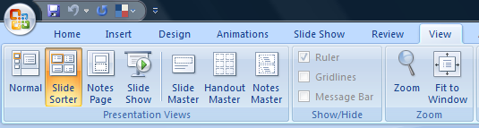

IV. Select the slides to be copied.
Slides can be copied in two ways. You can select all slides in the presentation, or you can choose only certain slides to copy. Instructions for each are presented below
Select all slides in presentation. Copy all slides in the presentation by (1) clicking on Home from the menu at the top of the page and then (2) clicking on Select on the far right side of the page near the top. Next, (3) click on Select All from the drop down menu. All slides in the presentation will be highlighted in yellow.
Click in this order:
1. Home 2. Select 3. Select All

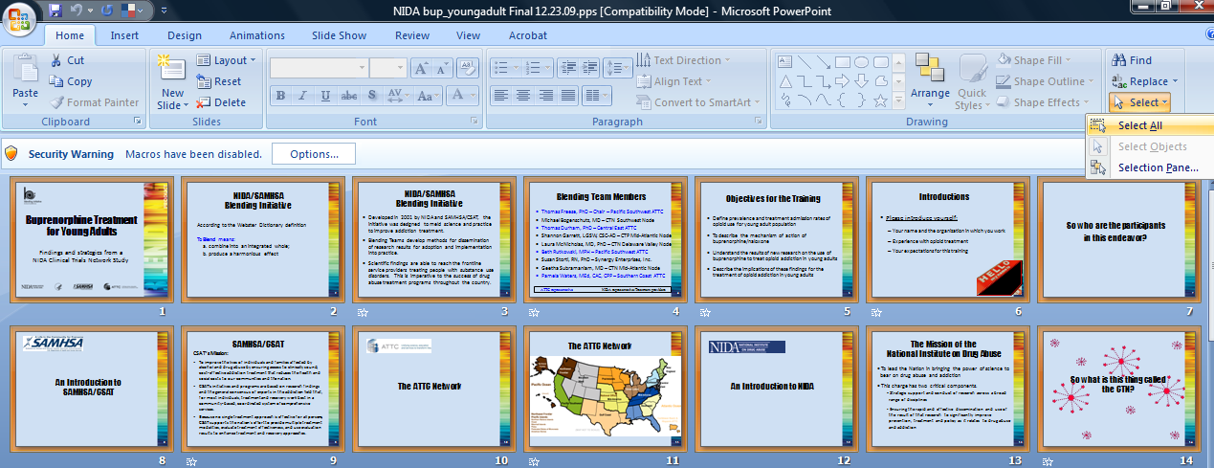

Finally, (4) copy the selected slides to the clipboard by clicking on Copy on the upper left of the screen.
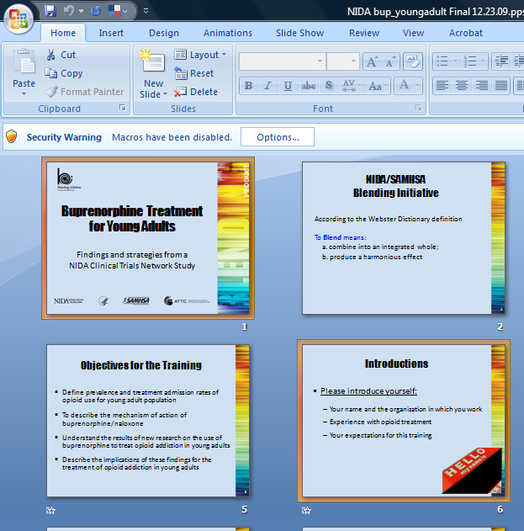
Select specific slides to copy. To copy only certain slides (rather than all of them), on your computer keyboard, hold down the control (Ctrl) button. While holding down Ctrl, click on the slides that you want to copy into the combined presentation. Only slides on which you click will be selected (highlighted in yellow). In the close-up example on the right, Slides 1 and 6 are selected (have a yellow box around them). Slides 2 and 5 are not selected.
Once you have clicked on all the slides that you want to select, let go of the Ctrl key and then click on Copy on the upper left side of the page.
Note: You may want to practice copying a few slides at a time until you are comfortable with this procedure.

V. Paste the copied slides into your presentation.
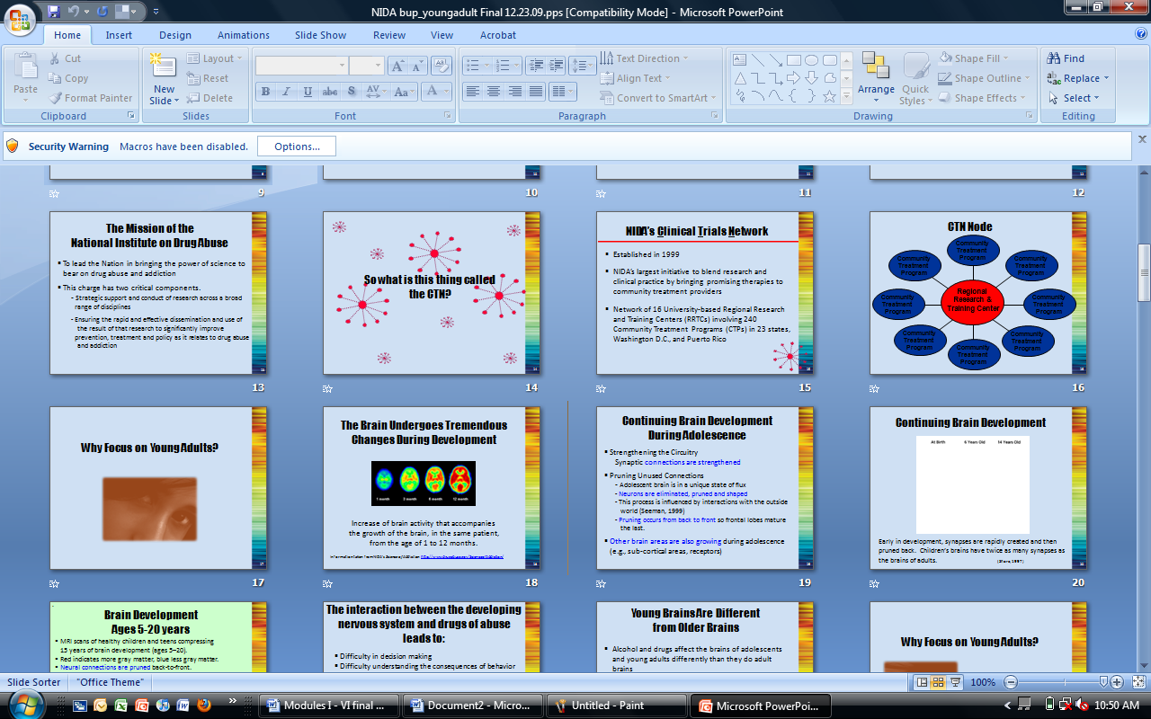
Open your master presentation (the presentation into which the slides are to be copied). Again go to the Slide Sorter view as described in Step III above. (1) Click in the space between the slides where you would like the copied slides to appear. A flashing line will appear between the slides. In this example, the copied slides will appear after Slide 18. Then (2) click on Paste in the upper left corner.

VI. Maintain original formatting.
When copying slides from one presentation to the other, the formatting of the copied slides will be altered to match the presentation into which they are inserted. However, this often leads to significant formatting irregularities. In the example below, Slides 4 to 6 were inserted using the method described above. Notice that some of the text is too dark and difficult to read with the new formatting.
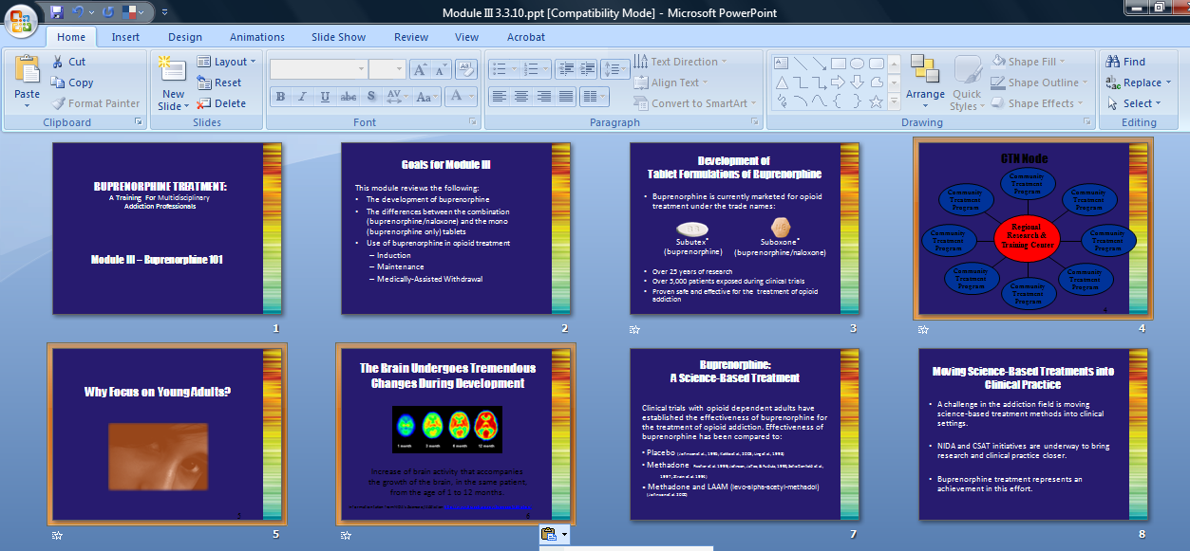
To prevent this problem, it is recommended that the inserted slides maintain the formatting of the original presentation. The following steps show how to do this.
After pasting the slides into the presentation, you will notice that a small clipboard appears near the last inserted slides.
(1) Click on the clipboard and then (2) click on Keep Source Formatting in the drop-down menu that appears.
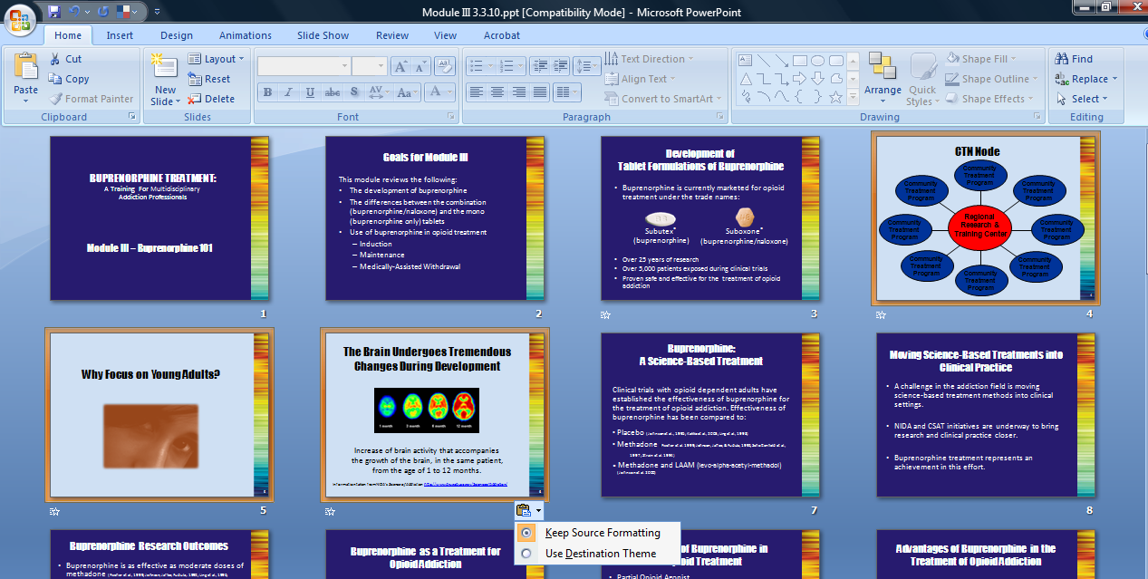

This will restore the formatting from the original presentation and ensure that the slides are legible when projected during a training session.
PowerPoint 1997-2003
To combine slides into a single presentation, open all presentations from which you will be drawing slides. Determine which document will be the master document into which slides from the other presentations will be copied. For instance, if you are conducting the Buprenorphine Treatment: A Training for Multidisciplinary Addiction Professionals, this would be your master document. It is recommended that you save a new copy of this presentation before altering it in order to preserve the original training content.
I. Save a new copy of your presentation.
(1) Click on the File button in the upper left corner of the toolbar and then (2) click
on Save As from the drop-down menu. A dialogue box will appear that will allow you to give the presentation a name and location.
Click in this order:
1. File
2. Save As

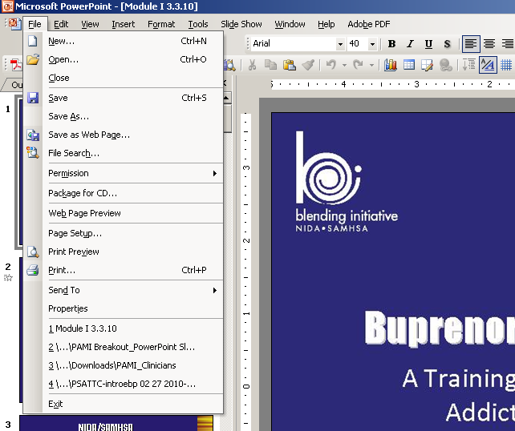
II. Open the presentation from which slides will be copied.

III. Select Slide Sorter view.
Go to the Slide Sorter view by (1) clicking on View from the menu at the top of the page and then (2) clicking Slide Sorter from the drop-down menu.

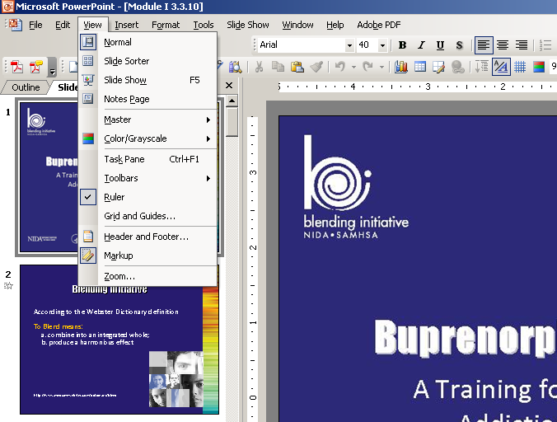
Click in this order:
1. View
2. Slide Sorter

IV. Select the slides to be copied.
Slides can be copied in two ways. You can select all slides in the presentation, or you can choose only certain slides to copy. Instructions for each are presented below.
Select all slides in presentation. Copy all slides in the presentation by (1) clicking on Edit in the top toolbar and then (2) clicking Select All from the drop-down menu. All slides in the presentation will be highlighted in dark blue.
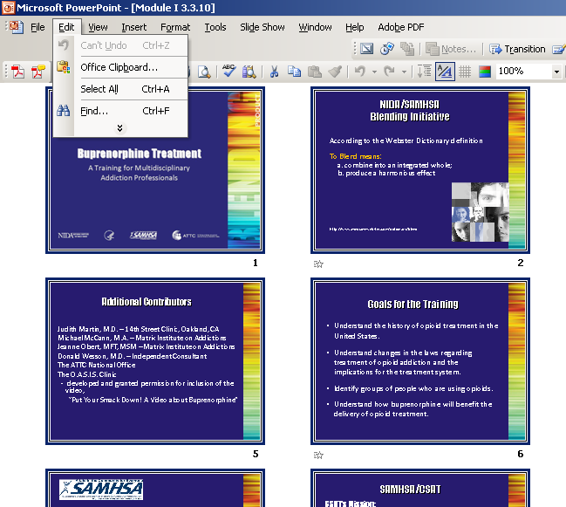
Click in this order:
1. Edit
2. Select All

Finally, (3) click on the Edit button in the top toolbar and then click on Copy from the drop-down list.
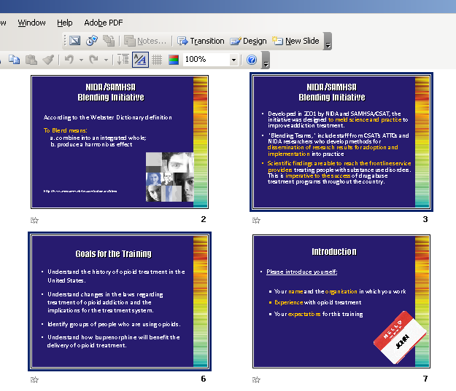
Select specific slides for copying. To copy only certain slides (rather than all of them), on your computer keyboard, hold down the control (Ctrl) button. While holding down Ctrl, click on the slides that you want to copy into the combined presentation. Only slides on which you click will be selected (highlighted in dark blue). In the close-up example on the right, Slides 3 and 6 are selected (have a dark blue border around them). Once you have clicked on all the slides that you want to select, let go of the Ctrl key and then click on the Edit button in the top toolbar and then click on Copy from the drop-down menu.

Note: You may want to practice copying a few slides at a time until you are comfortable with this procedure.

V. Paste the copied slides into your presentation.
Open your master presentation (the presentation into which the slides are to be copied). Again go to the Slide Sorter View as described in Step III above. (1) Click in the space between the slides where you would like the copied slides to appear. A flashing line will appear between the slides. In this example, the copied slides will appear after Slide 6. Then (2) click on Edit and then Paste in the upper left corner.
Click in space where slides are to be inserted.



VI. Maintain original formatting.
When copying slides from one presentation to the other, the formatting of the copied slides will be altered to match the presentation into which they are inserted. However, this often leads to significant formatting irregularities. In the example below, Slides 7 to 9 were inserted into this presentation using the method described above. Notice that some of the text is too dark and difficult to read with the new formatting.
Three slides copied

To prevent this problem, it is recommended that the inserted slides maintain the formatting of the original presentation. The following steps will show you how to do this.
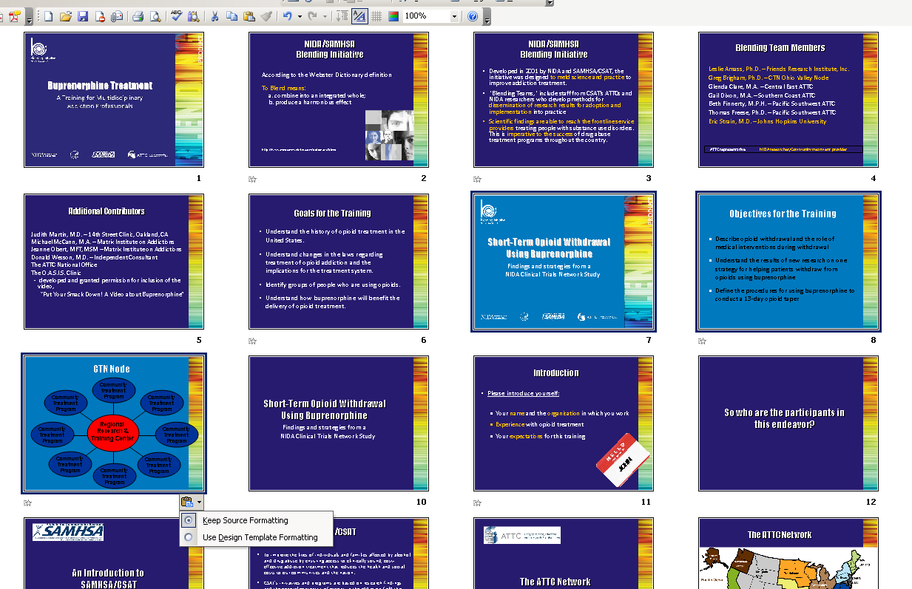
After pasting the slides into the presentation, you will notice that a small clipboard appears near the last inserted slide.
(1) Click on the clipboard and then (2) click on Keep Source Formatting in the drop-down menu that appears.
This will restore the formatting from the original presentation and ensure that the slides are legible when projected during a training session.

Module I

Introduction

Module I: Introduction

The goal of Module I is to provide the context for the rest of the training. The material contained within this module should help to demystify opioid treatment, provide an overview of the problem of opioid addiction in the United States, and set the stage for understanding the utility of medication treatment in general and buprenorphine treatment specifically.

It is important that the trainer keeps a balanced perspective and does NOT come across with the message that buprenorphine is better than or replaces methadone or other forms of opioid treatment. The message should be that buprenorphine represents an important advance in opioid treatment that provides another option for treatment.

Module I can also be presented as a stand-alone presentation (e.g., a one-hour workshop) by including slides 55-67. If the entire training package is being delivered, these slides should be omitted and the trainer(s) should end Module I after slide 53 and proceed with Module II.

The notes below contain information that can be presented with each slide. This information is designed as a guidepost and can be adapted to meet the needs of the local training situation. Information can be added or deleted at the discretion of the trainer(s).

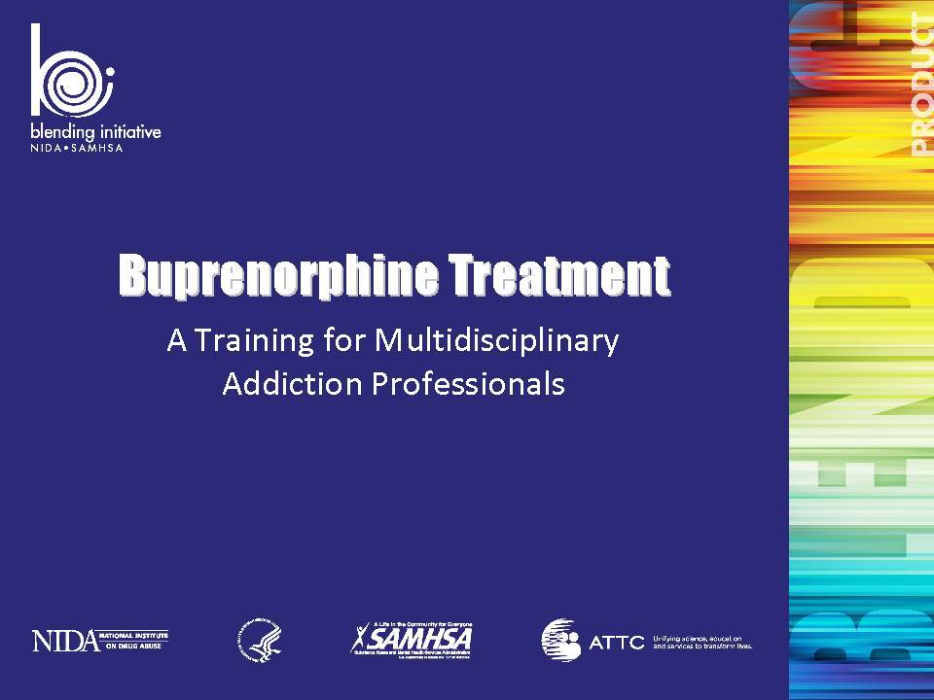 | Slide 1: Buprenorphine Treatment: A Training for Multidisciplinary Addiction Professionals  Welcome participants and take care of housekeeping details such as location of restrooms, turning off cell phones, participate actively, etc.  Briefly describe the development of the Blending Team product, as well as the purpose of the training as described in the introduction to this manual.  It is important to note that this training is introductory and is focused on building awareness and encouraging multidisciplinary addiction professionals to learn more about buprenorphine and its role in opioid treatment. It is NOT designed to provide an expert level of competency in utilizing buprenorphine for the treatment of opioid addiction.  Reiterate that throughout the training, the term “patient” has been used to refer to the individual seeking treatment. This terminology reflects the medical nature of buprenorphine treatment and underscores the fact that the treatment is largely physician-driven. The use of this term may be inconsistent with the vocabulary in common usage in the addiction treatment setting.  Also reiterate that throughout the training, the term “medication” is used to refer to buprenorphine and buprenorphine/naloxone. This terminology again reflects the medical nature of buprenorphine treatment and underscores the difference between a drug of abuse and medication used for the treatment of opioid treatment and medically-assisted withdrawal. | Slide 1
 | Slide 2: NIDA/SAMHSA Blending Initiative  Share the definition of “blend” based upon the Webster dictionary.  Reference:  Blend. (2010). In Merriam-Webster Online Dictionary. Retrieved March 16, 2010, from http://www.merriam-webster.com/dictionary/blend | Slide 2
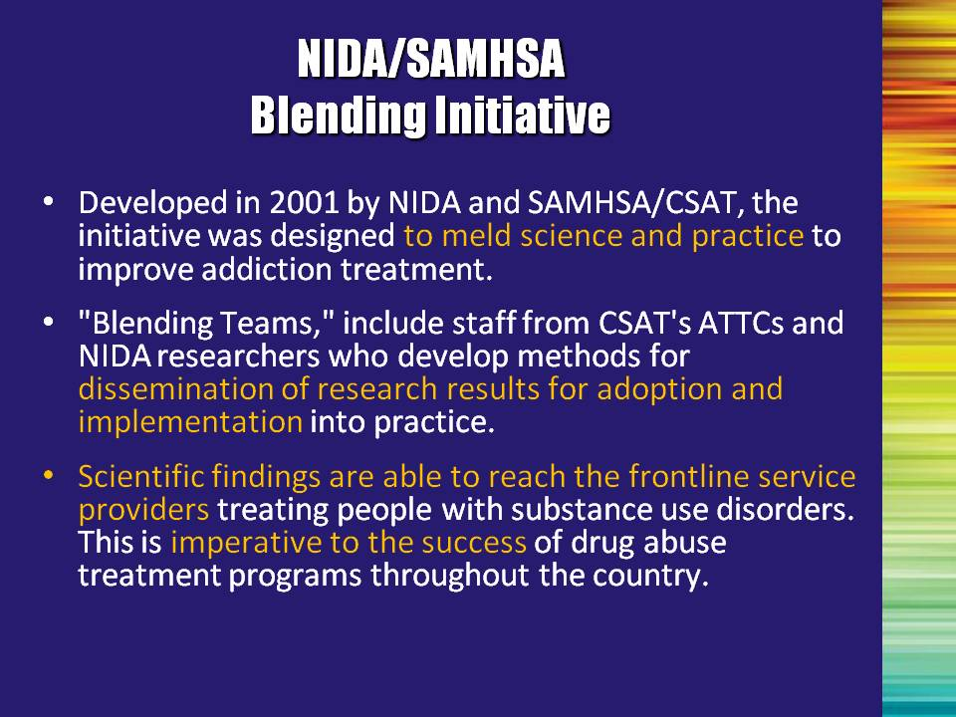 | Slide 3: NIDA/SAMHSA Blending Initiative  Developed in 2001 by the National Institute on Drug Abuse (NIDA) and the Substance Abuse and Mental Health Services Administration’s (SAMHSA) Center for Substance Abuse Treatment (CSAT), the NIDA/SAMHSA Blending Initiative is designed to meld science and practice together to improve substance use disorder treatment. The primary goal of this initiative is to develop methods for disseminating research findings that will accelerate the adoption and implementation of research-based drug abuse treatment into community-based practice.  Blending Products are designed to shorten the time that it takes scientific findings to become available in a usable way for frontline service providers. This is imperative for successful outcomes of clients in addiction treatment programs throughout the country. | Slide 3
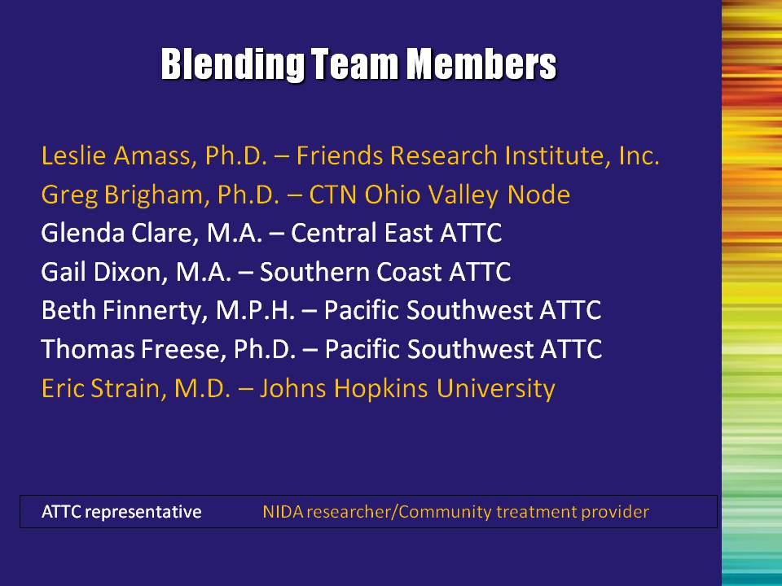 | Slide 4: Blending Team Members  Blending Teams are composed of NIDA-funded researchers, community-based substance abuse treatment practitioners and trainers from SAMHSA's Addiction Technology Transfer Center (ATTC) Network who work closely together to develop the NIDA/SAMHSA Blending Products.  Note to the Trainer(s): Acknowledge the members of the Blending Team who created this module. Note that the membership consisted of four ATTC representatives and three NIDA-funded researchers and community treatment providers. | Slide 4
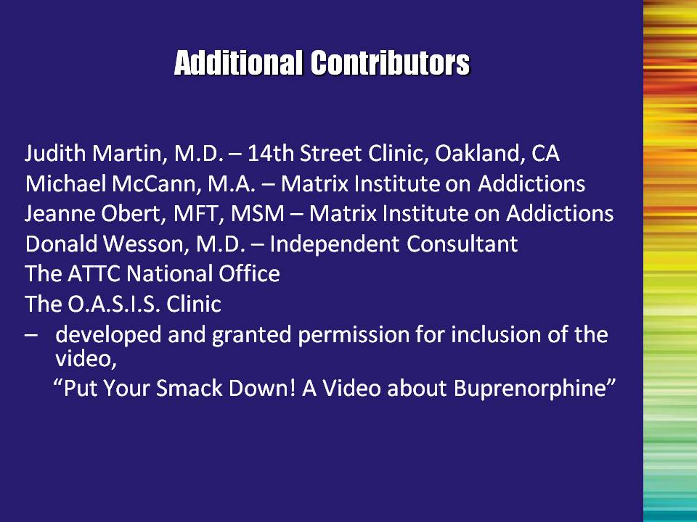 | Slide 5: Additional Contributors  Acknowledge additional contributors to the Blending Team product. | Slide 5
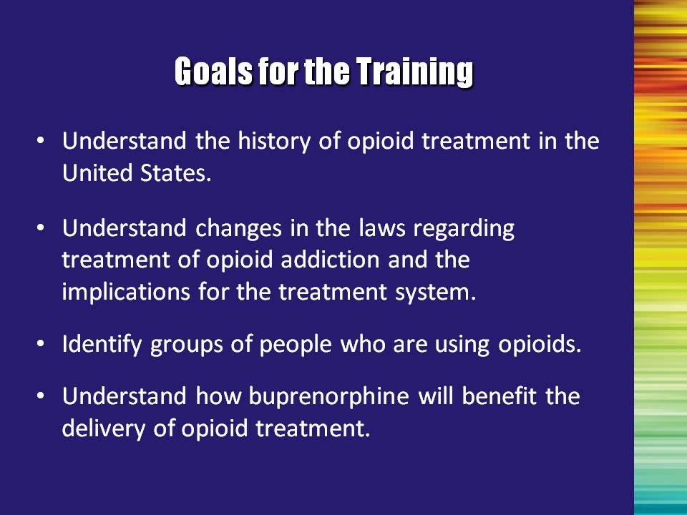 | Slide 6: Goals for the Training  There are four primary objectives for this training:  - Understand the history of opioid treatment in the United States.  - Understand changes in the laws regarding treatment of opioid addiction and the implications for the treatment system.  - Identify groups of people who are using opioids.  - Understand how buprenorphine will benefit the delivery of opioid treatment. | Slide 6
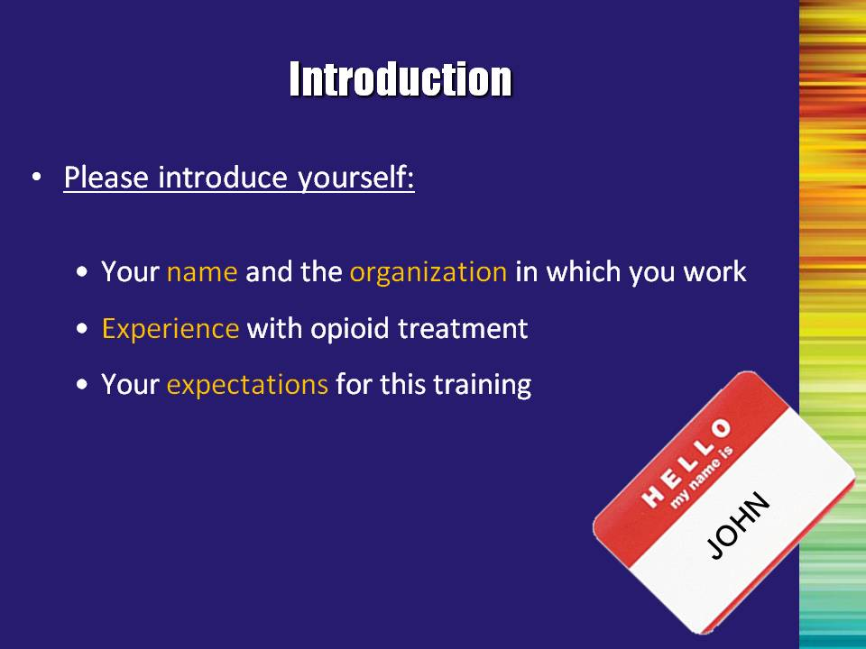 | Slide 7: Introductions  For smaller groups (20 or less): Begin the training by asking participants to briefly introduce themselves by providing their name and the agency for which they work, their experience with opioid treatment, and what they expect to gain from the training.  For larger groups: Personal introductions will take too much time to complete. Omit this slide and proceed by asking people to identify their role in the treatment system by raising their hand.  At minimum, ask:  Who is:  - A direct treatment provider  - A counselor  - A nurse  - A physician  - A social worker  - An administrator  - An educator  - Anyone that I missed? | Slide 7
 | Slide 8: So who are the participants in this endeavor?  So now we will introduce the key participants who helped put these materials together. | Slide 8
 | Slide 9: An Introduction to SAMHSA/CSAT  The Center for Substance Abuse Treatment (CSAT) of the Substance Abuse and Mental Health Services Administration (SAMHSA), U.S. Department of Health and Human Services (DHHS), was created in October 1992 with a congressional mandate to expand the availability of effective treatment and recovery services for alcohol and drug problems. | Slide 9
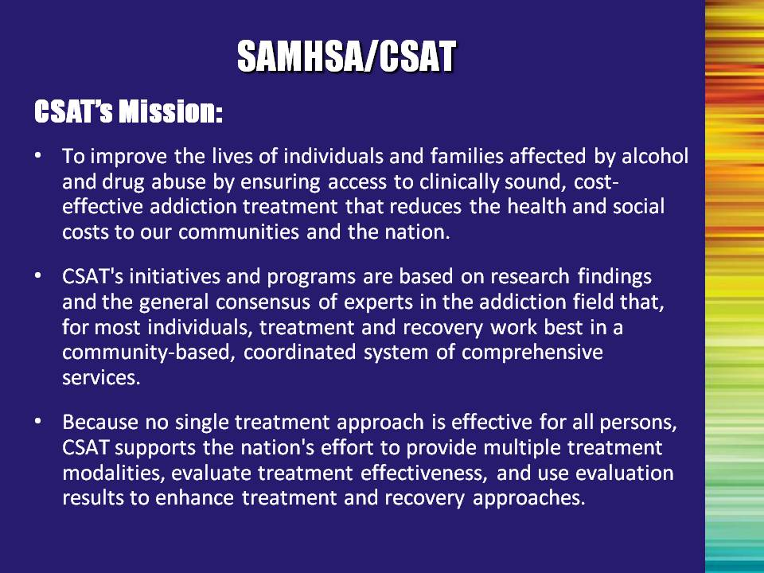 | Slide 10: SAMHSA/CSAT  Read CSAT mission.  Highlight the importance of the research base in all of CSAT’s programming and educating the field about the advances of science to continually improve the quality of services provided. | Slide 10
 | Slide 11: The ATTC Network  One of the major vehicles that SAMHSA has for ensuring that the workforce is adequately trained is the Addiction Technology Transfer Center (ATTC) Network. | Slide 11
 | Slide 12: The ATTC Network  Fourteen regional Centers and a National Office constitute the ATTC Network, which is dedicated to identifying and advancing opportunities for improving addiction treatment.  The vision of the ATTC Network is to unify science, education and services to transform the lives of individuals and families affected by alcohol and other drug addiction.  Serving the 50 United States, the District of Columbia, Puerto Rico, the U.S. Virgin Islands and the Pacific Islands, the ATTC Network delivers cutting-edge knowledge and skills that develop a powerful workforce. | Slide 12
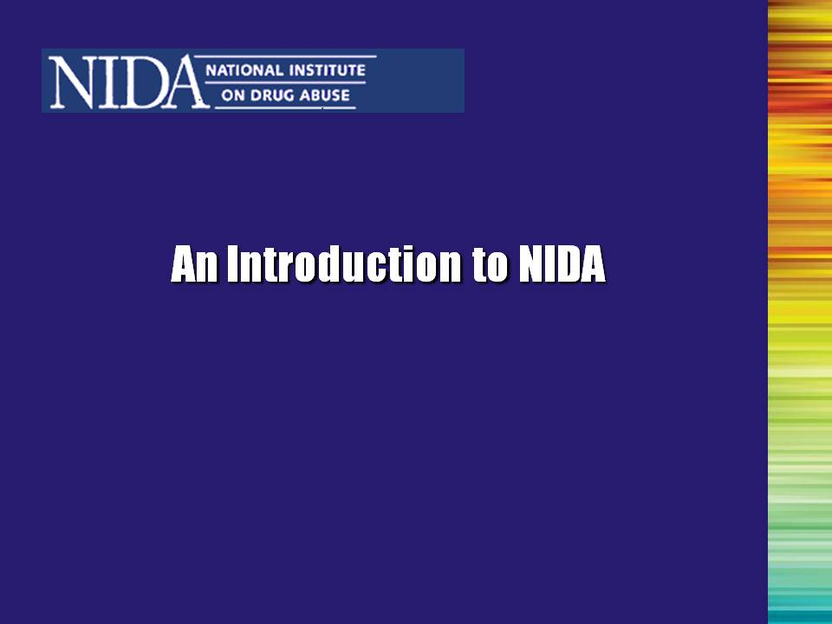 | Slide 13: An Introduction to the National Institute of Drug Abuse  The National Institute on Drug Abuse (NIDA) was established in 1974. In October 1992, it became part of the National Institutes of Health (NIH), U.S. Department of Health and Human Services (DHHS).  Recent scientific advances have revolutionized our understanding of drug abuse and addiction, and have had dramatic implications for how to best prevent and treat addiction. The majority of these advances have been supported by NIDA. | Slide 13
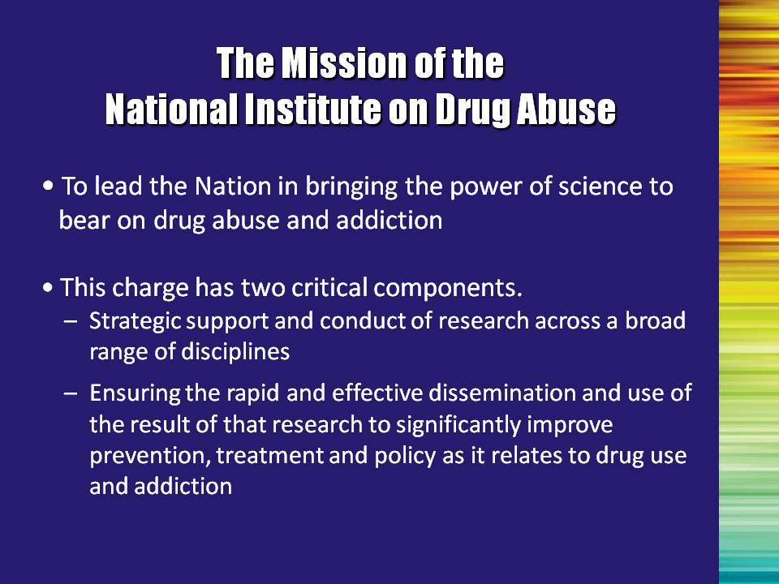 | Slide 14: The Mission of the National Institute on Drug Abuse  NIDA is not only seizing upon unprecedented opportunities and technologies to further the understanding of how drugs of abuse affect the brain and behavior, but is also working to ensure the rapid and effective transfer of scientific data to policy makers, drug abuse practitioners, other health care practitioners, and the general public. The scientific knowledge that is generated through NIDA-funded research is a critical element to improving the overall health of the Nation. The goal of NIDA is to ensure that science, not ideology or anecdote, forms the foundation for all of our Nation's drug abuse reduction efforts. | Slide 14
 | Slide 15: So what is this thing called the CTN?  To date, the efficacy of new treatments for drug addiction has been demonstrated primarily in specialized research settings, with somewhat restricted patient populations. This presents a problem when trying to apply these findings about new treatments into community-based treatment programs, which typically serve diverse populations. To address this problem, NIDA established the National Drug Abuse Treatment Clinical Trials Network (CTN). | Slide 15
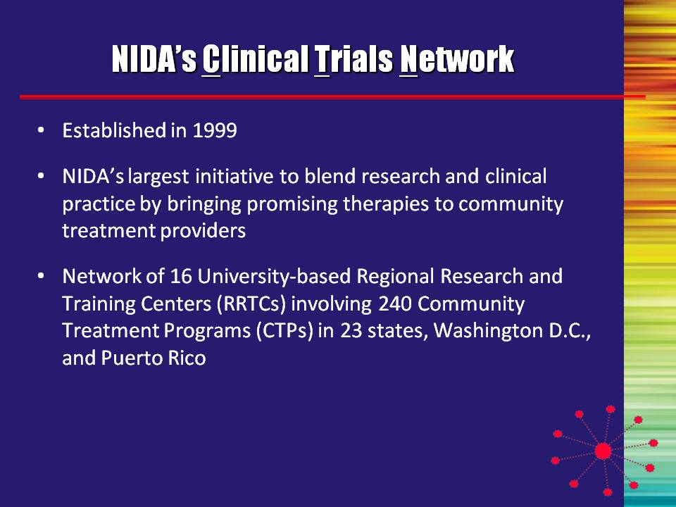 | Slide 16: NIDA’s Clinical Trials Network  The mission of the CTN is twofold:  - Conduct studies of behavioral, pharmacological, and integrated behavioral and pharmacological interventions to determine therapeutic effectiveness in rigorous, multisite clinical trials across a broad range of community-based treatment settings and diversified patient populations; and  - Transfer the research results to physicians, providers, and their patients to improve the quality of drug abuse treatment throughout the country using science as the vehicle. | Slide 16
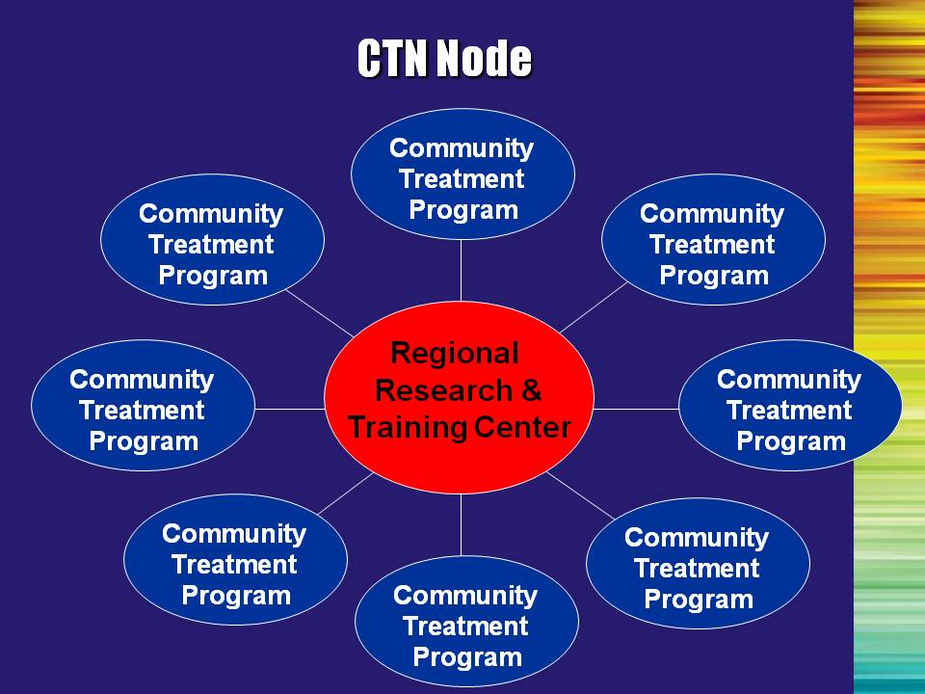 | Slide 17: CTN Node  The CTN comprises Nodes that are dispersed across the country. Each Node has one Regional Research Training Center (RRTC) and 5-10 affiliated community treatment programs (CTPs). CTN research is conducted in the CTPs. CTPs are chosen to participate in a given research protocol based on match between the study questions and requirements, and the populations served by the CTP. For instance, in the buprenorphine studies, a CTP could be chosen if they served an opioid dependent population from whom they could recruit study participants. | Slide 17
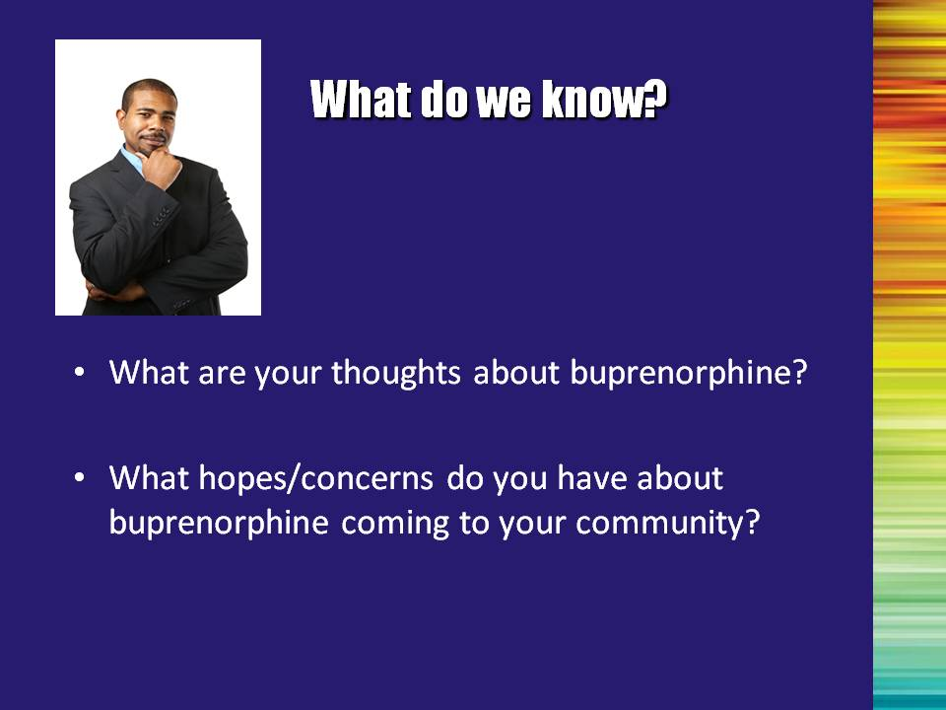 | Slide 18: What Do We Know?  Next, ask the group to share their thoughts about buprenorphine and any hopes/concerns they may have about buprenorphine being introduced in their local community. This will provide the trainer(s) with a sense of the audience’s background and experience with opioid treatment in general, and with buprenorphine in particular.  This exercise also allows the trainer(s) to become familiar with the expectations of the group. | Slide 18
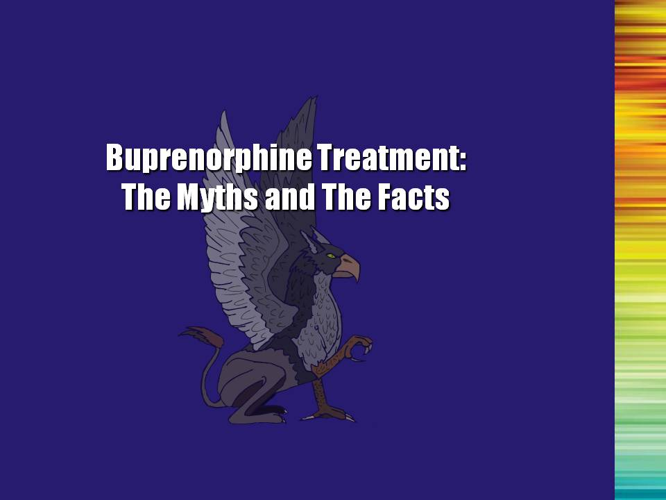 | Slide 19: Buprenorphine Treatment: The Myths and the Facts (Transition Slide)  When considering becoming part of a network of care that involves buprenorphine treatment, counselors may have to examine their own thinking about opioid addiction, in general, and about pharmacotherapy in particular. The following myths and facts can help to correct some of the common misconceptions regarding this type of treatment. | Slide 19
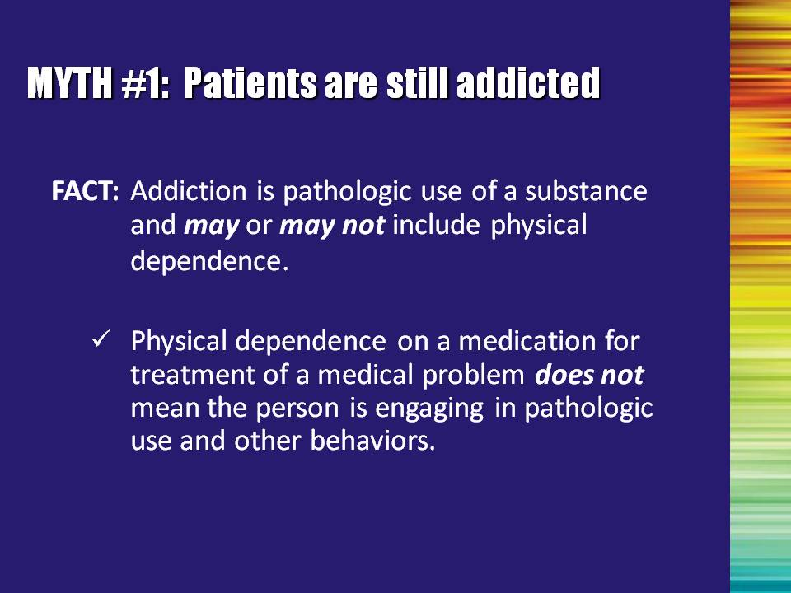 | Slide 20: Myth #1: Patients are still addicted  Fact: Addiction is defined by the pathological behaviors and compulsivity of use, not by the body’s adaptation to a medication. Using medications as a component of opioid treatment can help a person to function normally.  Physical dependence IS NOT the same thing as addiction. This is a really important concept that we will spend more time on later in the training. | Slide 20
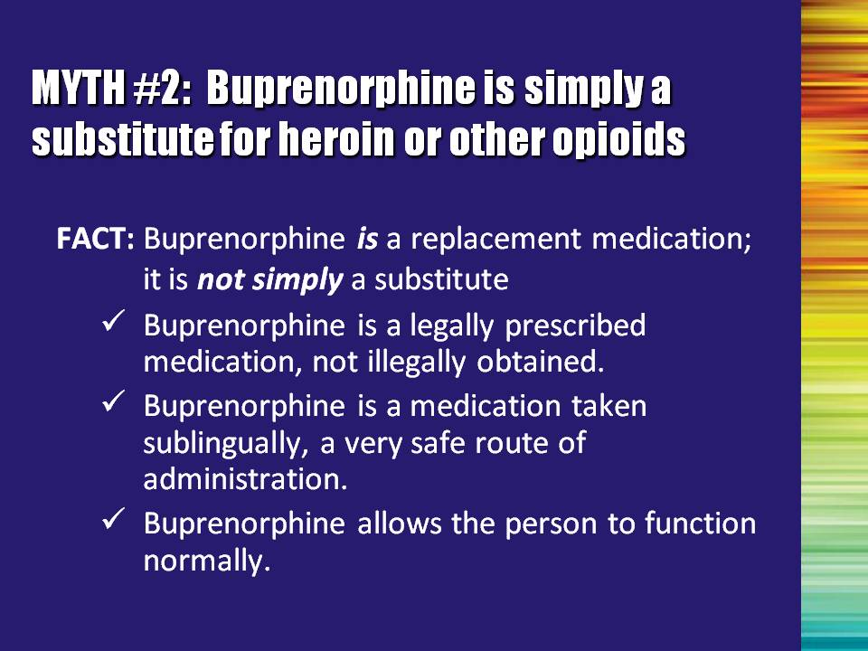 | Slide 21: Myth #2: Buprenorphine is simply a substitute for heroin or other opioids  Fact: Buprenorphine is a replacement medication in that it prevents withdrawal. However, it is not simply a substitute.  Buprenorphine is a legally prescribed medication. When taken sublingually, under medical supervision, it is very safe and allows the person to function normally.  Buprenorphine is a controlled substance, produced and distributed under close supervision and quality controls.  Helping the person to stop the negative and compulsive behaviors associated with drug use, and helping them to lead a functional normal life, is the goal of any treatment. Using a medication such as buprenorphine can be an important method for helping people to achieve this goal. | Slide 21
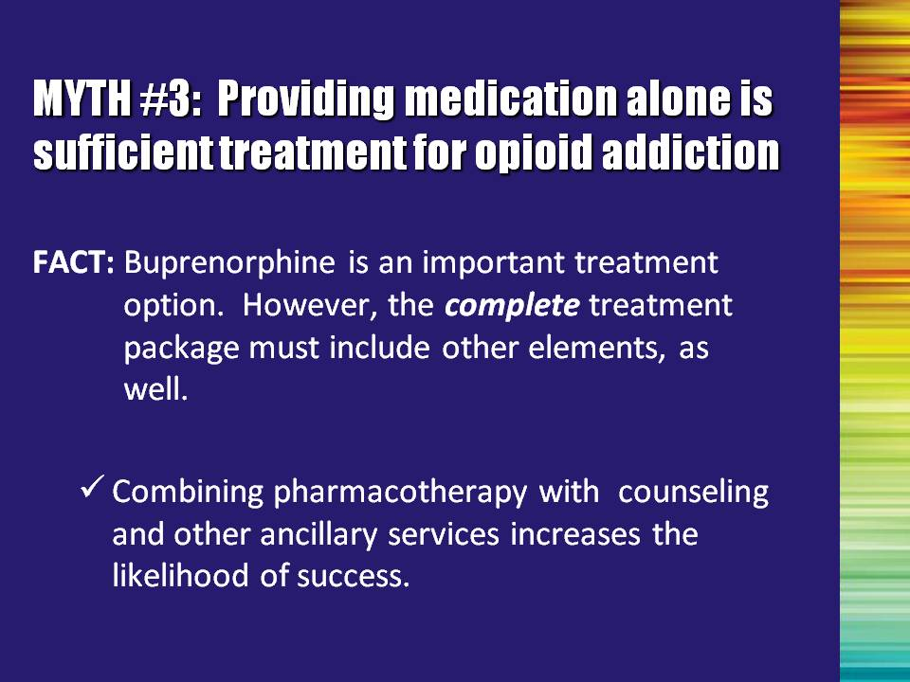 | Slide 22: Myth #3: Providing medication alone is sufficient treatment for opioid addiction  Fact: The combination of pharmacotherapy with counseling provides critical clinical advantages, such as improvements to patients’ psychosocial functioning, employment stability, and general lifestyle issues.  Note to the Trainer(s): This is an extremely important point for this particular audience. Law or regulation does not require the behavioral treatment (counseling) component of buprenorphine treatment. The successful dissemination of this treatment may very well hinge on the development of collaboration between physicians and other multidisciplinary addiction professionals. | Slide 22
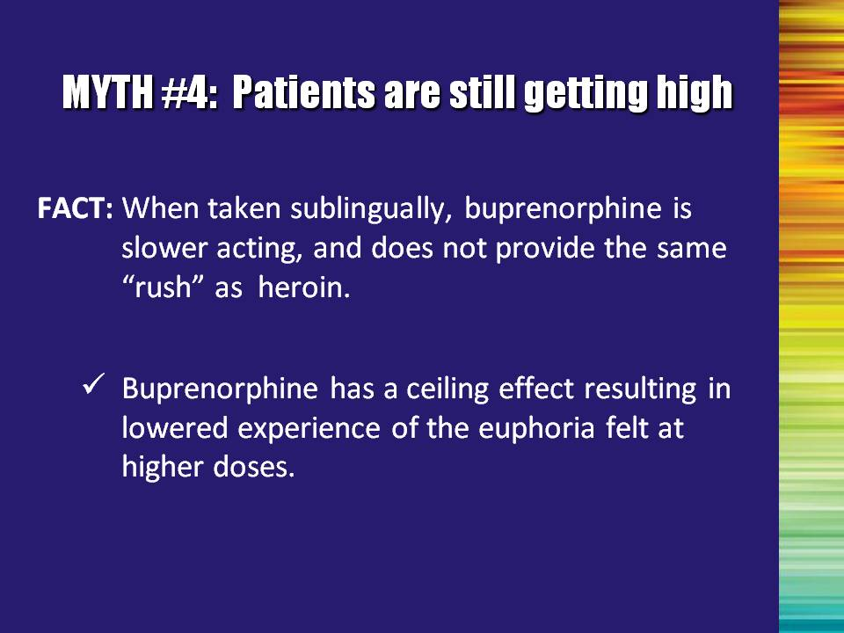 | Slide 23: Myth #4: Patients are still getting high  Fact: There is a ceiling effect in terms of the rushing euphoria.  When taken sublingually as prescribed, patients feel more stable than when they take heroin or other full agonists.  Buprenorphine occupies the same receptors as full agonists, but it occupies them for a much longer period of time. It also has a ceiling effect for the “rush” experience so that even at higher doses, there is less experience of this euphoric effect.  When the dose is adjusted adequately, patients prescribed buprenorphine should function without sedation or intoxication. | Slide 23
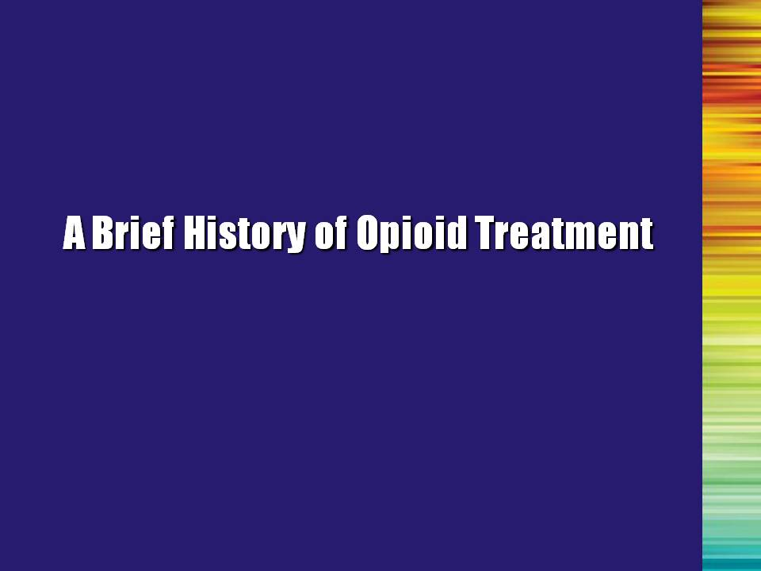 | Slide 24: A Brief History of Opioid Treatment (Transition Slide)  Before we can understand the role that buprenorphine can play in the treatment system, we need to do a quick review of how the treatment of opioid addiction has developed. | Slide 24
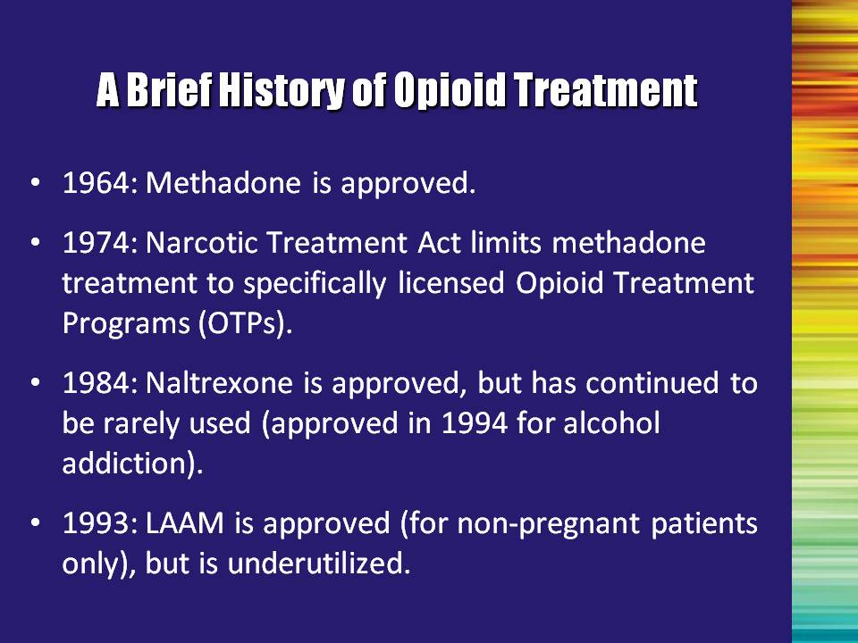 | Slide 25: A Brief History of Opioid Treatment  1964: Methadone was the first medical intervention approved for the treatment of drug addiction.  Until recently, the Controlled Substances Act allowed the use of narcotics for addiction treatment to only those opioid drugs approved by the U.S. Food and Drug Administration (FDA) for the detoxification or maintenance treatment of addiction. These drugs could only be dispensed by physicians in programs regulated by the Substance Abuse and Mental Health Services Administration (SAMHSA) and the U.S. Drug Enforcement Administration (DEA). These programs are usually called “methadone maintenance” or “opioid treatment programs (OTPs).”  Additional medications have been shown to be effective in the treatment of opioid addiction. However, use of these medications was not widespread, due, in part, to the failure to adequately transfer the technology to the field.  For example, levo-α-acetylmethadol (LAAM) or Orlaam (trade name), a synthetic opioid similar in structure to methadone, had trouble making it into the opioid treatment system – people were already using methadone and the way that LAAM was introduced to them was ineffective.  The goal in developing new medications is not to replace the old ones, but to increase the available treatment options.  **Some states do not have methadone maintenance available to its opioid addicted individuals. Be sure to find out the local methadone-related policies that exist in your State.** | Slide 25
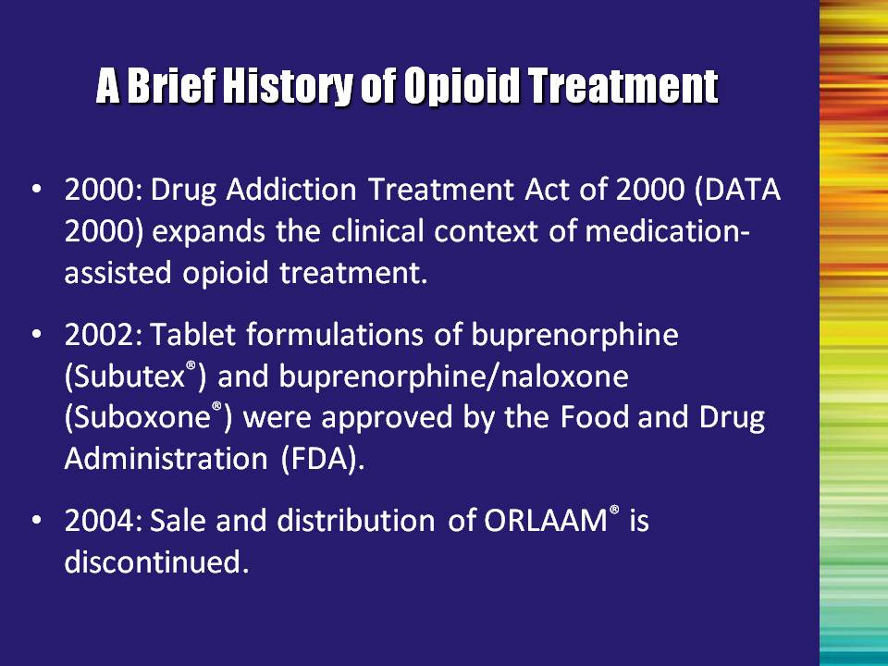 | Slide 26: A Brief History of Opioid Treatment  Define the Drug Addiction Treatment Act of 2000 (DATA 2000) and note that we will talk more about that in just a minute.  Note the approval of buprenorphine and buprenorphine/ naloxone in 2002, which set the stage for the implementation of DATA 2000.  Notes about LAAM:  ORLAAM® was withdrawn from the European market in March 2001.  Extensive changes (including additional warnings and contraindications) were made to U.S. package insert in April 2001.  Roxane Laboratories announced the discontinuation of LAAM on August 23, 2003 (due, in part, to reports of severe cardiac-related adverse events, including slowing of cardiac conduction [QT interval prolongation] and cardiac arrest). The risks of continued distribution and use in the face of less toxic treatment alternatives outweighed the overall benefits.  Notes about Methadone:  Currently, there is significant controversy about potential harmful effects of methadone on cardiac conduction. Although several reports suggest that some patients receiving methadone are at increased risk for QTc prolongation and a potentially fatal arrhythmia (torsade de pointes; Maremmani et al., 2005; Pimentel & Mayo, 2008), others have not replicated these findings. | Slide 26
 | Slide 26: A Brief History of Opioid Treatment, Continued  Most of the uncertainty is due to the lack of large controlled studies. Until large controlled studies become available, caution should prevail.  Currently, it is suggested that patients entering methadone therapy (MT) be screened for cardiac risk factors. An electrocardiogram (ECG), which is an electrical recording of the heart and is used in the investigation of heart disease, might be considered in new patients with a history of known heart disease or recent symptoms like unexplained seizures, exertional chest pain or discomfort, exertional shortness of breath, unexplained syncope or heart palpitations. During MT, an ECG evaluation might be considered before starting QT-prolonging medications (particularly psychotropic drugs in dually diagnosed patients). There is no consensus on when to perform an ECG during MT.  References:  Maremmani, I., Pacini, M., Cesaroni, C., Lovrecic, M., Perugi, G., & Tagliamonte. (2005). QTc interval prolongation in patients on long-term methadone maintenance therapy. European Addiction Research, 11, 44-49.  Pimentel, L. & Mayo, D. (2008). Chronic methadone therapy complicated by torsades de pointes: A case report. Journal of Emergency Medicine, 34(3), 287-  290. | Slide 26
 | Slide 27: Understanding DATA 2000 (Transition Slide)  The Drug Addiction Treatment Act of 2000 (DATA 2000) changed the available options for providing treatment for opioid addiction and is critical in the discussion of buprenorphine and how it can be used. | Slide 27
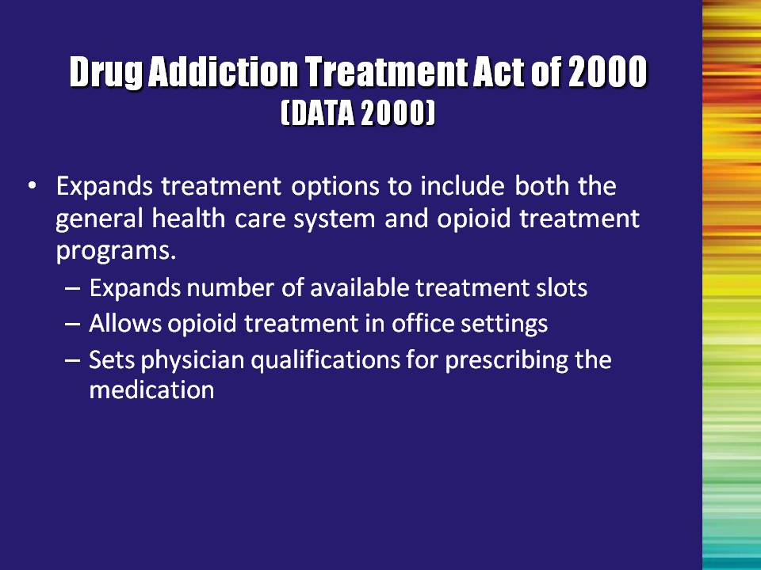 | Slide 28: Drug Addiction Treatment Act of 2000 (DATA 2000)  DATA 2000 amended the Controlled Substances Act, allowing qualified physicians to prescribe approved narcotic medications (in Schedules III, IV, V, or combinations of such drugs approved by the FDA for the treatment of opioid addiction) from their office settings.  The DEA places all drugs and medications on a schedule. Placement is based upon the substance’s medicinal value, harmfulness, and potential for abuse or addiction. Schedule I is reserved for the most dangerous drugs that have no recognized medical use, while Schedule V is the classification used for the least dangerous drugs. Methadone is Schedule II and Buprenorphine is Schedule III.  This means that buprenorphine is considered a safer drug with lower potential for abuse than methadone. Therefore, buprenorphine is subject to fewer prescribing restrictions than methadone.  As a result, opioid-addicted patients may receive treatment in a qualified physician’s office instead of an opioid treatment program, making treatment available to persons who might otherwise not have received it.  DATA 2000 preempts individual state laws unless a state passed a new law before October 8, 2005. | Slide 28
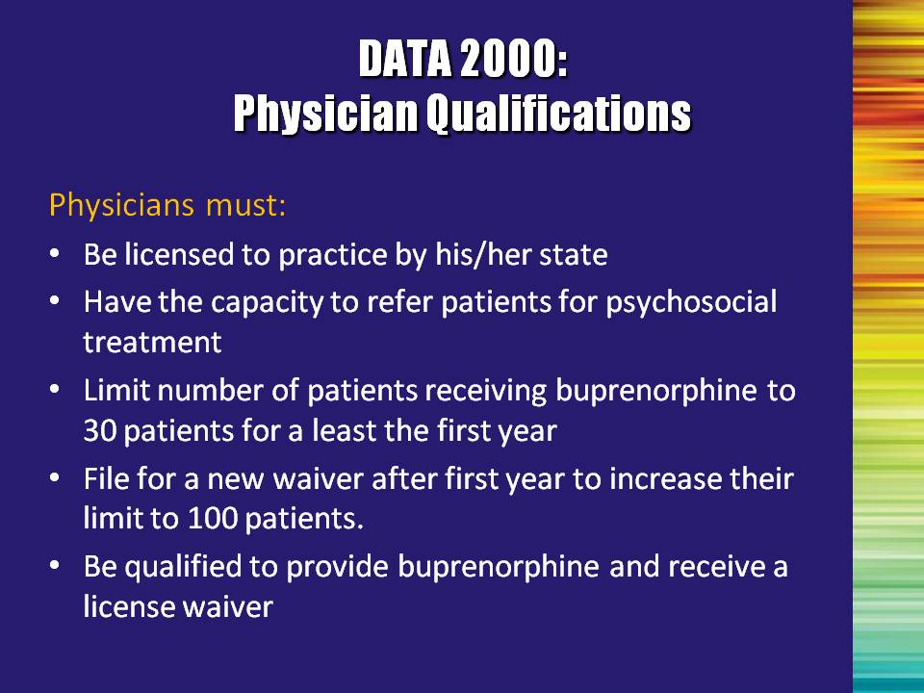 | Slide 29: DATA 2000: Physician Qualifications  **Nurse practitioners and physician assistants MAY NOT prescribe buprenorphine under the terms of DATA 2000.**  Bullet #2: Psychosocial treatment may include counseling and ancillary services (e.g., medical care, employment and education, etc.).  There is no mandate for patients who are prescribed buprenorphine to receive psychosocial counseling. The fact that a physician has the capacity to refer a patient for psychosocial treatment does not mean they will actually make a referral or that the patient will follow through with a referral. It is critical that multidisciplinary addiction professionals be proactive in developing linkages with physicians in their local areas.  Bullet #3: While originally limited to 30 patients for individual or group practices, the regulations were changed so that individual physicians (not groups), were limited to 30 for their first year. After gaining at least one year of experience, they can apply for an additional waiver that will allow them to increase their number of patients to 100.  The patient limits do not apply to opioid treatment programs (OTPs) that prescribe buprenorphine. However, OTPs must follow the same regulations as those set up for the provision of methadone.  Note to the Trainer(s): This is a good place to briefly discuss the waiver process all physicians must go through before they are able to prescribe buprenorphine.  A physician must (1) meet the training requirements or be otherwise “qualified”; and (2) complete a waiver notification form and submit it to SAMHSA/CSAT. CSAT then reviews and evaluates the form. If approved, a special, unique license number is issued and added to the physician’s existing DEA license number. | Slide 29
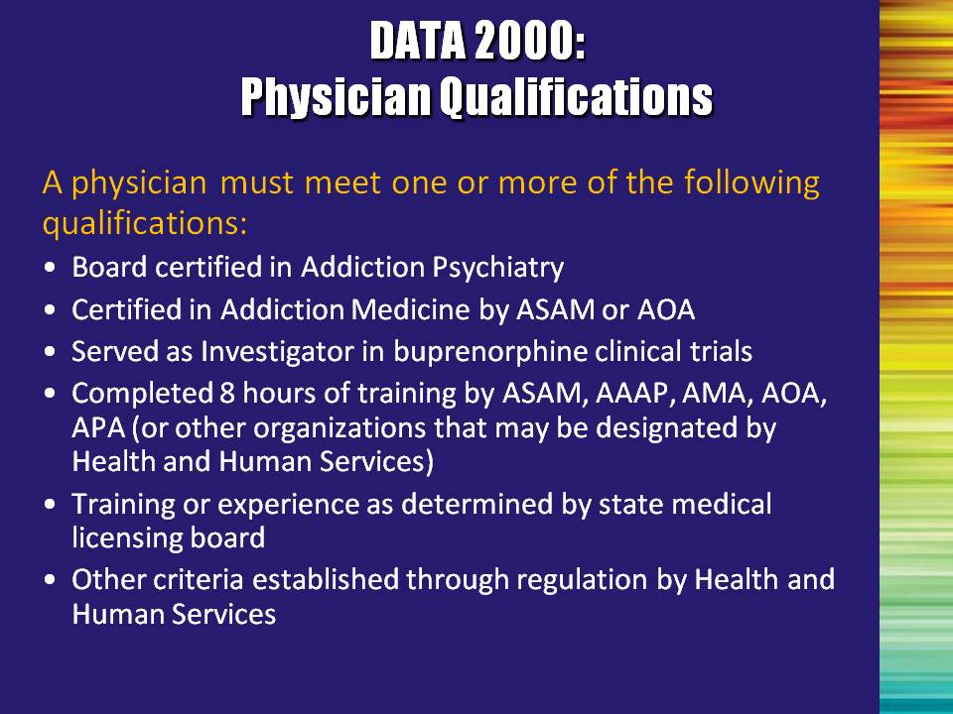 | Slide 30: DATA 2000: Physician Qualifications  Summarize each bullet point.  ASAM – American Society of Addiction Medicine  AOA – American Osteopathic Association  AAAP – American Academy of Addiction Psychiatry  AMA – American Medical Association  APA – American Psychiatric Association | Slide 30
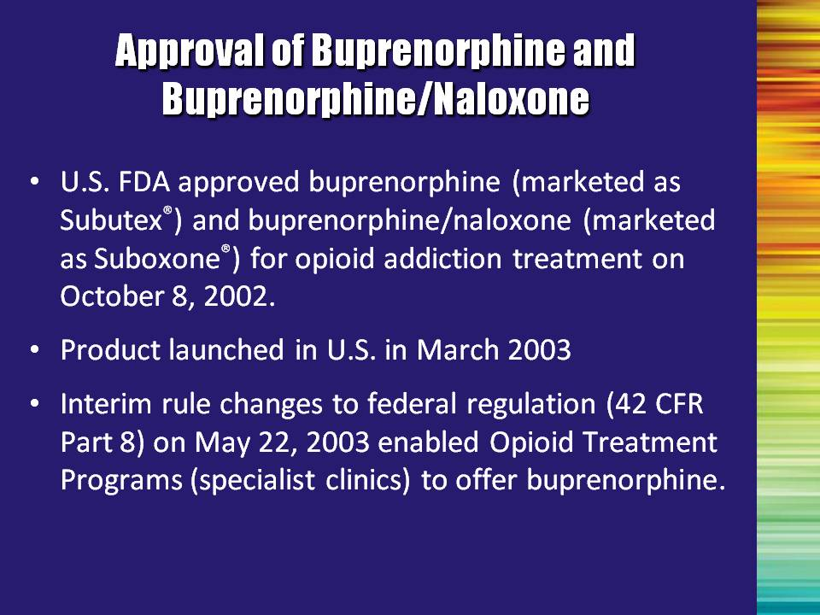 | Slide 31: Approval of Buprenorphine and Buprenorphine/Naloxone  Prior to 2002, buprenorphine was only available in the United States in an injectable form and was only approved for the treatment of pain.  Sublingual formulations of buprenorphine were approved by the FDA in late 2002 for the treatment of opioid addiction and made available by the pharmaceutical company in March 2003.  When the regulations went into effect in 2002, the medication was only approved for prescription in physicians’ offices. Office-based implementation requires that a physician complete the necessary training requirements and secure a waiver. Following one year of experience, they are allowed to treat up to 100 patients.  In May of 2003, the regulations were modified so that OTPs could use buprenorphine as well, but they have to do so under the same regulations as methadone, thereby creating two distinct implementation schemes for buprenorphine treatment, i.e., office-based vs. OTPs. | Slide 31
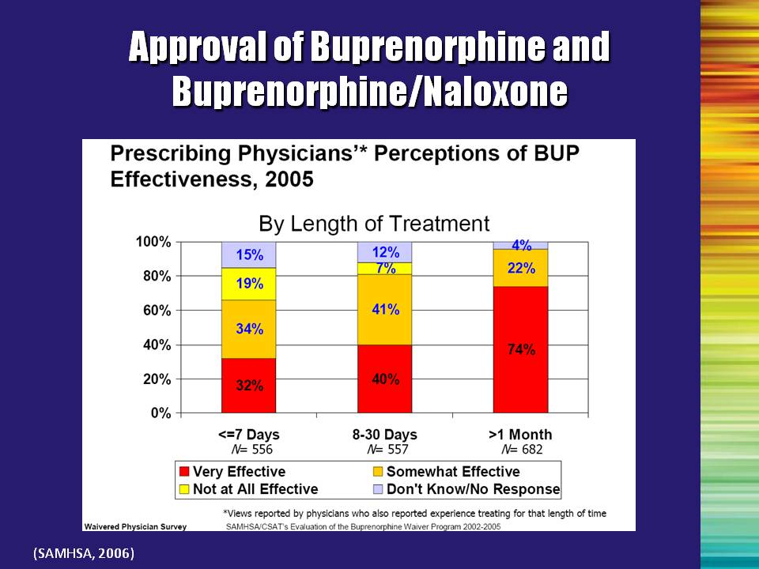 | Slide 32: Approval of Buprenorphine and Buprenorphine/Naloxone  SAMHSA began a 3-year evaluation of DATA 2000 starting on the date of FDA approval (October 8, 2002).  Evaluation findings regarding the effectiveness of buprenorphine treatment for opioid dependence provided under the Waiver Program can be summarized as follows:  - Most prescribing physicians perceived buprenorphine to be effective, particularly for treatment of longer duration.  - Positive treatment outcomes were observed among patients treated in a variety clinical practice settings.  - Outcomes are consistent with the results of numerous clinical trials that have found buprenorphine to be effective in research contexts  - Buprenorphine treatment appeared to be somewhat more effective for patients who were dependent on prescription opioids than for those primarily dependent on heroin.  In addition, the buprenorphine manufacturer is conducting a post-marketing risk management program.  Reference:  Westat and The Avista Group. (2006). The SAMHSA evaluation of the impact of the DATA waiver program. Final summary report (Task Order 277-00-6111). Rockville, MD: Center for Substance Abuse Treatment, Substance Abuse and Mental Health Services Administration. | Slide 32
 | Slide 33: Only physicians can prescribe the medication. However, the entire treatment system should be engaged.  Read slide aloud. | Slide 33
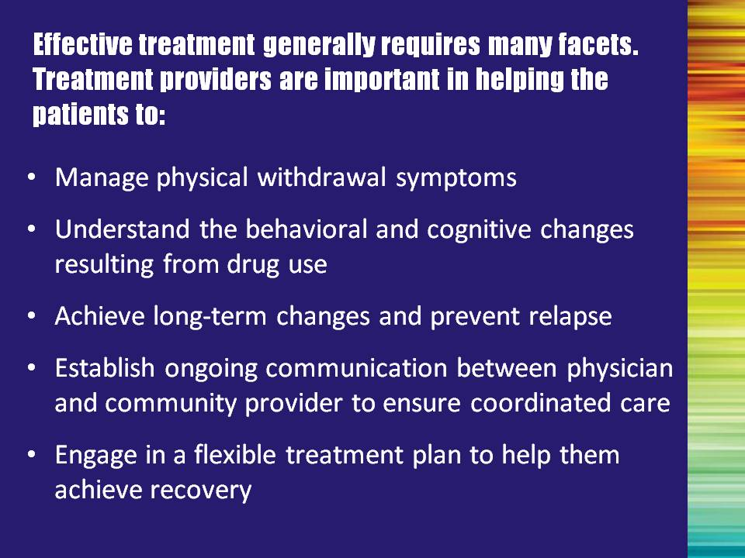 | Slide 34: Effective treatment generally requires many facets. Treatment providers are important in helping the patients to:  Summarize bullet points.  Here are a few other points worth mentioning:  - Encourage patients to abstain from further use of their drug(s) of abuse.  - Provide psychosocial and counseling services along with pharmaceutical treatment to increase the likelihood of achieving long-term, comprehensive lifestyle changes and prevent relapse.  It is important to stress the importance of flexible partnerships.  The multidisciplinary professional/physician relationship may take many forms, ranging from members of a common treatment team within the same facility (co-located) to geographically separated independent practitioners. The multidisciplinary professional and physician should have common treatment philosophies and goals, and have rapid access to each other. | Slide 34
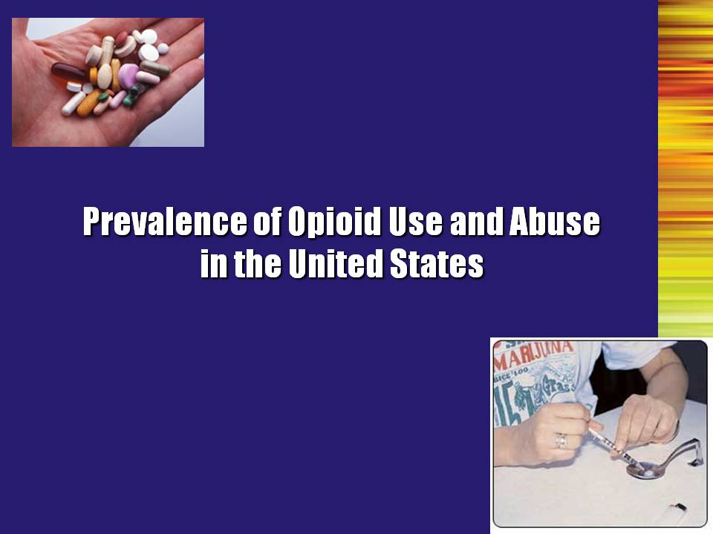 | Slide 35: Prevalence of Opioid Use and Abuse in the United States (Transition Slide)  So how significant is the problem of opioid use in the United States? Let’s look at some of the available statistics. | Slide 35
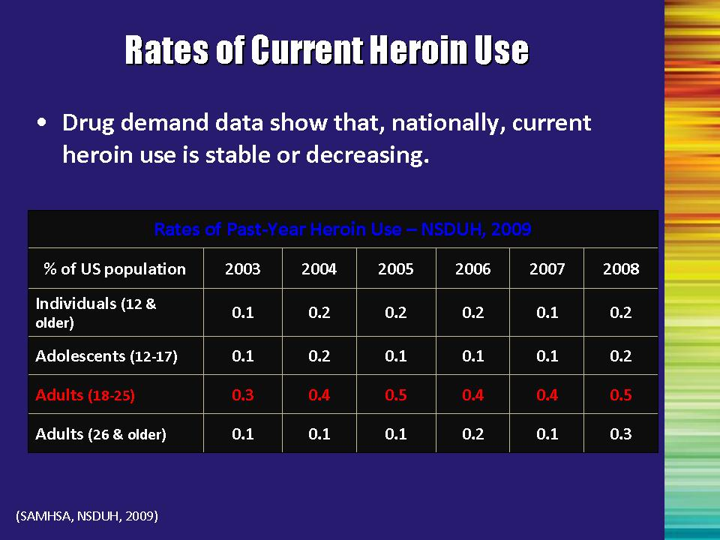 | Slide 36: Rates of Current Heroin Use  The National Survey on Drug Use and Health (NSDUH) provides information on the prevalence of substance use in the United States and associated problems resulting from use. The survey is conducted on a nationwide sample and collects information on the demographics, patterns of use, treatment, perception of risk, criminal behavior, and mental health issues.  Data from multiple NSDUH surveys indicate that rates of heroin use have been stable or have declined for most age groups. These data show that past year rates of heroin use did not significantly change in any measured age group during that same period. The exception is for 18-25 year olds, where the 2008 estimate was significantly higher than the 2003 estimate, with the highest level of usage among young adults aged 18-25 (SAMHSA, 2009).  Additional Information for the Trainer(s):  The National Drug Intelligence Center (U.S. Department of Justice) reports that although heroin use is stable, it could increase as more prescription narcotic abusers switch to heroin. Officials who were surveyed in treatment facilities throughout the country reported that many abusers of prescription opiates, such as OxyContin, Percocet, and Vicodin, eventually begin abusing heroin because it is typically cheaper and easier to obtain, and it provides a more intense high. Treatment officials also reported that once an individual switches from prescription opiates to heroin, he or she rarely switches back to exclusively abusing prescription opiates (National Drug Intelligence Center, 2007).  References:  Substance Abuse and Mental Health Services Administration. (2009). Results from the 2008 National Survey on Drug Use and Health: National Findings (Office of Applied Studies, NSDUH Series H-36, HHS Publication No. SMA 09-4434). Rockville, MD.  National Drug Intelligence Center. (2007). National Drug Threat Assessment 2008. (Document ID: 2007-Q0317-003). Washington, DC: U.S. Department of Justice | Slide 36
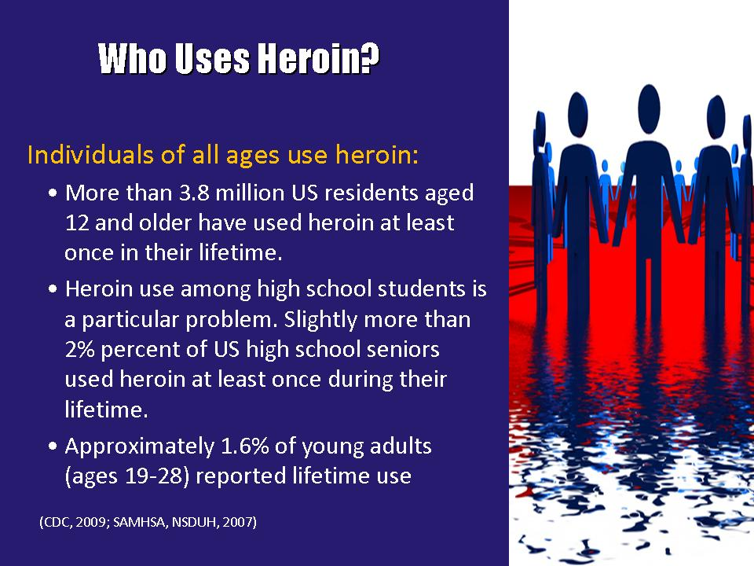 | Slide 37: Who Uses Heroin?  According to the 2008 NSDUH, more than 3.8 million people over the age of 12 have used heroin at least one time. Approximately 453,000 (0.2%) reported past year heroin use and 213,000 (0.1%) reported past month heroin use (SAMHSA, 2009).  The number of heroin users that reported past month heroin use decreased from 338,000 in 2006 to 153,000 in 2007.  - Among high school students surveyed as part of the 2007 Centers for Disease Control and Prevention’s (CDC) Youth Risk Behavior Surveillance System (YRBSS), 2.3% have used heroin at least once during their lifetime.  - Approximately 0.5% of college students and 1.6% of young adults (ages 19-28) reported lifetime use of heroin (CDC, 2008).  References:  Substance Abuse and Mental Health Services Administration. (2009). Results from the 2008 National Survey on Drug Use and Health: National Findings (Office of Applied Studies, NSDUH Series H-36, HHS Publication No. SMA 09-4434). Rockville, MD.  Center for Disease Control and Prevention. Youth risk behavior surveillance – United States, 2007. Surveillance Summaries, June 6, 2009. MMWR 2008; 57 (No. SS-4). | Slide 37
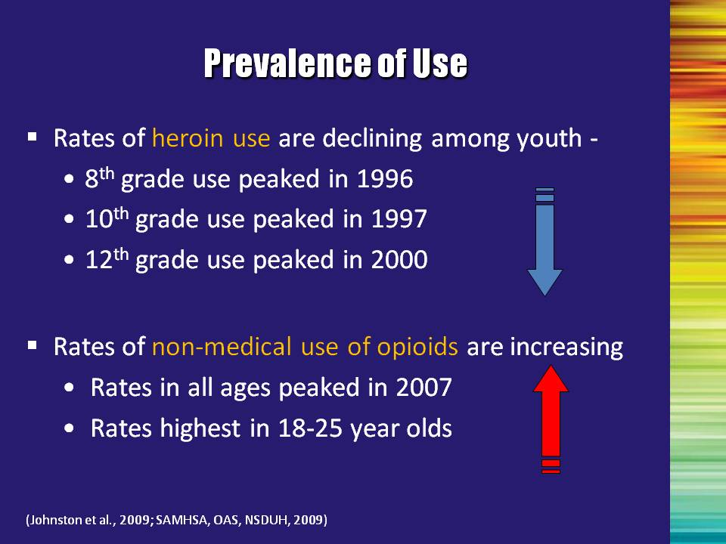 | Slide 38: Prevalence of Use  Recent concern has focused on opioid use among young people. Rates of heroin use are on the downturn among youth, however, rates of non-medical use of opioids have been steadily increasing.  The annual prevalence of heroin use among youth rose in the mid- and late 1990s, reaching peak levels in 1996 among 8th graders (1.6%), in 1997 among 10th graders (1.4%), and in 2000 among 12th graders (1.5%). Since those peak levels, heroin use has declined among students in all three grade levels to 0.7-.09% (Johnston, O’Malley, Bachman, & Schulenberg, 2009).  However, for the general population over 12 years of age, recent data showed that 13.4% of individuals who reported new use of heroin in the past 13 to 24 months also met criteria for substance dependence (SAMHSA, Office of Applied Studies, 2008).  References:  Johnston, L. D., O'Malley, P. M., Bachman, J. G., & Schulenberg, J. E. (2009). Monitoring the Future national survey results on drug use, 1975-2008. Volume I: Secondary school students (NIH Publication No. 09-7402). Bethesda, MD: National Institute on Drug Abuse.  Substance Abuse and Mental Health Services Administration, Office of Applied Studies. (February 5, 2009). The NSDUH Report: Trends in Nonmedical Use of Prescription Pain Relievers: 2002 to 2007. Rockville, MD.  Substance Abuse and Mental Health Services Administration, Office of Applied Studies. (March 27, 2008). The NSDUH Report: Substance Use and Dependence Following Initiation Following Alcohol or Illicit Drug Use. Rockville, MD. | Slide 38
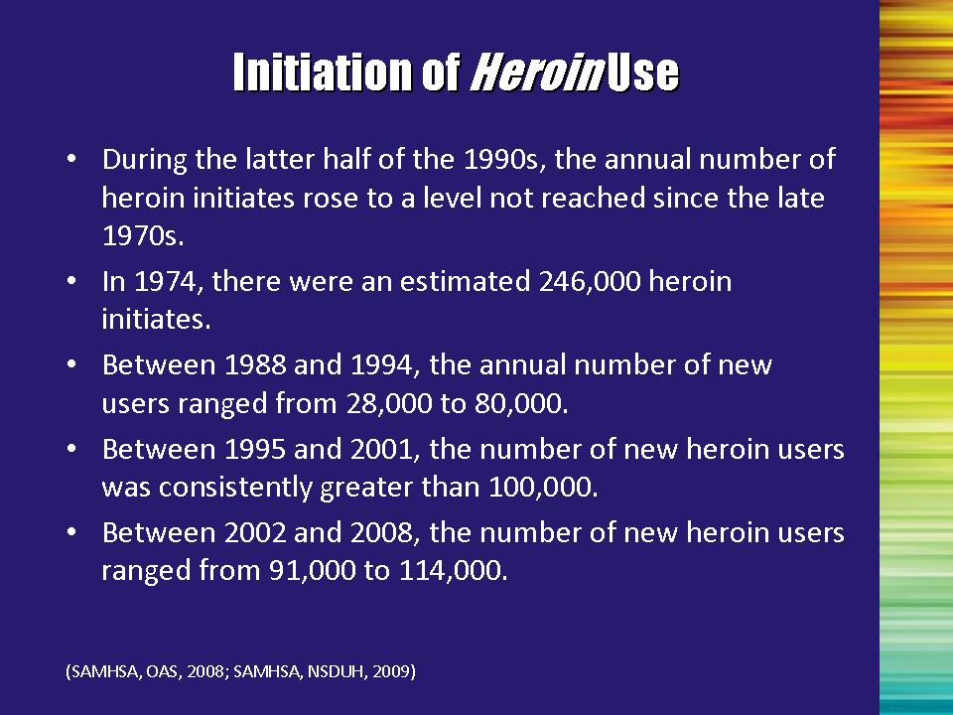 | Slide 39: Initiation of Heroin Use  During the latter half of the 1990s, the annual number of heroin initiates rose to a level not reached since the late 1970s.  - In 1974, there were an estimated 246,000 heroin initiates.  - Between 1988 and 1994, the annual number of new users ranged from 28,000 to 80,000.  - Between 1995 and 2001, the number of new heroin users was consistently greater than 100,000.  - Between 2002 and 2007, the number of new heroin users ranged from 91,000 to 117,000.  In 2007, there were 106,000 first-time users of heroin aged 12 or older; the average age at first use of heroin was 21.8 years.  In 2008, there were 114,000 persons aged 12 or older who had used heroin for the first time within the past 12 months. The average age at first use among recent initiates aged 12 to 49 was 23.4 years in 2008. There were no significant changes in the number of initiates or in the average age at first use from 2007 to 2008. (SAMHSA, 2008)  The number of heroin initiates in 2008 was not significantly different from the number in 2002 (117,000) (SAMHSA, 2008).  References:  Substance Abuse and Mental Health Services Administration, Office of Applied Studies (2008). Results from the 2007 National Survey on Drug Use and Health: National Findings (NSDUH Series H-34, DHHS Publication No. SMA 08-4343). Rockville, MD.  Substance Abuse and Mental Health Services Administration. (2009). Results from the 2008 National Survey on Drug Use and Health: National Findings (Office of Applied Studies, NSDUH Series H-36, HHS Publication No. SMA 09-4434). Rockville, MD. | Slide 39
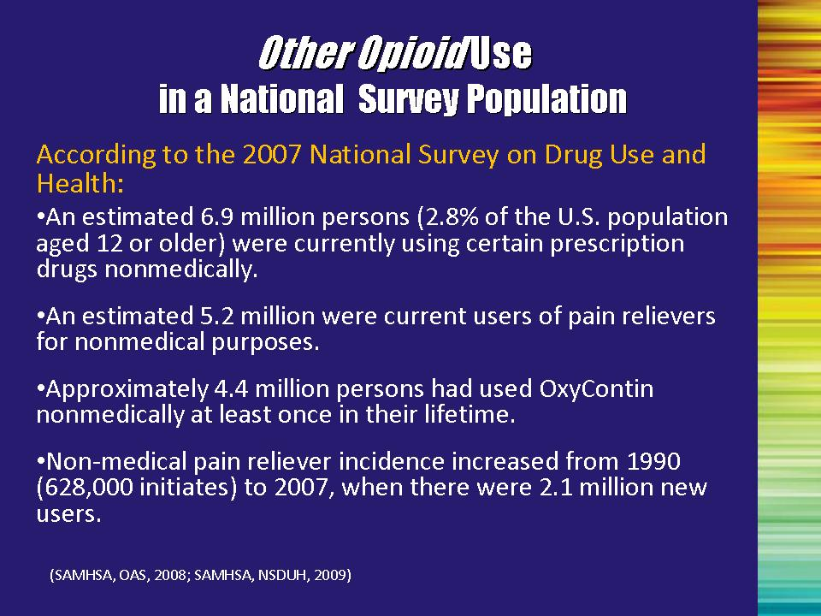 | Slide 40: Other Opioid Use in a Household Survey Population  Heroin is only one of the types of opioids for which people seek substance abuse treatment. Prescription opioids are also prone to abuse.  Prescription pain reliever use increased nearly fourfold in the decade between 1990 and 2000, and has continued to consistently increase.  In 2007, approximately 2.1% of Americans (5.2 million people) were currently using pain relievers nonmedically, and approximately 4.4 million people had used OxyContin for nonmedical purposes at least once in their lives (SAMHSA, 2009b).  In 2008, a small decline was noted in the percentage (1.9%) of individuals using pain relievers nonmedically; however this decline is not statistically significant (SAMHSA, 2009).  Overall, between 2004 and 2008, the percentage and the number of persons dependent on or abusing pain relievers increased from 0.6 to 0.7 percent and from 1.4 to 1.7 million (SAMHSA, 2009).  References:  Substance Abuse and Mental Health Services Administration, Office of Applied Studies (2008). Results from the 2007 National Survey on Drug Use and Health: National Findings (NSDUH Series H-34, DHHS Publication No. SMA 08-4343). Rockville, MD.  Substance Abuse and Mental Health Services Administration. (2009). Results from the 2008 National Survey on Drug Use and Health: National Findings (Office of Applied Studies, NSDUH Series H-36, HHS Publication No. SMA 09-4434). Rockville, MD.  Substance Abuse and Mental Health Services Administration, Office of Applied Studies. (2009). The NSDUH Report: Trends in Nonmedical Use of Prescription Pain Relievers: 2002 to 2007. Rockville, MD. | Slide 40
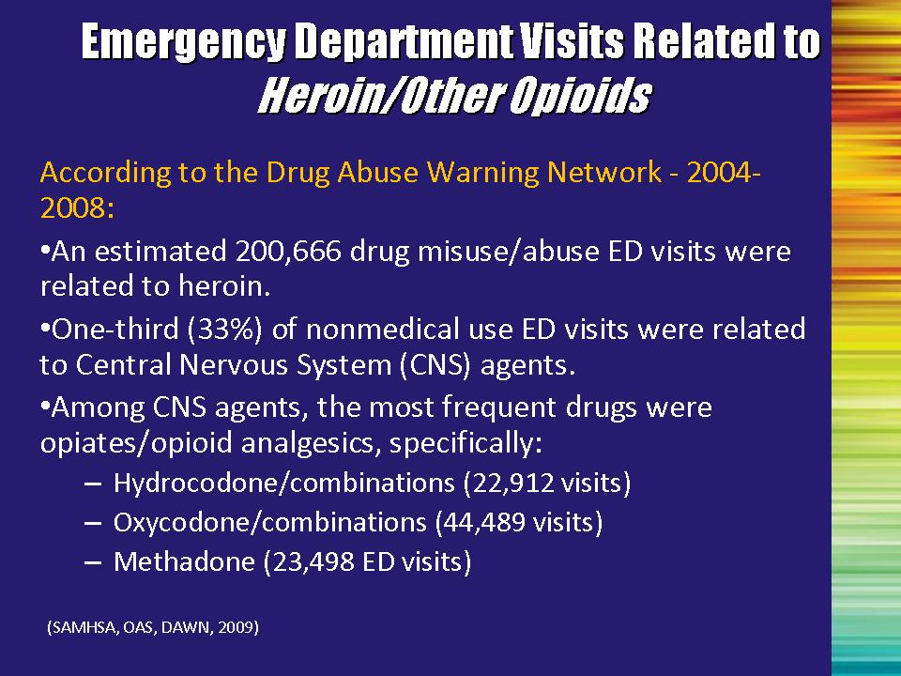 | Slide 41: Emergency Department Visits Related to Heroin and Other Opioids  The Drug Abuse Warning Network (DAWN) collects data from emergency departments (ED) to determine if drugs are mentioned as a factor contributing to the ED visit. Examination of these data provides an indicator of changes in the level of use in the population.  In 2008, of 993,370 drug misuse/abuse ED visits, an estimated 200,666 were related to heroin. This is an increase from 2006 at which time 189,780 drug misuse/abuse ED visits were related to heroin.  One-third (33%) of the nonmedical use ED visits were related to medications that affect the central nervous system (CNS), such as prescription pain killers and sedatives. Among those, the most frequently mentioned were hydrocodone/combinations, oxycodone/combinations, and methadone.  According to the DAWN system, other opiates/opioids included, but were not limited to narcotic analgesics/combinations such as codeine combinations, hydrocodone combinations, methadone, morphine combinations, opium combinations, and oxycodone combinations.  Reference:  Drug Abuse Warning Network, 2004–2008: Selected Tables of National Estimates of Drug-Related Emergency Department Visits. Rockville, MD: Office of Applied Studies, SAMHSA, 2009 | Slide 41
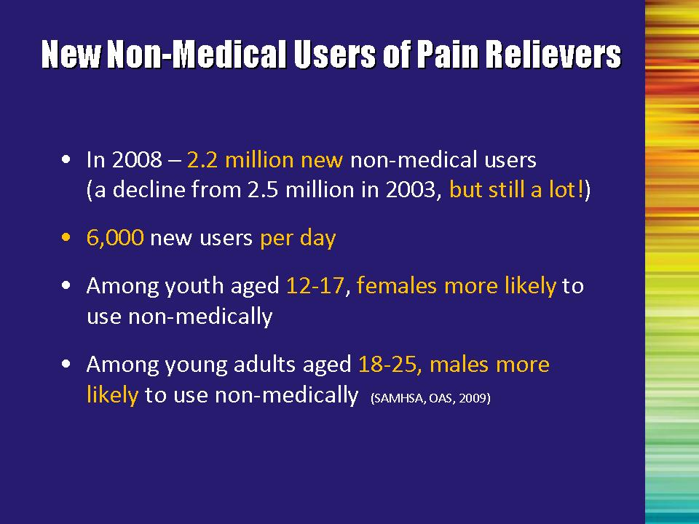 | Slide 42: Non-Medical Users of Pain Relievers  Data from the 2008 NSDUH show that 2.2 million people, aged 12 or older, initiated nonmedical use of prescription pain relievers within the past year. This averages to approximately 6,000 initiates (new users) per day (SAMHSA, 2009).  Among youth aged 12 to 17, females were more likely than males to have used pain relievers non-medically in the past year, whereas males aged 18 to 25 and males aged 26 to 34 had higher rates than their female counterparts (SAMHSA, OAS, 2009).  Data from DAWN (SAMHSA, 2008) showed that ED visits involving hydrocodone/combinations increased 44% and oxycodone/combinations increased 56% from 2004 to 2006.  References:  Substance Abuse and Mental Health Services Administration, Office of Applied Studies. Drug Abuse Warning Network, 2006: National Estimates of Drug-Related Emergency Department Visits. DAWN Series D-30, DHHS Publication No. (SMA) 08-4339, Rockville, MD, 2008.  Substance Abuse and Mental Health Services Administration. (2009). Results from the 2008 National Survey on Drug Use and Health: National Findings (Office of Applied Studies, NSDUH Series H-36, HHS Publication No. SMA 09-4434). Rockville, MD. | Slide 42
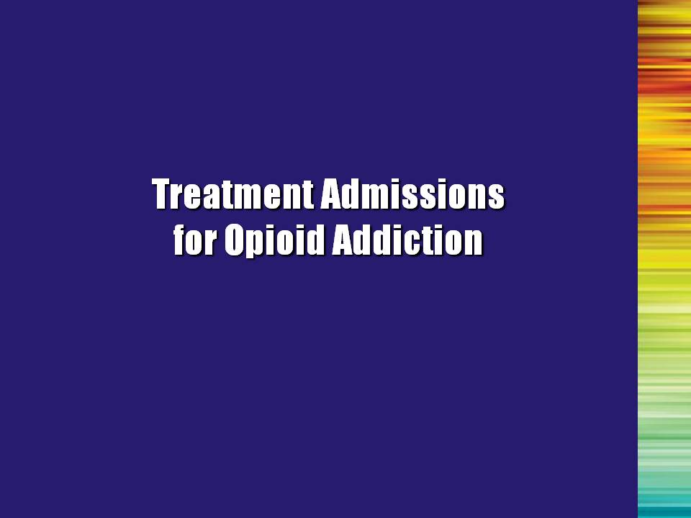 | Slide 43: Treatment Admissions for Opioid Addiction (Transition Slide)  Another indicator of a drug problem is to look at the number and demographics of people seeking treatment for particular drugs. These data will provide another way to look at the populations affected by particular drugs.  Note to the Trainer(s): In the next series of slides, trainers are encouraged to add slides containing state-specific data following each of the national data slides. | Slide 43
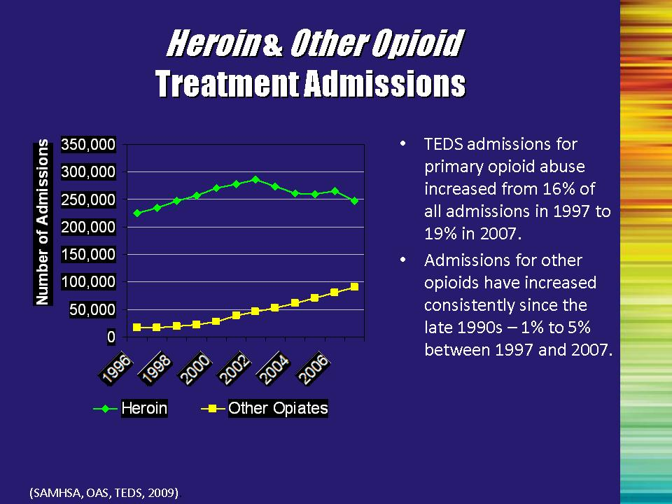 | Slide 44: Heroin and Other Opioid Treatment Admissions  The Treatment Episode Data Set (TEDS) is part of SAMHSA’s Drug and Alcohol Services Information System (DASIS). TEDS is a compilation of data on the demographic and substance abuse characteristics of admissions to (and more recently, on discharges from) substance abuse treatment.  - Information from TEDS showed that admissions for primary opioid abuse increased from approximately 16% to 19% between 1997 and 2007.  - Admissions for other opioids have increased consistently since the late 1990s – 1.0% to 5.0% between 1997 and 2007.  Reference:  Substance Abuse and Mental Health Services Administration, Office of Applied Studies. Treatment Episode Data Set (TEDS). Highlights - 2007. National Admissions to Substance Abuse Treatment Services, DASIS Series: S-45, DHHS Publication No. (SMA) 09-4360, Rockville, MD, 2009. | Slide 44
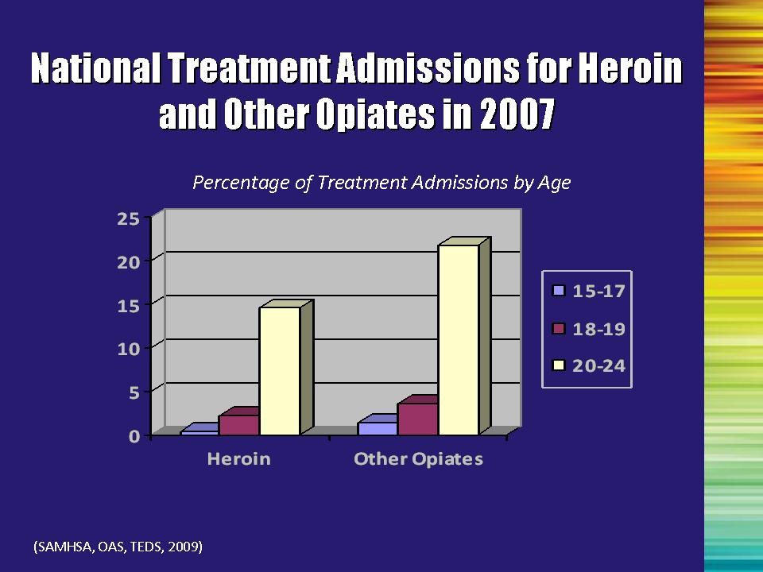 | Slide 45: National Treatment Admissions for Heroin and Other Opiates in 2007  The TEDS also reported that, from 1997 to 2007, the number of persons who were admitted to treatment programs across the United States with a primary problem with opiates other than heroin increased from 16,274 to 90,516. The table shows the “primary drug” data for treatment admissions in 2007 by age breakouts for adolescents and young adults. Of the age categories shown on this slide, the highest percentage of treatment admissions are among young adults aged 20 to 24 for both heroin (14.5%) and other opiates (21.8%).  Reference:  Substance Abuse and Mental Health Services Administration, Office of Applied Studies. Treatment Episode Data Set (TEDS). Highlights - 2007. National Admissions to Substance Abuse Treatment Services, DASIS Series: S-45, DHHS Publication No. (SMA) 09-4360, Rockville, MD, 2009. | Slide 45
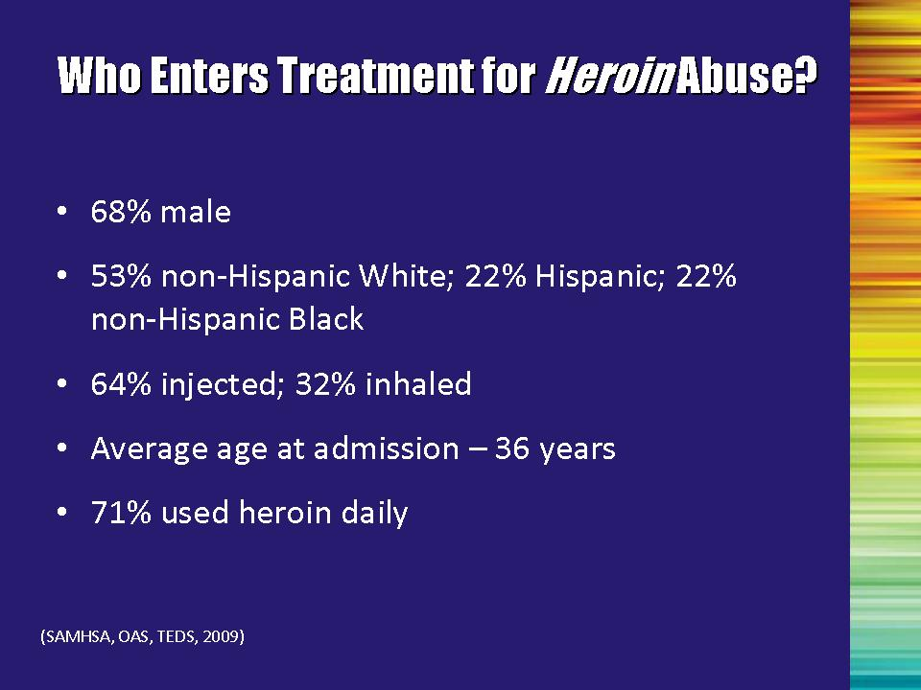 | Slide 46: Who Enters Treatment for Heroin Abuse?  - In 2007, admissions for opiate abuse (primarily heroin) accounted for nearly one-fifth of all substance abuse treatment admissions.  - Patients entering treatment were about 2/3 male (68%); just over half (53%) were non-Hispanic White, 22% were Hispanic, and 22% were non-Hispanic Black  - Two-thirds (64%) of patients seeking treatment used by injection, 32% inhaled, and 2% reported smoking  - Average age at admission was 36 years.  - Nearly three quarters (71%) used heroin on a daily basis.  References:  Substance Abuse and Mental Health Services Administration, Office of Applied Studies. Treatment Episode Data Set (TEDS). Highlights - 2007. National Admissions to Substance Abuse Treatment Services, DASIS Series: S-45, DHHS Publication No. (SMA) 09-4360, Rockville, MD, 2009.  Substance Abuse and Mental Health Services Administration, Office of Applied Studies. (August 27, 2009). The TEDS Report: Heroin and Other Opiate Admissions to Substance Abuse Treatment. Rockville, MD. | Slide 46
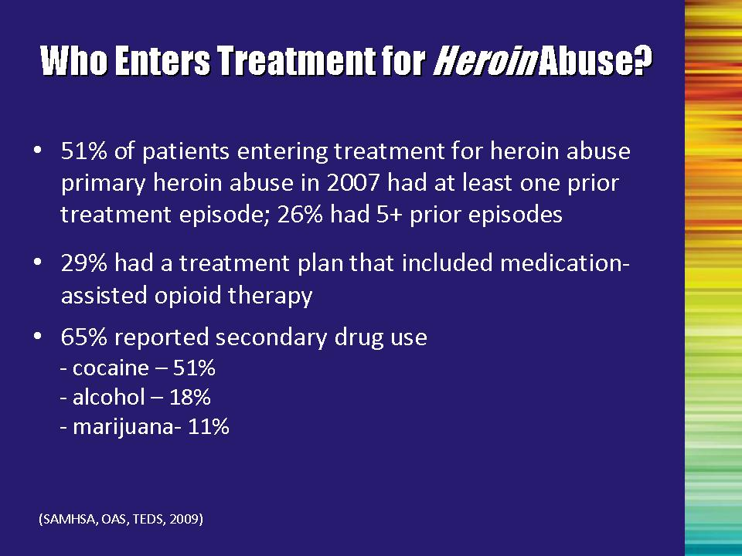 | Slide 47: Who Enters Treatment for Heroin Abuse?  - Approximately 1/2 (51%) of patients entering treatment for heroin abuse in 2007 had at least one prior treatment admission, and 26% of heroin admissions reported 5 or more previous treatment admissions.  - Twenty-nine percent were seeking treatment that included medication-assisted opioid therapy.  - Approximately 65% of heroin admissions reported secondary drug use. Most commonly reported were cocaine (51%), alcohol (18%), and marijuana (11%)  Reference:  Substance Abuse and Mental Health Services Administration, Office of Applied Studies. (August 27, 2009). The TEDS Report: Heroin and Other Opiate Admissions to Substance Abuse Treatment. Rockville, MD. | Slide 47
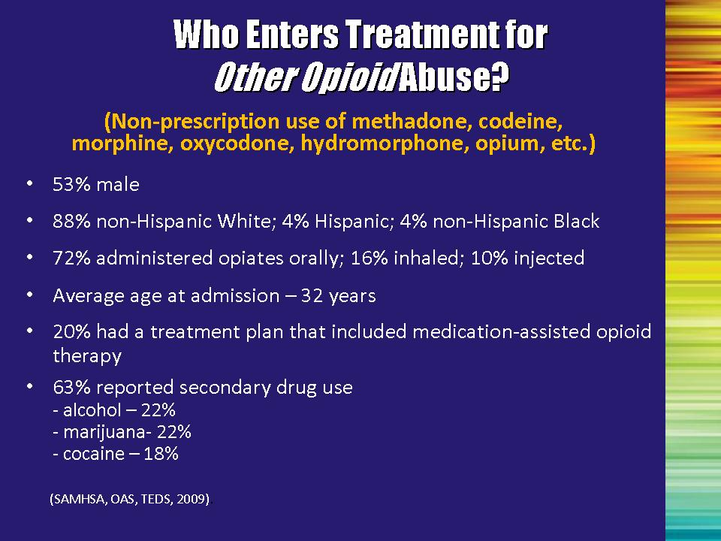 | Slide 48: Who Enters Treatment for Other Opioid Abuse?  In 2007, among those entering treatment for abuse of other opiates:  - 47% had at least one prior treatment admission; 9% reported 5 or more previous treatment admissions.  - slightly more than 1/2 (53%) were male.  - the great majority (88%) was non-Hispanic White; 4% Hispanic, and 4% non-Hispanic Black.  - about 72% took the drug orally; 16% inhaled; and 10% injected.  - 20% had a treatment plan that included medication-assisted opioid therapy.  - Average age at admission was 32 years.  - Approximately 63% reported secondary drug use; most commonly reported were alcohol (22%), marijuana (22%), and cocaine (18%).  References:  Substance Abuse and Mental Health Services Administration, Office of Applied Studies. Treatment Episode Data Set (TEDS). Highlights - 2007. National Admissions to Substance Abuse Treatment Services, DASIS Series: S-45, DHHS Publication No. (SMA) 09-4360, Rockville, MD, 2009.  Substance Abuse and Mental Health Services Administration, Office of Applied Studies. (August 27, 2009). The TEDS Report: Heroin and Other Opiate Admissions to Substance Abuse Treatment. Rockville, MD. | Slide 48
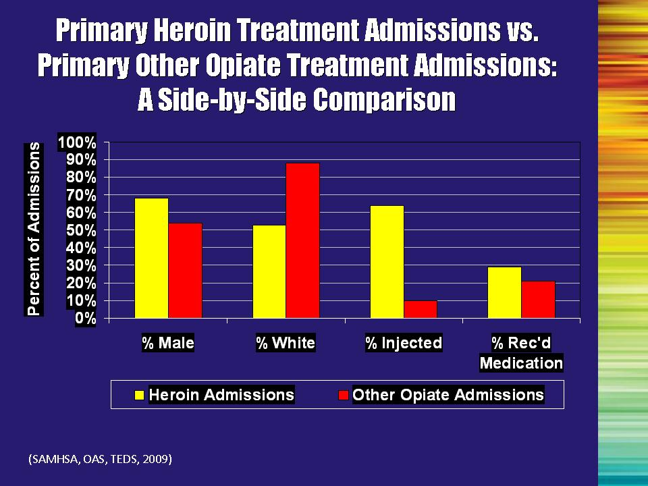 | Slide 49: Primary Heroin Treatment Admissions vs. Primary Other Opioid Treatment Admissions: A Side-by-Side Comparison  A side-by-side graphic comparison helps to illustrate the differences in the demographics of heroin users and other opiate users.  Injection continues to be the predominant method of heroin use among addicted users seeking treatment. However, researchers have observed a shift in heroin use patterns: As the purity of heroin has increased, users have begun to use alternative methods of administration, such as smoking and snorting/inhaling.  References:  Substance Abuse and Mental Health Services Administration, Office of Applied Studies. Treatment Episode Data Set (TEDS). Highlights - 2007. National Admissions to Substance Abuse Treatment Services, DASIS Series: S-45, DHHS Publication No. (SMA) 09-4360, Rockville, MD, 2009a.  Substance Abuse and Mental Health Services Administration, Office of Applied Studies. (August 27, 2009). The TEDS Report: Heroin and Other Opiate Admissions to Substance Abuse Treatment. Rockville, MD. | Slide 49
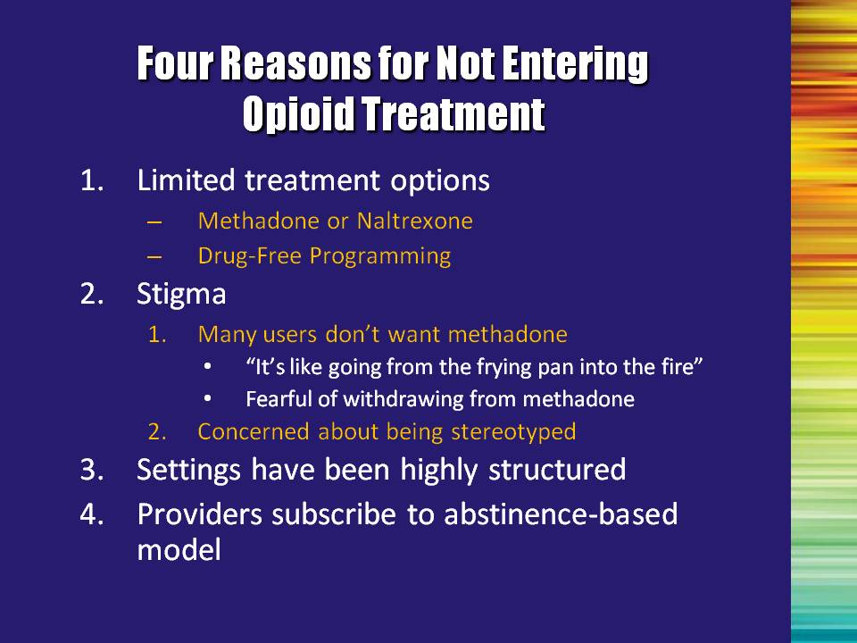 | Slide 50: Four Reasons for Not Entering Opioid Treatment  The above information clearly indicates that opioid use has been increasing, and that a large number of people are seeking treatment for opioids. Data have also been collected that indicate that there are many more users of heroin than people seeking and/or receiving treatment. This raises the question: “Why are some people not entering treatment?”  #1: The current treatment system involves either a medical model (e.g., OTPs) or psychosocial programming. Many OTPs do not have large behavioral treatment components and many psychosocial programs do not provide adequate medical intervention to help the person through the withdrawal process.  #2: Anecdotal evidence suggests that people may feel that getting off methadone is much harder than getting off heroin. Lack of understanding about how methadone should be used, as well as the possibility for illicit use of methadone, contributes to this feeling. Additionally, people are afraid of being labeled and stereotyped due to their opioid addiction (e.g., “junkies”).  #3. OTPs have very structured rules requiring regular attendance. Programs often open early in the morning and close by mid-afternoon. Clients who are not able to follow the rules or attend the program during operating hours may not be able to receive the treatment.  #4: Many providers believe that treatment requires abstinence from all drugs. However, many opioid users are not able to stop using opioids. They often cannot tolerate the withdrawal experience, and even if they can, may be drawn back to using. Using a medication such as methadone or buprenorphine to assist with the withdrawal process or to prevent people from going through withdrawal will help them to participate in treatment and function more normally. | Slide 50
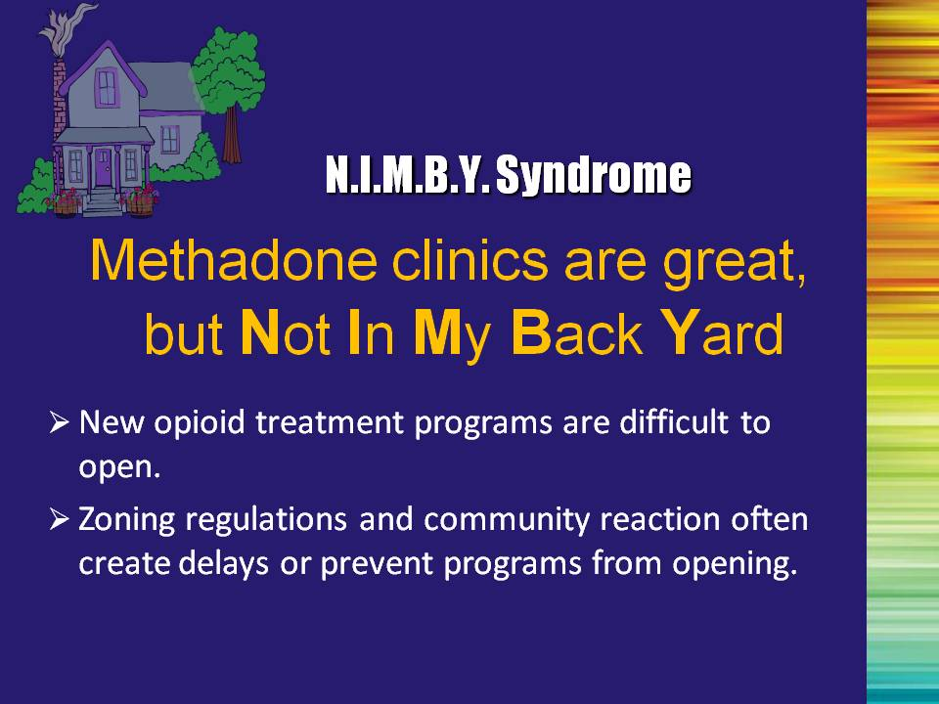 | Slide 51: N.I.M.B.Y. Syndrome  Another factor that limits the availability to treatment is the “NIMBY” syndrome. This stands for “Not In My Back Yard.” Even people who recognize the importance of providing opioid treatment may not want a new program opening up in their neighborhood. This makes opening new programs very difficult. | Slide 51
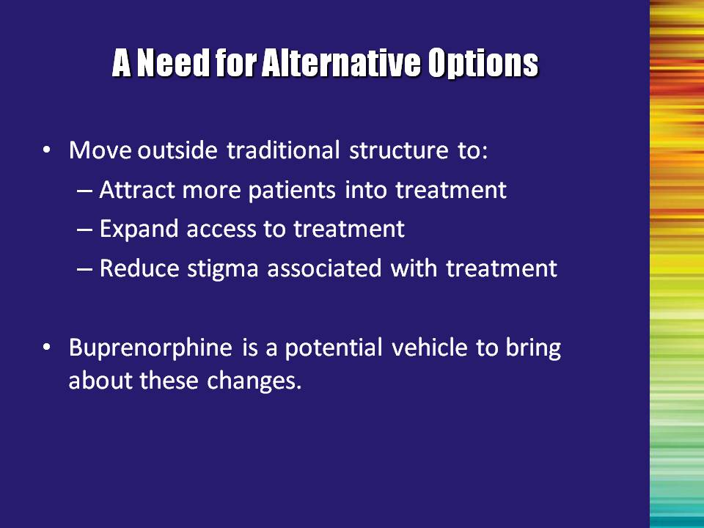 | Slide 52: A Need for Alternative Options  DATA 2000 allows for a new treatment option. Opioid treatment will continue to be offered through opioid treatment programs as it has been in the past. DATA 2000 allows for treatment in physician offices, and expands beyond the structure in place for methadone. By doing so:  - more patients may be willing to seek treatment;  - more patients will have access to treatment; and  - stigma may be reduced by broadening the definition and locations of available treatment options. | Slide 52
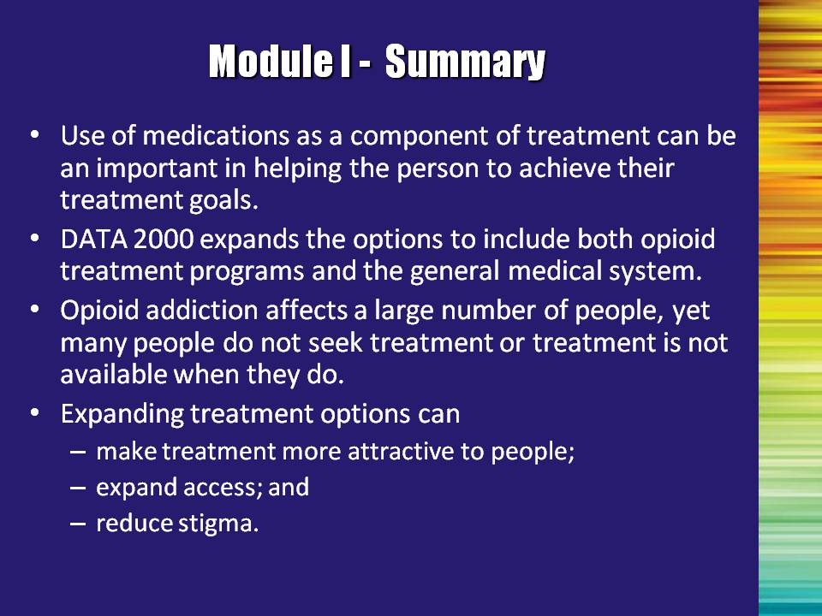 | Slide 53: Module I - Summary  Review each bullet.  - Use of medications as a component of treatment can be important in helping the person achieve their treatment goals.  - DATA 2000 expands the options to include both opioid treatment programs and the general medical system.  - Opioid addiction affects a large number of people, yet treatment may not available to treatment-seekers or many do not seek treatment at all.  - Expanding treatment options can  - make treatment more attractive to people;  - expand access; and  - reduce stigma. | Slide 53
 | Slide 54: Transition Slide  Note to the Trainer(s): This slide is purposefully blank. If you are conducting the full training, end here and skip to Module II. If you are doing Module I as a stand-alone training, please continue to the next slide. | Slide 54
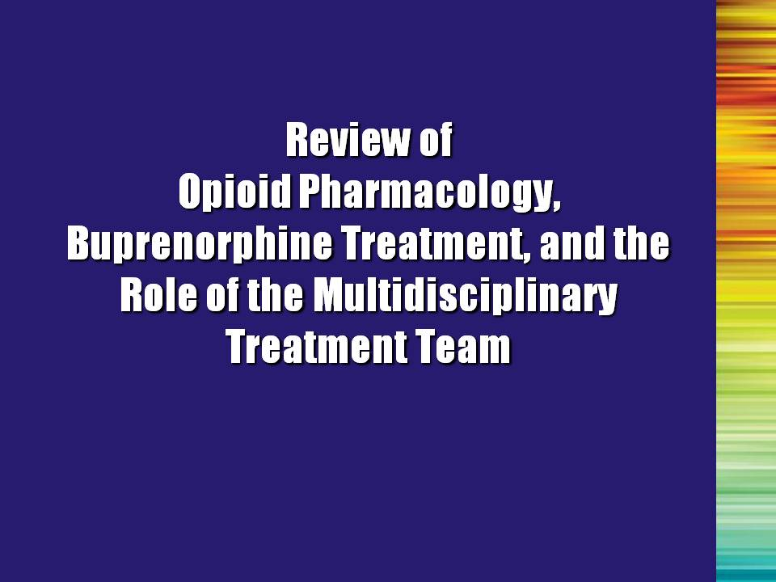 | Slide 55: Review of Opioid Pharmacology, Buprenorphine Treatment, and the Role of the Multidisciplinary Treatment Team  So let’s review some specific information about opioids and the role of buprenorphine in the treatment system. Then we will discuss the critical role of the multidisciplinary team in providing this treatment. | Slide 55
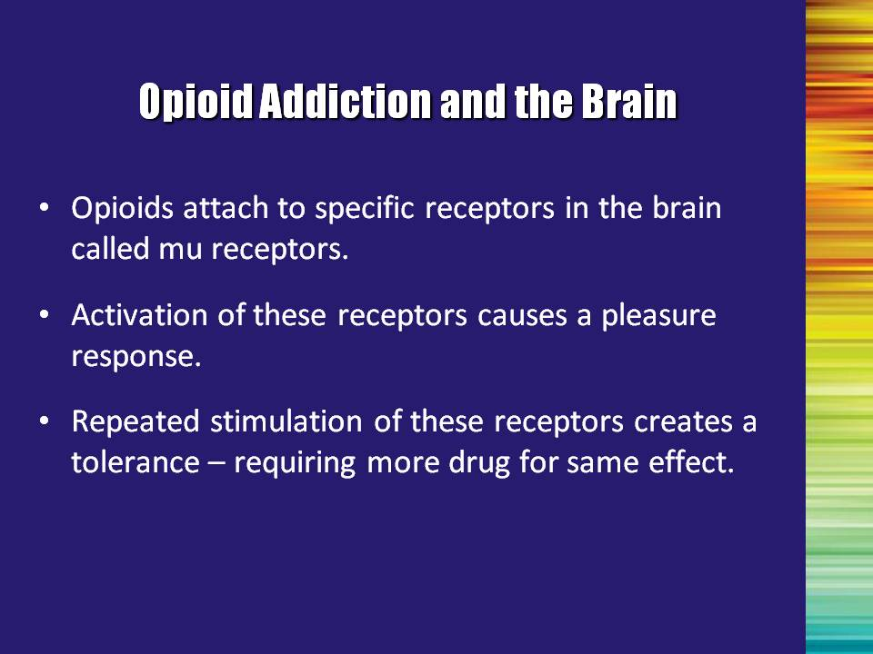 | Slide 56: Opioid Addiction and the Brain  First, here are a few basic facts about opioids and how they affect the brain:  - Opioids bind to receptors in the brain that are specifically designed for them.  - Once opioids bind to these receptors, they cause an intense euphoric rush, which is experienced as extremely pleasurable.  - With repeated administration of the drug, the body begins to adapt, and tolerance develops. This means that it requires more of the drug to get the same affect and withdrawal occurs if the amount of use is decreased or stopped.  Note to the Trainer(s): It is important to emphasize that the presence of tolerance or withdrawal is not enough to say that someone is addicted to the drug. Addiction requires continued use in spite of negative consequences resulting from use. Physical dependence may or may not be present. For further discussion of dependence versus addiction, please refer to Module II. | Slide 56
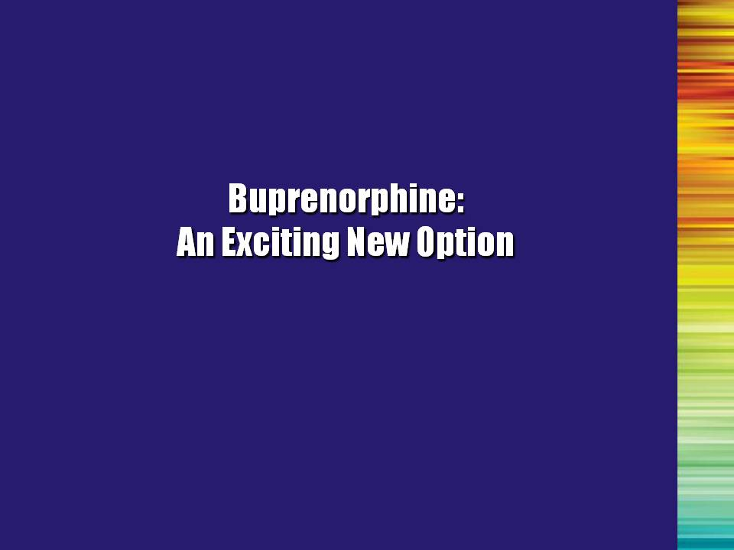 | Slide 57: Buprenorphine: An Exciting New Option  Buprenorphine represents an exciting addition to the available opioid treatment options. | Slide 57
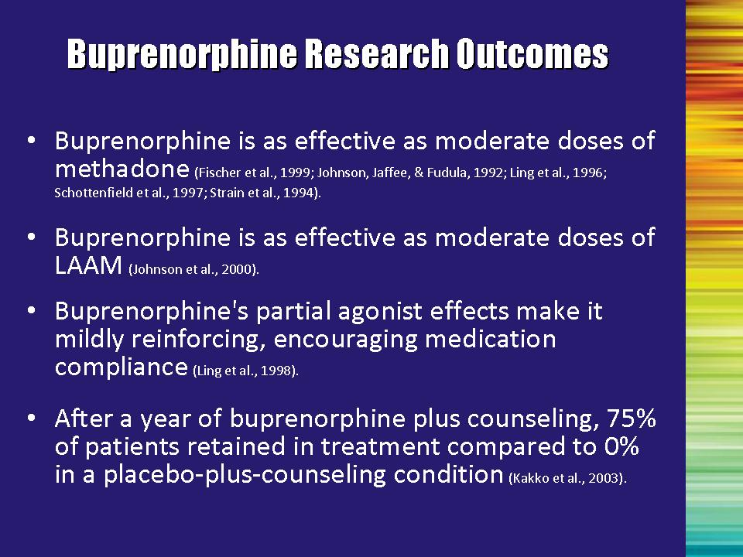 | Slide 58: Buprenorphine Research Outcomes  Clinical trials have established the effectiveness of buprenorphine for the treatment of opioid addiction. The clinical studies have shown the following about buprenorphine:  Bullet #1: Patients on buprenorphine did as well as patients on a moderate dose of methadone (e.g., 60mg).  However, it is unclear if buprenorphine can be as effective as higher doses of methadone (such as 80 mg per day to more than 100 mg per day).  Bullet #2: Patients on buprenorphine did as well as patients on a moderate dose of LAAM (70mg/70mg/85mg on a Monday/Wednesday/Friday schedule).  Note to the Trainer(s): LAAM is no longer being marketed in the United States due to safety concerns. This information is provided as evidence of efficacy of buprenorphine.  Bullet #3: Patients found that taking buprenorphine was a pleasant experience, which encouraged them to be compliant.  Bullet #4: When compared to placebo-plus-counseling, 3/4 of the patients receiving buprenorphine and counseling were still in treatment after one year. None of the placebo patients were retained. | Slide 58
 | Slide 58: Buprenorphine Research Outcomes, Continued  References: Bullet#1  Fischer, G., Gombas, W., Eder, H., Jagsch, R., Peternell, A., Stuhlinger, G., ... Kasper, S. (1999). Buprenorphine versus methadone maintenance for the treatment of opioid dependence. Addiction, 94(9), 1337-1347.  Johnson, R. E., Jaffe, J. H., & Fudala, P. J. (1992). A controlled trial of buprenorphine treatment for opioid dependence. Journal of the American Medical Association, 267, 2750–2755.  Schottenfeld, R. S., Pakes, J. R., Oliveto, A., Ziedonis, D., & Kosten T. R. (1997). Buprenorphine vs methadone maintenance treatment for concurrent opioid dependence and cocaine abuse. Archives of General Psychiatry, 54, 713–720.  Strain, E. C., Stitzer, M. L., Liebson, I. A., & Bigelow, G. E. (1994). Comparison of buprenorphine and methadone in the treatment of opioid dependence. American Journal of Psychiatry, 151, 1025–1030.  Reference: Bullet #2  Johnson, R. E., Chutuape, M. A., Strain, E. C., Walsh, S. L., Stitzer, M. L., & Bigelow, G. E. (2000). A comparison of levomethadyl acetate, buprenorphine, and methadone for opioid dependence. New England Journal of Medicine, 343(18), 1290-1297.  Reference: Bullet #3  Ling, W., Charuvastra, C., Collins, J. F., Batki, S., Brown, L. S., Jr., Kintaudi, P., … Segal, D. (1998) Buprenorphine maintenance treatment of opiate dependence: A multicenter, randomized clinical trial. Addiction, 93, 475–486.  Reference: Bullet #4  Kakko, J., Svanborg, K., Kreek, M., & Heilig, M. (2003). 1-year retention and social function after buprenorphine-assisted relapse prevention treatment for heroin dependence in Sweden: A randomised, placebo-controlled trial. The Lancet, 361(9358), 662-668. | Slide 58
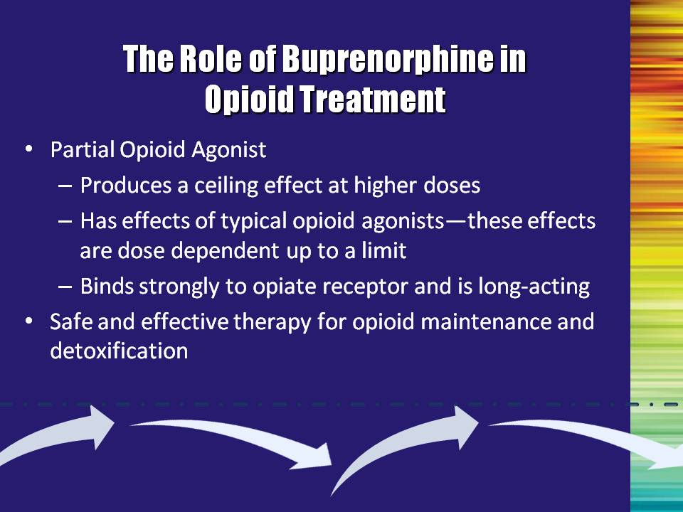 | Slide 59: The Role of Buprenorphine in Opioid Treatment  The partial agonist properties of the medication are important to understand.  The effects of the medication at lower doses are virtually the same as that of full agonists. However, as the dose is increased, the effects level out for buprenorphine (especially respiratory suppression), whereas they continue to increase with full agonist medications. This is called a “ceiling effect.” This ceiling effect greatly decreases the risk of overdose when compared to full agonists.  Buprenorphine has a very HIGH affinity for opioid receptors. It displaces morphine, methadone, and other full agonist opioids from the receptor. Additionally, buprenorphine dissociates slowly from the receptor.  This high affinity for and slow dissociation from the receptor result in buprenorphine blocking the effects of other opioids, such as heroin. Additionally, the high affinity and slow dissociation give rise to buprenorphine’s prolonged therapeutic effects.  Clinical trials have demonstrated that buprenorphine is a safe and effective medication for both opioid maintenance and medically-assisted withdrawal (detoxification). Additionally, because buprenorphine is very long-acting, dosing can occur on a less-than-daily basis, as infrequently as three times per week. | Slide 59
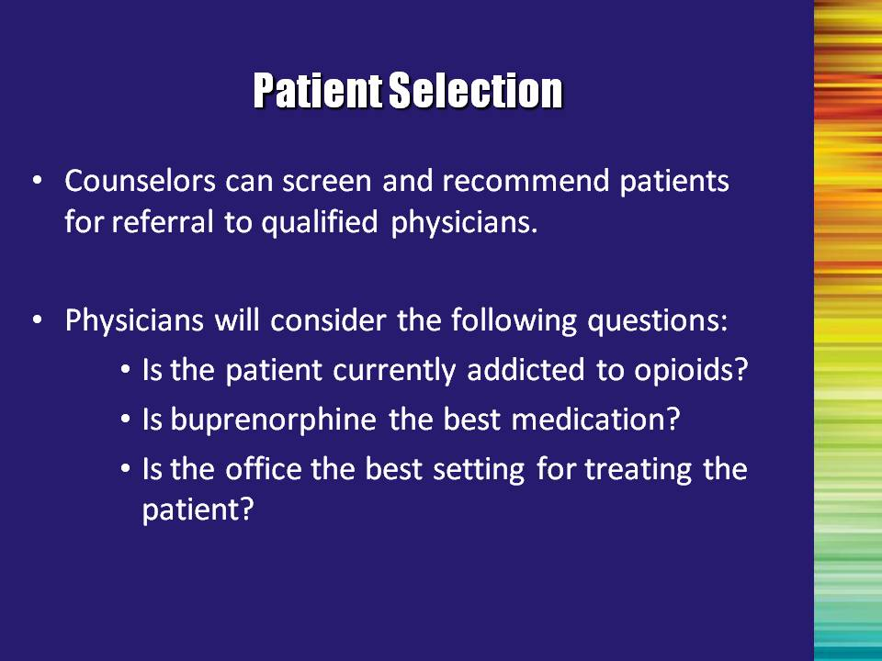 | Slide 60: Patient Selection  The patient’s appropriateness for treatment may change during the course of treatment.  Potential patients or other treatment providers may ask the counselor about appropriateness for treatment.  The physician will do the final screening prior to prescribing the medication. He/she will look at current opioid use, appropriateness for buprenorphine versus other medications, and the most appropriate setting for the treatment to occur (office-based vs. OTP).  Useful and informed communication with the physician is enhanced by complete knowledge of the entire treatment process. | Slide 60
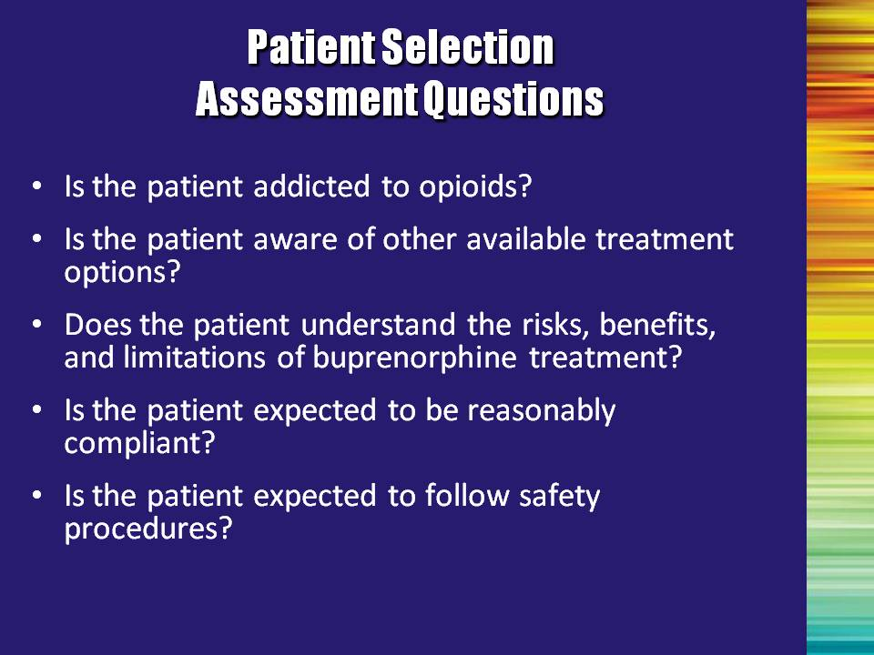 | Slide 61: Patient Selection: Assessment Questions  The patient selection process includes determining if the patient is addicted to opioids, if buprenorphine is the optimal medication for the patient, and if an office or a clinic is the optimal site for treatment. Once a thorough assessment is conducted, the physician can determine if addiction to opioids is present using DSM-IV-TR criteria. Treatment success is enhanced by good patient assessment and selection. Ten simple criteria can help to guide patient assessments of appropriateness of office-based buprenorphine treatment.  Read criteria aloud and discuss as follows:  Bullet #1: Is the patient addicted to opioids? Treatment with buprenorphine will generally be conducted with individuals who meet criteria for opioid addiction. However, a physician may consider buprenorphine treatment for a patient with problematic opioid use that has not progressed to addiction. An example of this might be if, in the physician’s clinical judgment, the patient has a high risk of progression to addiction or is injecting opioids. Additional candidates include patients with a history of good response to buprenorphine who have had their medication discontinued (perhaps due to incarceration) and are now at risk of relapse (released from prison).  Bullet #2: Is the patient aware of other available treatment options? Even if a patient is addicted to opioids and a suitable candidate for buprenorphine treatment, he/she may not be best treated in an office setting. Patients should be made aware of all of the options available to them and be assisted in making a decision regarding their treatment. Their willingness to participate is critical to compliance with any treatment regimen.  Co-occurring disorders (other substance use disorders, psychiatric disorders, or medical conditions) may lead to the decision to not treat the individual in an office-based setting, since that office cannot provide the other needed services. For example, a physician’s office may not be able to provide psychotherapy needed by a patient with a severe personality disorder or the monitoring needed for a patient with AIDS. | Slide 61
 | Slide 61: Patient Selection: Assessment Questions, Continued  Bullet #3: Does the patient understand the risks, benefits, and the limitations of bu0prenorphine treatment? The patient needs to be conscious/aware of what buprenorphine WILL and WILL NOT do. Are there indications to suggest that the patient is reliable (i.e., steady employment, showing up on time for appointments, taking other medications as prescribed)? Have cost issues been explained and compared with other treatment options?  Bullet #4: Is the patient expected to be reasonably compliant? Is the patient in a situation where he/she can be expected to attend sessions as required, manage the medication appropriately, and take it as prescribed? If the answer is “no,” the treatment team should explore the possibility of conducting the treatment in a highly structured environment (e.g., residential, partial hospitalization).  Bullet #5: Is the patient expected to follow safety procedures?  Can the patient manage his/her medication appropriately (e.g., keep it away from children in the home), and take it as prescribed? | Slide 61
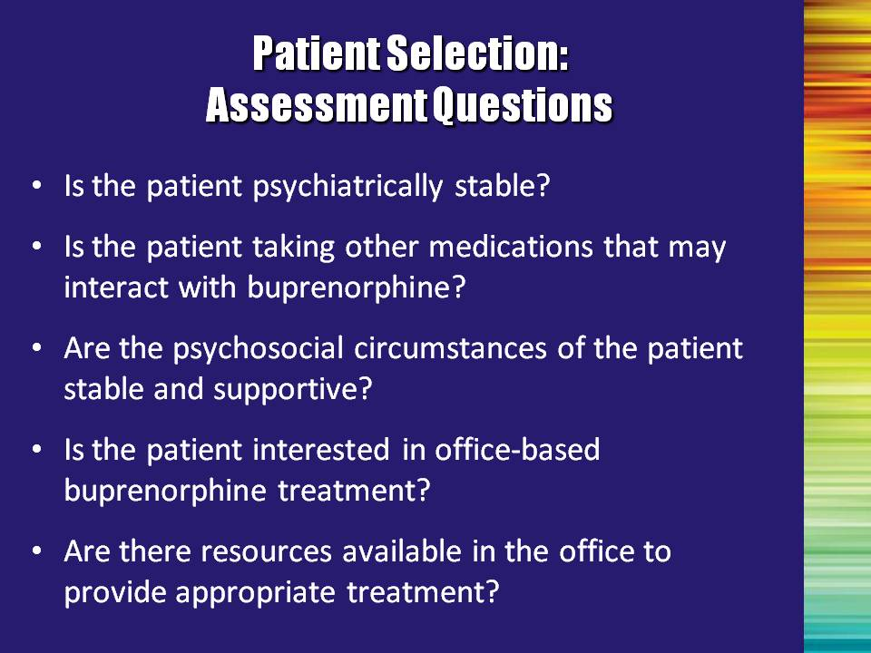 | Slide 62: Patient Selection: Assessment Questions  Read the remaining criteria aloud.  Bullet #1: Is the patient psychiatrically stable? Do they need to be stabilized first? Do they need treatment for co-occurring disorders?  Additional Information for Trainer(s): According to the Buprenorphine Treatment Guidelines (TIP 40), the presence and severity of co-morbid psychiatric conditions must be assessed prior to initiating buprenorphine treatment, and a determination made whether referral to specialized behavioral health services is necessary. The psychiatric disorders most commonly encountered in patients addicted to opioids are other substance abuse disorders, depressive disorders, posttraumatic stress disorder, substance-induced psychiatric disorders, and antisocial and borderline personality disorder.  Reference:  Center for Substance Abuse Treatment. Clinical Guidelines for the Use of Buprenorphine in the Treatment of Opioid Addiction. Treatment Improvement Protocol (TIP) Series 40. DHHS Publication No. (SMA) 04-3939. Rockville, MD: Substance Abuse and Mental Health Services Administration, 2004.  Bullet #2: Is the patient taking other medications that may interact with buprenorphine? Other medications may include naltrexone, benzodiazepines, or other sedative hypnotics. Another way of asking this question is, “Is this an appropriate medication for the person to be taking?” Additional medications and health conditions should be brought to the attention of the physician, so that the physician is fully informed in making the decision to prescribe buprenorphine or any other medication.  Bullet #3: Are the psychosocial circumstances of the patient stable and supportive? What stressors, relationships, supports, living situation, etc. does the patient have that can contribute to or undermine the success of the recovery plan? | Slide 62
 | Slide 62: Patient Selection: Assessment Questions, Continued  Read the remaining criteria aloud.  Bullet #4: Is the patient interested in office-based buprenorphine treatment? Even if a patient is a suitable candidate for buprenorphine treatment, he/she may not be best treated in an office setting. Stability and structure of the patient’s living situation will help the treatment team determine the most appropriate setting.  Bullet #5: Are there resources available in the office to provide appropriate treatment? Has a comprehensive recovery plan been developed and coordinated between the psychosocial treatment team and the physician? What additional resources need to be added in order to facilitate coordinated care?  If resources are not available in the physician’s office, attempts should be made to work in cooperation with a local substance abuse treatment program. | Slide 62
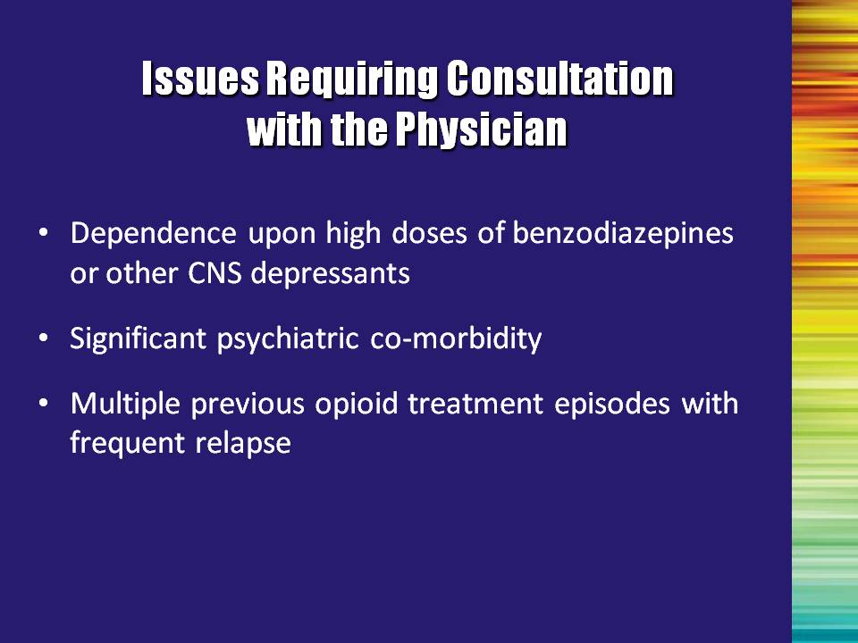 | Slide 63: Issues Requiring Consultation with the Physician  The multidisciplinary addiction professional should be aware of the following factors and inform the physician of any changes or arising information.  Read factors aloud.  Bullet #1: Patients taking high doses of benzodiazepines, alcohol or other CNS depressants. The use of benzodiazepines in combination with buprenorphine (especially if injected in an overdose attempt) may result in death. Since alcohol is a sedative-hypnotic, patients should be cautioned to avoid alcohol while taking buprenorphine.  Bullet #2: Significant psychiatric co-morbidity. This may or may not be an issue (case-specific), but should be evaluated to determine appropriate course of treatment for drug addiction and other psychiatric conditions.  Bullet #3: Multiple previous opioid addiction treatment episodes with frequent relapse during those episodes (may also indicate a perfect candidate). Again not exclusionary, but understanding what led to previous treatment failures may help to shape the current recovery plan. Changing to a new treatment, rather than continuing an unsuccessful one, may work well for them.  Bullet #4: Non-response or poor response to buprenorphine treatment in the past. | Slide 63
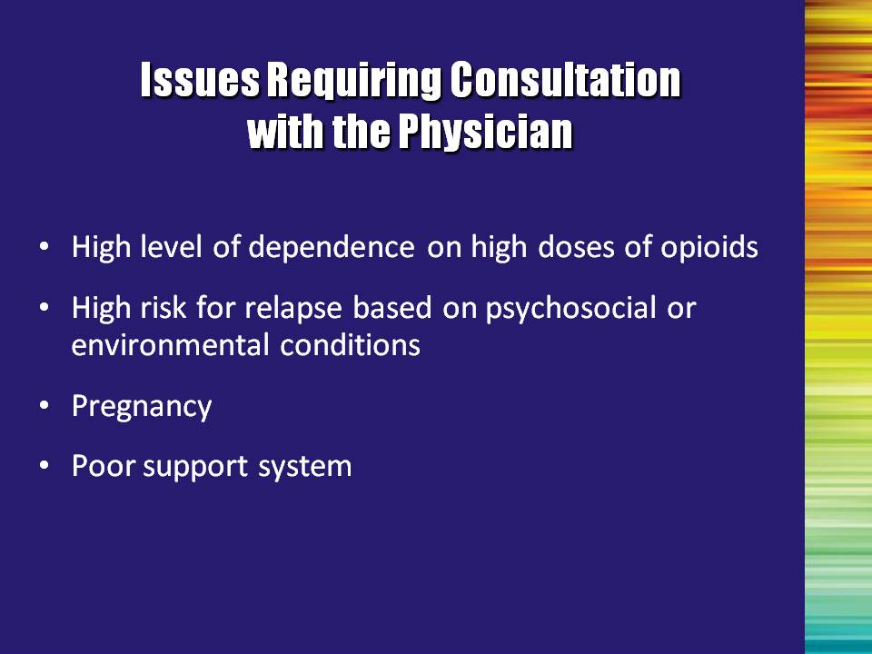 | Slide 64: Issues Requiring Consultation with the Physician  Bullet #1: High level of dependence on high doses of opioids. Level of opioid use needs to be evaluated carefully to determine if buprenorphine is appropriate, and if so, the best way to transition the person onto the medication. This is a medical decision, but the addiction professional should bring all the information that they have to the physician and work with the physician in the development of the recovery plan.  Bullet #2: High risk for relapse to opioid use. For example, living in a place where others are consuming heroin or other opioids. This may be an issue of timing; the patient may need a more structured environment (e.g., residential care), or they may be saying that they are not ready to enter treatment.  Bullet #3: Pregnancy - Buprenorphine is not currently approved for the treatment of opioid-addicted pregnant women. Clinical trials are ongoing and it looks promising, but right now, pregnant women should be treated with methadone. A physician who discovers that a patient on buprenorphine has become pregnant will likely develop a plan to transition her onto methadone. However, if buprenorphine is determined to be the best treatment after weighing all of the pros and cons, the physician may still prescribe buprenorphine. For additional information regarding buprenorphine and pregnant women, refer to Modules IV and VI.  Bullet #4: Poor social support system. A poor social support system is not ideal for any recovery process. The treatment team should work with the patient to develop a plan to help the person strengthen and engage effective support. | Slide 64
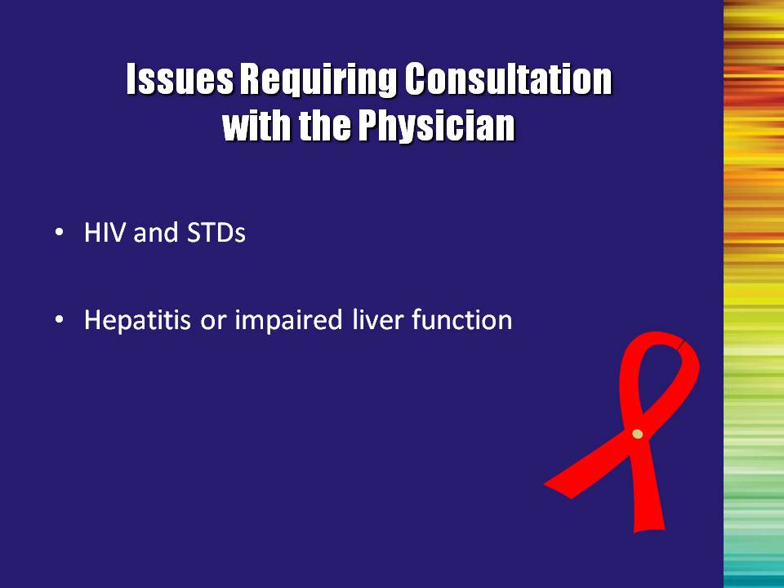 | Slide 65: Issues Requiring Consultation with the Physician  It is important to consult with a physician and coordinate care to make appropriate treatment decisions.  Bullet #1: Human immunodeficiency virus (HIV) and sexually transmitted diseases (STDs): Of particular concern for opioid-addicted patients are issues regarding HIV/AIDS and hepatitis C virus (HCV). Multidisciplinary addiction professionals should ask patients about their HIV and HCV status, and when they were last tested. If patients have not been tested recently, they should be referred to a physician or given information on how to locate a testing site. If patients are positive for HIV or HCV, they should be asked about the medications they are taking and encouraged to comply with their medication regimen. The treatment team should communicate any new information to the physician regarding the patient’s medications in order to monitor potential medication interactions with buprenorphine.  Additional Information for Trainer(s): Buprenorphine should be used cautiously in combination with HIV antiretroviral medications that may inhibit, induce, or be metabolized by the same liver enzyme system involved with the buprenorphine (cytochrome P450 3A4) enzyme system. Protease inhibitors inhibit cytochrome P450 3A4. Metabolism of buprenorphine and/or the antiretroviral medications may be altered when they are combined. Therefore, therapeutic blood levels may need to be monitored. Note that this is a precaution, not a contraindication; successful treatment of addiction with buprenorphine in HIV-infected patients has been well demonstrated (Carrieri et al., 2000).  Bullet #2: Hepatitis or impaired liver function: Medication interaction is a concern here, as well. However, buprenorphine has not been shown to have negative effects on the liver.  Reference:  Carrieri, M. P., Vlahov, D., Dellamonica, P., Gallais, H., Lepeu, G., Spire, B., & Obadia, Y. (2000). Use of buprenorphine in HIV-infected injection drug users: Negligible impact on virologic response to HAART. The Manif-2000 Study Group. Drug and Alcohol Dependence, 60(1), 51–54. | Slide 65
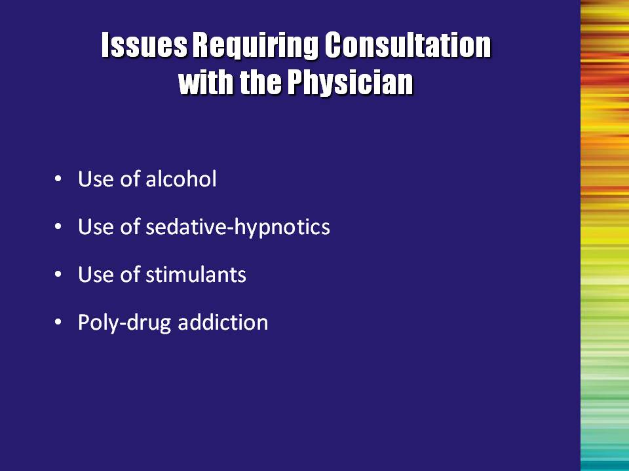 | Slide 66: Issues Requiring Consultation with the Physician  Bullet #1 through Bullet #3: Use of alcohol, sedative-hypnotics, and stimulants: As was previously mentioned, the combination of other drugs should be carefully evaluated, especially given the fact that reported overdoses have been related to a combination of CNS depressants and buprenorphine (Reynaud, Petit, Potard, & Courty, 1998; Reynaud, Tracqui, Petit, Potard, & Courty,1998).  Bullet #4: Other drugs: Buprenorphine is a treatment for opioid addiction, not other substance use disorders. Addiction to other drugs (e.g., stimulants or sedatives) is common among opioid-addicted patients and may interfere with overall treatment adherence. Patients should be encouraged to abstain from the use of all non-prescribed drugs while receiving buprenorphine treatment. However, although a predictor of poor adherence, use of other drugs IS NOT an absolute contraindication to buprenorphine treatment. They may need to be referred for more intensive treatment.  References:  Reynaud, M., Petit, G., Potard, D., & Courty, P. (1998). Six deaths linked to concomitant use of buprenorphine and benzodiazepines. Addiction, 93(9), 1385–1392.  Reynaud, M., Tracqui, A., Petit, G., Potard,D., & Courty, P. (1998). Six deaths linked to misuse of buprenorphine-benzodiazepine combinations. American Journal of Psychiatry, 155(3), 448–449. | Slide 66
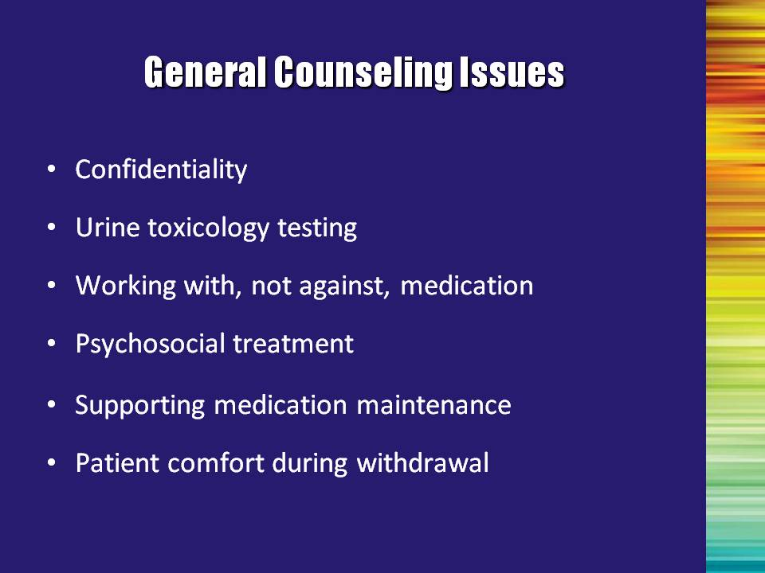 | Slide 67: General Counseling Issues  Bullet #1: Confidentiality: Care should be taken to execute appropriate professional service agreements and releases of information in order to comply with confidentiality and HIPAA regulations.  Bullet #2: Urine toxicology testing (drug testing) is a common practice and is conducted primarily to assess treatment efficacy. The physician, counselor, and/or other staff may conduct urine testing. Testing provides the patient with an additional tool to prevent drug use. In traditional opioid treatment programs, positive drug tests may or may not result in dismissal from treatment.  In the case of office-based buprenorphine treatment, the physician and the treatment provider must come to a common understanding of how drug testing will be used and what will happen if the person has a positive test.  Counselors should stress that testing is a standard procedure that can help their treatment and is not a surveillance tool based on an assumption of patients’ dishonesty.  Bullet #3: Working with, not against, the medication: Recovery is more than medication. Many buprenorphine patients may feel that once they have dealt with the physical aspect of their opioid addiction and have received a medication, they do not need additional treatment in the form of psychosocial counseling. At the same time, the addiction professional should not diminish the importance of medication compliance. | Slide 67
 | Slide 67: General Counseling Issues, continued  Bullet #4: Psychosocial treatment: Counselors and administrators in such programs should consider their treatment philosophy before accepting patient referrals from physicians prescribing buprenorphine or referring current clients to a physician for buprenorphine treatment.  Bullet #5: Supporting medication maintenance: Patients who are being maintained on buprenorphine need ongoing counseling to reduce the risk of relapse, and assist them in addressing ongoing psychosocial, mental health and other substance use issues.  Bullet #6: Patient comfort: Counseling patients during withdrawal can be frustrating. Patients who are physically sick may have trouble being receptive to the cognitive and behavioral issues involved in the counseling process. Patients who are on buprenorphine, however, are generally not distracted by their own physical distress. | Slide 67

Module II

Opioids 101
Module II: Opioids 101

Module II is designed to introduce participants to basic facts about opioids, including information on pharmacology, acute and long-term effects, and basic information about treatments for opioid addiction. This module contains background information necessary to understand the role of buprenorphine in the opioid treatment system. If the audience is already highly knowledgeable about opioid treatment, this module should be abbreviated or omitted.

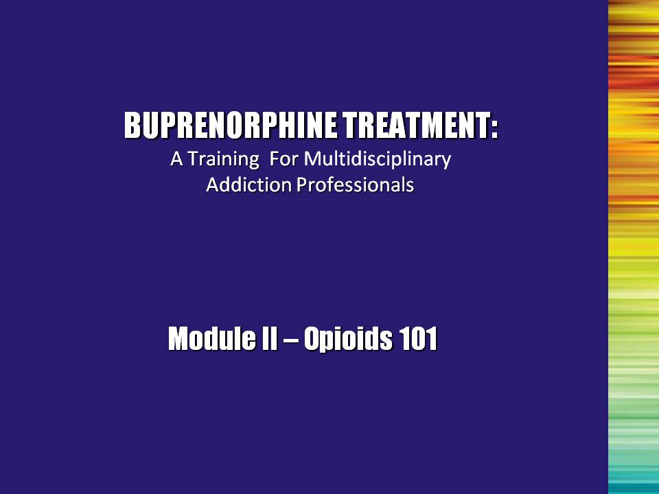 | Slide 1: Title Slide  The next module provides an overview of opioids and opioid treatment, setting the stage to see the role of buprenorphine in the treatment system. | Slide 1
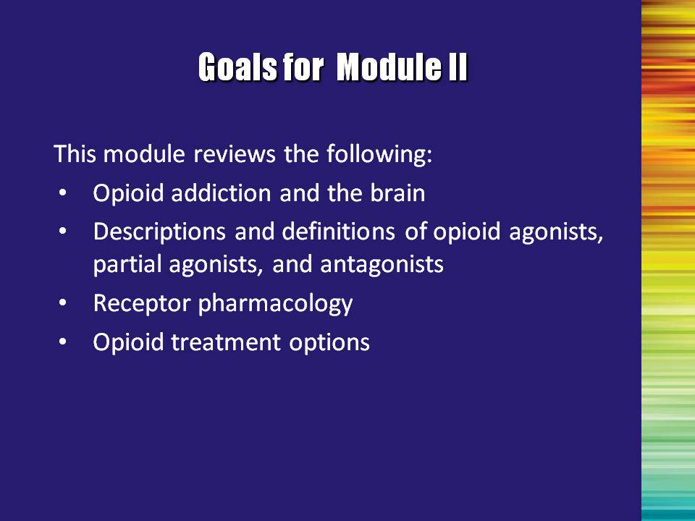 | Slide 2: Goals for Module II  We are now going to turn a little more directly to the issue of opioid addiction.  This module reviews the following:  - Opioid addiction and the brain  - Descriptions and definitions of opioid agonists, partial agonists and antagonists  - Receptor pharmacology  - Opioid treatment options | Slide 2
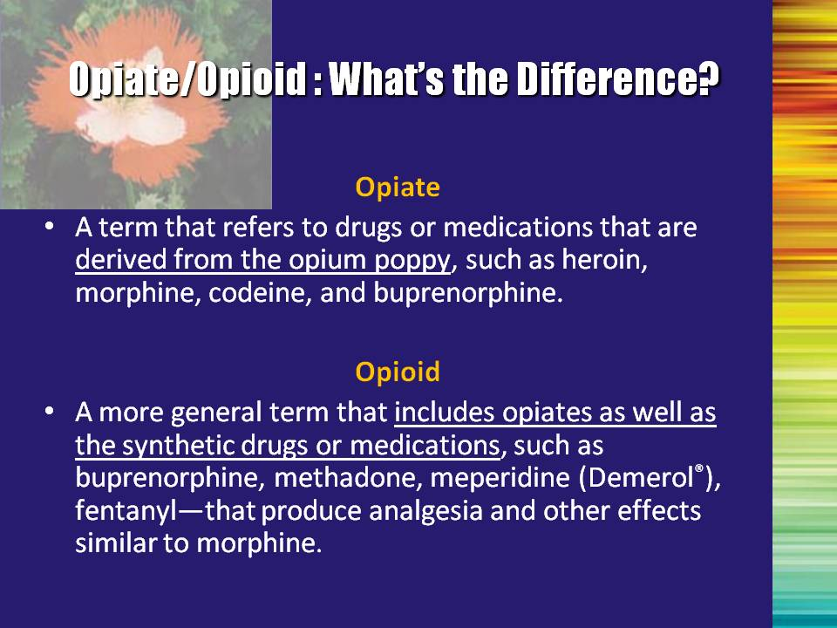 | Slide 3: Opiate/Opioid: What’s the Difference?  Throughout this training we are using the term opioid to define the class of drug with which we are dealing. It is important to understand what this term means.  - Opiate refers only to drugs or medications that are derived directly from the opium poppy. Examples include heroin, morphine, and codeine.  - Opioid is a broader term referring to opiates and other synthetically-derived drugs or medications that operate on the opioid receptor system and produce effects similar to morphine. Examples include methadone, buprenorphine, meperidine, and fentanyl.  Note to the Trainer(s): All opiates are opioids, but not all opioids are opiates. | Slide 3
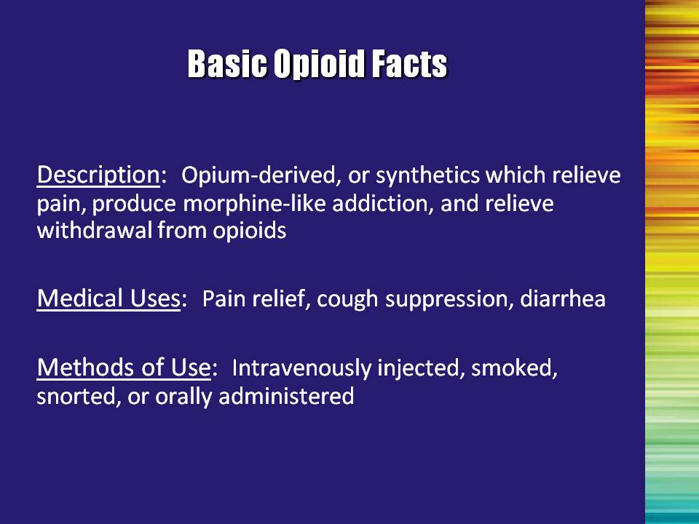 | Slide 4: Basic Opioid Facts  Description: All opioids work basically the same way, regardless of their derivation.  Medical Uses: There are benefits to using opioids; they are not just used recreationally.  Methods: Bottom line – you can get opioids into your body in many ways. | Slide 4
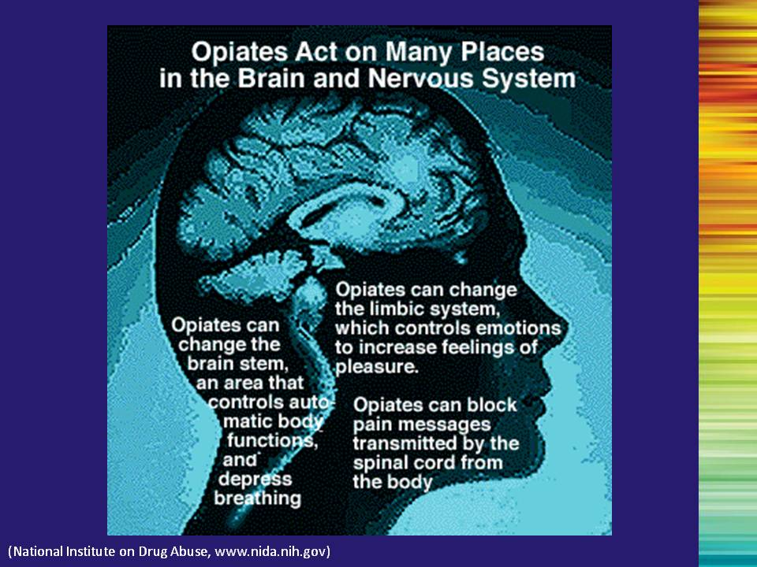 | Slide 5: NIDA Brain Graphic  Opioids affect the brain globally, including areas that control:  - Autonomic bodily functions such as breathing, blood pressure, pulse;  - Emotions, especially the areas of the brain responsible for feeling pleasure;  - Pain – opioids block the transmission of pain messages from the body to the brain thereby diminishing or stopping the experience of the pain.  Reference:  National Institute on Drug Abuse. (2007). Retrieved from http://www.nida.nih.gov | Slide 5
 | Slide 6: Receptor Pharmacology: Terminology  Let’s take the next few minutes to review some receptor pharmacology-related terms.  Receptor  A specific cell or place on a cell to which a specific molecule binds. There are unique receptors for many different molecules, including specific opioid receptors. | Slide 6
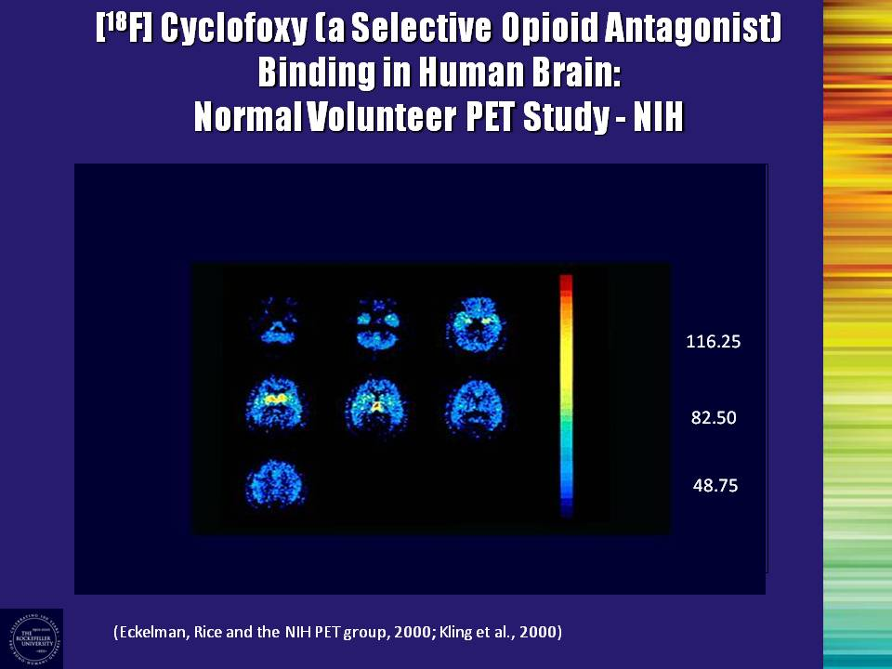 | Slide 7: Receptor Pharmacology: Terminology  This Positron Emission Tomography (PET) scan image identifies the location of opioid receptors (mu and kappa) in the brain in normal, healthy volunteers (Kling et al. 2000)  PET scans are a nuclear imaging tool which produces a three-dimensional image or picture of the biological functions of the body. Physicians use them to pinpoint disease states in the body.  Note to the Trainer(s): This is an image of a single brain at different time intervals. The concentration of color indicates receptors located in the limbic reward system.  Reference:  Kling, M. A., Carson, R. E., Borg, L., Zametkin, A., Matochik, J. A., Schluger, J., … Kreek, M. J. (2000). Opioid receptor imaging with positron emission tomography and [(18)F] cyclofoxy in long-term, methadone-treated former  heroin addicts. Journal of Pharmacology and Experimental Therapeutics,  295(3), 1070-1076. | Slide 7
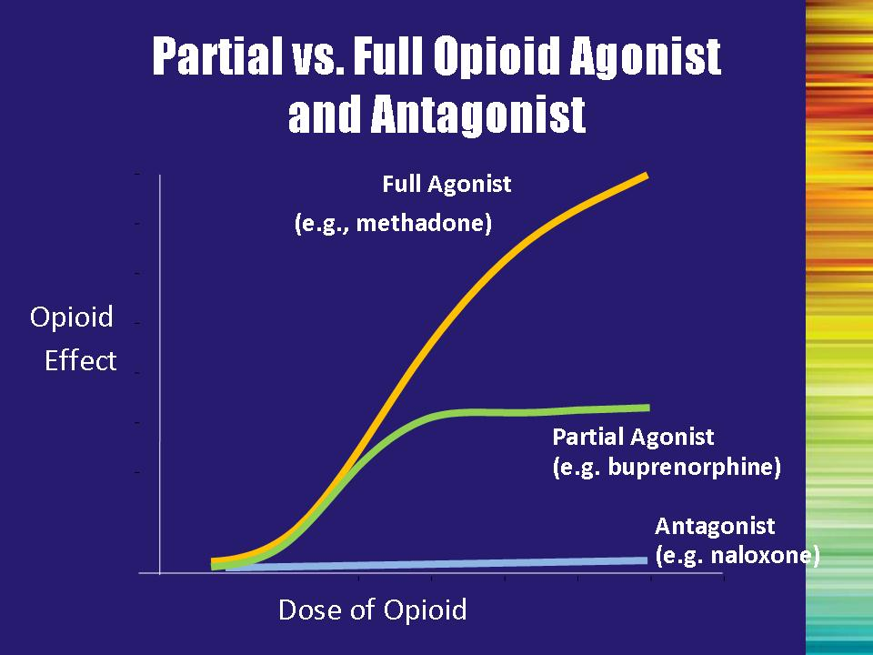 | Slide 8: Partial vs. Full Opioid Agonist and Antagonists  This slide graphically depicts the different types of opioids (whether they are prescribed medications such as Vicodin or methadone, or illicit substances like heroin).  Move forward to reveal first line (full agonist)  Full agonists (e.g., heroin, opium, Vicodin, methadone, etc.) fully activate the receptors so that the more you use, the more effect you experience. If someone continues to use, they will eventually experience overdose and, possibly, death.  The following metaphor may be helpful in explaining the differences between the types of opioids:  Opioid agonists work like having the right key to a door. You put the key in the lock, the lock turns and the door opens completely.  Move forward to reveal the next line (antagonists)  Opioid antagonists (e.g., naltrexone, naloxone) fill the receptors and block the action of other opioids. If the person has used an opioid agonist, the antagonist will replace it on the receptor and the person will experience withdrawal. If the person is stable on an antagonist, and uses another opioid, the antagonist will block the effects, preventing the user from experiencing the high.  The door metaphor continued:  Opioid antagonists work like having the wrong key to a door. You put the key in the lock; the door remains locked and will not open. Additionally, since the key is in the lock, no other key can be put in the lock (even if it is the right key for that door) until the wrong key is removed.  Move forward to reveal the last line (partial agonists)  Opioid partial agonists (e.g., buprenorphine) are in the middle. | Slide 8
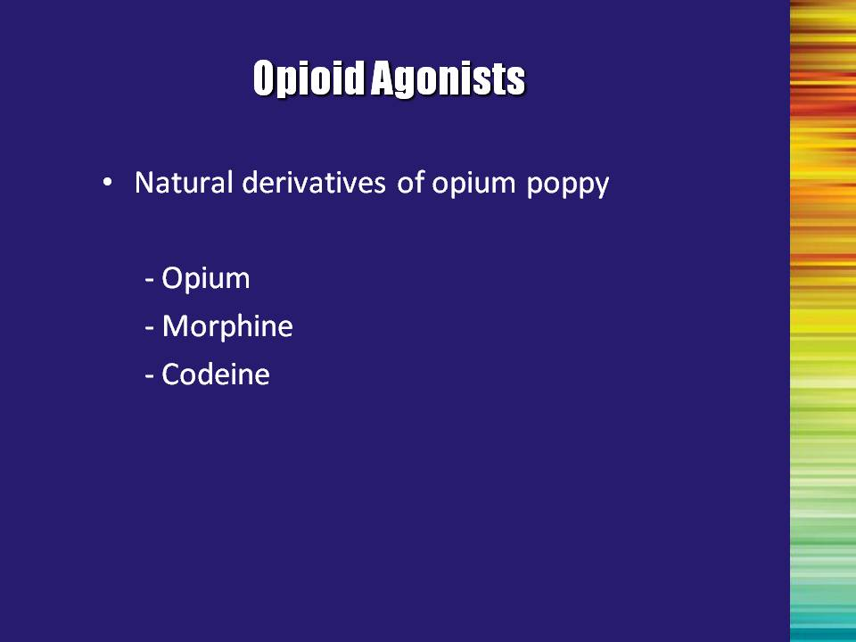 | Slide 9: Opioid Agonists  Natural Derivatives  These substances are derived directly from the opium poppy. They are the drugs that we can also call opiates.  Note to the Trainer(s): Be sure to tell participants that the following pictures may serve as triggers and to act accordingly. | Slide 9
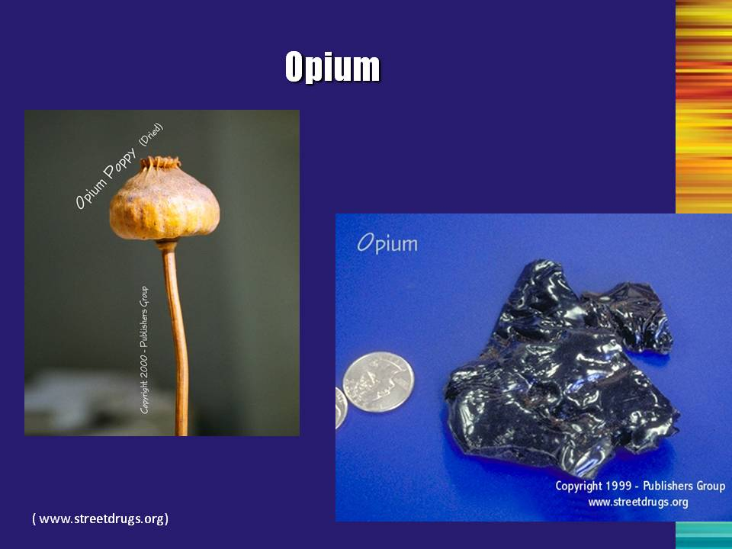 | Slide 10: Opium  Show picture for a few seconds and then move on.  Reference:  Publishers Group, LLC. (2009). Retrieved from http://www.streetdrugs.org | Slide 10
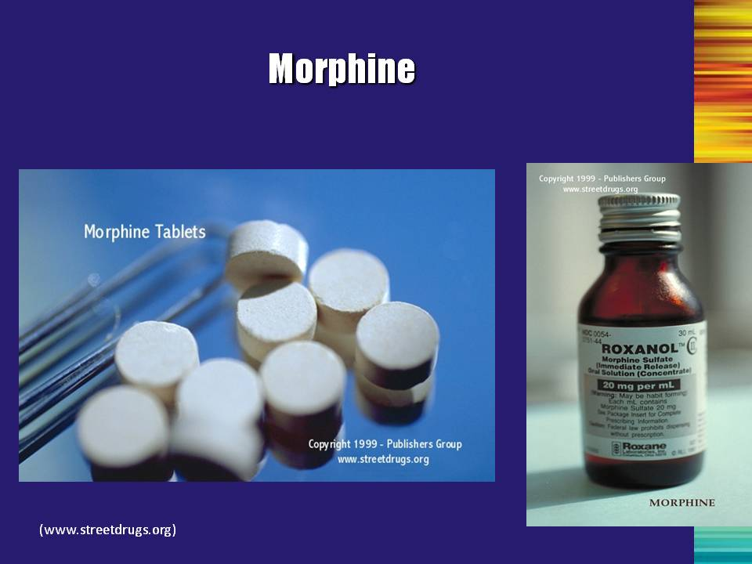 | Slide 11: Morphine  Show picture for a few seconds and then move on.  Reference:  Publishers Group, LLC. (2009). Retrieved from http://www.streetdrugs.org | Slide 11
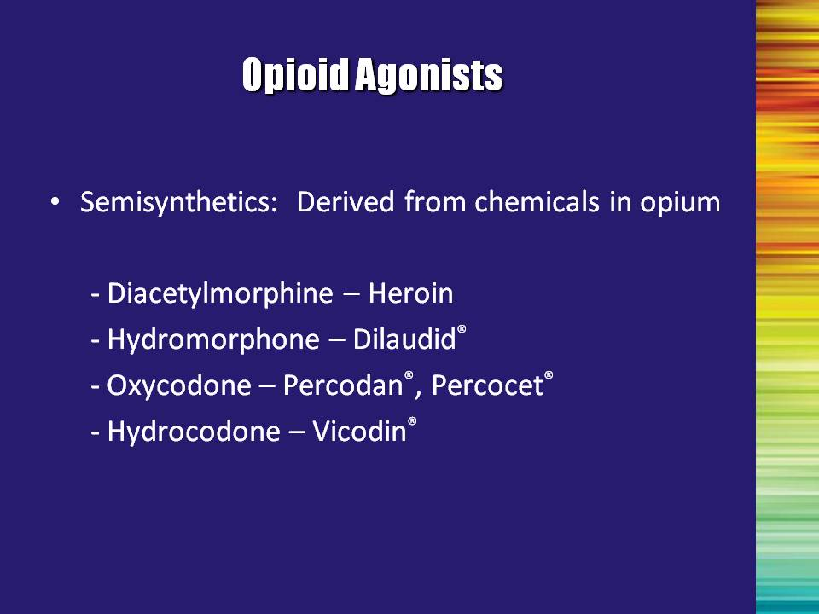 | Slide 12: Opioid Agonists  Semi-synthetics  These substances are derived from chemicals extracted from the opium poppy. They also fall into both the opiate and opioid categories. | Slide 12
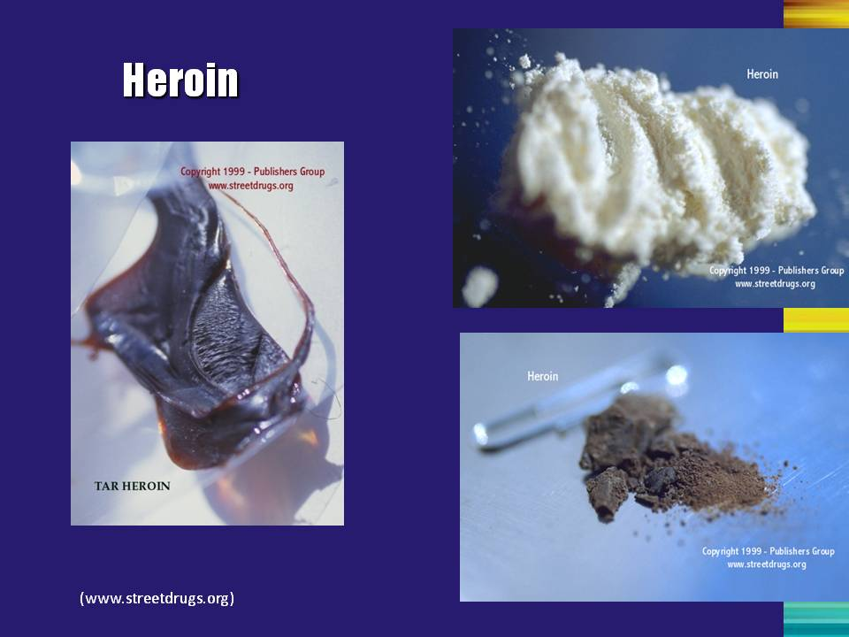 | Slide 13: Heroin  Left-hand side picture – Mexican black tar heroin (mostly used in the Western U.S.)  Right-hand side top picture – South American white heroin (dominates the heroin market east of the Mississippi River)  Right-hand side bottom picture – Mexican brown heroin  Reference:  Publishers Group, LLC. (2007). Retrieved from http://www.streetdrugs.org | Slide 13
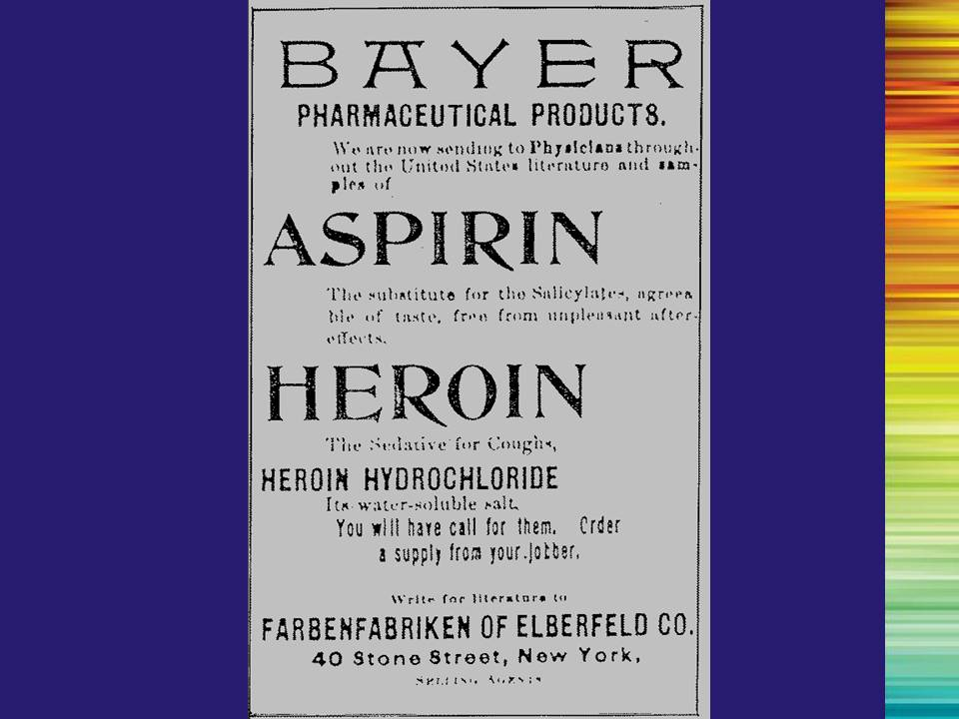 | Slide 14: Bayer Graphic  Heroin has been around for a long time and was originally marketed under the Bayer Label as a cough suppressant. This advertisement is from 1897. It is no longer considered to have any medical uses.  Note: In larger rooms the text of this slide is difficult to read and should therefore be read aloud. | Slide 14
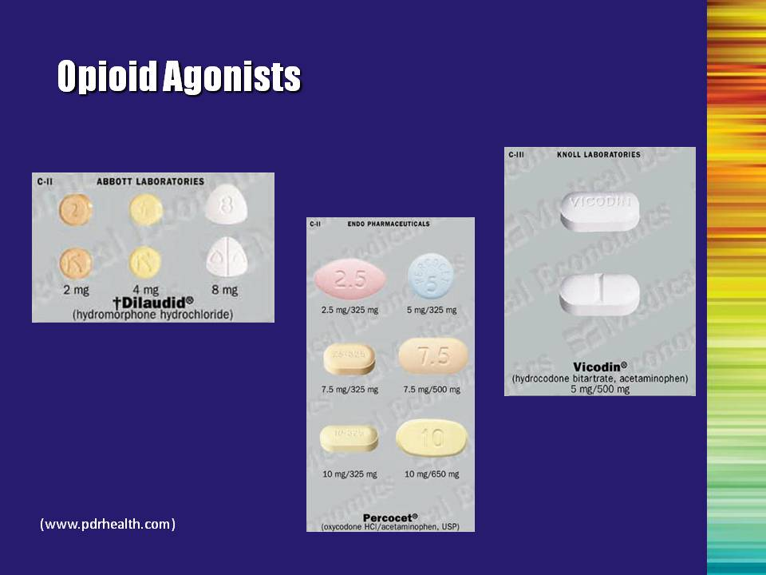 | Slide 15: Opioid Agonists  Show picture for a few seconds and then move on.  Reference:  PDR Network, LLC. (2007). Retrieved from http://www.pdrhealth.com | Slide 15
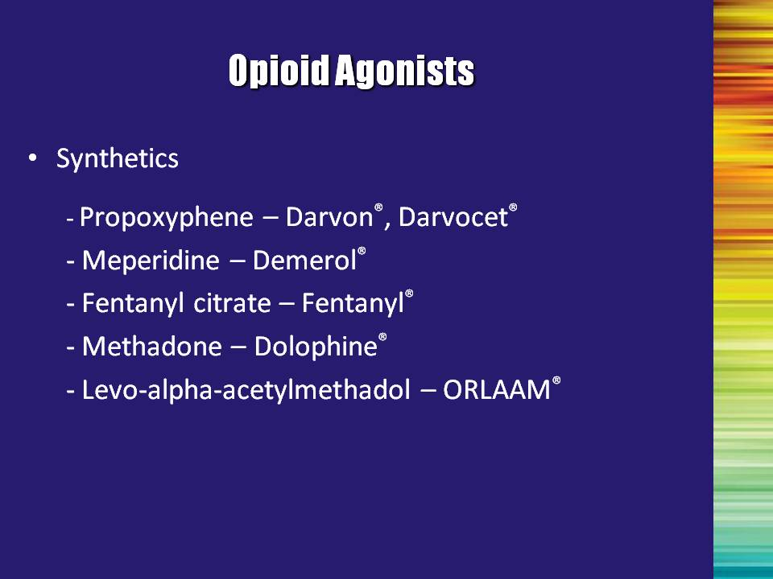 | Slide 16: Opioid Agonists  Synthetics  These substances are synthetically manufactured. They are considered opioids, but are NOT opiates. | Slide 16
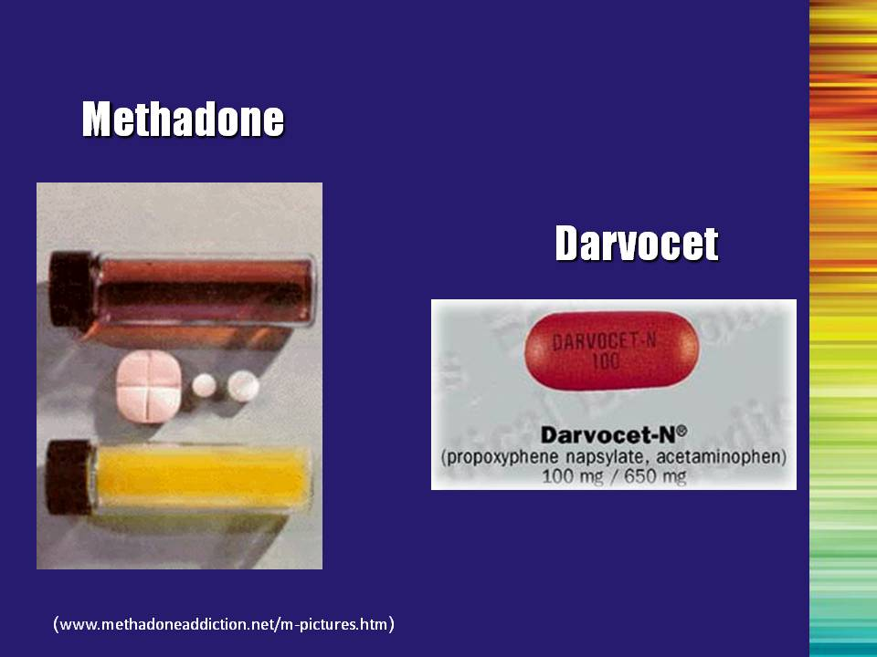 | Slide 17: Methadone/Darvocet  Show picture for a few seconds and then move on.  Reference:  Methadone Addiction.com (2008). Retrieved from www.methadoneaddiction.net/m-pictures.htm | Slide 17
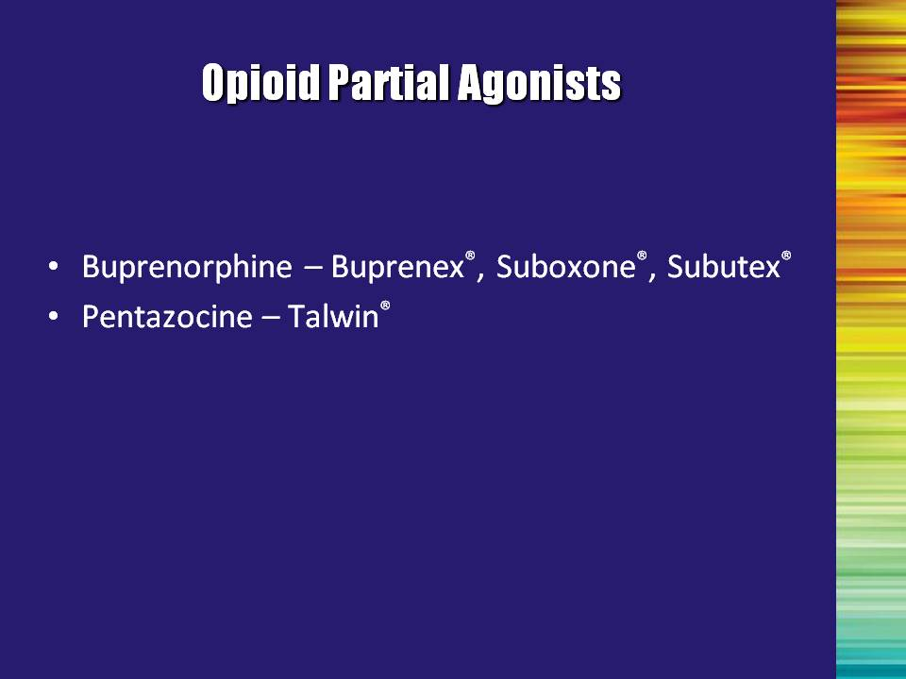 | Slide 18: Opioid Partial Agonists  Buprenorphine/naloxone combination tablet (currently marketed as Suboxone®) and the buprenorphine-only tablet (currently marketed as Subutex®) are the formulations that are approved for the treatment of opioid addiction. Both medications are administered sublingually.  It may be worth noting that buprenorphine is the only medication with FDA approval for the treatment of opioid addiction that is not schedule II (methadone is schedule II), and that only Suboxone® and Subutex® are approved. Using either of these medications for the treatment of pain is off label.  Although Buprenex® (injectable formulation of buprenorphine) and Talwin® (Pentazocine) are also partial opioid agonists and approved for the treatment of pain; they ARE NOT approved for the treatment of opioid addiction.  Many medications can be used off label for purposes other than what they were originally studied for (this is known as off-label use). However, due to laws related to addiction treatment, it is illegal to use injectable buprenorphine (Buprenex®) and pentazocine (Talwin®) for treating opioid addiction. | Slide 18
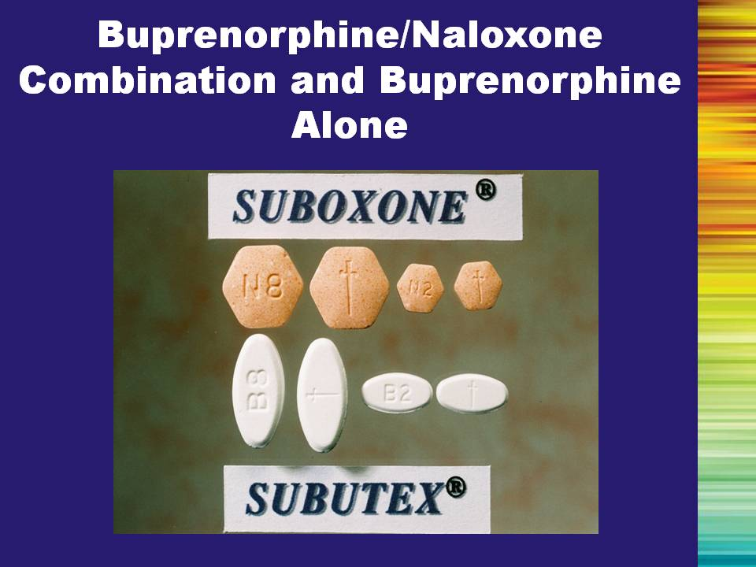 | Slide 19: Buprenorphine/Naloxone Combination and Buprenorphine Alone  This is what the two sublingual buprenorphine tablets currently being marketed look like. | Slide 19
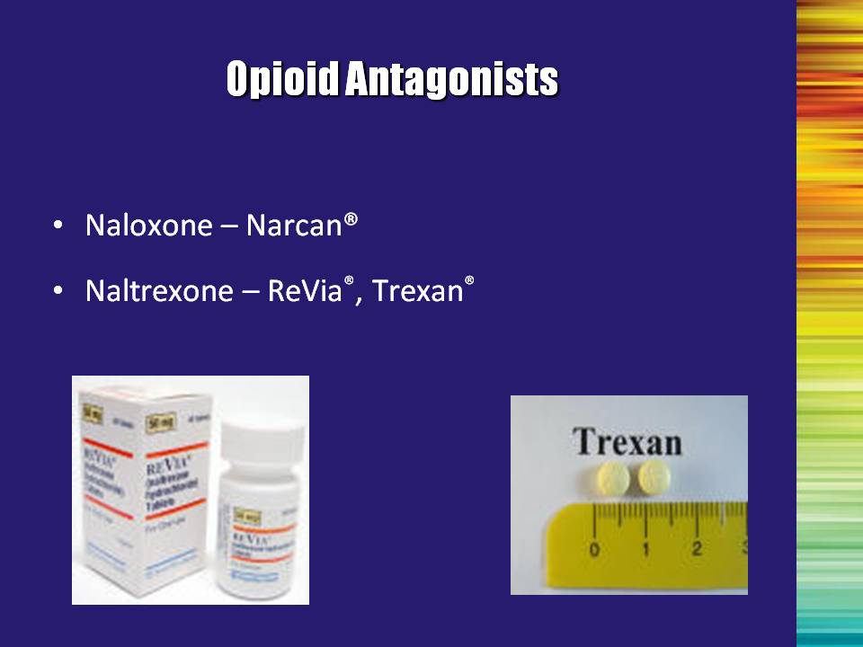 | Slide 20: Opioid Antagonists  As was previously stated, antagonists are those substances that block the effects of opioid agonists. Two examples are naloxone (the same medication in the buprenorphine/naloxone combination tablet) and naltrexone. | Slide 20
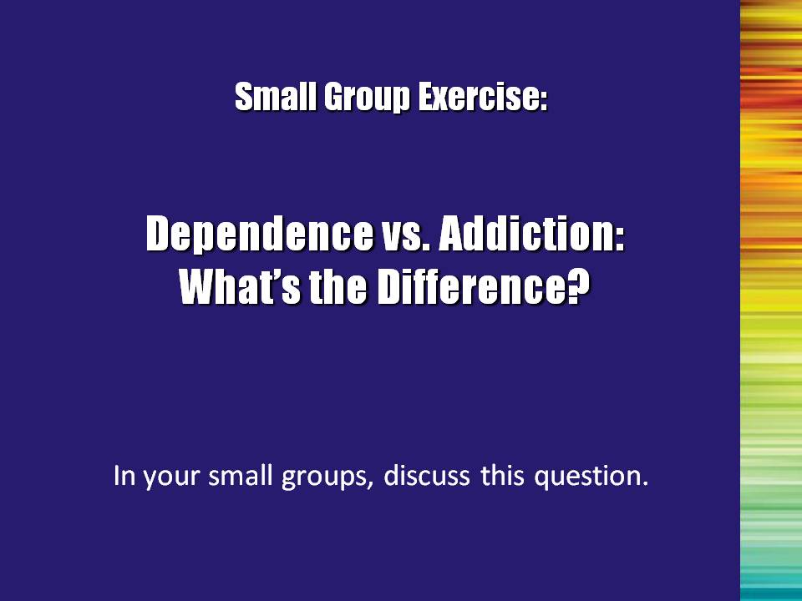 | Slide 21: Dependence vs. Addiction: What’s the Difference?  SMALL GROUP EXERCISE  Break the audience into small groups (3-4 people), and ask them to discuss the difference between dependence and addiction. After approximately 10 minutes, have the group reconvene and ask for a few volunteers to describe their discussions. | Slide 21
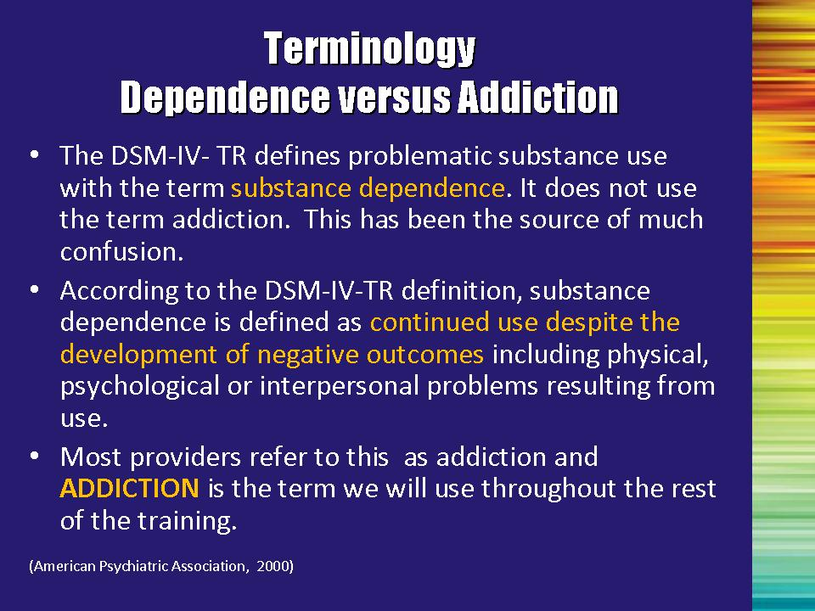 | Slide 22: Dependence versus Addiction  Most providers use the term “addiction” to describe this pattern of problems. In order to keep this term distinct, we will use the term addiction (rather than dependence) throughout this training to refer to this pattern of problems resulting from use.  Reference:  American Psychiatric Association. (2000). Diagnostic and statistical manual of mental disorders: DSM-IV-TR (4th edition). Arlington, VA: Author. | Slide 22
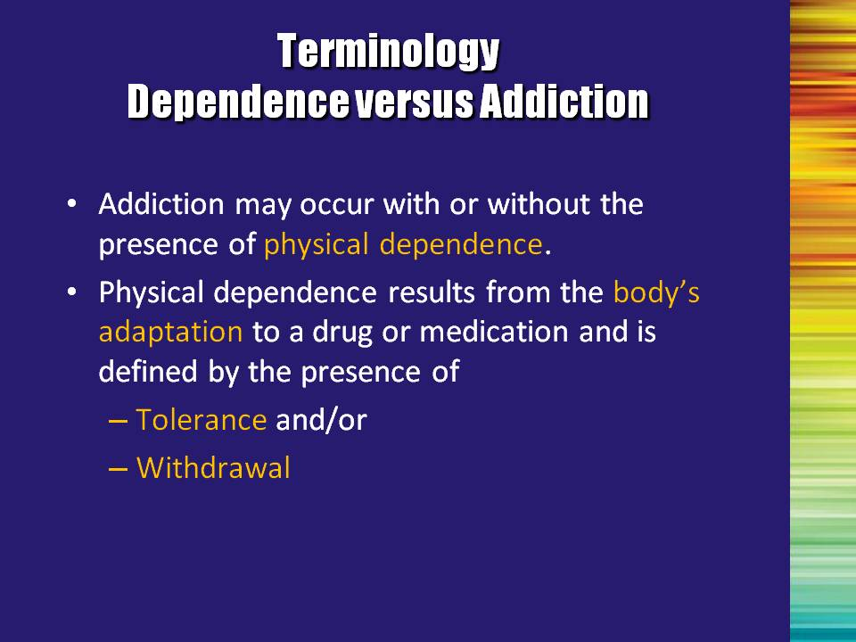 | Slide 23: Dependence versus Addiction  The term “dependence” is used to describe the body’s reaction to the presence of an addictive substance -that is physical dependence on the substance.  Physical dependence is one symptom of addiction, but it is important to remember that addiction can occur with or without physical dependence.  Physical dependence is defined by the presence of tolerance and/or withdrawal.  Let’s look at the specific definitions of these terms. | Slide 23
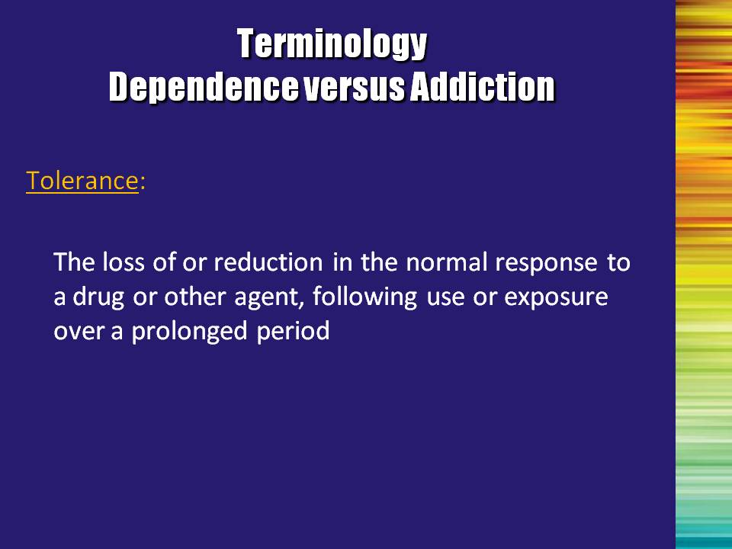 | Slide 24: Dependence versus Addiction  Tolerance  Tolerance deals with the body’s adaptation to a drug or medication. With repeated exposure, the response to the substance lessens. It therefore requires a higher dose to get the same effect. | Slide 24
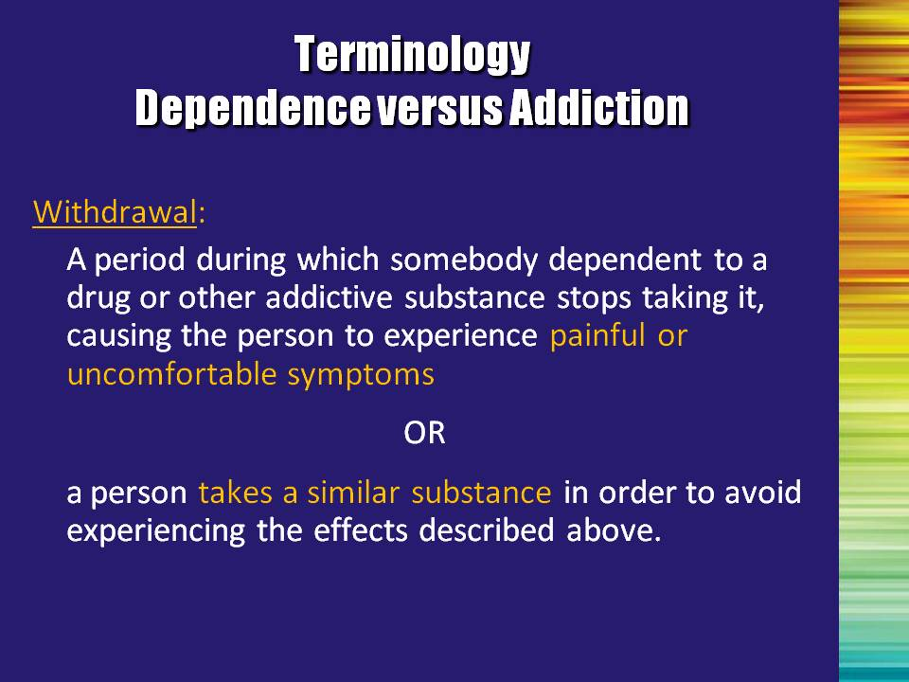 | Slide 25: Dependence versus Addiction  Withdrawal  This is another indicator of the body’s adaptation to the drug. This process occurs when the normal dose is reduced or stopped and the person experiences painful or uncomfortable symptoms, OR the person uses a similar substance in order to avoid these painful feelings (i.e. methadone or buprenorphine is used to address impending withdrawal).  Let’s look at the problems that the DSM-IV-TR identifies. | Slide 25
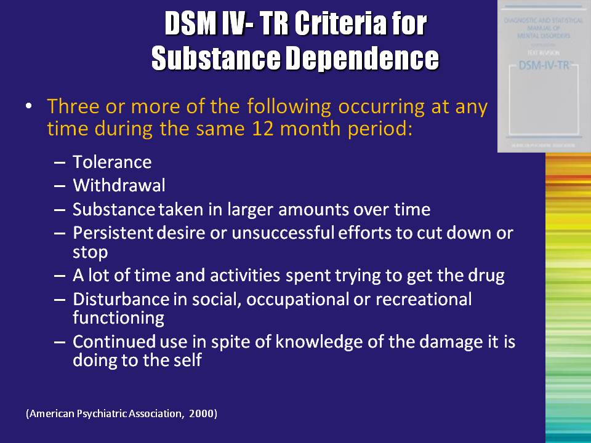 | Slide 26: DSM-IV-TR Criteria for Substance Dependence  According to the DSM-IV-TR, substance use disorders occur on a continuum. The less severe form of the problem is called abuse and is defined as having repeated problems associated with use, but generally the individual is still at least somewhat functional in their lives. As the problem worsens, the person moves on to addiction (or what the DSM-IV-TR calls substance dependence) in which functioning is markedly impaired.  Addiction is based on clusters of behaviors and physical effects. It is defined as a “maladaptive pattern of substance use leading to clinically significant impairment or distress as manifested by three (or more) of seven symptoms occurring at any time during a 12-month period.”  Read the bullets aloud.  Additional points to mention:  Bullet #3: “taking larger amounts” – indicates a loss of control over moderating your drug use. “Over time” can also be stated as “longer periods than intended.”  Reference:  American Psychiatric Association. (2000). Diagnostic and statistical manual of mental disorders: DSM-IV-TR (4th edition). Arlington, VA: Author. | Slide 26
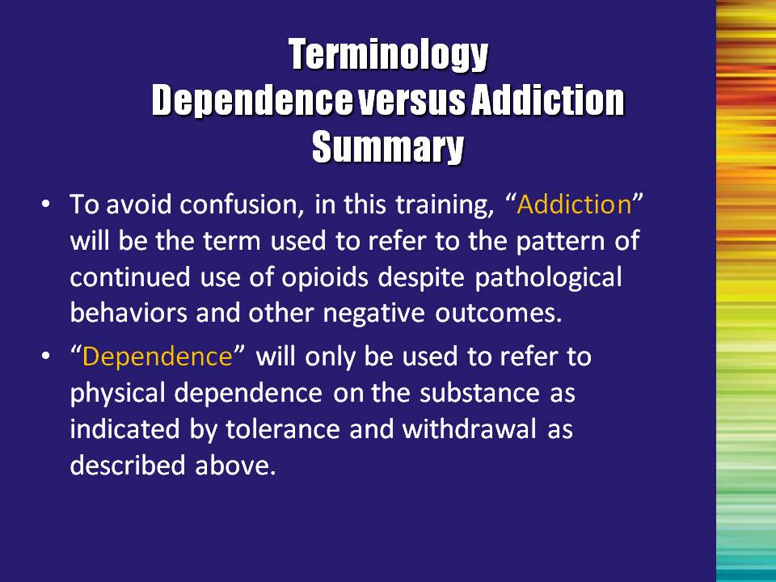 | Slide 27: Dependence versus Addiction - Summary  For clarity, let’s review the terms again:  Read slide aloud. | Slide 27
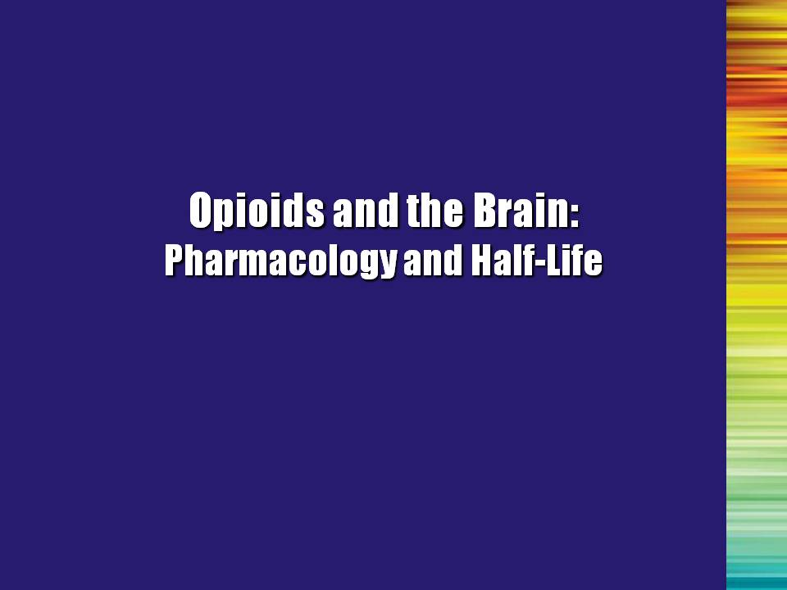 | Slide 28: Opioids and the Brain: Pharmacology and Half-Life (Transition Slide)  So now that you know which drugs and medications are included in the class known as opioids, let’s look at how they work. | Slide 28
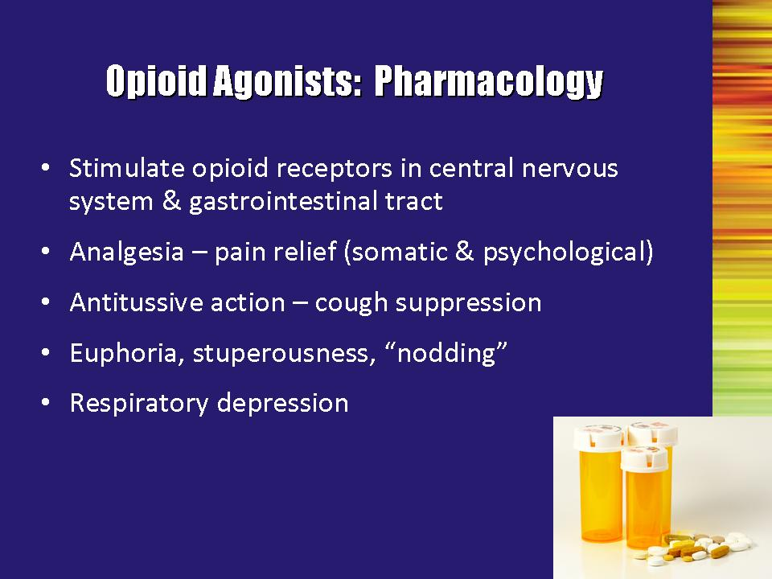 | Slide 29: Opioid Agonists: Pharmacology  So how do opioids work?  Opioids work by stimulating the opioid receptors in the brain and gastrointestinal (GI) tract. When they bind to the receptor, users experience relief from pain, cough suppression, feelings of euphoria, and they may become stuperous. If the dose is high enough, they may experience a slowing of respiration. This final symptom can lead to death. | Slide 29
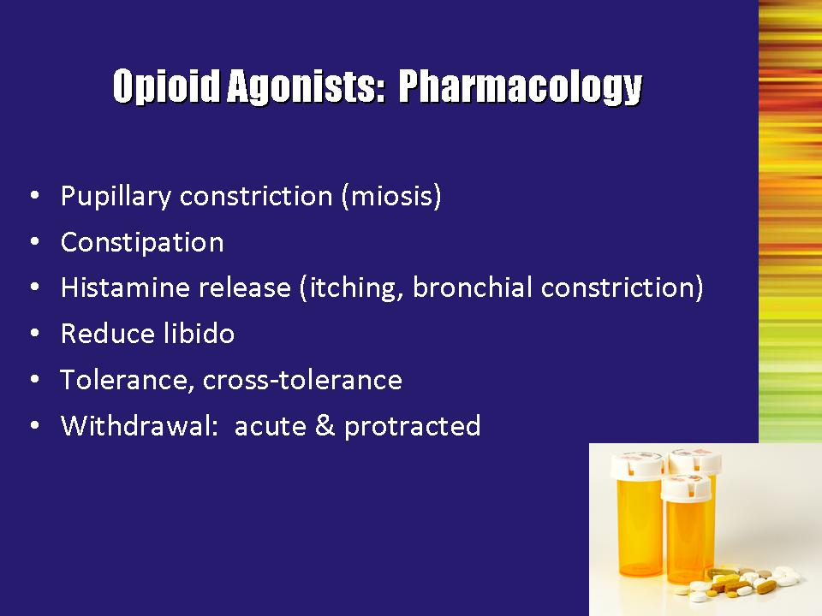 | Slide 30: Opioid Agonists: Pharmacology  Acute effects of opioids include:  - Constriction of the pupils so that they become very small (sometimes referred to as pinpoint pupils)  - Constipation  - An allergic-type reaction accompanied by itching and/or difficulty breathing  - Lower libido due to decreases in sex hormones.  With chronic use, tolerance and withdrawal symptoms develop and the above symptoms may become more significant.  Cross tolerance: We have already discussed the definition of tolerance. With opioids, you also see cross-tolerance. This means that once tolerance develops for one substance (e.g., heroin) you will see tolerance for other opioids, as well (e.g., codeine or Demerol). If the person is receiving treatment with an opioid medication (either as a treatment for opioid addiction or for other medical indications), the dose will need to be adjusted depending upon the level of tolerance.  In a person who is otherwise generally healthy, withdrawal from an opioid agonist is not life threatening. However, it is characterized by drug cravings and marked distress, including flu-like symptoms, joint pain, sweating, runny nose, diarrhea, nausea, and anxiety. It is also frequently associated with relapse to drug use. Once the immediate withdrawal from the drug is over (usually after a few days), there are residual emotional and physical symptoms that place the patient at significant risk for relapse. | Slide 30
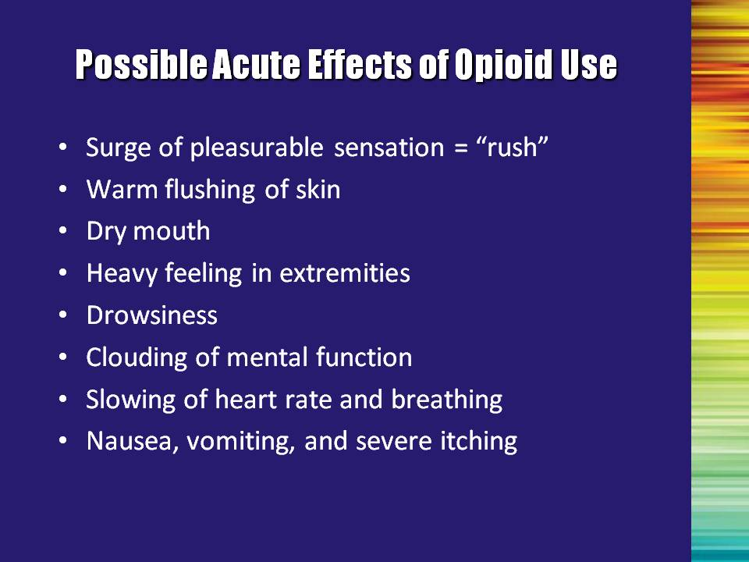 | Slide 31: Possible Acute Effects of Opioid Use  Summarize the symptoms associated with acute effects, chronic use, and withdrawal.  Bullet #1: Rush is generally reported with administration by injection or smoking. It is not commonly associated with oral administration.  Bullet #5: Drowsiness is commonly referred to as “nodding out.” | Slide 31
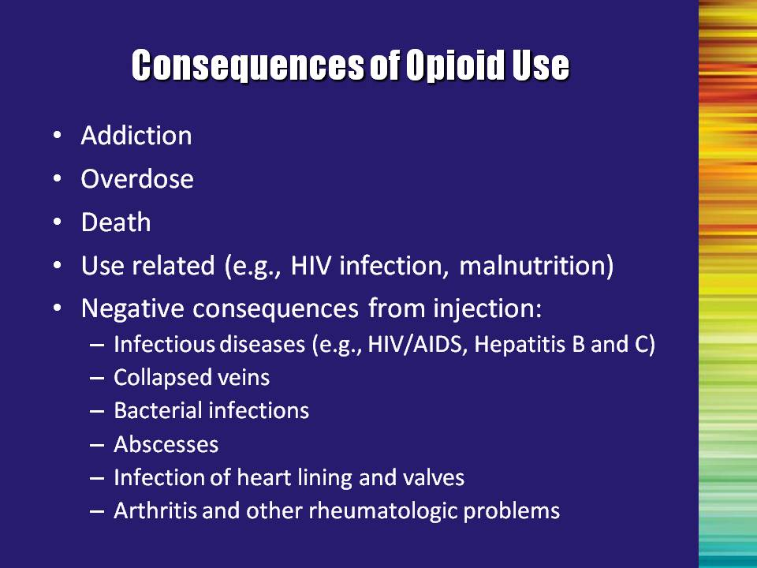 | Slide 32: Consequences of Opioid Use  The first three consequences (addiction, overdose, and death) refer to opioid use in general. There are also consequences from behaviors that may be associated with substance use such as infections resulting form unprotected sexual behaviors, malnutrition, etc.  Many of the consequences refer specifically to injection drug use:  - Collapsed veins resulting from repeated injections.  Ask trainees: What do people do if their veins collapse? (Answer: find another place).  Ask trainees: Where besides the bend in the arm might people inject?  (Answer: other possible places include between toes/fingers, in the neck, in the thigh, under the tongue, in the groin or genital area).  - Viral Infections such as HIV or Hepatitis C, resulting from sharing injection equipment with people.  - Bacterial infections may be caused by not cleaning the injection site properly or by using needles that have been exposed to bacteria. This can introduce bacteria into the blood stream.  - An abscess is a subcutaneous infection. If untreated, an abscess can rupture and lead to sepsis or even death.  - Blood infections can be contracted from bacteria transferred into the bloodstream via dirty needles/ syringes. The bacteria settles in the heart, causing an infection of the heart lining (endocarditis) or a breakdown of heart valves (which causes them to become less effective at bringing blood to and from the heart).  - Arthritis and other rheumatologic problems may develop as a result of chronic infections and muscle/tissue inflammation. | Slide 32
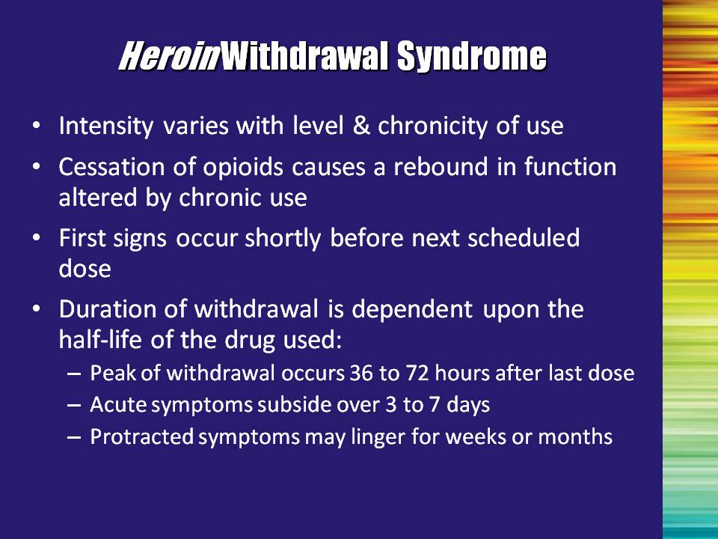 | Slide 33: Heroin Withdrawal Syndrome  Once the body becomes accustomed to the drug being on board, it may react if the drug is removed. The intensity of the withdrawal symptoms will depend on the level of use (dose and type of opioid) and the frequency and duration of use (chronicity).  Withdrawal symptoms are basically a rebound effect; those functions that have been depressed or altered by the opioid suddenly emerge again. Withdrawal symptoms are often the opposite of symptoms seen when actively using the opioid (e.g., people get constipated when taking opioids and have diarrhea when withdrawing).  First signs of withdrawal occur shortly before the next scheduled dose of buprenorphine.  - Length of the withdrawal depends upon the half-life. Half-life is the time it takes for half a given amount of a substance, such as a drug, to be removed from living tissue through natural biological activity. The slower the medication is removed from the body, the longer the experience lasts. Usually the next dose of a medication is taken at about one half-life.  Opioids with short half-lives (e.g., heroin) have acute withdrawal symptoms that peak at 3-4 days and then subside by days 3-7. Opioids with longer half-lives (e.g., methadone – half-life of 24 hours) have longer acute withdrawal periods.  It is important to note that unlike methadone, buprenorphine has a fairly short half-life. However, it still has a very long duration of action. In this case, the duration of action results from high receptor affinity or the strength with which a medication binds to a receptor.  Regardless of the length of the acute withdrawal, there are protracted withdrawal symptoms (e.g., aches and pains, general malaise) that persist for weeks or months after use ceases. | Slide 33
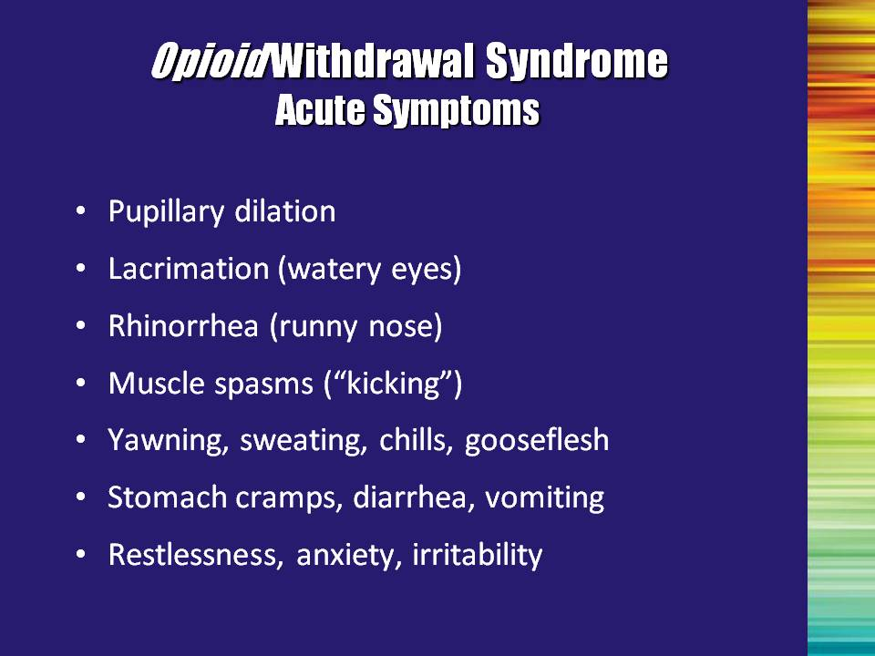 | Slide 34: Opioid Withdrawal Syndrome: Acute Symptoms  Acute withdrawal symptoms are the opposite of acute intoxication symptoms.  Summarize the acute withdrawal symptoms.  Note regarding the term “gooseflesh”: This symptom is where the phrase “going cold turkey” comes from. | Slide 34
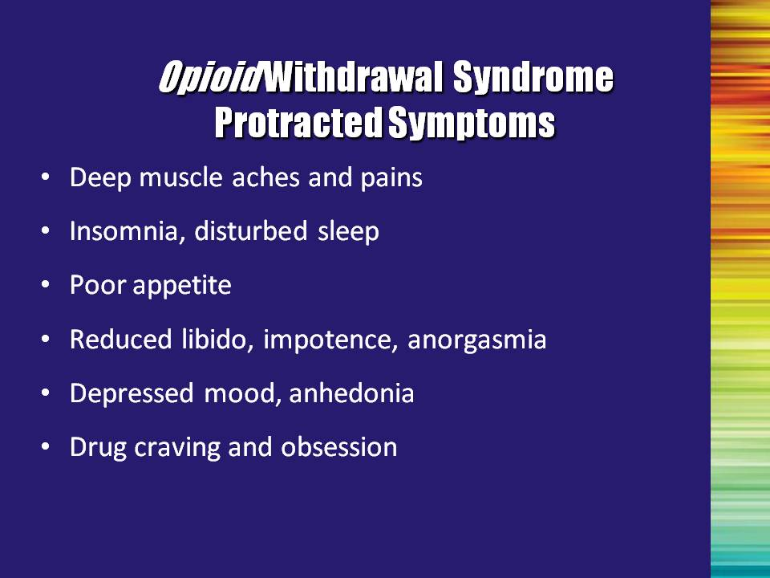 | Slide 35: Opioid Withdrawal Syndrome: Protracted Symptoms  Protracted withdrawal symptoms are less severe than the acute symptoms, but are still experienced as extremely disruptive and uncomfortable.  Summarize the protracted withdrawal symptoms.  Anorgasmia = inability to have an orgasm  Anhedonia = overall lack of pleasure (everything is gray) | Slide 35
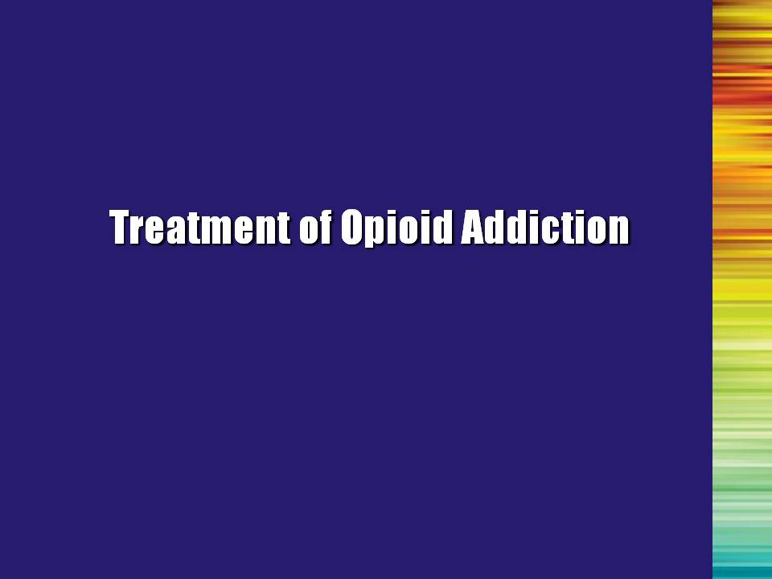 | Slide 36: Treatment of Opioid Addiction (Transition Slide)  Anyone who takes opioids for a period of time will develop a physical dependence. For instance, a patient who is taking Vicodin over a period of time for pain will experience withdrawal symptoms if they suddenly stop taking them. As previously discussed, this does not mean that they are addicted. It just means that their body has adapted to the medication. Generally, the prescribing physician will help the patient gradually taper down on the dose once the medication is no longer needed.  However, if a person has an addiction to opioids—that is he/she has lost control over his/her use, and/or has developed the problems associated with addiction (whether or not physical dependence is present)—it is unlikely that he/she is going to stop using without some sort of treatment.  The next section of the training will examine the treatment options available for opioid addiction. | Slide 36
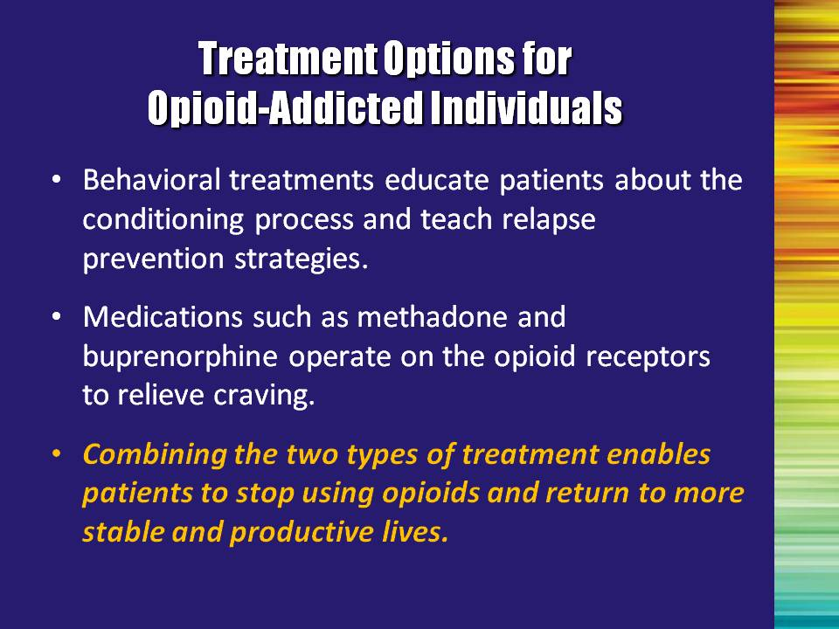 | Slide 37: Treatment Options for Opioid-Addicted Individuals  The successful treatment for opioid addiction requires both management of physical withdrawal symptoms and behavioral and cognitive changes that encourage the patient to abstain from using the drug of abuse in the future. Providing psychosocial and counseling services along with pharmaceutical treatment increases the likelihood of achieving long-term, comprehensive lifestyle changes and preventing relapse. You want to help the patient restore a degree of normalcy to brain function and behavior, thereby leading to increased employment rates, reduced criminal behavior, and lowered risk of HIV, hepatitis C, and other diseases.  Note to the Trainer(s): Bullet #3: Stress the importance of combining both treatment approaches and tailoring treatment to meet the particular needs of the patient (e.g., deciding between inpatient and outpatient, behavioral and pharmacological, etc.). | Slide 37
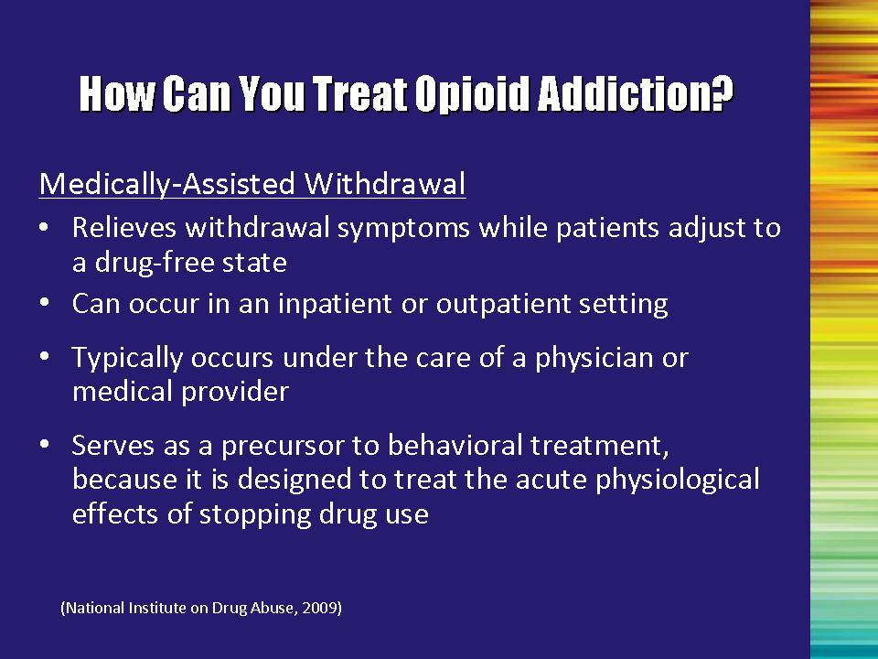 | Slide 38: How Can You Treat Opioid Addiction?  Medically-Assisted Withdrawal  The individual is systematically withdrawn from addicting drugs. Medications (e.g., methadone, buprenorphine, and clonidine) are used to alleviate withdrawal symptoms while the person gradually returns to an opioid-free state. It can be done successfully in inpatient or outpatient settings.  Generally, a medical provider supervises the withdrawal to monitor medical safety and administer medications to relieve discomfort.  This approach is not sufficient by itself to transition someone to maintaining an ongoing opioid-free life. Longer-term treatment that helps the person to develop new behaviors and strategies for coping is critical.  Patients who are not successful in withdrawing or who choose not to withdraw from opioids should be considered for treatment with medications as part of the treatment plan.  Reference:  National Institute on Drug Abuse. (2009). Principles of drug addiction treatment – A research-based guide (2nd edition). Washington, DC: National Institute on Drug Abuse, National Institutes of Health, US Department of Health and Human Services. | Slide 38
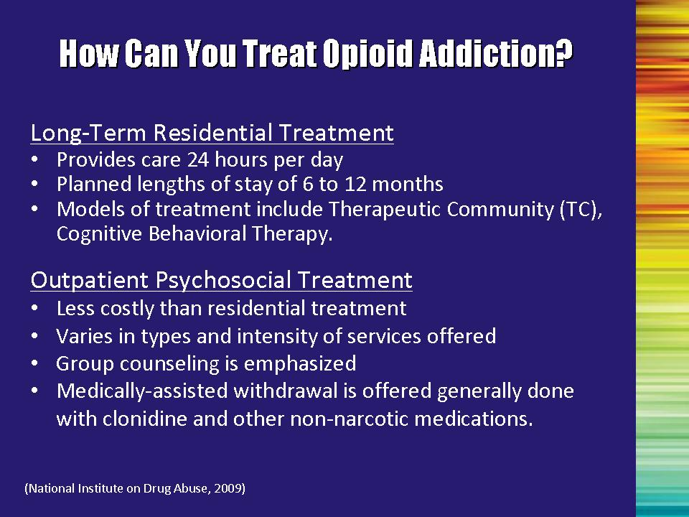 | Slide 39: How Can You Treat Opioid Addiction?  Long-Term Residential Treatment  - Provides a highly structured environment, including 24-hour care and lengths of stay from 6 -12 months  - May employ a variety of models, including Therapeutic Communities and cognitive behavioral therapy  Outpatient Psychosocial Treatment  - Patients involved in outpatient psychosocial treatment continue to live in the community while receiving their treatment allowing them to continue to hold jobs and make use of social supports in the community  - Less costly than residential treatment  - Varies in types and intensity of services offered  - Group counseling is emphasized  - Medically-assisted withdrawal is offered; generally done with clonidine and other non-narcotic medications. Patients report being very uncomfortable during the withdrawal process when clonidine is used, consequently, many leave treatment prematurely.  Reference:  National Institute on Drug Abuse. (2009). Principles of drug addiction treatment – A research-based guide (2nd edition). Washington, DC: National Institute on Drug Abuse, National Institutes of Health, US Department of Health and Human Services. | Slide 39
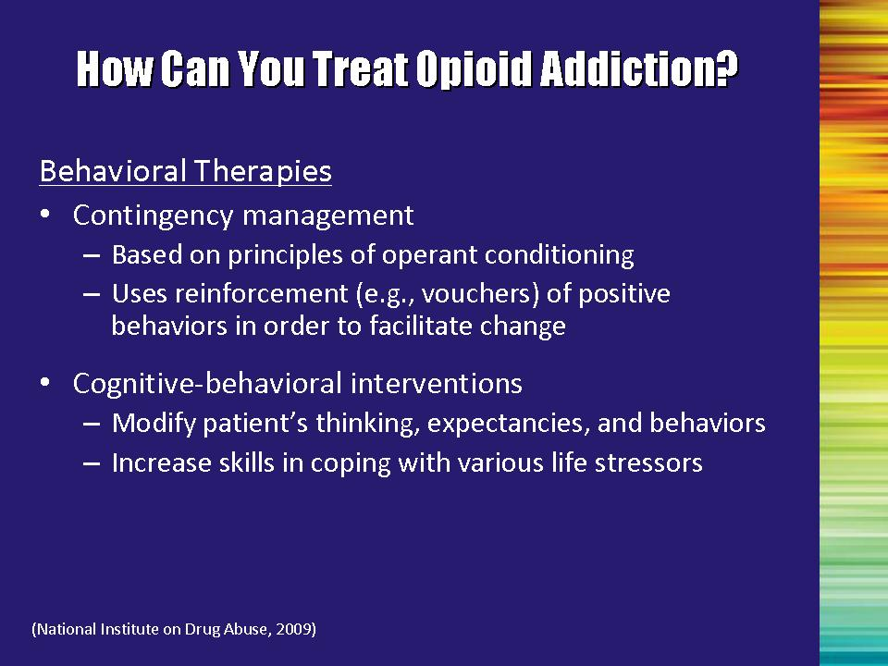 | Slide 40: How Can You Treat Opioid Addiction?  Behavioral Therapies  Behavioral therapies are designed to help individuals change their thought patterns around drug use and learn new behaviors to help them stop using and to avoid relapse. Two general strategies have shown a great deal of promise:  Contingency management:  - Helps the patient to adopt new behaviors by reinforcing behaviors that move them toward their recovery goals.  Research has shown that motivational incentive programs that use low-cost reinforcement (prizes, vouchers, clinic privileges, etc.), delivered in conjunction with on-site urine screening, promotes higher rates of treatment retention and abstinence from drug abuse.  The Promoting Awareness of Motivational Incentives (PAMI) Blending Product, developed through the Blending Initiative, is based on the positive research outcomes and lessons learned from the NIDA CTN study, Motivational Incentives for Enhanced Drug Abuse Recovery (MIEDAR). The tools contained in this training package are designed to build awareness of motivational incentives as a research-based therapeutic strategy within the addiction treatment field.  This Blending Product is available at:  - www.drugabuse.gov/Blending/  - www.attcnetwork.org | Slide 40
 | Slide 40: How Can You Treat Opioid Addiction?, Continued  Behavioral Therapies  Cognitive-behavioral interventions:  - Help the patient to change the way they think and behave with regards to drug use;  - Increase positive coping strategies.  Many different types of behavioral therapies have been used successfully for substance abuse disorders. These include:  - Motivational Enhancement Therapy  - The Matrix Model  - Cognitive and Cognitive-Behavioral Therapy  - Community Reinforcement Approach  - Self-Help Programs  Note to the Trainer(s): The following resources can be obtained free of charge:  SAMHSA’s Treatment Improvement Protocol (TIP) series includes a number of documents that contain best-practice guidelines for the provision of interventions and therapies for individuals with substance abuse disorders.  The Principles of Drug Addiction Treatment: A Research-Based Guide (a.k.a., the NIDA Blue Book) reviews treatment approaches that have empirical support for their efficacy.  Reference:  National Institute on Drug Abuse. (2009). Principles of drug addiction treatment – A research-based guide (2nd edition). Washington, DC: National Institute on Drug Abuse, National Institutes of Health, US Department of Health and Human Services. | Slide 40
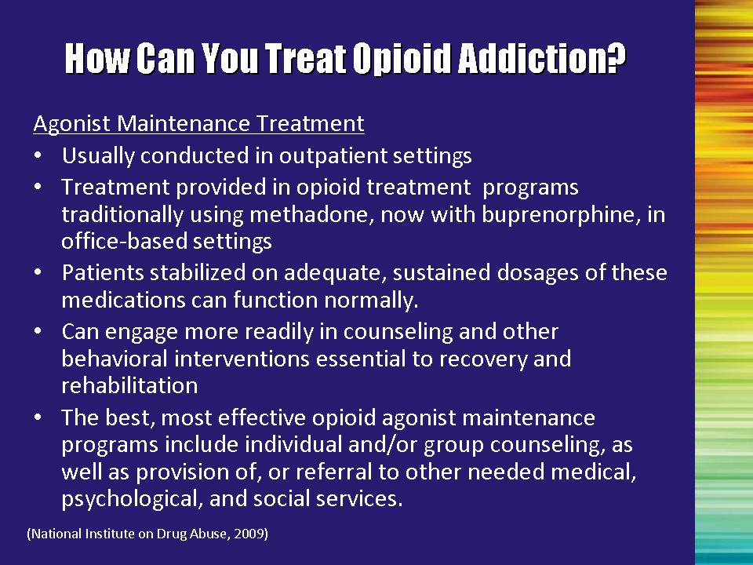 | Slide 41: How Can You Treat Opioid Addiction?  Agonist Maintenance Treatment  Agonist maintenance helps to stabilize people so that they don’t constantly experience the cycles of use and withdrawal. This allows them to function more normally, engage in treatment, and diminish the negative behaviors associated with use.  These treatments have been conducted primarily on an outpatient basis in specific opioid treatment programs, traditionally using methadone. With the addition of buprenorphine to the treatment system, patients can also receive treatment through physicians in the offices.  Maintenance programs are most effective if they are combined with an effective behavioral treatment program.  Additionally, patients may need treatment for other medical or psychological conditions. They may also need a variety of social support services including:  - Vocational rehabilitation  - Employment  - Education  - Housing  - Case management  - Parenting  - Socialization skills  - Anger management  Reference:  National Institute on Drug Abuse. (2009). Principles of drug addiction treatment – A research-based guide (2nd edition). Washington, DC: National Institute on Drug Abuse, National Institutes of Health, US Department of Health and Human Services. | Slide 41
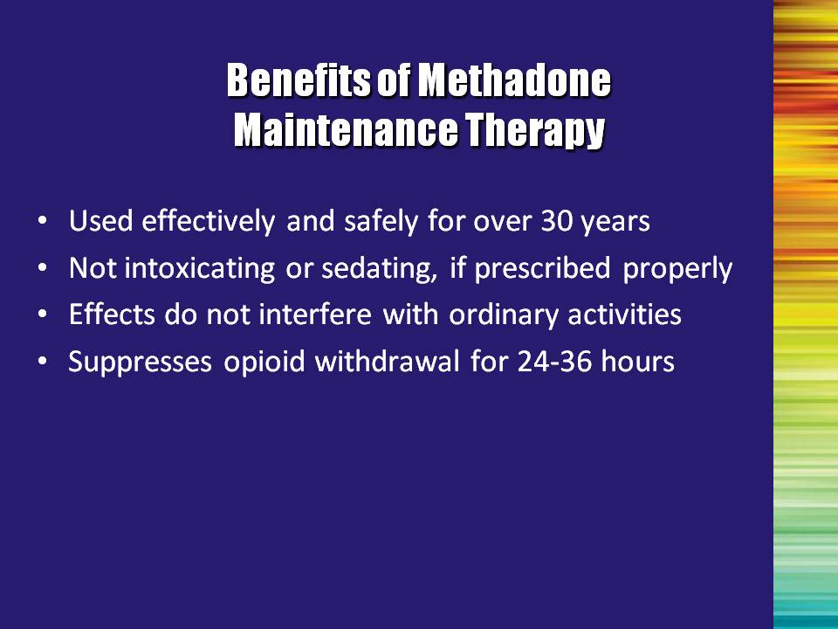 | Slide 42: Benefits of Methadone Maintenance Therapy  Review and summarize bullet points.  - Bullet #1: Used effectively and safely for over 30 years.  - Bullet #2: Not intoxicating or sedating, if prescribed properly  - Bullet #3: Effects do not interfere with ordinary activities  - Bullet #4: Suppresses opioid withdrawal for 24-36 hours | Slide 42
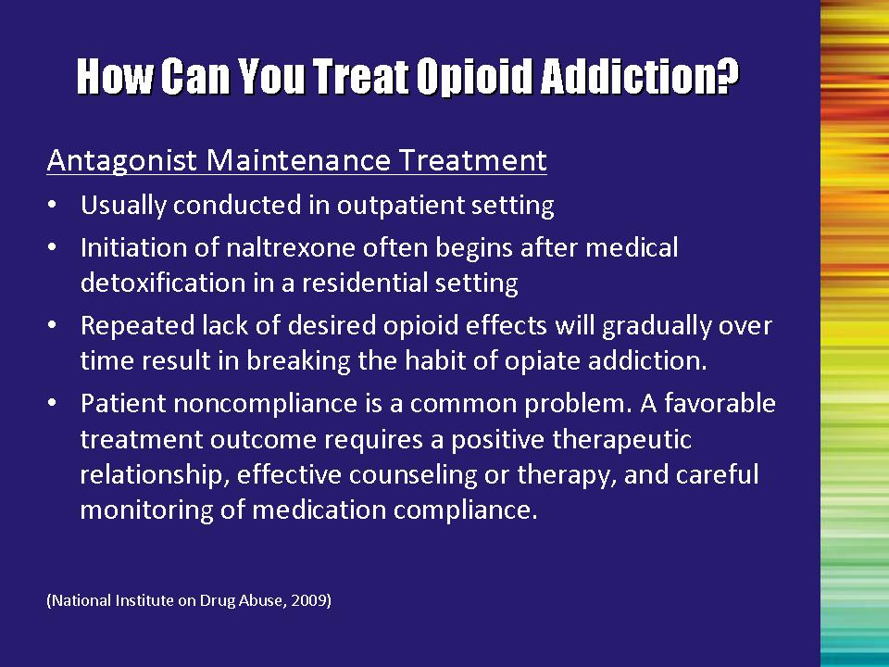 | Slide 43: How Can You Treat Opioid Addiction?  Antagonist Maintenance Treatment  Use of opioid antagonists can also be effective. As with agonist treatment, antagonist treatment is generally conducted through an outpatient setting.  The antagonist is prescribed after medical withdrawal from opioids is complete. If antagonists are administered before complete withdrawal, the person may experience immediate and intense withdrawal.  Antagonists block the effects of any illicit opioid. Over time, this helps the person to break the pattern and desire of use.  One problem with antagonist treatment is that patients stop taking them because they want to get the experience of taking an agonist.  Effective antagonist maintenance therefore requires:  - A positive therapeutic relationship with the treatment provider  - Ongoing counseling  - Monitoring of medication to determine level of compliance.  Reference:  National Institute on Drug Abuse. (2009). Principles of drug addiction treatment – A research-based guide (2nd edition). Washington, DC: National Institute on Drug Abuse, National Institutes of Health, US Department of Health and Human Services. | Slide 43
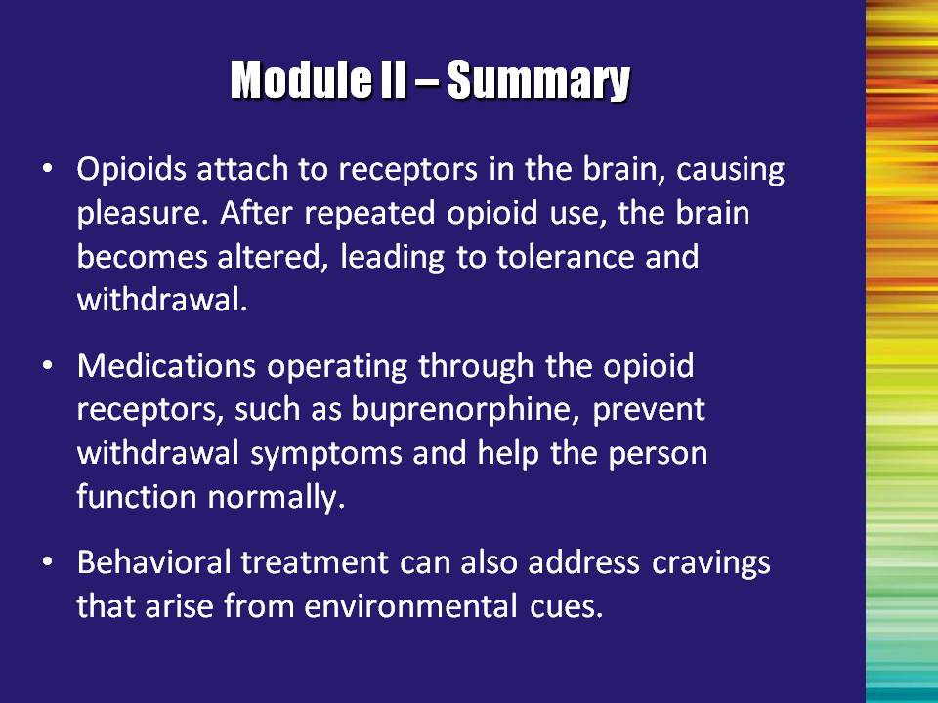 | Slide 44: Module II – Summary  Review and summarize bullet points.  - Bullet #1: Opioids attach to receptors in the brain, causing pleasure. After repeated opioid use, the brain becomes altered, leading to tolerance and withdrawal.  - Bullet #2: Medications operating through the opioid receptors, such as buprenorphine, prevent withdrawal symptoms and help the person function normally.  - Bullet #3: Behavioral treatment can also address cravings that arise from environmental cues. | Slide 44

Module III

Buprenorphine 101

Module III: Buprenorphine 101

This module is designed to provide an overview of the development and pharmacology of buprenorphine. It also provides, in summary form, information about treatment using the medication: induction, maintenance, and medically-assisted withdrawal. The primary focus of the treatment section is to provide an overview of the medical aspects of treatment and the role of non-medical practitioners at each of these phases of treatment. Specific information on counseling patients who are taking buprenorphine is provided in Module VI.

To avoid training participants perceiving the trainer(s) as “selling” buprenorphine, be sure to frame the availability of buprenorphine as an additional option (not just a replacement for/alternative to methadone). The availability of buprenorphine for the treatment of opioid addiction is allowing for an expansion of opioid treatment. The training is not, in any way, meant to advocate one treatment over another; instead, it is an addition to the repertoire of medications available for the treatment of opioid addiction.

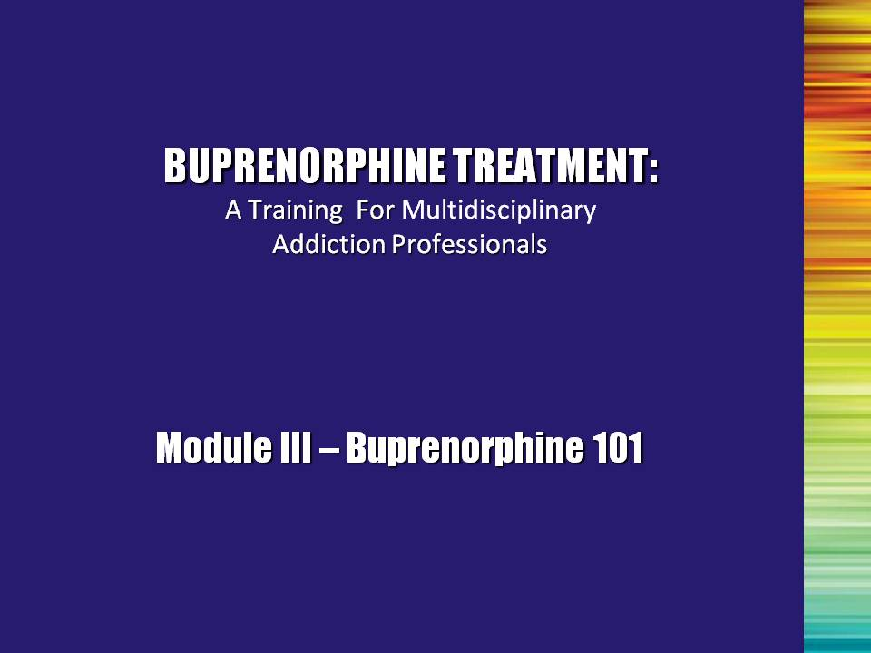 | Slide 1: Title Slide  Now it’s time to talk specifically about buprenorphine. What is this medication and how does it work? That is the question that we will answer in this module. | Slide 1
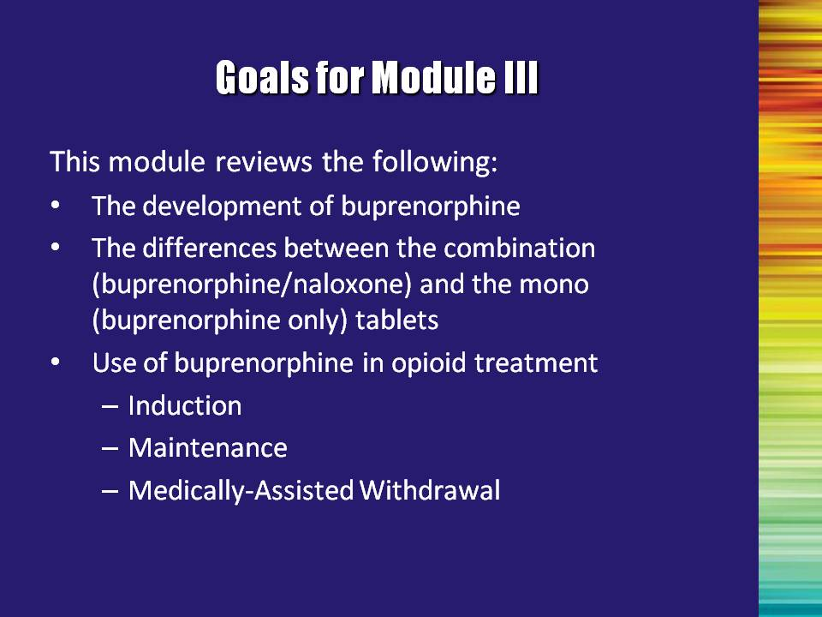 | Slide 2: Goals for Module III  Now that we have reviewed the basics of opioid addiction and treatment, we will now review:  - The development of buprenorphine  - Compare the differences between the combination (buprenorphine/naloxone) and the mono (buprenorphine only) tablets available for the treatment of opioid addiction  - Examine the use of buprenorphine in the various phases of opioid treatment (e.g., induction, maintenance, medically-assisted withdrawal). | Slide 2
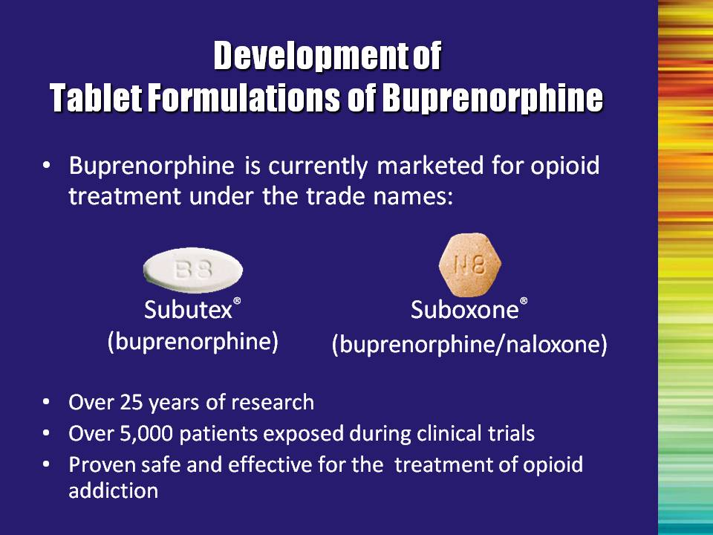 | Slide 3: Development of Tablet Formulations for Buprenorphine  Buprenorphine was developed by a pharmaceutical company called Reckitt Benckiser. They had exclusive marketing rights until Fall 2009, and distribute the medication as:  - Subutex® = a sublingual tablet containing buprenorphine hydrochloride only  - Suboxone® = a sublingual tablet containing both buprenorphine hydrochloride and naloxone hydrochloride in a 4:1 ratio  Reckitt Benckiser’s exclusive rights expired in the fall of 2009, so generic versions of the medication may become available in the future.  Buprenorphine/naloxone is the focus of U.S. marketing efforts, even though both formulations are available in the United States.  These medications have a tremendous amount of research behind them to show that they are both safe and effective in the treatment of opioid addiction. | Slide 3
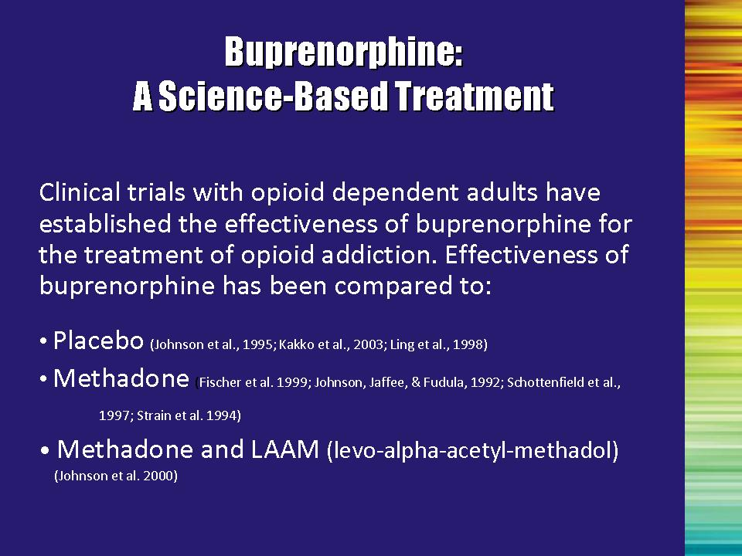 | Slide 4: Buprenorphine: A Science-Based Treatment  In the development of the medication, the effectiveness of buprenorphine has been compared to that of other currently available medications. These studies have shown that buprenorphine treatment:  - is more effective than placebo; and  - has similar effectiveness to moderate doses of  methadone and LAAM.  References:  Fischer, G., Gombas, W., Eder, H., Jagsch, R., Peternell, A., Stuhlinger, G., ... Kasper, S. (1999). Buprenorphine versus methadone maintenance for the treatment of opioid dependence. Addiction, 94(9), 1337-1347.  Johnson, R. E., Jaffe, J. H., & Fudala, P. J. (1992). A controlled trial of buprenorphine treatment for opioid dependence. Journal of the American Medical Association, 267, 2750–2755.  Johnson, R. E., Eissenberg, T., Stitzer, M. L., Strain, E. C., Liebson, I. A., & Bigelow, G. E. (1995) A placebo controlled clinical trial of buprenorphine as a treatment for opioid dependence. Drug and Alcohol Dependence, 40(1), 17-25.  Kakko, J., Svanborg, K., Kreek, M., & Heilig, M. (2003). 1-year retention and social function after buprenorphine-assisted relapse prevention treatment for heroin dependence in Sweden: A randomised, placebo-controlled trial. The Lancet, 361(9358), 662-668.  Ling, W., Charuvastra, C., Collins, J. F., Batki, S., Brown, L. S., Jr., Kintaudi, P., et al. (1998). Buprenorphine maintenance treatment of opiate dependence: A multicenter, randomized clinical trial. Addiction, 93, 475–486.  Schottenfeld, R. S., Pakes, J. R., Oliveto, A., Ziedonis, D., & Kosten T. R. (1997). Buprenorphine vs methadone maintenance treatment for concurrent opioid dependence and cocaine abuse. Archives of General Psychiatry, 54, 713–720.  Strain, E. C., Stitzer, M. L., Liebson, I. A., & Bigelow, G. E. (1994). Comparison of buprenorphine and methadone in the treatment of opioid dependence. American Journal of Psychiatry, 151, 1025–1030. | Slide 4
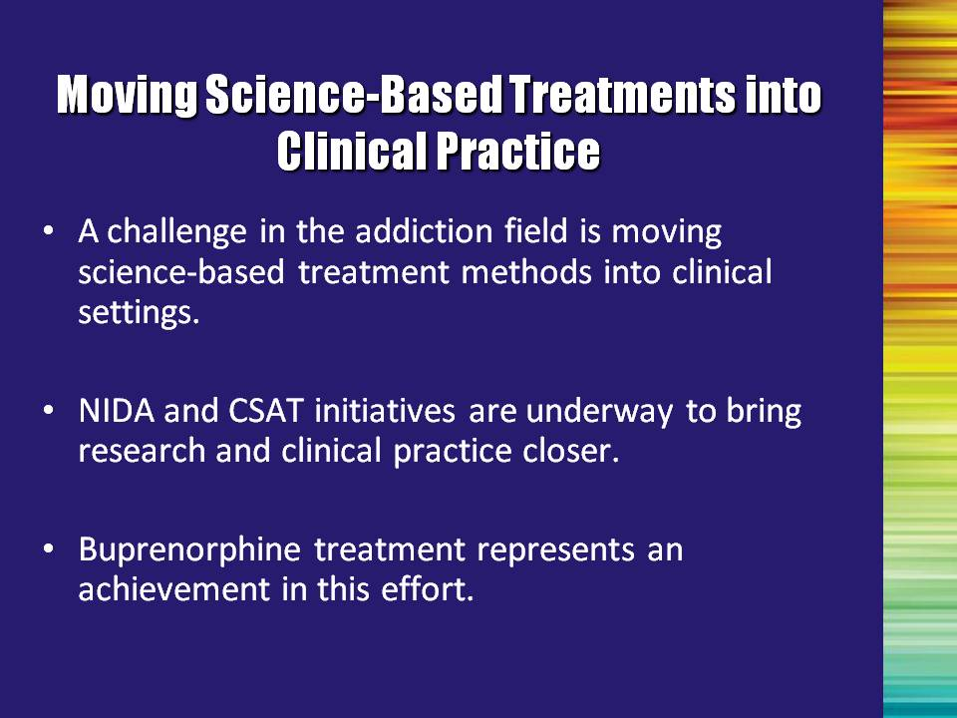 | Slide 5: Moving Science-Based Treatments into Clinical Practice  Many treatments that are developed never make it into real-world practice.  This has been a problem for quite some time and both the National Institute on Drug Abuse (NIDA) and the Substance Abuse Mental Health Services Administration (SAMHSA) has recognized this. The Blending Team that developed these materials resulted from one initiative designed to help move scientific findings into practical application: The NIDA/SAMHSA Blending Initiative.  Buprenorphine is an important treatment advancement and represents an exciting opportunity for individuals to develop strategies to work with both providers and researchers to find ways to make this treatment a readily-available option. | Slide 5
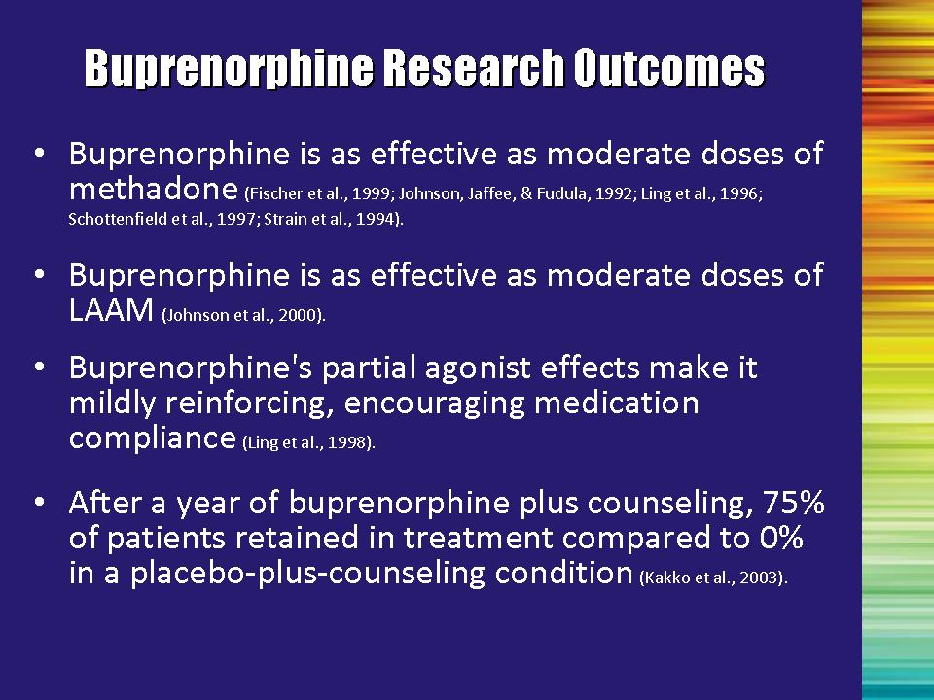 | Slide 6: Buprenorphine Research Outcomes  Clinical trials have established the effectiveness of buprenorphine for the treatment of opioid addiction. The clinical studies have shown the following about buprenorphine:  Bullet #1: Patients on buprenorphine did as well as patients on a moderate dose of methadone (e.g., 60mg).  However, it is unclear if buprenorphine can be as effective as higher doses of methadone (such as 80 mg per day to more than 100 mg per day).  Bullet #2: Patients on buprenorphine did as well as patients on a moderate dose of LAAM (70mg/70mg/85mg on a Monday/Wednesday/Friday schedule).  Note to the Trainer(s): LAAM is no longer being marketed in the US due to safety concerns. This information is provided as evidence of efficacy of buprenorphine.  Bullet #3: Patients found that taking buprenorphine was a pleasant experience, which encouraged them to be compliant.  Bullet #4: When compared to placebo-plus-counseling, 3/4 of the patients receiving buprenorphine and counseling were still in treatment after one year. None of the placebo patients were retained.  References: Bullet #1  Fischer, G., Gombas, W., Eder, H., Jagsch, R., Peternell, A., Stuhlinger, G., ... Kasper, S. (1999). Buprenorphine versus methadone maintenance for the treatment of opioid dependence. Addiction, 94(9), 1337-1347.  Johnson, R. E., Jaffe, J. H., & Fudala, P. J. (1992). A controlled trial of buprenorphine treatment for opioid dependence. Journal of the American Medical Association, 267, 2750–2755.  Schottenfeld, R. S., Pakes, J. R., Oliveto, A., Ziedonis, D., & Kosten T. R. (1997). Buprenorphine vs methadone maintenance treatment for concurrent opioid dependence and cocaine abuse. Archives of General Psychiatry, 54, 713–720.  Strain, E. C., Stitzer, M. L., Liebson, I. A., & Bigelow, G. E. (1994). Comparison of buprenorphine and methadone in the treatment of opioid dependence. American Journal of Psychiatry, 151, 1025–1030.  Reference: Bullet #2  Johnson, R. E., Chutuape, M. A., Strain, E. C., Walsh, S. L., Stitzer, M. L., & Bigelow, G. E. (2000). A comparison of levomethadyl acetate, buprenorphine, and methadone for opioid dependence. New England Journal of Medicine, 343(18), 1290-1297. | Slide 6
 | Slide 6: Buprenorphine Research Outcomes, continued  Reference: Bullet #3  Ling, W., Charuvastra, C., Collins, J. F., Batki, S., Brown, L. S., Jr., Kintaudi, P., … Segal, D. (1998). Buprenorphine maintenance treatment of opiate dependence: A multicenter, randomized clinical trial. Addiction, 93, 475–486.  Reference: Bullet #4  Kakko, J., Svanborg, K., Kreek, M., & Heilig, M. (2003). 1-year retention and social function after buprenorphine-assisted relapse prevention treatment for heroin dependence in Sweden: A randomised, placebo-controlled trial. The Lancet, 361(9358), 662-668. | Slide 6
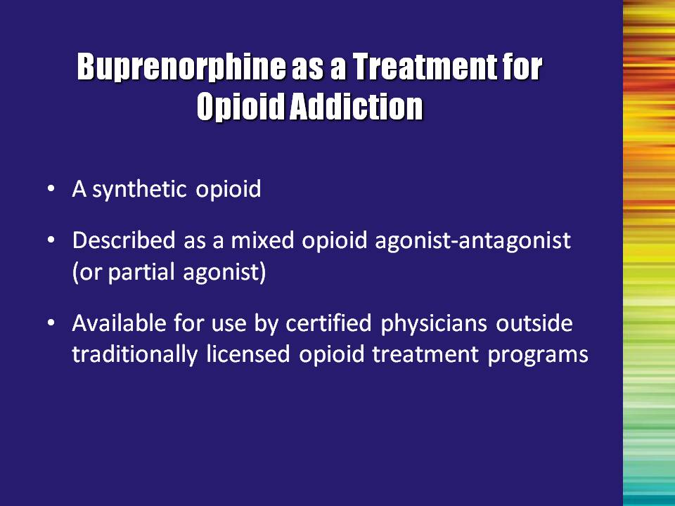 | Slide 7: Buprenorphine as a Treatment for Opioid Addiction  Buprenorphine is a partial agonist, resulting in a good safety profile for the medication.  With the changes in the treatment legislation, this medication becomes the first available outside of the opioid treatment program (OTP) system. This expands both the availability of and access to treatment. | Slide 7
 | Slide 8: The Role of Buprenorphine in Opioid Treatment  The partial agonist properties of the medication are important to understand.  The effects of the medication at lower doses are virtually the same as that of full agonists. However, as the dose is increased, the effects level out for buprenorphine (especially respiratory suppression), whereas they continue to increase with full agonist medications. This is called a “ceiling effect.” This ceiling effect greatly decreases the risk of overdose when compared to full agonists.  Buprenorphine has a very HIGH affinity for opioid receptors. It displaces morphine, methadone, and other full agonist opioids from the receptor. Additionally, buprenorphine dissociates slowly from the receptor.  This high affinity for and slow dissociation from the receptor result in buprenorphine blocking the effects of other opioids, such as heroin. Additionally, the high affinity and slow dissociation give rise to buprenorphine’s prolonged therapeutic effects.  Clinical trials have demonstrated that buprenorphine is a safe and effective medication for both opioid maintenance and medically-assisted withdrawal (detoxification). Additionally, because buprenorphine is very long-acting, dosing can occur on a less-than-daily basis, as infrequently as three times per week. | Slide 8
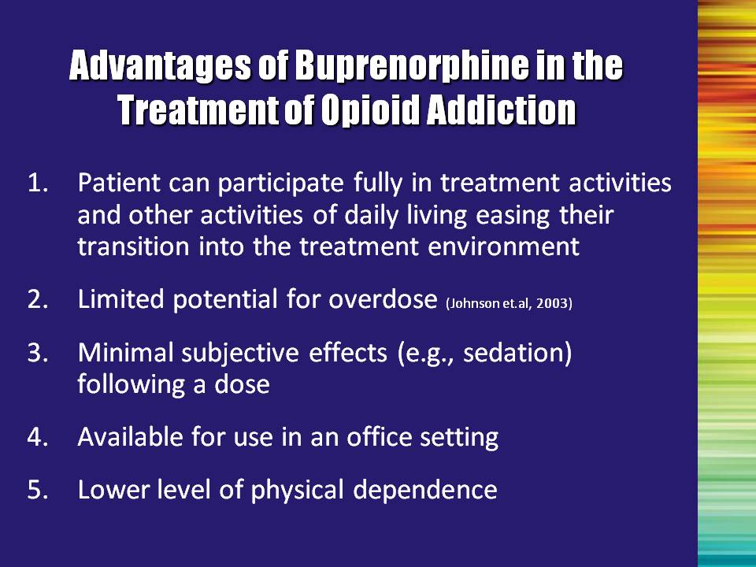 | Slide 9: Advantages of Buprenorphine in the Treatment of Opioid Addiction  When transitioned onto buprenorphine, patients can participate fully in treatment activities rather than being sick from withdrawal for several days. This means that treatment can begin as soon as they seek it (while motivation is high).  There are no known cases of overdose directly related to buprenorphine. To date, cases in which overdose has occurred involved use of alcohol or other respiratory depressants (e.g., benzodiazepines). Refer to Johnson, et al. 2003, for a more detailed discussion.  Patients report minimal sedation following a dose.  The treatment setting can be determined to fit the needs of the patient - outpatient treatment or office-based.  Reference:  Johnson, R. E., Strain, E. C., & Amass, L. (2003). Buprenorphine: How to use it right. Drug and Alcohol Dependence, 70, S59-S77. | Slide 9
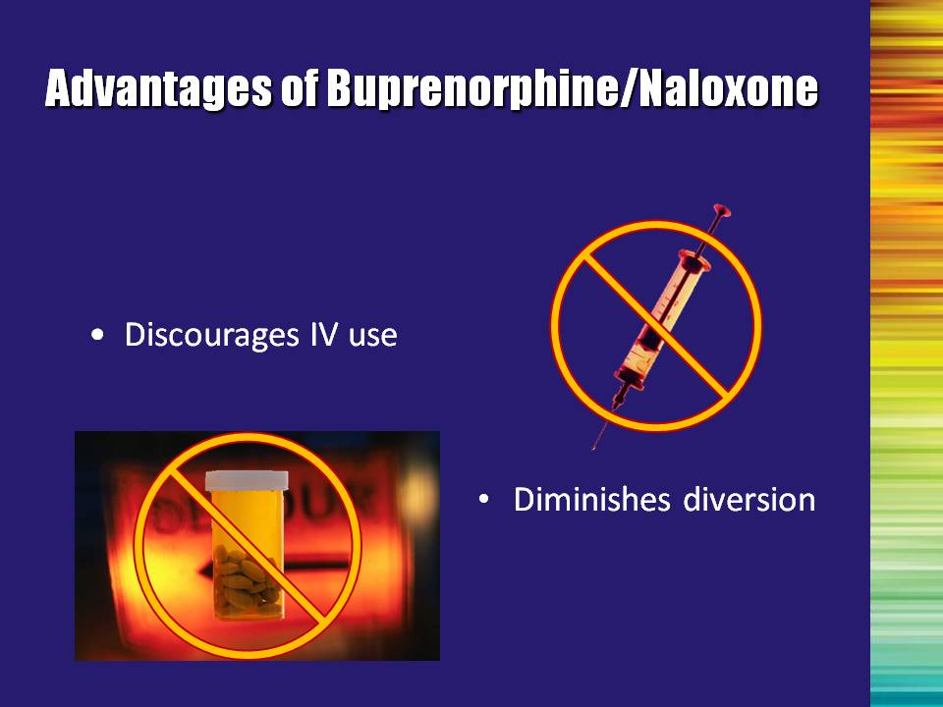 | Slide 10: Advantages of Buprenorphine/Naloxone  The buprenorphine/naloxone formulation has some advantages compared with the buprenorphine only formulation:  - It discourages injection of the product because, when injected, the naloxone will lead to withdrawal, whereas when taken sublingually as prescribed, it will not have that effect.  - Because of the above point, the combination tablet lowers the likelihood that the medication will be diverted.  - An additional advantage to the buprenorphine/naloxone formulation is it allows for take-home dosing. | Slide 10
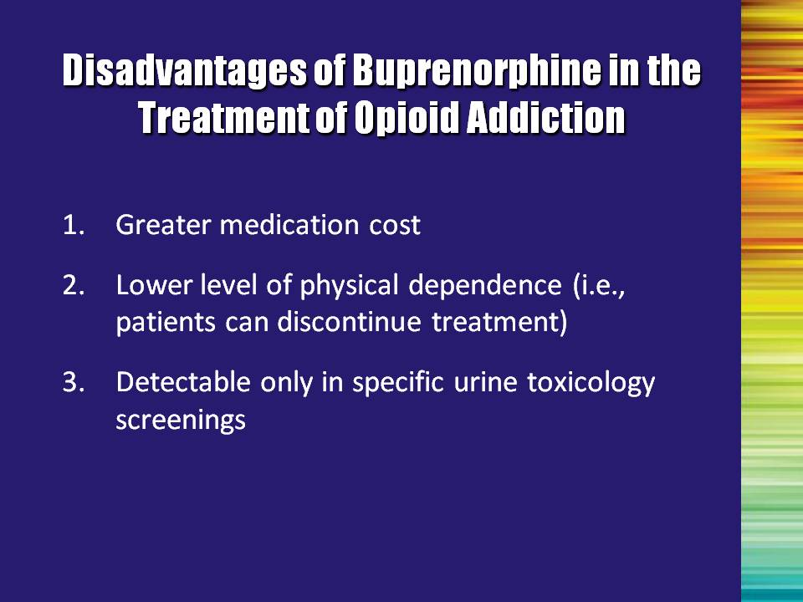 | Slide 11: Disadvantages of Buprenorphine in the Treatment of Opioid Addiction  There are definitely disadvantages to the medication, as well.  Buprenorphine is more costly than methadone. According to the manufacturer, Suboxone® (16 mg/day) costs $308 for a month’s supply, compared to less than $30 for a month’s supply of methadone at usual doses.  Overall, the medication causes a lower level of physical dependence. While this is generally seen as an advantage of the medication, it does make it easier for patients to discontinue treatment and return to use.  Buprenorphine is detectable in urine tests however many tests do not include buprenorphine in the panel of drugs screened. Special tests may need to be ordered to ensure that compliance with the medication can be monitored. | Slide 11
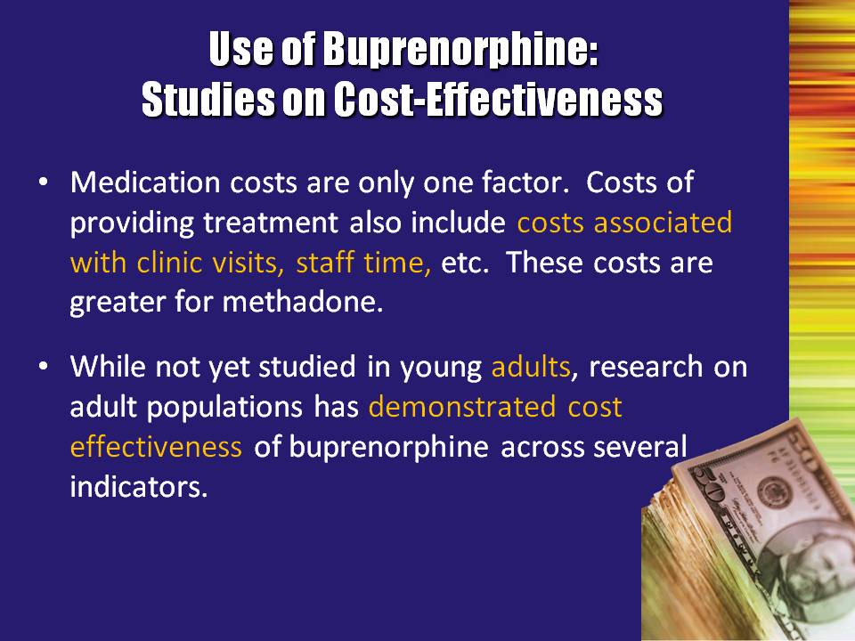 | Slide 12: Use of Buprenorphine: Studies on Cost-Effectiveness  There has been much discussion regarding the costs associated with the use of buprenorphine for the treatment of opioid dependence. When considering the costs of providing treatment, you must also include costs associated with clinic visits, staff time, and general operating and facility expenditures.  Recently, research conducted on adult populations has demonstrated the utilization of buprenorphine is cost-effective across several indicators. | Slide 12
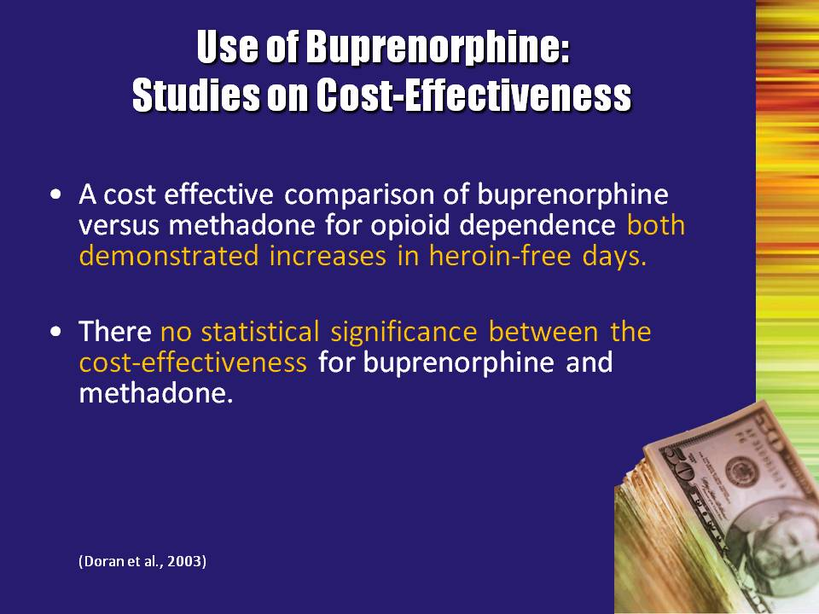 | Slide 13: Use of Buprenorphine: Studies on Cost-Effectiveness  Doran and colleagues (2003) conducted a clinical trial designed to assess the safety, efficacy and cost-effectiveness of buprenorphine versus methadone in the management of opioid dependence. The trial utilized a flexible dosing regime that was tailored to the clinical need of the patients, with high maximum doses, using the marketed tablet formulation, under double-blind conditions. A total of 405 subjects were randomized to a treatment at one of three specialist outpatient drug treatment centers in Adelaide and Sydney, Australia. The perspective of the cost-effectiveness analysis was that of the service provider and included costs relevant to the provision of treatment. The primary outcome measure used in the economic analysis was change in heroin-free days from baseline to the sixth month of treatment.  Key findings included:  - Both buprenorphine and methadone demonstrated increases in heroin-free days  - There was no statistical significance between the cost-effectiveness for buprenorphine and methadone.  Reference:  Doran, C. M., Shanahan, M., Mattick, R. P., Bell, J., White, J., & Ali, R. (2003). Buprenorphine versus methadone maintenance: A cost effectiveness analysis. Drug and Alcohol Dependence, 71(3), 295-302. | Slide 13
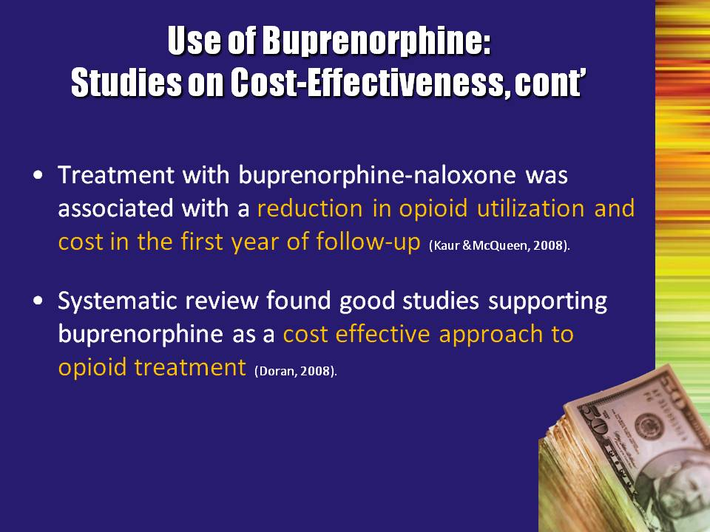 | Slide 14: Use of Buprenorphine: Studies on Cost-Effectiveness, cont’  Another study, conducted by Kaur and McQueen (2008), found that the treatment with buprenorphine/naloxone was associated with a reduction in opioid utilization and cost in the first year of follow-up.  Doran (2008) conducted a systematic review of the literature and found a number of studies supporting buprenorphine as a cost-effective approach to opioid treatment.  References:  Doran, C. M. (2008). Economic evaluation of interventions to treat opiate dependence: a review of the evidence. Pharmocoeconomics, 26(5), 371-393.  Kaur, A. D., McQueen, A. & Jan, S. (2008). Opioid drug utilization and cost outcomes associated with the use of buprenorphine-naloxone in patients with a history of prescription opioid use. Journal of Managed Care Pharmacy, 14(2), 186-194. | Slide 14
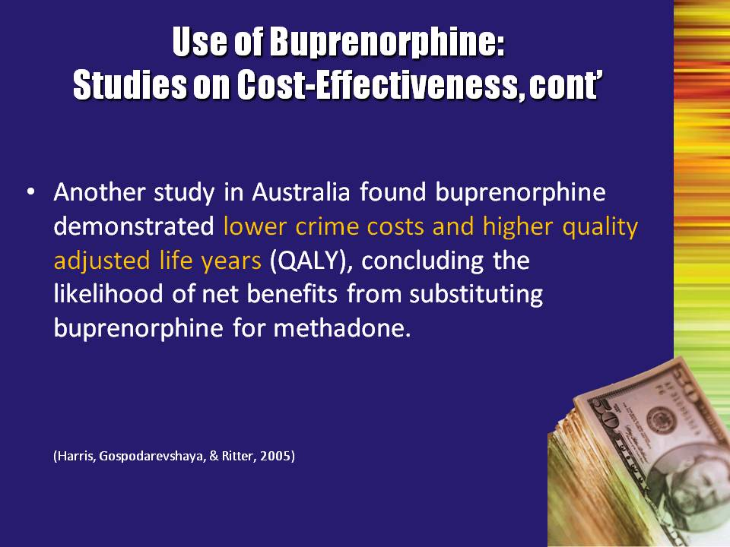 | Slide 15: Use of Buprenorphine: Studies on Cost-Effectiveness, cont’  Harris and colleagues (2005) were the first to examine the cost-effectiveness of buprenorphine as maintenance treatment for heroin dependence in a primary care setting. The study was a randomized, open-label, 12-month trial of 139 heroin-dependent patients in a community setting receiving individualized treatment regimens of buprenorphine or methadone. The study took a broad societal perspective and included health, crime and personal costs. The main outcomes were incremental cost per additional day free of heroin use and per the quality adjusted life years (QALY).  The researchers found that buprenorphine demonstrated lower crime costs and higher QALY.  Reference:  Harris, A. H., Gospodarevskaya, E., & Ritter, A. J. (2005). A randomised trial of the cost effectiveness of buprenorphine as an alternative to methadone maintenance treatment for heroin dependence in a primary care setting. Pharmocoeconomics, 23(1), 77-91. | Slide 15
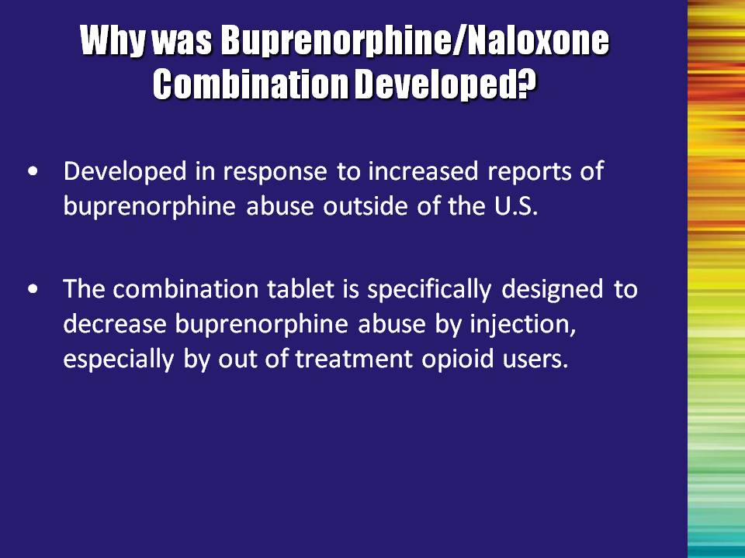 | Slide 16: Why was Buprenorphine/Naloxone Combination Developed?  In other countries where buprenorphine has been available, there were reports of increasing abuse of the medication. Therefore, the U.S. developers worked to find a way of preventing misuse of the medication as much as possible.  Since use of the buprenorphine/naloxone combination tablet by injection will cause withdrawal, the likelihood of misuse by out-of-treatment opioid users is greatly decreased. | Slide 16
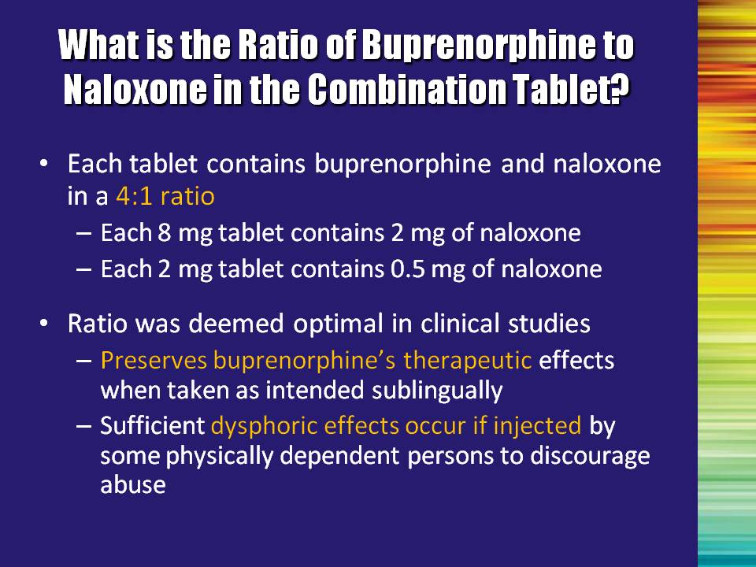 | Slide 17: What is the Ratio of Buprenorphine to Naloxone in the Combination Tablet?  The combination includes buprenorphine and naloxone in a ratio of 4:1.  This ratio was found to maintain the clinical effects when taken sublingually as intended, BUT cause sufficient discomfort if injected by a physically dependent patient (to discourage them from doing so). | Slide 17
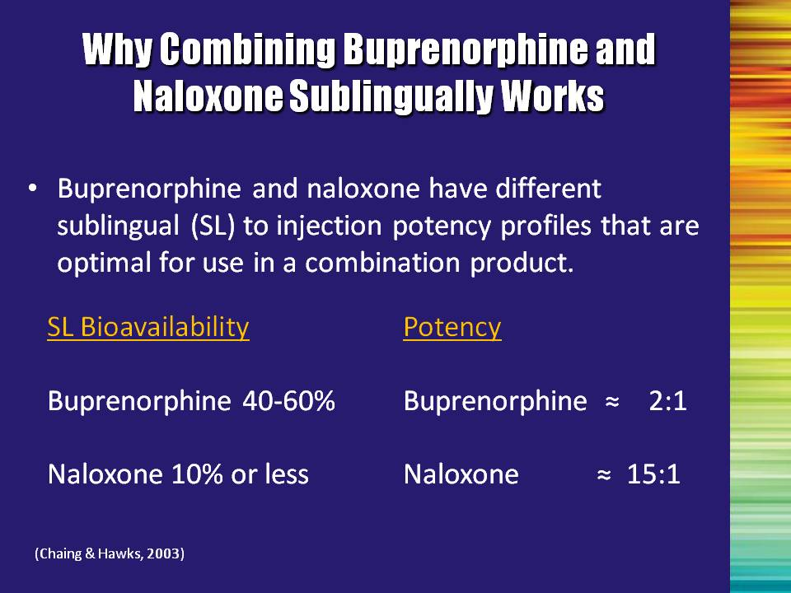 | Slide 18: Why Combining Buprenorphine and Naloxone Sublingually Works  Digestive juices would kill buprenorphine’s effects if you were to swallow it. By administering it sublingually, the medication dissolves under the tongue and is absorbed directly into the blood stream. Buprenorphine and naloxone have very different absorption rates when taken this way.  When taken under the tongue, the person receives approximately 40-60% of the buprenorphine available, but only 10% of the naloxone.  However, when you look at the relative potency comparing sublingual administration to injection, buprenorphine is approximately twice as strong when injected as when taken sublingually. Naloxone, on the other hand, is 15 times more effective by injection.  This means that when taken by injection, the naloxone is the stronger medication and the antagonist effects dominate.  Reference:  Chiang, C.N, & Hawks, R.L., (2003). Pharmacokinetics of the combination tablet of buprenorphine and naloxone. Drug and Alcohol Dependence, 70, S39-S47. | Slide 18
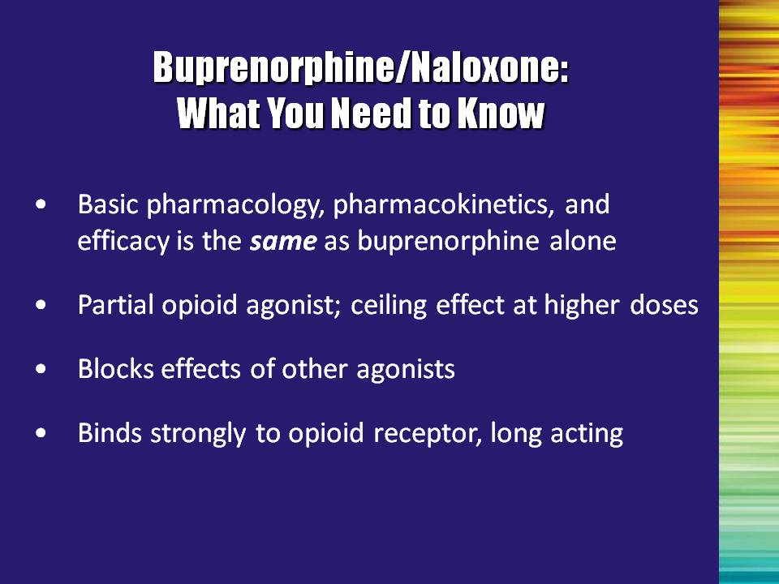 | Slide 19: Buprenorphine/Naloxone: What You Need to Know  - The effect of the combination tablet is virtually identical to the buprenorphine-only product when taken sublingually.  - Both formulations demonstrate the ceiling effect at higher doses.  - Both formulations prevent the intoxicating effects if someone decides to also use another opioid.  - They are long-acting because of the high receptor affinity; meaning they bind strongly to the receptor site.  Additional Information for the Trainer:  Safety  Because of its ceiling effect and poor bioavailability, buprenorphine is safer in overdose than opioid full agonists. The maximal effects of buprenorphine appear to occur in the 16 to 32 mg dose range for sublingual tablets. Higher doses are unlikely to produce greater effects.  Note to the Trainer(s): At 16 mg, 96% of the receptor sites are full; at 24 mg, approximately 99% of the receptor sites are full.  Respiratory depression from buprenorphine (or buprenorphine/ naloxone) overdose is less likely than from other opioids. There is no evidence of organ damage with chronic use of buprenorphine, but increases in liver enzymes are sometimes seen. There is no evidence of significant disruption of cognitive or psychomotor performance with buprenorphine maintenance dosing.  Side Effects  Side effects of buprenorphine are similar to those of other opioids and include nausea, vomiting, and constipation. Buprenorphine and buprenorphine/naloxone can precipitate the opioid withdrawal syndrome. Additionally, the withdrawal syndrome can be precipitated in individuals maintained on buprenorphine. | Slide 19
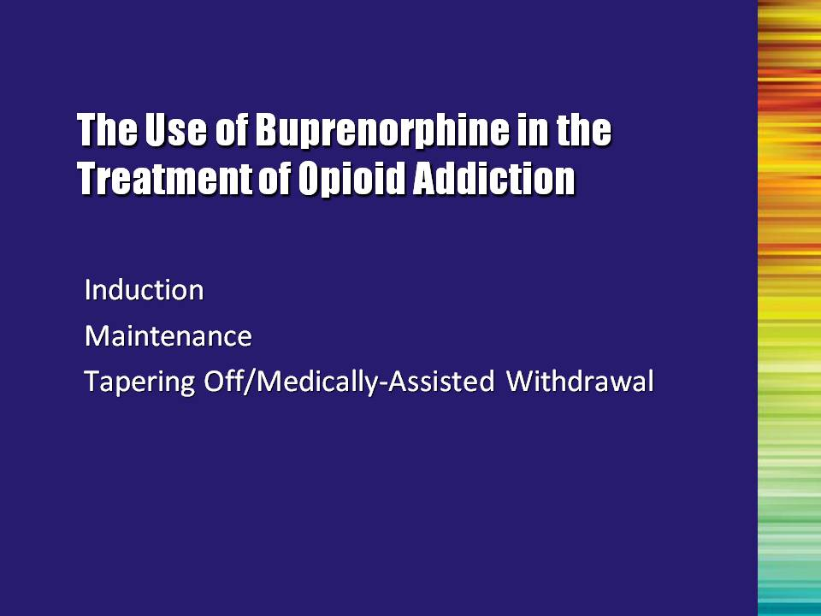 | Slide 20: The Use of Buprenorphine in the Treatment of Opioid Addiction (Induction, Maintenance, Tapering Off/Medically-assisted Withdrawal) (Transition Slide)  Now let’s look at how people are transitioned onto buprenorphine and then examine the two primary treatment options: maintenance and medically-assisted withdrawal. | Slide 20
 | Slide 21: Induction  The term induction refers to the procedures used to transition someone from other opioids onto buprenorphine. | Slide 21
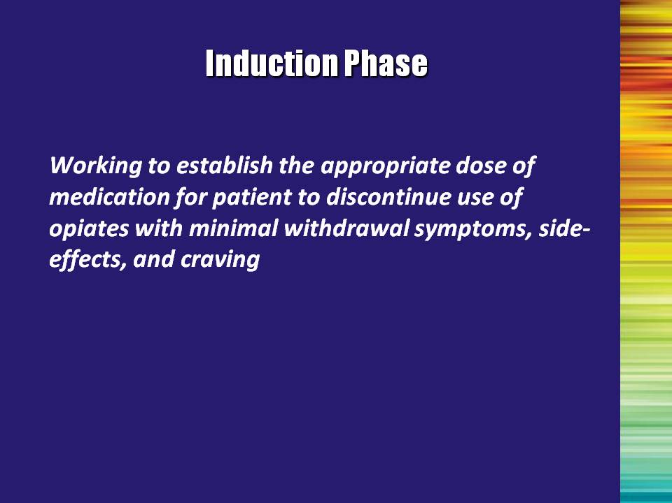 | Slide 22: Induction Phase  During induction, the physician works with the patient to figure out the most effective dose so that he/she can stop other opioid use with minimal withdrawal symptoms.  While the physician primarily guides this process, the multidisciplinary team is critical in providing supportive care and counseling to help the patient through the process. | Slide 22
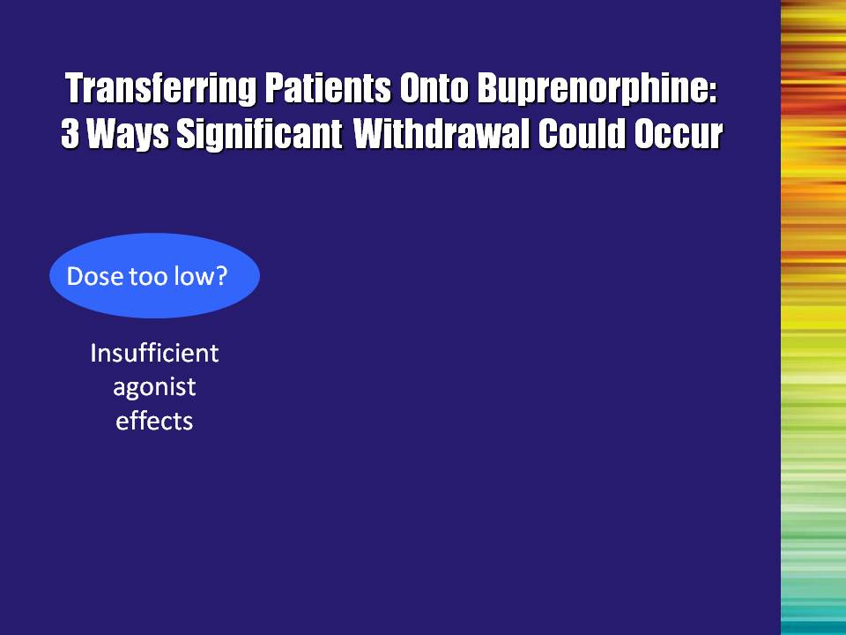 | Slide 23: Transferring Patients Onto Buprenorphine: 3 Ways Significant Withdrawal Could Occur  There are three ways that a patient can experience withdrawal symptoms.  First, if an insufficient dose of buprenorphine is given, the person may experience withdrawal from being undermedicated. | Slide 23
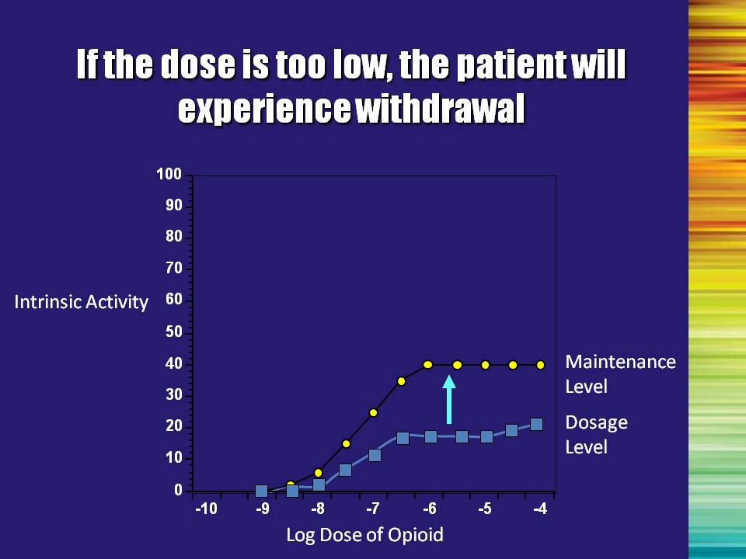 | Slide 24: If the dose is too low, the patient will experience withdrawal  This graph represents how under-medication can result in withdrawal symptoms. If the patient is given a low level of medication (represented by the green line), but needs a higher level in order to not feel sick (represented by the white line), the person will feel sick unless the dosage is increased to bring them up to this level. | Slide 24
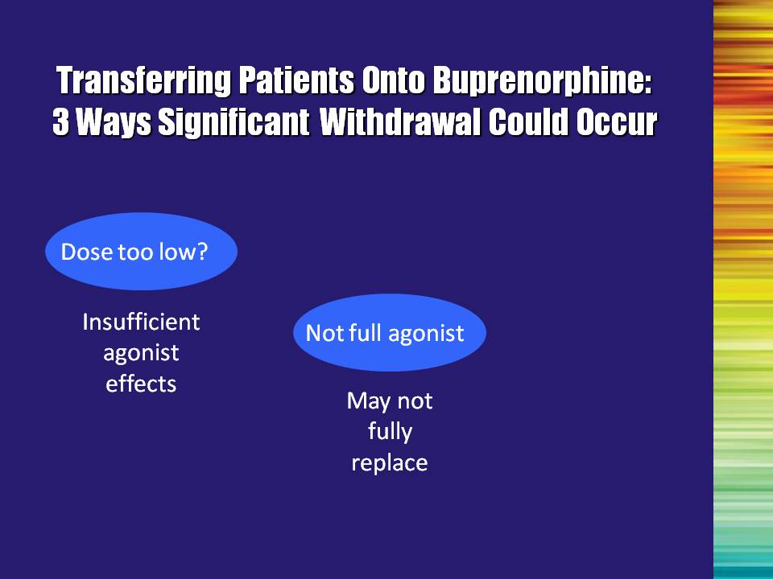 | Slide 25: Transferring Patients Onto Buprenorphine: 3 Ways Significant Withdrawal Could Occur  A second way that a person can experience withdrawal has to do with the properties of buprenorphine itself—the ceiling effect. | Slide 25
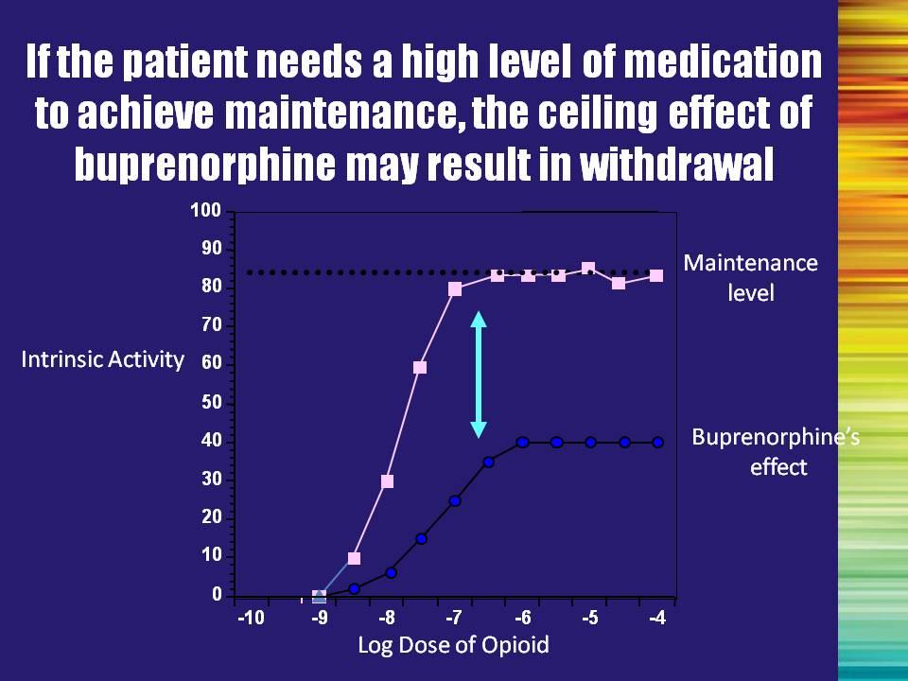 | Slide 26: If the patient needs a high level of medication to achieve maintenance, the ceiling effect of buprenorphine may result in withdrawal  As described before, as the dose of buprenorphine increases, the agonist effects level off. For someone who is dependent on very high doses of opioids, they may need an effect greater than can be achieved with buprenorphine in order to not feel sick.  In this case, treatment would need to be provided using a full agonist (e.g. methadone) or the person would need to taper down their level of drug use to a lower level before switching to buprenorphine. This can be done in a structured OTP, but should not be attempted with someone using illicit opioids. | Slide 26
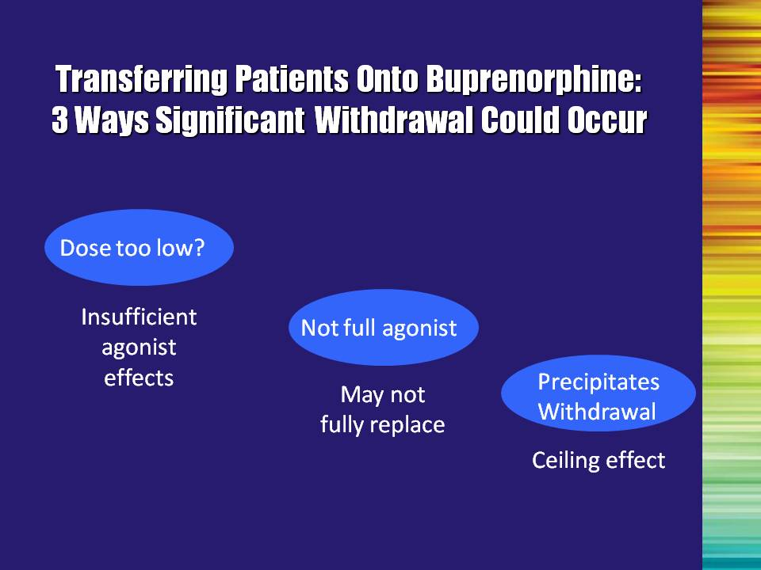 | Slide 27: Transferring Patients Onto Buprenorphine: 3 Ways Significant Withdrawal Could Occur  Finally, there is precipitated withdrawal. This also has to do with the ceiling effect and receptor affinity. | Slide 27
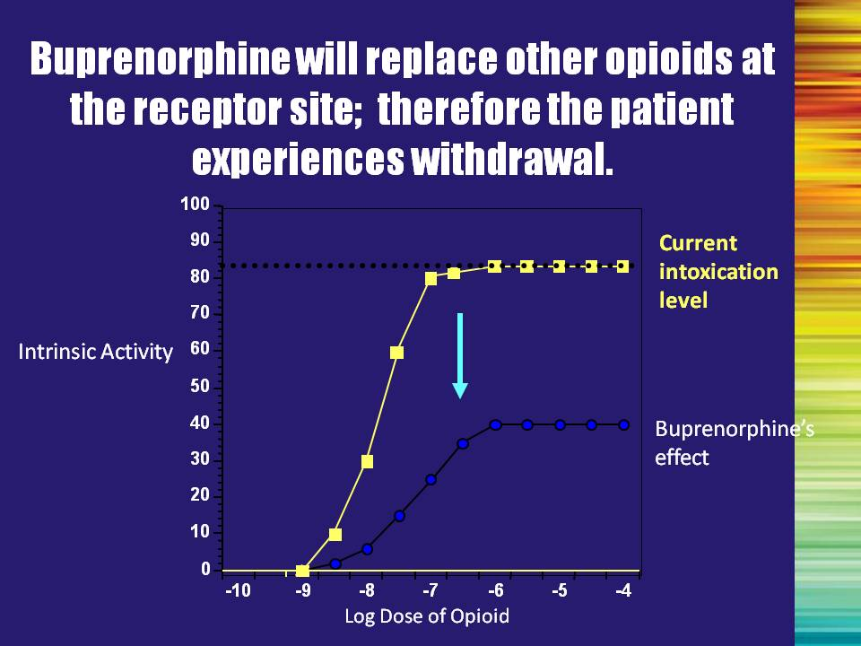 | Slide 28: Buprenorphine will replace other opioids at the receptor site; therefore the patient experiences withdrawal  If the person is currently intoxicated on an opioid, the opioid receptors are filled with this drug. Buprenorphine, however, has a stronger affinity for the receptors than illicit opioids and will replace these opioids on the receptor. Due to the ceiling effect, the experience of the patient will be that the level of opioids in the system has suddenly decreased. This will be experienced as withdrawal.  In order to avoid this, buprenorphine should only be administered once the person is in mild withdrawal. This will result in a reduction of the withdrawal symptoms and the experience of feeling better/normal. | Slide 28
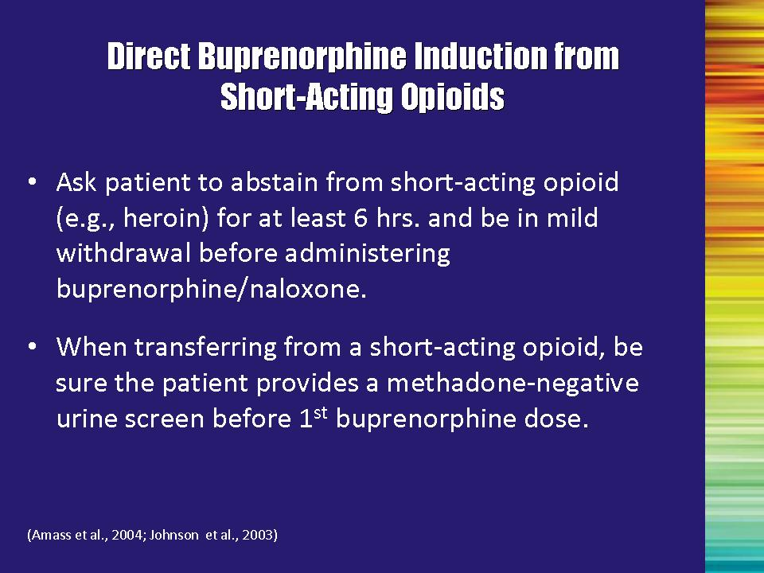 | Slide 29: Direct Buprenorphine Induction from Short-Acting Opioids  Patients who are using either short- or long-acting opioids can be inducted onto buprenorphine/naloxone. The PHYSICIAN is responsible for this aspect of the patient’s care.  The multidisciplinary addiction professional should be available, however, during the induction process to provide supportive counseling.  In order to be inducted onto buprenorphine, the patient must be in mild withdrawal. This ensures that they have a smooth transition onto the medication and will not have unexpected withdrawal symptoms.  Mild withdrawal can be evaluated based on clinical signs. Using a structured instrument such as the Clinical Opioid Withdrawal Scale (COWS), developed by Wesson and Ling (2003), can provide a way of rating these clinical signs to determine opioid withdrawal.  Clinical Opiate Withdrawal Scale (COWS): This is an 11-item interviewer-administered questionnaire designed to provide a description of signs of opioid withdrawal that can be observed directly in the patient (e.g., sweating, runny nose, etc.). Provides for accurate objectification of symptoms, allowing for appropriate prescribing of medication. | Slide 29
 | Slide 29: Direct Buprenorphine Induction from Short-Acting Opioids, Continued  As previously discussed, if a patient transitions immediately from heroin to buprenorphine, buprenorphine will replace the heroin at the receptor and the patient will have the experience of suddenly having much less opioids in their system than they are used to – they will go into withdrawal. However, if they are already in mild withdrawal, the buprenorphine will have the expected agonist effects and the patient will experience a comfortable transition.  The patient should also be monitored for methadone use, as this can complicate the transition as well.  Reference:  Amass, L., Ling, W., Freese, T. E., Reiber, C., Annon J. J., Cohen, A. J., … Horton, T. (2004). Bringing buprenorphine-naloxone detoxification to community treatment providers: The NIDA Clinical Trials Network field experience. American Journal on Addictions, 13(Suppl1), S42-S66.  Johnson, R. E., Strain, E. C., & Amass, L. (2003). Buprenorphine: How to use it right. Drug and Alcohol Dependence, 70, S59-S77.  Wesson, D. R., & Ling, W. (2003). The Clinical Opiate Withdrawal Scale (COWS). Journal of Psychoactive Drugs, 35, 253-259. | Slide 29
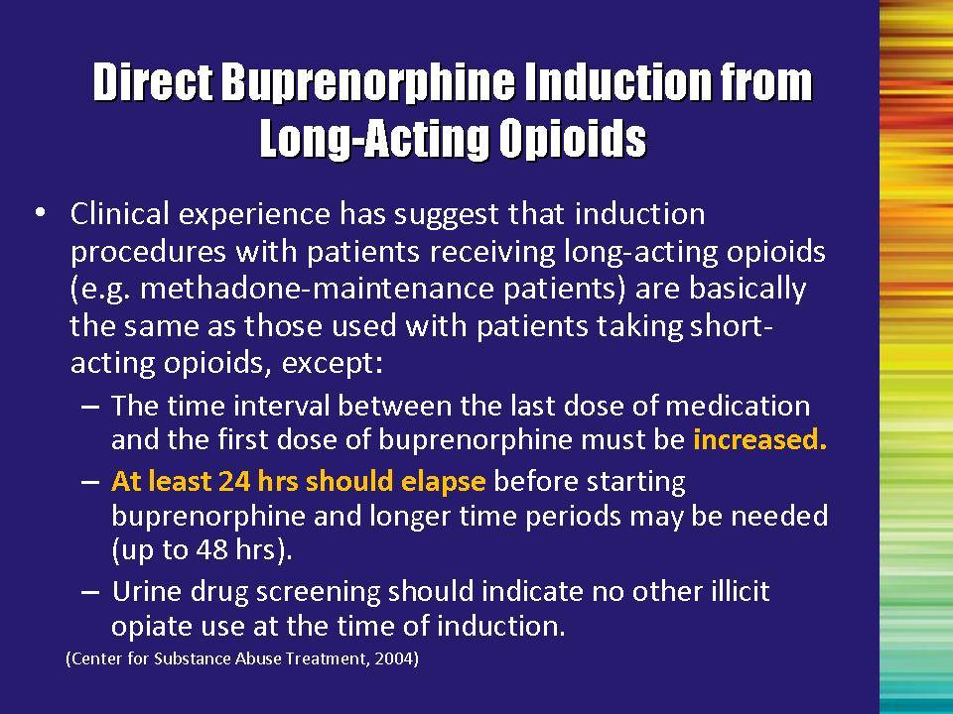 | Slide 30: Direct Buprenorphine Induction from Long-Acting Opioids  Clinical experience has indicated that patients being transitioned from long-acting opioids (e.g., methadone) can be successfully inducted using similar procedures as those used for short-acting opioids  According to SAMHSA’s Clinical Guidelines for the Use of Buprenorphine in the Treatment of Opioid Addiction (TIP 40), patients should be tapered to a lower dose of their current medication (e.g., 30 mg or less of methadone). The patient should not begin receiving buprenorphine until at least 24 hours after their last dose and then can begin on buprenorphine. These patients should begin on a very low dose of buprenorphine (e.g., 2 mg) and then gradually receive more if needed.  Reference:  Center for Substance Abuse Treatment. (2004). Clinical Guidelines for the Use of Buprenorphine in the Treatment of Opioid Addiction. Treatment Improvement Protocol (TIP) Series 40. DHHS Publication No. (SMA) 04-3939. Rockville, MD: Substance Abuse and Mental Health Services Administration. | Slide 30
 | Slide 31: Stabilization and Maintenance (Transition Slide)  Once the patient is on the medication, the next step is to make sure he/she is stabilized. | Slide 31
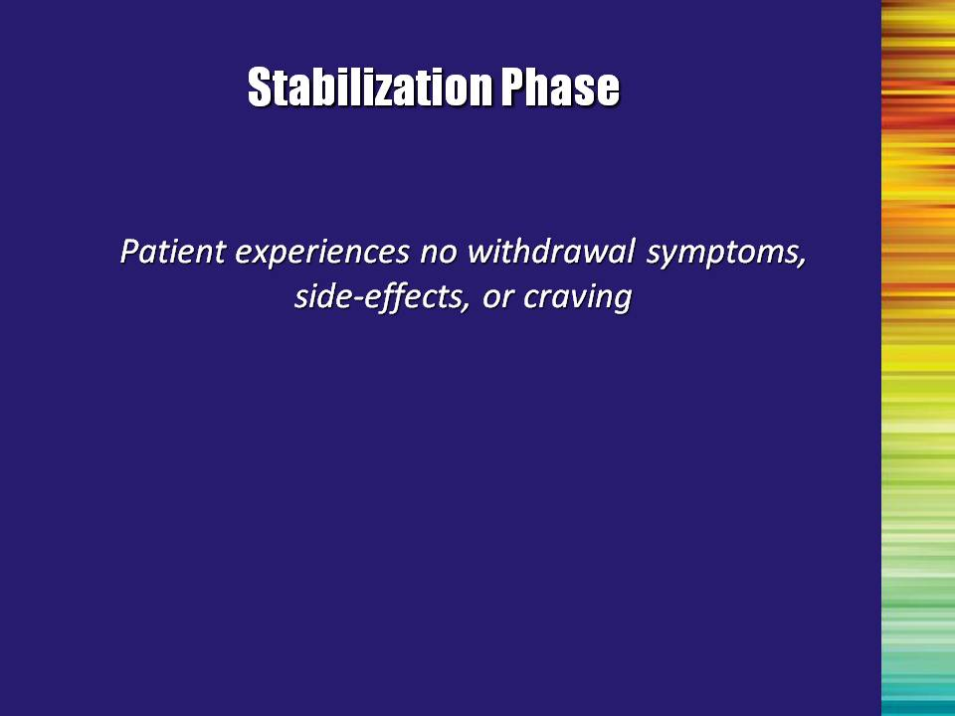 | Slide 32: Stabilization Phase  By stabilization, we mean that they do not experience any negative symptoms or craving.  At this point, the decision can be made to either move on to the maintenance phase or to withdraw with medically-assisted withdrawal. | Slide 32
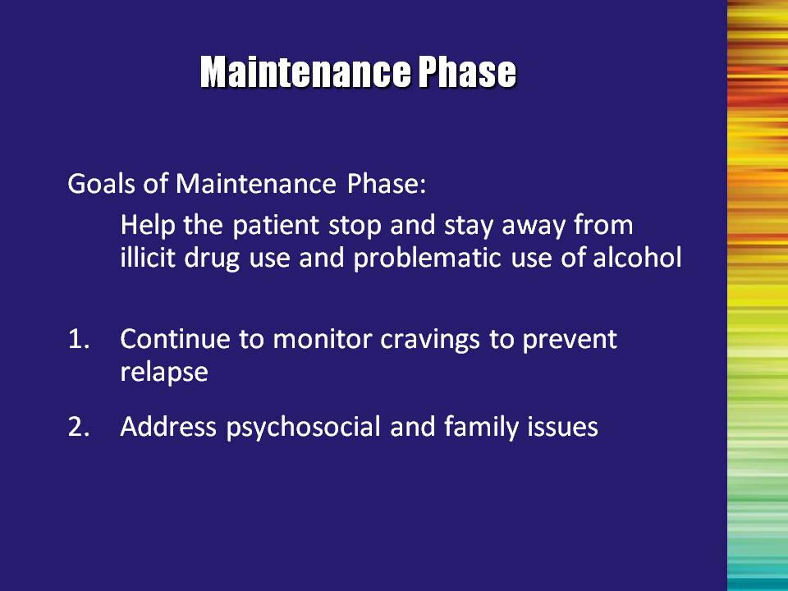 | Slide 33: Maintenance Phase  The goal of maintenance is cessation of illicit drug use and problematic alcohol use.  The treatment professional should address any underlying issues, such as psychiatric co-morbidity and psychosocial issues (employment, legal, family/social, etc.). | Slide 33
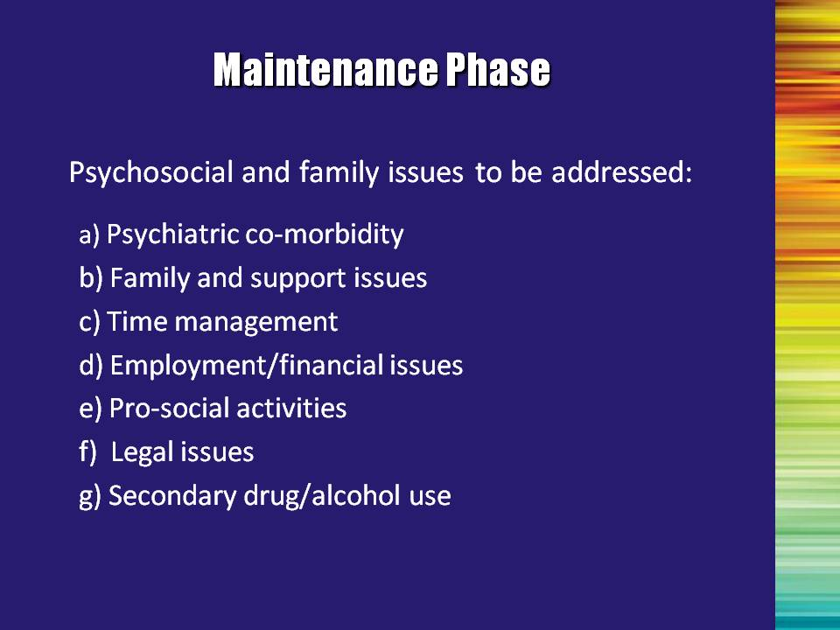 | Slide 34: Maintenance Phase  During maintenance treatment, providers should assess the patient and provide treatment for other issues that the patient is facing, to help get him/her stabilized and live a more fulfilled life.  Read/summarize the bullet points.  Maintenance treatment may be fairly short (e.g., <12 months) or a lifetime process. Research and clinical consensus (CSAT, 2004) suggest that the longer a patient is maintained on medication treatment (methadone or buprenorphine), the higher the likelihood that they will experience less illicit drug use and the fewer complications.  Reference:  Center for Substance Abuse Treatment. (2004). Clinical Guidelines for the Use of Buprenorphine in the Treatment of Opioid Addiction. Treatment Improvement Protocol (TIP) Series 40. DHHS Publication No. (SMA) 04-3939. Rockville, MD: Substance Abuse and Mental Health Services Administration. | Slide 34
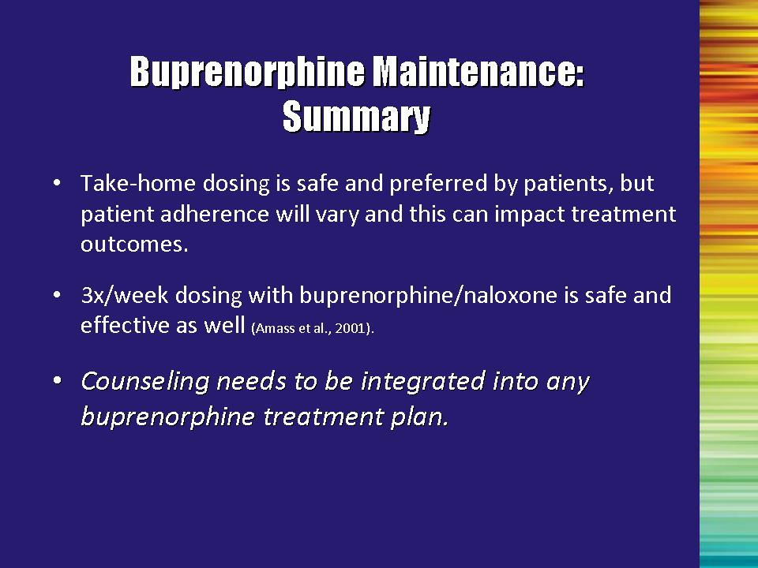 | Slide 35: Buprenorphine Maintenance: Summary  Use of take-home dosing is desired by many patients, but ongoing monitoring is critical to determine compliance.  In adults, dosing every day is not necessary. Researchers have demonstrated that a three-time-per-week dosing schedule was safe and effective. Information about less than daily dosing is not available for adolescents.  In order to be effective, it is imperative that counseling be incorporated into the treatment plan and supported by the entire multidisciplinary team.  Reference:  Amass, L., Kamien, J. B., & Mukulich, S. K. (2001). Thrice weekly supervised dosing with the combination buprenorphine-naloxone tablet is preferred to daily supervised dosing by opioid-dependent humans. Drug and Alcohol Dependence, 61(1), 173-181. | Slide 35
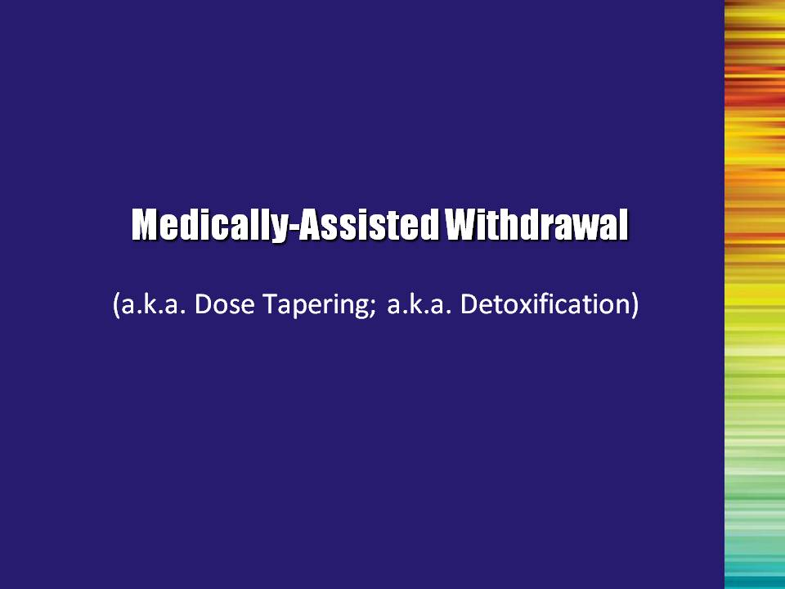 | Slide 36: Medically-assisted Withdrawal (a.k.a. Dose Tapering; a.k.a. Detoxification) (Transition Slide)  Not all patients are appropriate for withdrawal from the medications. Unstable living situations, multiple relapses, previous failed detoxification attempts, or lack of desire to withdraw from opioids, may indicate that maintenance is a better treatment option.  Note to the Trainer(s): The following is a very brief summary of medically-assisted withdrawal. For a more in-depth training, insert the Optional Module entitled, Short Term Opioid Withdrawal Using Buprenorphine | Slide 36
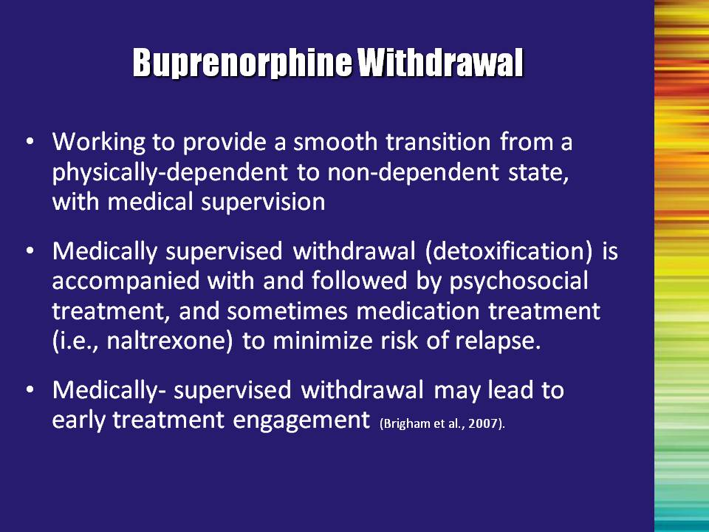 | Slide 37: Buprenorphine Withdrawal  However, if appropriate, the goal of medically-assisted withdrawal is to help patients transition off of opioids so that they are no longer physically dependent.  Psychosocial treatment is a critical component of this (and all treatments) to help them avoid relapse and facilitate early engagement in treatment.  Reference:  Brigham, G. S., Amass, L., Winhusen, T., Harrer, J. M., & Pelt. A. (2007). Using buprenorphine short-term taper to facilitate early engagement. Journal of Substance Abuse Treatment, 32, 349-356. | Slide 37
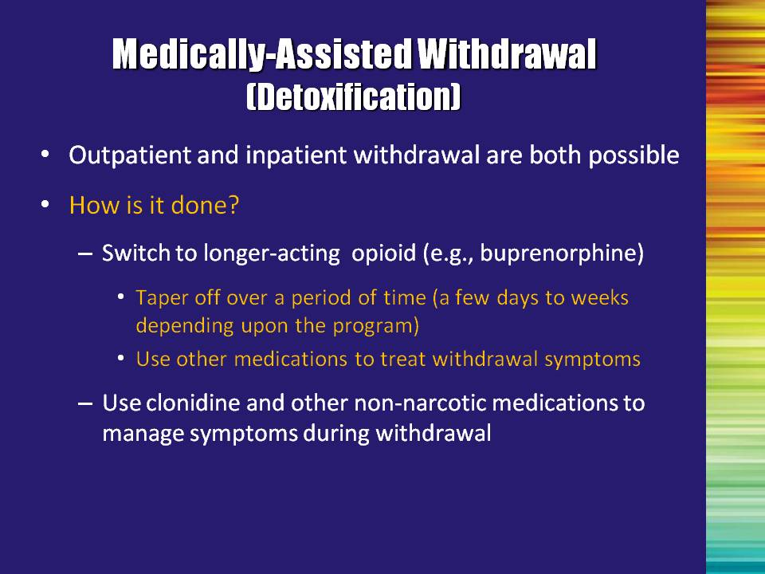 | Slide 38: Medically-Assisted Withdrawal (Detoxification)  Medically-assisted withdrawal can be successful in either inpatient or outpatient settings. It is important for the multidisciplinary team to provide supportive wrap-around services to get the patient through this difficult stage.  This is done by transitioning the patient onto a long-acting opioid like buprenorphine and then tapering him/her off over a period of time.  Other medications may be helpful if withdrawal symptoms are present to help the patient to stay comfortable. | Slide 38
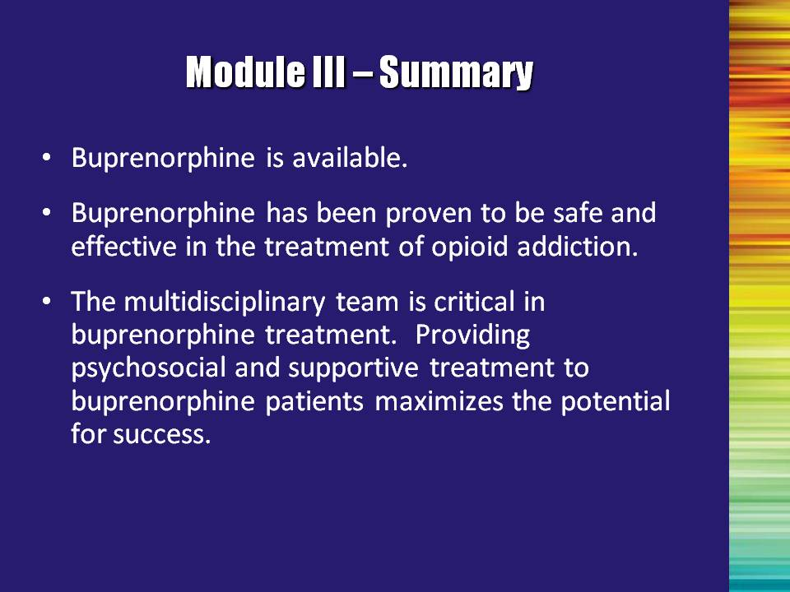 | Slide 39: Module III – Summary  Read/summarize the bullet points.  - Buprenorphine is available.  - Buprenorphine has been proven to be safe and effective in the treatment of opioid addiction.  - The multidisciplinary team is critical in buprenorphine treatment. Providing psychosocial and supportive treatment to buprenorphine patients maximizes the potential for success. | Slide 39

Module IV

Identification of Patients
for Buprenorphine Treatment
Module IV: Identification of Patients for Buprenorphine Treatment

Overall Notes: Be sure to keep people on task – this is the one module where attendees may feel compelled to go beyond the scope of their training/experience, or may start to ask a lot of questions related to the medical aspects of buprenorphine treatment. Remind them of the objectives of this course and proceed with the content of Module IV.

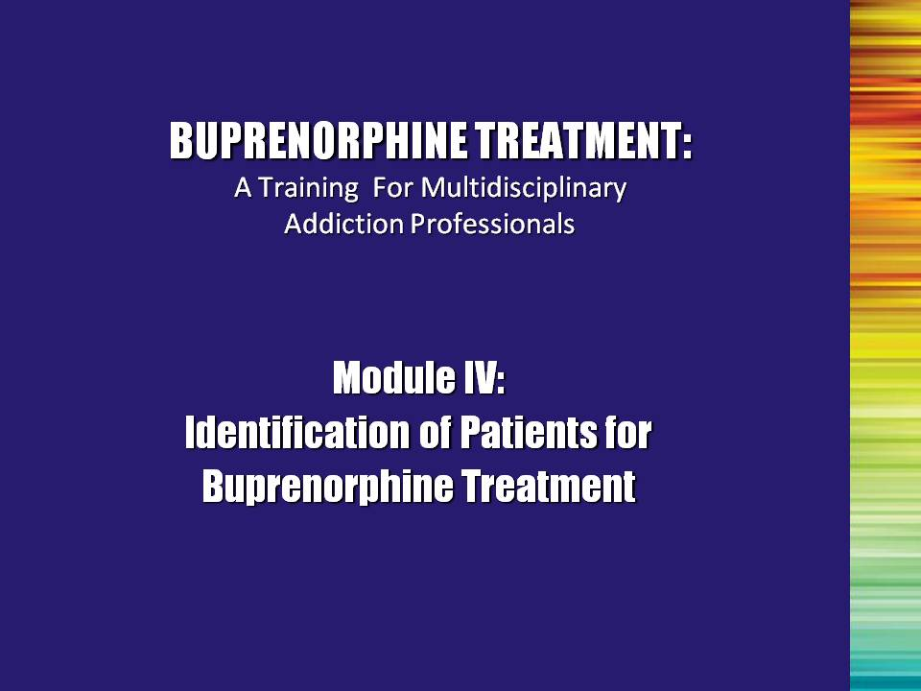 | Slide 1: Title Slide  Conducting assessments of patients for their suitability for this medication and for the most suitable location for treatment (office-based vs. opioid treatment program, or OTP-based) is a critical process. Multidisciplinary addiction professionals should have a good understanding of the essential components of this process. This module will explore the issue of selecting appropriate patients for buprenorphine treatment.  Although the physician will most likely be the individual to determine suitability for buprenorphine treatment, multidisciplinary addiction professionals should be knowledgeable about patient selection and suitability issues for the following reasons:  - The patient’s appropriateness for treatment may change during the course of buprenorphine treatment;  - Potential patients or other treatment providers may ask the counselor about appropriateness for treatment; and  - Useful and informed communication with the physician is enhanced by a complete knowledge of the entire treatment process. | Slide 1
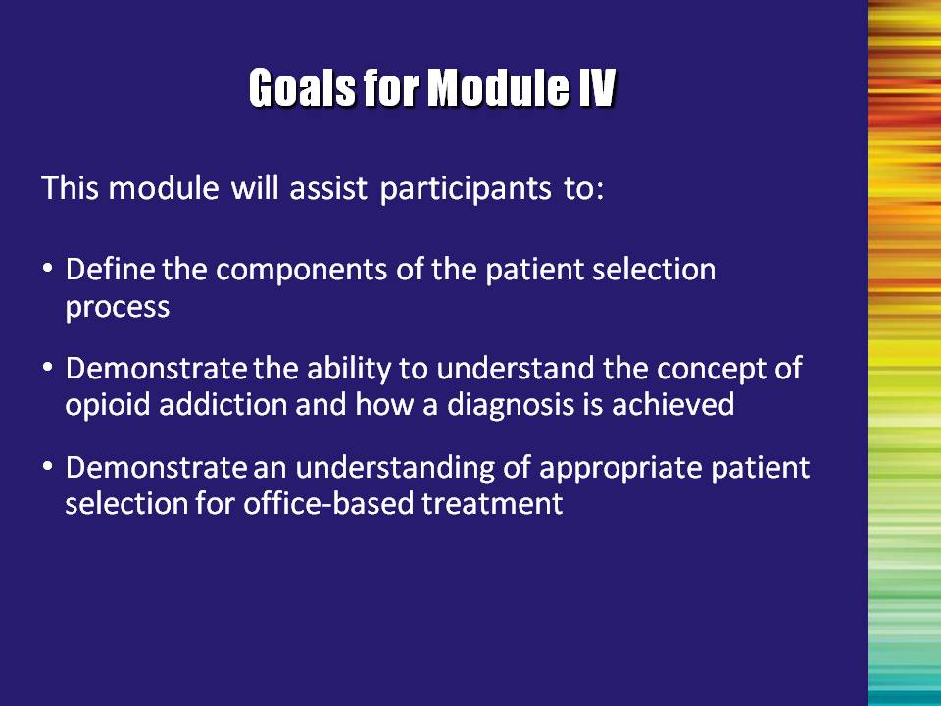 | Slide 2: Goals for Module IV  This module will assist participants to:  - Define the components of the patient selection process.  - Demonstrate the ability to understand the concept of opioid addiction and how a diagnosis is achieved.  - Demonstrate an understanding of appropriate patient selection for office-based treatment. | Slide 2
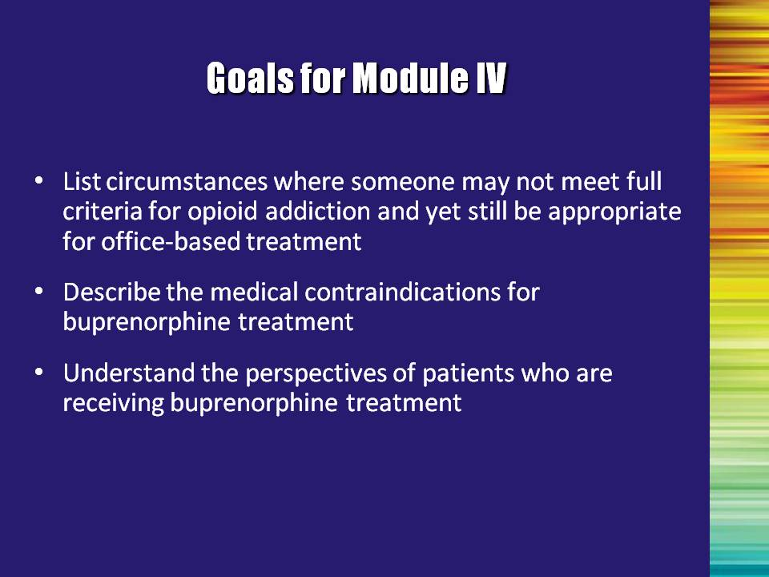 | Slide 3: Goals for Module IV  - List circumstances where someone may not meet full criteria for opioid addiction and yet still be appropriate for office-based treatment.  - Describe the medical contraindications for buprenorphine treatment.  - Discuss the case studies presented in the CD-ROM entitled, “Put Your Smack Down! A Video About Buprenorphine.” | Slide 3
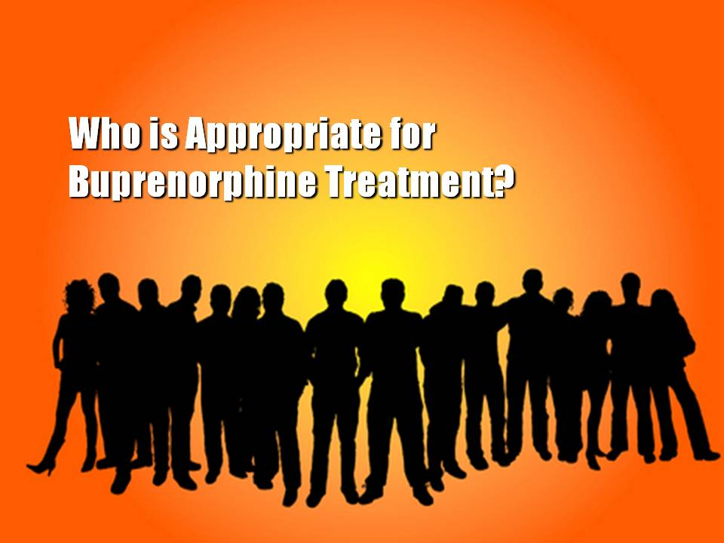 | Slide 4: Who is Appropriate for Buprenorphine Treatment?  The following set of slides will review assessment questions, situations in which multidisciplinary addiction professionals should consult with the treating physician, and additional issues relating to patient selection. | Slide 4
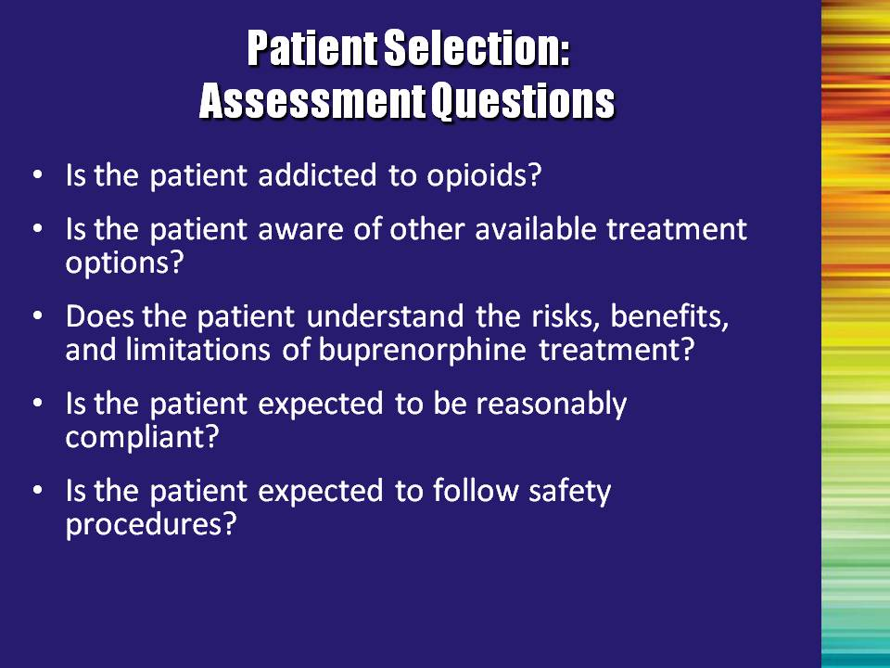 | Slide 5: Patient Selection: Assessment Questions  The patient selection process includes determining if the patient is addicted to opioids, if buprenorphine is the optimal medication for the patient, and if an office or a clinic is the optimal site for treatment. Once a thorough assessment is conducted, the physician can determine if addiction to opioids is present using the DSM-IV-TR criteria mentioned earlier. Treatment success is enhanced by good patient assessment and selection. Ten simple criteria can help to guide patient assessments of appropriateness of office-based buprenorphine treatment.  Read criteria aloud and discuss as follows:  Bullet #1: Is the patient addicted to opioids? Treatment with buprenorphine will generally be conducted with individuals who meet criteria for opioid addiction. However, a physician may consider buprenorphine treatment for a patient with problematic opioid use that has not progressed to addiction. An example of this might be if, in the physician’s clinical judgment, the patient has a high risk of progression to addiction or is injecting opioids. Additional candidates include patients with a history of good response to buprenorphine who have had their medication discontinued (perhaps due to incarceration) and are now at risk of relapse (released from prison).  Bullet #2: Is the patient aware of other available treatment options? Even if a patient is addicted to opioids and a suitable candidate for buprenorphine treatment, he/she may not be best treated in an office setting. Patients should be made aware of all of the options available to them and be assisted in making a decision regarding their treatment. Their willingness to participate is critical to compliance with any treatment regimen.  Co-occurring disorders (other substance use disorders, psychiatric disorders, or medical conditions) may lead to the decision to not treat the individual in an office-based setting, since that office cannot provide the other needed services. For example, a physician’s office may not be able to provide psychotherapy needed by a patient with a severe personality disorder or the monitoring needed for a patient with AIDS. | Slide 5
 | Slide 5: Patient Selection: Assessment Questions, Continued  Bullet #3: Does the patient understand the risks, benefits, and the limitations of buprenorphine treatment? The patient needs to be conscious/aware of what buprenorphine WILL and WILL NOT do. Are there indications to suggest that the patient is reliable (i.e., steady employment, showing up on time for appointments, taking other medications as prescribed)? Have cost issues been explained and compared with other treatment options?  Bullet #4: Is the patient expected to be reasonably compliant? Is the patient in a situation where he/she can be expected to attend sessions as required, manage the medication appropriately, and take it as prescribed? If the answer is “no,” the treatment team should explore the possibility of conducting the treatment in a highly structured environment (e.g., residential, partial hospitalization)  Bullet #5: Is the patient expected to follow safety procedures? Can the patient manage his/her medication appropriately (e.g., keep it away from children in the home), and take it as prescribed? | Slide 5
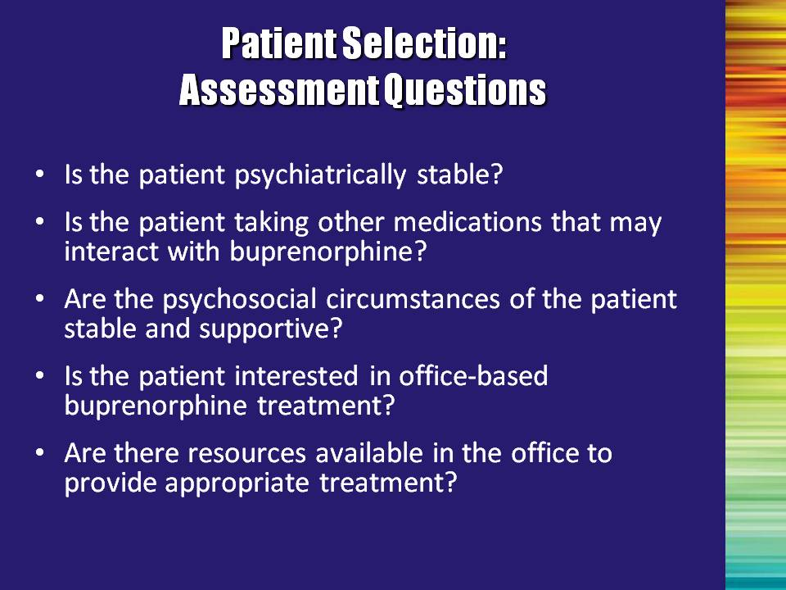 | Slide 6: Patient Selection: Assessment Questions  Read the remaining criteria aloud.  Bullet #1: Is the patient psychiatrically stable? Do they need to be stabilized first? Do they need treatment for co-occurring disorders?  Additional Information for the Trainer(s): According to the Buprenorphine Treatment Guidelines (TIP 40), the presence and severity of co-morbid psychiatric conditions must be assessed prior to initiating buprenorphine treatment, and a determination made whether referral to specialized behavioral health services is necessary. The psychiatric disorders most commonly encountered in patients addicted to opioids are other substance abuse disorders, depressive disorders, posttraumatic stress disorder, substance-induced psychiatric disorders, and antisocial and borderline personality disorder.  Reference:  Center for Substance Abuse Treatment. Clinical Guidelines for the Use of Buprenorphine in the Treatment of Opioid Addiction. Treatment Improvement Protocol (TIP) Series 40. DHHS Publication No. (SMA) 04‐3939. Rockville, MD: Substance Abuse and Mental Health Services Administration, 2004.  Bullet #2: Is the patient taking other medications that may interact with buprenorphine? Other medications may include naltrexone, benzodiazepines, or other sedative hypnotics. Another way of asking this question is, “Is this an appropriate medication for the person to be taking?” Additional medications and health conditions should be brought to the attention of the physician, so that the physician is fully informed in making the decision to prescribe buprenorphine or any other medication.  Bullet #3: Are the psychosocial circumstances of the patient stable and supportive? What stressors, relationships, supports, living situation, etc. does the patient have that can contribute to or undermine the success of the recovery plan? | Slide 6
 | Slide 6: Patient Selection: Assessment Questions, Continued  Read the remaining criteria aloud.  Bullet #4: Is the patient interested in office-based buprenorphine treatment? Even if a patient is a suitable candidate for buprenorphine treatment, he/she may not be best treated in an office setting. Stability and structure of the patient’s living situation will help the treatment team determine the most appropriate setting.  Bullet #5: Are there resources available in the office to provide appropriate treatment? Has a comprehensive recovery plan been developed and coordinated between the psychosocial treatment team and the physician? What additional resources need to be added in order to facilitate coordinated care?  If resources are not available in the physician’s office, attempts should be made to work in cooperation with a local substance abuse treatment program. | Slide 6
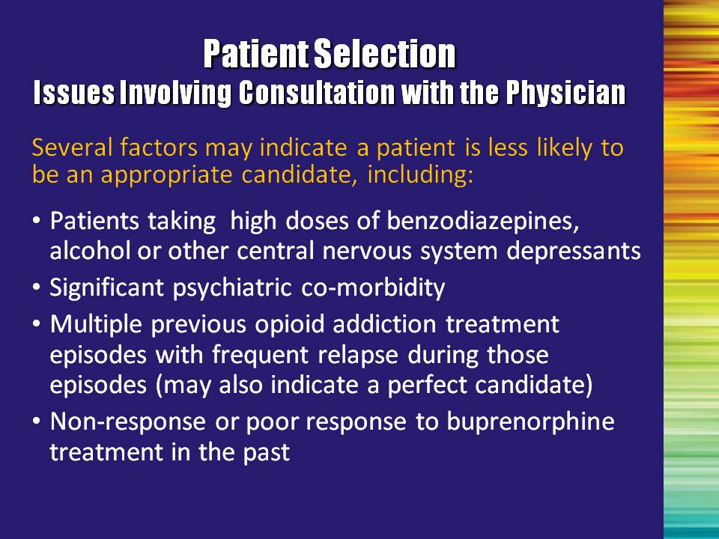 | Slide 7: Patient Selection: Issues Involving Consultation with the Physician  The multidisciplinary addiction professional should be aware of the following factors and inform the physician of any changes or arising information.  Read factors aloud.  Bullet #1: Patients taking high doses of benzodiazepines, alcohol or other central nervous system (CNS) depressants. The use of benzodiazepines in combination with buprenorphine (especially if injected in an overdose attempt) may result in death. Since alcohol is a sedative-hypnotic, patients should be cautioned to avoid alcohol while taking buprenorphine.  Bullet #2: Significant psychiatric co-morbidity. This may or may not be an issue (case-specific), but should be evaluated to determine appropriate course of treatment for drug addiction and other psychiatric conditions.  Bullet #3: Multiple previous opioid addiction treatment episodes with frequent relapse during those episodes (may also indicate a perfect candidate). Again not exclusionary, but understanding what led to previous treatment failures may help to shape the current recovery plan. Changing to a new treatment, rather than continuing an unsuccessful one, may work well for them.  Bullet #4: Non-response or poor response to buprenorphine treatment in the past. | Slide 7
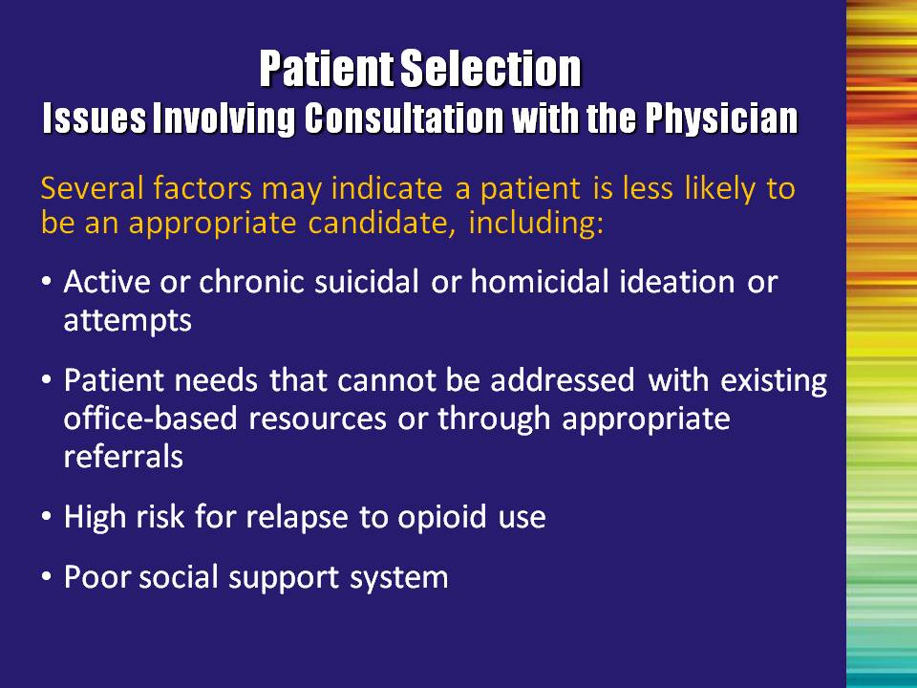 | Slide 8: Patient Selection: Issues Involving Consultation with the Physician  Read factors aloud.  Bullet #1: Active or chronic suicidal or homicidal ideation or attempts.  Bullet #2: Patient needs that cannot be addressed with existing office-based resources or through appropriate referrals.  Bullet #3: High risk for relapse to opioid use. For example, living in a place where others are consuming heroin or other opioids. This may be an issue of timing; the patient may need a more structured environment (e.g., residential care), or they may be saying that they are not ready to enter treatment.  Bullet #4: Poor social support system. A poor social support system is not ideal for any recovery process. The treatment team should work with the patient to develop a plan to help the person strengthen and engage effective support. | Slide 8
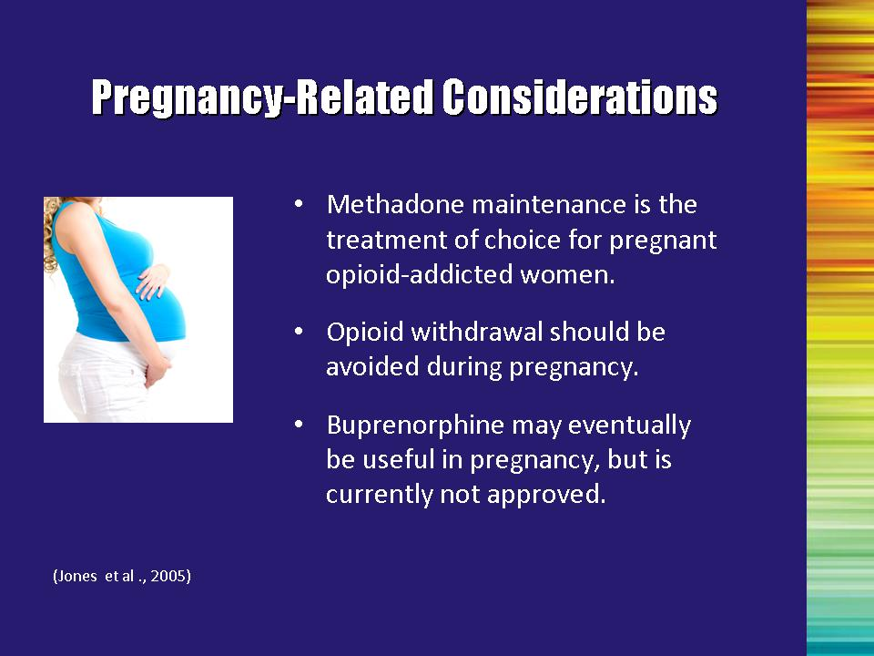 | Slide 9: Patient Selection: Pregnancy-Related Considerations  Bullet #1: Methadone maintenance is the treatment of choice for pregnant opioid-addicted women.  Bullet #2: Pregnancy itself is traumatic to the body (especially if the woman is experiencing “morning sickness”). Generally, it is not recommended for a woman who is already in a vulnerable condition to go through any additional trauma/discomfort of withdrawing from an opioid. If withdrawal is indicated in the treatment plan, most physicians will urge the patient to wait until after delivery. Methadone plus behavioral treatment would then be considered for the immediate treatment plan.  Bullet #3: Buprenorphine may eventually be useful in pregnancy, but is currently not FDA approved.  Reference:  Jones, H. E., Johnson, R. E., Jasinski, D. R., O’Grady, K. E., Chisholm, C. A., Choo, R. E., … Milio, L. (2005). Buprenorphine versus methadone in the treatment of pregnant opioid-dependent patients: Effects on the neonatal abstinence syndrome. Drug and Alcohol Dependence, 79, 1-10. | Slide 9
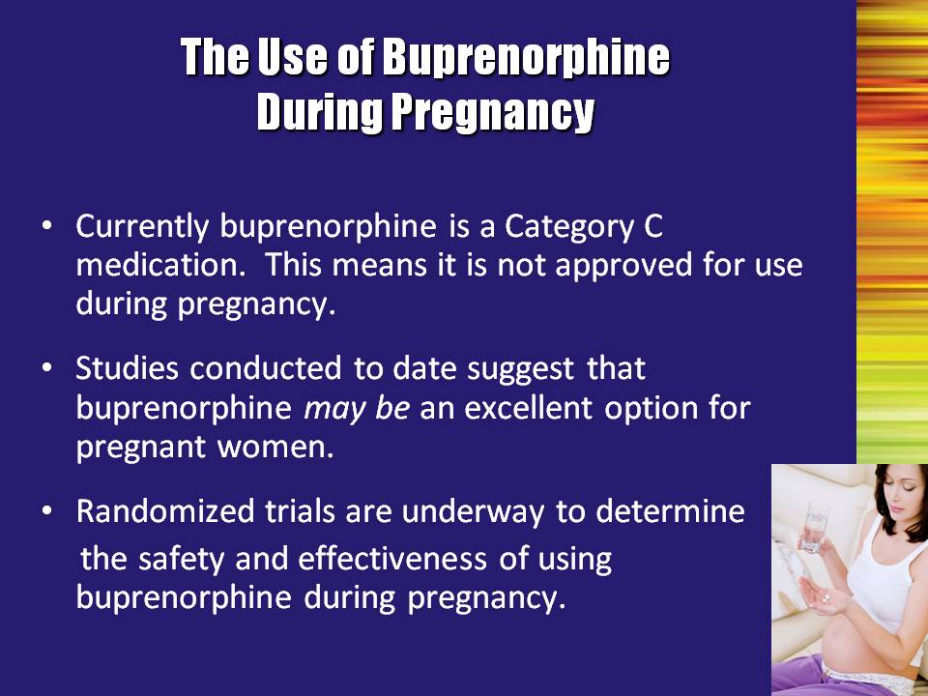 | Slide 10: Patient Selection: The Use of Buprenorphine During Pregnancy  There is no evidence of any harmful effects of buprenorphine relative to pregnancy, but in the absence of controlled clinical trials, risk cannot be ruled out.  Bullet #1: Currently buprenorphine is a Category C medication. This means it is not approved for use during pregnancy.  Bullet #2: Studies conducted to date suggest that buprenorphine may be an excellent option for pregnant women.  Bullet #3: Randomized trials are underway to determine the safety and effectiveness of using buprenorphine during pregnancy. | Slide 10
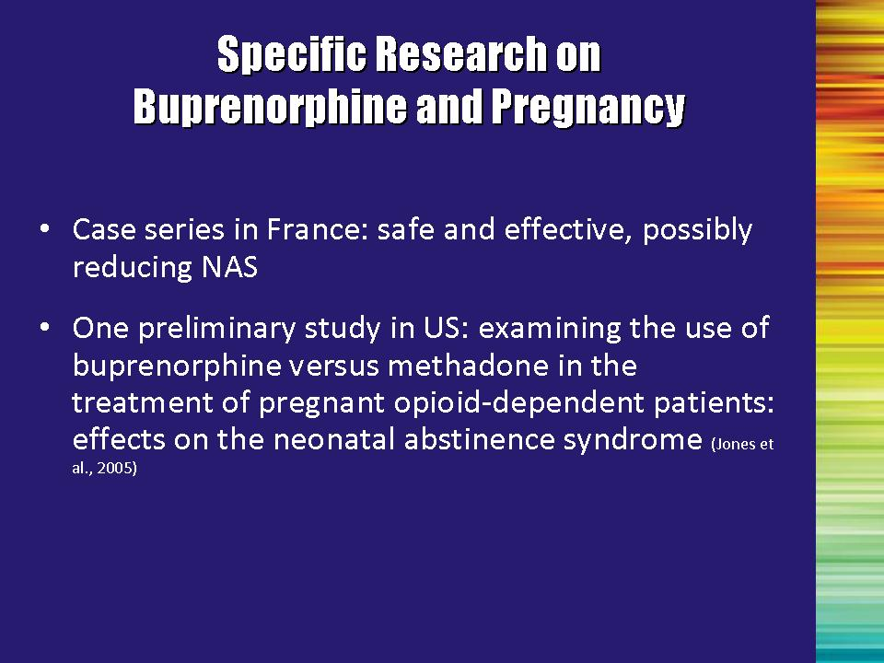 | Slide 11: Specific Research on Buprenorphine and Pregnancy  Research on the use of buprenorphine is limited. In a case series conducted in France, buprenorphine was found to be safe and effective and to possibly reduce neonatal abstinence syndrome (NAS).  There has been one preliminary study conducted in the United States by Jones and colleagues (2005). This study examined the use of buprenorphine versus methadone in the treatment of pregnant opioid-dependent patients and effects on NAS.  Reference:  Jones, H. E., Johnson, R. E., Jasinski, D. R., O’Grady, K. E., Chisholm, C. A., Choo, R. E., … Milio, L. (2005). Buprenorphine versus methadone in the treatment of pregnant opioid-dependent patients: Effects on the neonatal abstinence syndrome. Drug and Alcohol Dependence, 79, 1-10. | Slide 11
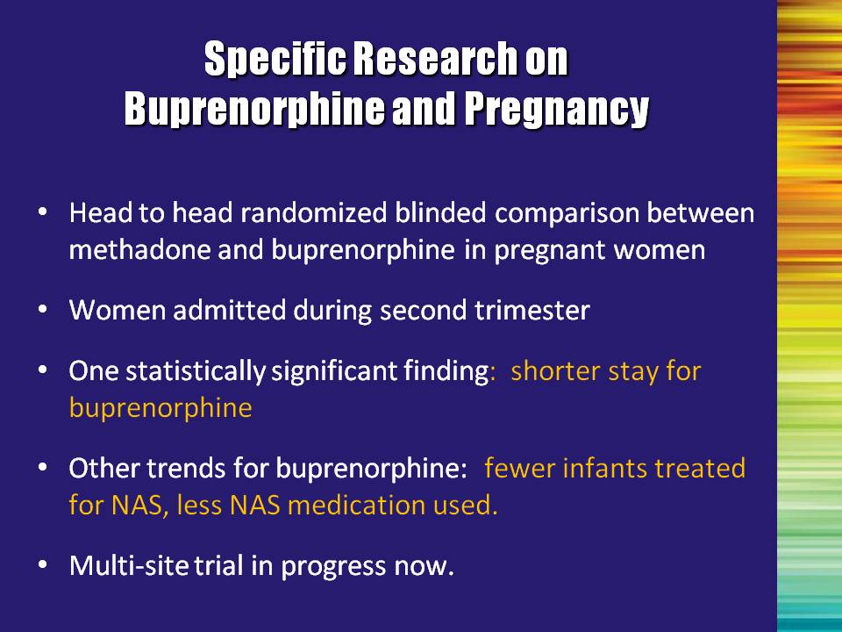 | Slide 12: Specific Research on Buprenorphine and Pregnancy  This research was conducted as a head to head randomized, blinded comparison between methadone and buprenorphine in pregnant women. Women were admitted during their second trimester.  One statistically significant finding was that the length of hospitalization was shorter for buprenorphine-exposed neonates than for methadone-exposed neonates.  Other trends showed that fewer buprenorphine-exposed infants were treated for neonatal abstinence syndrome; of those treated for NAS, less medication was administered.  Results suggest that buprenorphine is not inferior to methadone on outcome measures assessing NAS and maternal and neonatal safety when administered starting in the second trimester of pregnancy.  A multi-site trial is now in progress.  Reference:  Jones, H. E., Johnson, R. E., Jasinski, D. R., O’Grady, K. E., Chisholm, C. A., Choo, R. E., … Milio, L.. (2005). Buprenorphine versus methadone in the treatment of pregnant opioid-dependent patients: Effects on the neonatal abstinence syndrome. Drug and Alcohol Dependence, 79, 1-10. | Slide 12
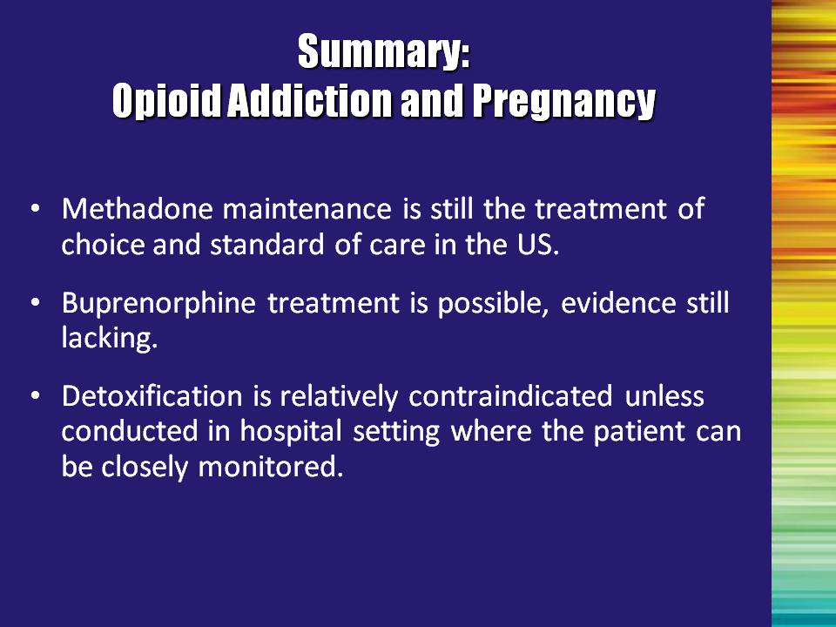 | Slide 13: Summary: Opioid Addiction and Pregnancy  Bullet #1: Methadone maintenance is still the treatment of choice and standard of care in the United States.  Bullet #2: Buprenorphine treatment is possible, evidence still lacking.  More research is needed before buprenorphine is approved for this indication. In the meantime, it can be used off-label if methadone is not available or appropriate AND the benefits of treatment outweigh the risk of using this medication.  Note to the Trainer(s): In cases where it is determined that the benefits of buprenorphine treatment during pregnancy outweigh the risks, it is important to utilize the mono-product to minimize the chance of precipitated withdrawal.  Bullet #3: Detoxification is generally contraindicated unless conducted in a hospital setting where the patient can be closely monitored.  In general, complete withdrawal from opioids is contraindicated. If indicated:  - It should be done in a hospital with careful monitoring.  - Risk of relapse is high and detrimental; ongoing care with monitoring is essential. | Slide 13
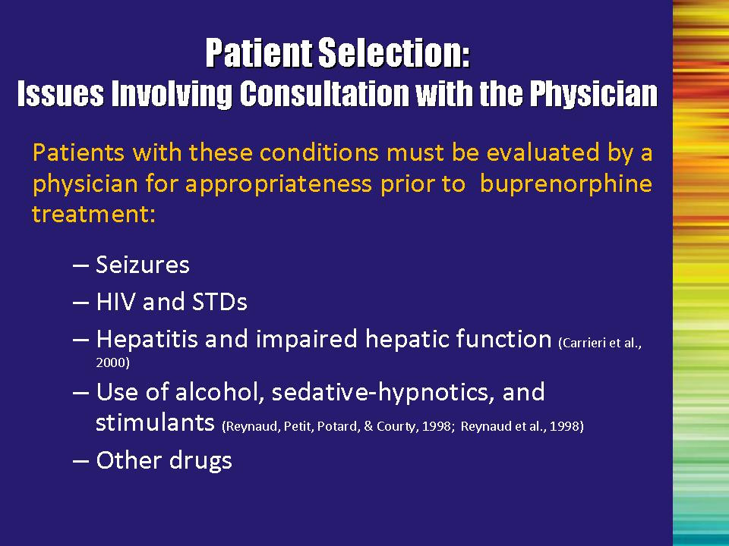 | Slide 14: Patient Selection: Issues Involving Consultation with the Physician  In all cases, consult with the physician who will make medical decisions as to how to treat these individuals.  Bullet #1: Seizures: Seizures can occur with some opioids. While not seen with buprenorphine, careful evaluation should be made.  Bullet # 2 and #3: Human immunodeficiency virus (HIV), hepatitis C virus (HCV), and sexually transmitted diseases (STDs): Of particular concern for opioid-addicted patients are issues regarding HIV/AIDS and HCV. Multidisciplinary addiction professionals should ask patients about their HIV and HCV status, and when they were last tested. If patients have not been tested recently, they should be referred to a physician or given information on how to locate a testing site. If patients are positive for HIV or HCV, they should be asked about the medications they are taking and encouraged to comply with their medication regimen. The treatment team should communicate any new information to the physician regarding the patient’s medications in order to monitor potential medication interactions with buprenorphine.  Additional Information for the Trainer(s): Buprenorphine should be used cautiously in combination with HIV antiretroviral medications that may inhibit, induce, or be metabolized by the same liver enzyme system involved with the buprenorphine (cytochrome P450 3A4) enzyme system. Protease inhibitors inhibit cytochrome P450 3A4. Metabolism of buprenorphine and/or the antiretroviral medications may be altered when they are combined. Therefore, therapeutic blood levels may need to be monitored. Note that this is a precaution, not a contraindication; successful treatment of addiction with buprenorphine in HIV-infected patients has been well demonstrated (Carrieri et al., 2000).  Bullet #4: Use of alcohol, sedative-hypnotics, and stimulants: As was previously mentioned, the combination of other drugs should be carefully evaluated, especially given the fact that reported overdoses have been related to a combination of CNS depressants and buprenorphine (Reynaud, Petit, Potard, & Courty, 1998; Reynaud, Tracqui, Petit, Potard, & Courty,1998). | Slide 14
 | Slide 14: Patient Selection: Issues Involving Consultation with the Physician, continued  Bullet #5: Other drugs: Buprenorphine is a treatment for opioid addiction, not other substance use disorders. Addiction to other drugs (e.g., stimulants or sedatives) is common among opioid-addicted patients and may interfere with overall treatment adherence. Patients should be encouraged to abstain from the use of all non-prescribed drugs while receiving buprenorphine treatment. However, although a predictor of poor adherence, use of other drugs IS NOT an absolute contraindication to buprenorphine treatment. They may need to be referred for more intensive treatment.  References:  Carrieri, M.P., Vlahov, D., Dellamonica, P., Gallais, H., Lepeu, G.,Spire, B., & Obadia, Y. (2000). Use of buprenorphine in HIV-infected injection drug users: Negligible impact on virologic response to HAART. The Manif-2000 Study Group. Drug and Alcohol Dependence, 60(1), 51–54.  Reynaud, M., Petit, G., Potard, D., & Courty, P. (1998). Six deaths linked to concomitant use of buprenorphine and benzodiazepines. Addiction, 93(9), 1385–1392.  Reynaud, M., Tracqui, A., Petit, G., Potard,D. & Courty, P. (1998). Six deaths linked to misuse of buprenorphine-benzodiazepine combinations. American Journal of Psychiatry, 155(3), 448–449. | Slide 14
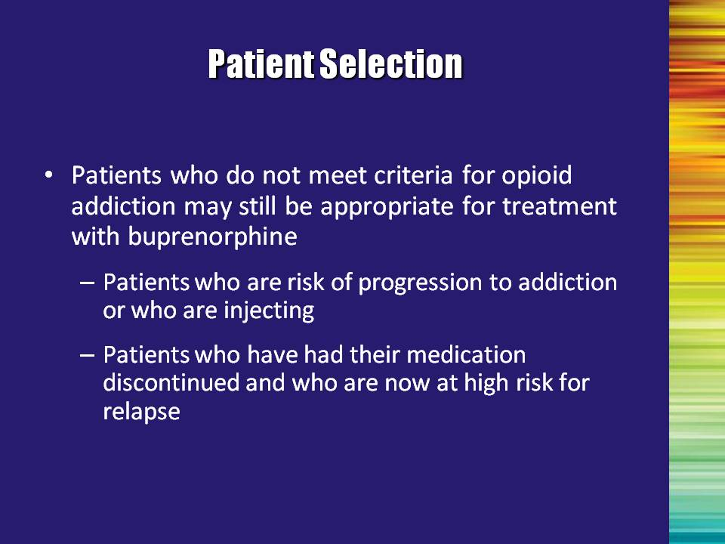 | Slide 15: Patient Selection  There are instances in which patients who do not meet criteria for current opioid addiction may still be candidates for buprenorphine treatment.  Read the two examples aloud.  - Patients who are at risk of progression to addiction or who are injecting;  - Patients who have had their medication discontinued and who are now at high risk for relapse. | Slide 15
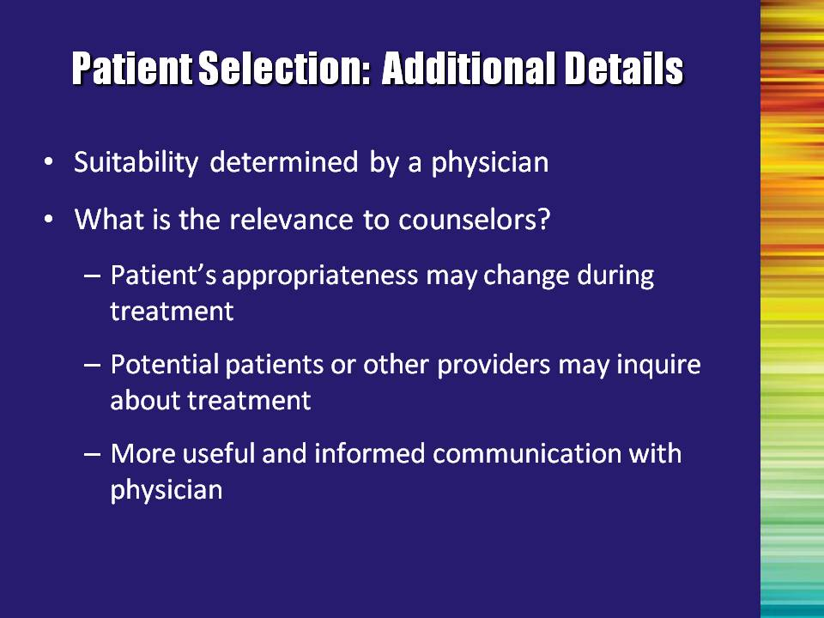 | Slide 16: Patient Selection: Additional Details  The multidisciplinary addiction professional can have a lot of impact on or influence over the physician’s decision regarding patient suitability – even though the addiction professional is not personally responsible for determining suitability. | Slide 16
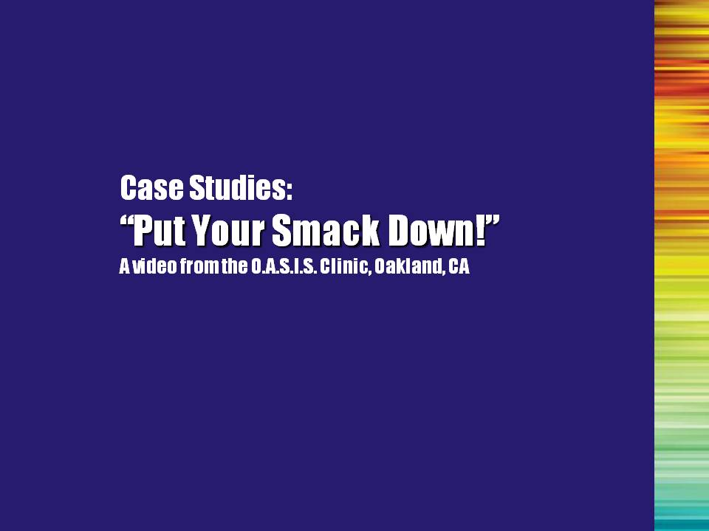 | Slide 17: Optional  Case Studies: “Put Your Smack Down!”  A Video from the O.A.S.I.S. Clinic, Oakland, CA  Preface the video with the following statement:  We are now going to watch a video that was developed by the O.A.S.I.S. Clinic in Oakland, CA. The video shows people talking about their experience with taking buprenorphine.  The purpose of showing this video is to add the patient experience into the conversations. However, it is important to remember that this is only their opinion. Some of the statements come across as if buprenorphine should replace methadone. As we have discussed, buprenorphine is one option for treatment, not a replacement for any existing treatment. Also, there is a lot of talk about how long someone needs to be abstinent from heroin prior to induction with buprenorphine. Physicians use a variety of induction strategies; the 24-hour wait is one way of handling it.  Play the video now. Make sure that the computer speakers are turned up. | Slide 17
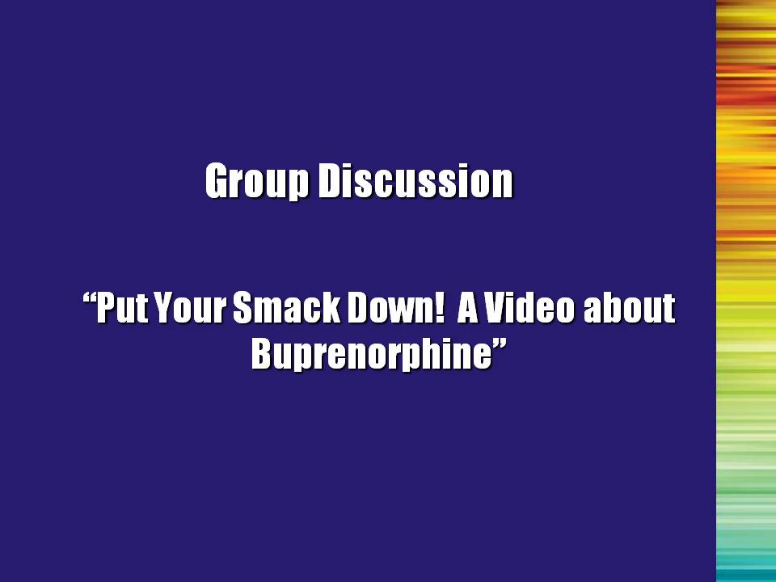 | Slide 18: Optional  Group Discussion of Case Studies Presented in “Put Your Smack Down! A Video About Buprenorphine”  Upon completion of the video, spend a few minutes discussing the buprenorphine patients’ experiences and other possible case studies, if people have specific examples.  What reactions, comments or questions do you have about the information in the video?  Does anyone have any other case examples that they would like to share? | Slide 18
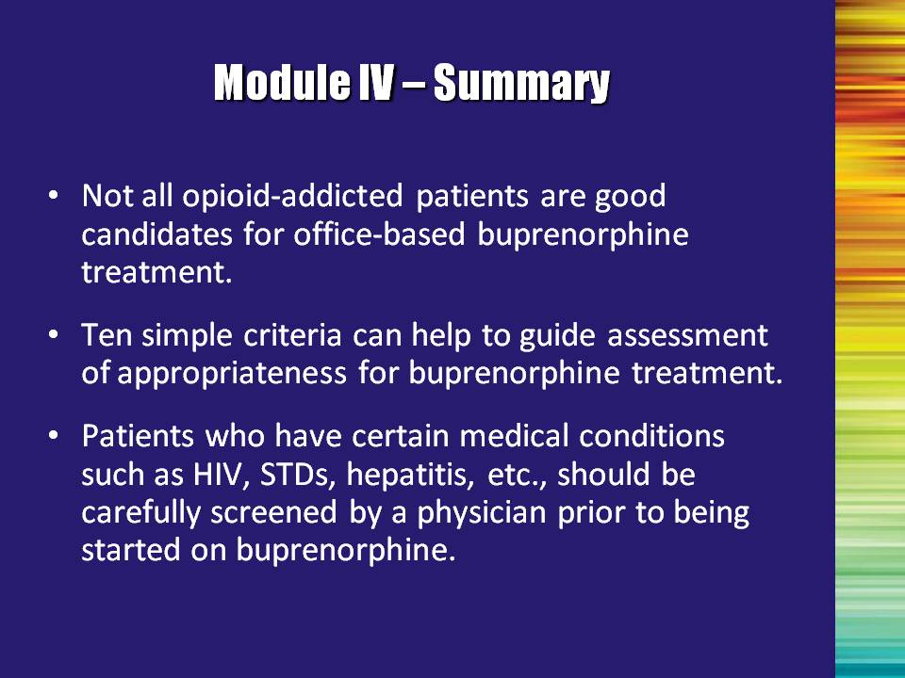 | Slide 19: Module IV – Summary  - Not all opioid-addicted patients are good candidates for office-based buprenorphine treatment.  - Ten simple criteria can help guide assessment of appropriateness for buprenorphine treatment.  - Patients with certain medical conditions, including HIV, STDs, and HCV, should be evaluated by a physician prior to beginning buprenorphine treatment. | Slide 19

Module V

Coordinated Care
Module V: Coordinated Care

Overall notes: Again, it is important to stress the importance of people remaining within the scope of their practice. This is not just a suggestion – there are ethical parameters to stay within, and certification and credentialing guidelines to follow.

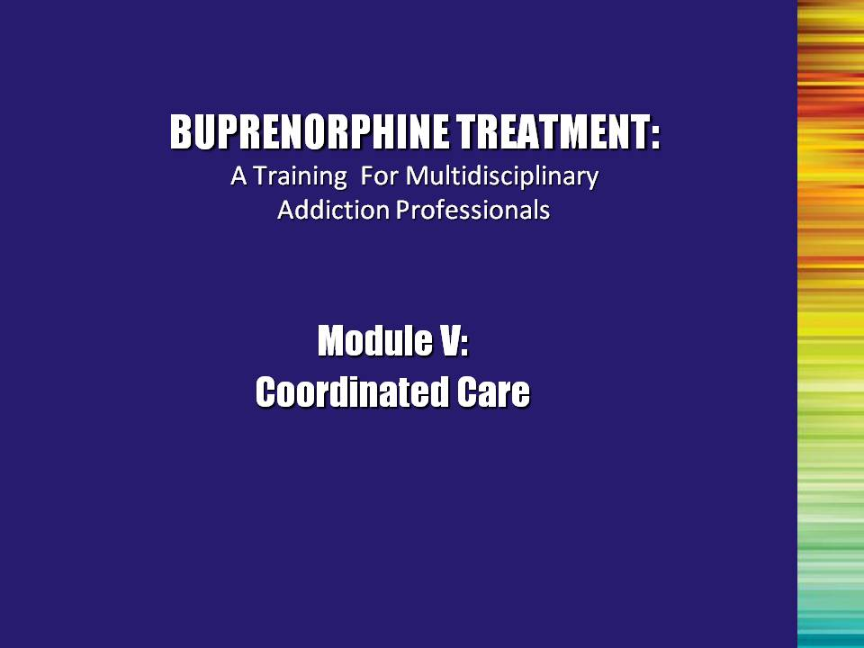 | Slide 1: Title Slide  The patient who enrolls in buprenorphine treatment is facing more than a medical issue. The disease of addiction can affect all aspects of a patient’s life and the consequences of addiction must be addressed if substance abuse treatment is to be effective. Since a variety of different professionals from several agencies may participate in some aspect of treatment or patient care, it is important to examine how that care can be delivered in a consistent, coordinated, and patient-friendly manner. This module will explore the issue of effective coordination of care. | Slide 1
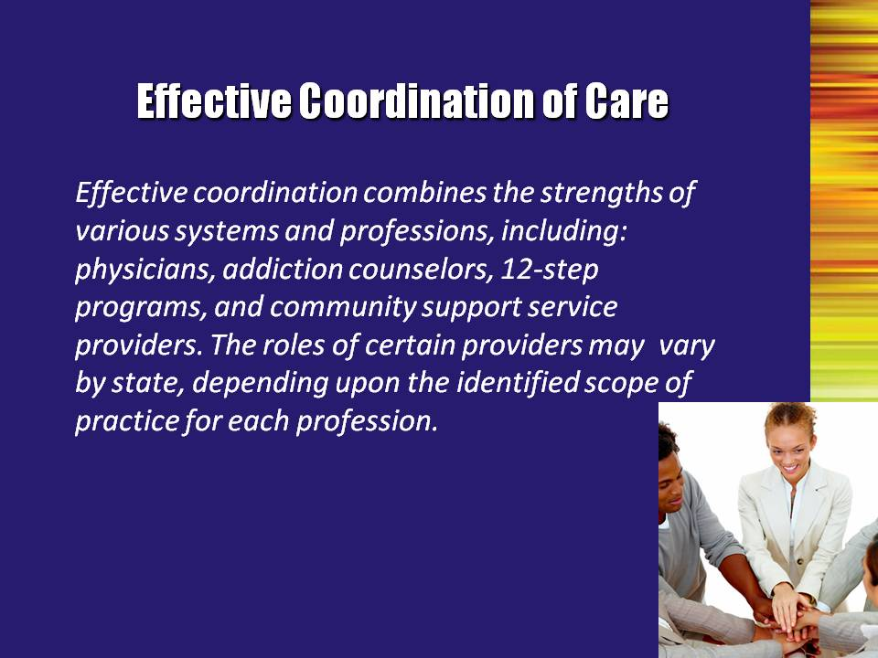 | Slide 2: Effective Coordination of Care  Read quote aloud.  While previous opioid treatment occurred only in the context of federally regulated programs, buprenorphine treatment extends the treatment arena to the physician’s office. Developing a coordinated system of care is the only means that the physician has of ensuring that his/her patient is benefiting from the drug he/she has prescribed.  Treatment is most successful when there are comprehensive and continuing services. This collaborative approach can best be achieved through care coordination.  Important points to mention:  - Obtaining a signed release of information is highly recommended to prevent any delays in communication between multidisciplinary addiction professionals and the treating physician.  - If you are seeing physical signs of withdrawal and/or use, you should bring a physician into the loop immediately (again, do not go beyond the scope of your practice/experience).  Note to the Trainer(s): Discuss what to do if a patient starts asking the professional about the side effects of buprenorphine – encourage them to discuss any medical matters with their physician.  When in doubt, refer the patient back to his/her treating physician. | Slide 2
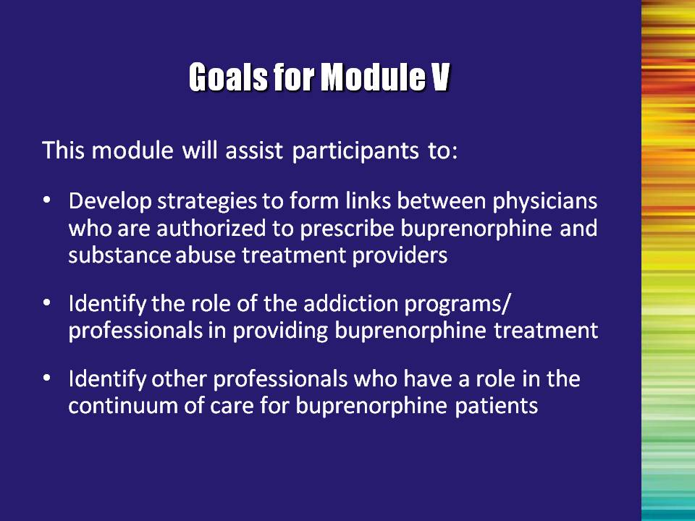 | Slide 3: Goals for Module V  This module will assist participants to:  - Develop strategies to form links between physicians who are authorized to prescribe buprenorphine and substance abuse treatment providers.  - Identify the role of the addiction programs/professionals in providing buprenorphine treatment.  - Identify other professionals who have a role in the continuum of care for buprenorphine patients. | Slide 3
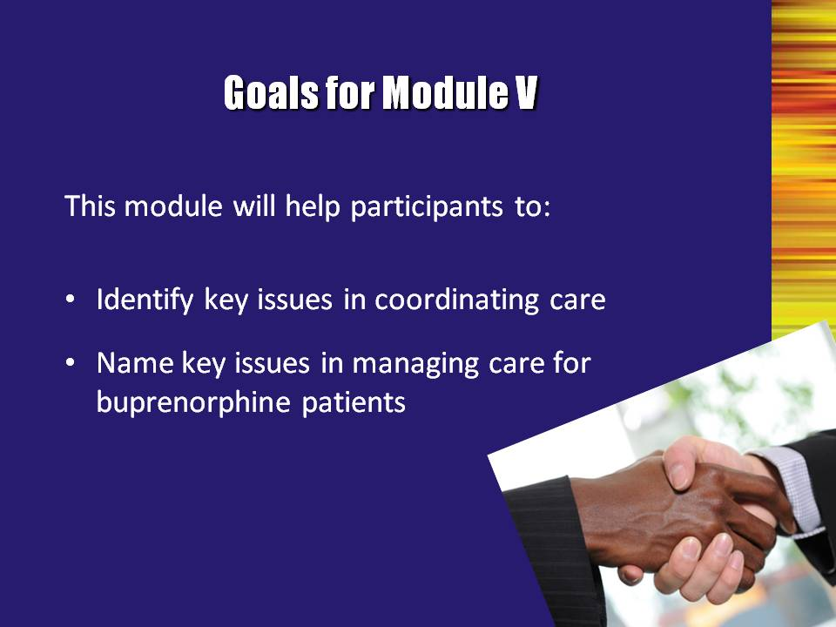 | Slide 4: Goals for Module V  - Identify key issues in coordinating care.  - Name key issues in managing care for buprenorphine patients. | Slide 4
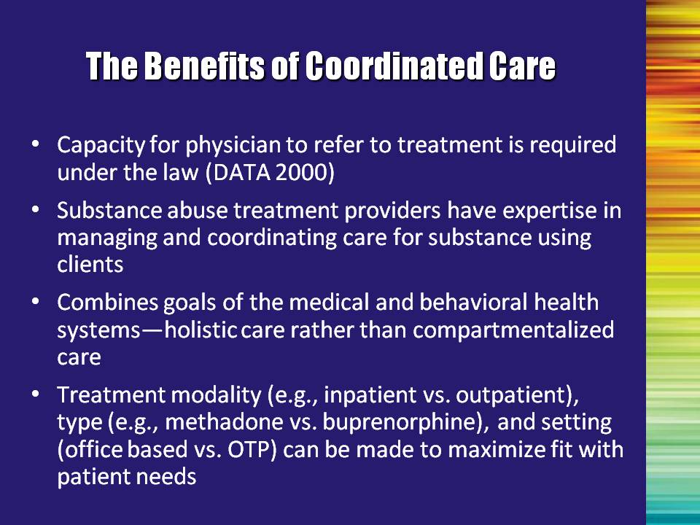 | Slide 5: The Benefits of Coordinated Care  Review the benefits of coordinated care, as stated on the slide.  Coordinated care is critical for effective learning. However, it is critical that service providers adhere to local and federal laws pertaining to confidentiality and the Health Insurance Portability and Accountability Act of 1996 (HIPAA). This includes, but is not limited to, ensuring that the patient wants the collaboration to occur and provides signed releases of information to allow for communication between the various professionals who are helping them. | Slide 5
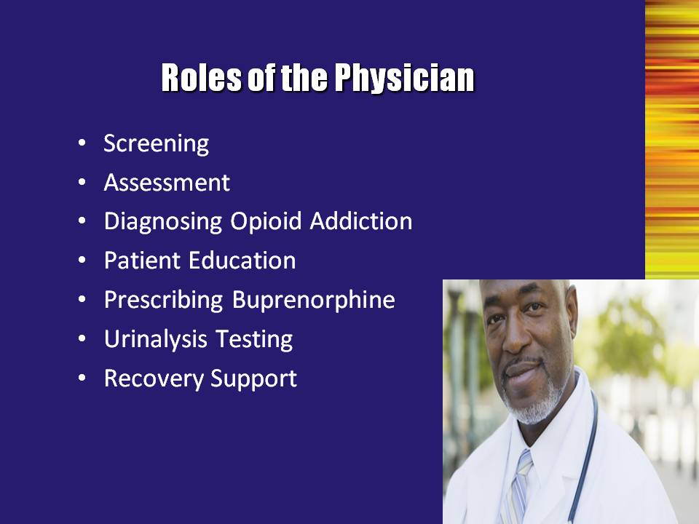 | Slide 6: Roles of the Physician  Read the roles aloud.  The medical system has physical health as its primary goal. In this system, the physician may focus on alleviating the discomforts of withdrawal by helping the person to taper off of opioids or providing medication on an ongoing basis to help stabilize the patient. Additionally, the physician may focus on a longer term goal of helping the person to maintain abstinence from illicit opioids.  The physician’s choice of treatment should be determined by the intensity of intervention necessary to support the recovery of an individual patient. The continuum of treatment intensities range from episodic office-based therapy to intensive inpatient therapy. | Slide 6
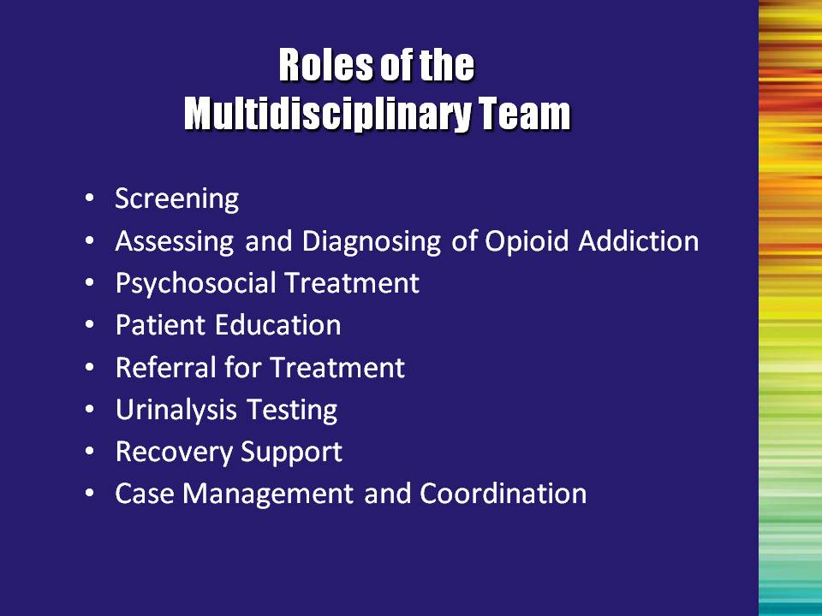 | Slide 7: Roles of the Multidisciplinary Team  Read the roles aloud.  The treatment process is complex. The missions of substance abuse treatment and recovery agencies generally focus on helping individuals make positive changes in their lives. Various treatment services may come under the auspices of the health care system; others are affiliated with mental health systems; still others function as independent, separate agencies. Funding sources, client referrals, staffing, facilities, and many other aspects of treatment programs often vary markedly from agency to agency.  The Center for Substance Abuse Treatment’s (CSAT) vision for publicly funded addiction treatment and recovery services requires that the treatment and recovery infrastructure and individual community-based programs be empowered to:  - Comprehensively assess the needs of individuals who request assistance;  - Match individual needs with the interventions and recovery services that best suit their requirements, as well as the needs of their families and significant others;  - Provide an appropriate array of specific treatment and recovery services along a sustained continuum of care for both the individual and his/her collaterals; and  - Determine the outcome of specific treatment and recovery services.  Note to the Trainer(s): Two additional points to reiterate:  - Encourage practitioners to stay within their scope of practice. One of the benefits of coordinated care is the linkage to other individuals/agencies who have the necessary expertise to treat various aspects of the patient’s condition.  - There is NO wrong door for treatment. | Slide 7
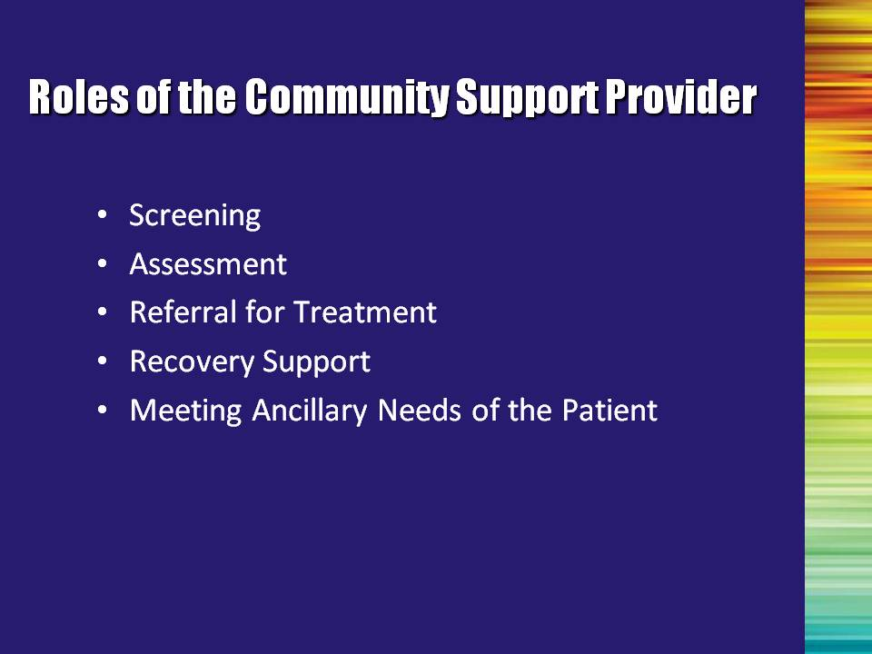 | Slide 8: Roles of the Community Support Provider  Read the roles aloud. Ask the audience to provide examples of community support providers that are available in their area. | Slide 8
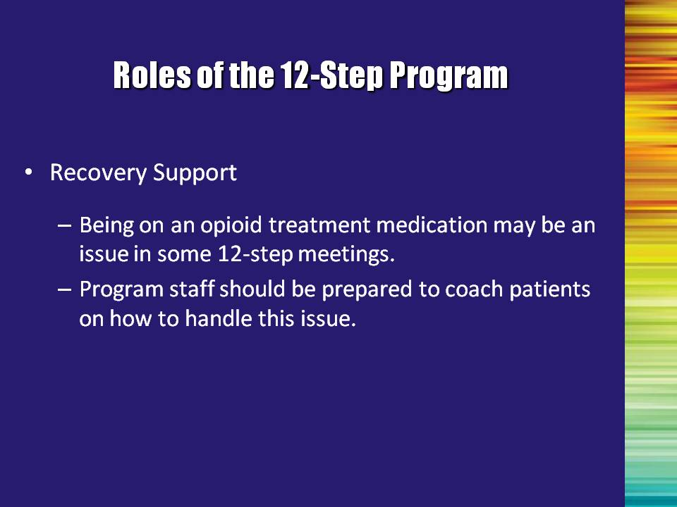 | Slide 9: Roles of the 12-Step Program  The stigma associated with opioid maintenance therapy may be an issue in 12-Step meetings. Patients are very likely to require coaching in this area.  Some patients may have had negative experiences in the past at 12-Step meetings because they were taking medication for their drug addiction or for psychiatric disorders.  Although 12-Step programs accept people who are taking medications, some 12-Step participants do not discriminate between drugs of abuse and appropriately used medications, and are therefore intolerant of medication-taking individuals.  AA has developed an AA-approved publication called “The AA Member – Medications and Other Drugs.” Addiction professionals should become familiar with this publication. Additional information addressing12-Step meetings will be covered in Module VI.  Each professional will need to develop an effective approach with which they feel comfortable. For example, professionals might coach their patients that there is no need to disclose their medical history or medications they are taking in public settings such as 12-Step meetings. Addiction professionals may also link patients up with 12-Step support people who are understanding and supportive of their buprenorphine treatment.  Addiction professionals may also want to develop special support groups for patients who are participating in buprenorphine treatment and attending 12-Step meetings. | Slide 9
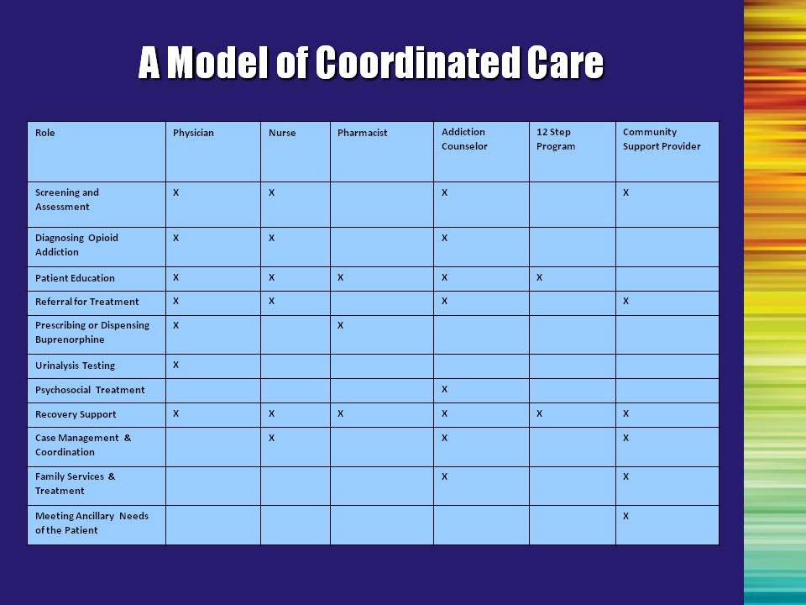 | Slide 10: A Model of Coordinated Care  This slide represents the “complexity of care.” All involved systems and their key players have a role in care coordination. Often, agency personnel develop informal means of collaboration, as one staff member becomes familiar with the programs and service providers in another agency. These staff members, and sometimes their agencies, may work very closely to meet the needs of mutual patients because of such voluntary efforts.  Reiterate that effective coordination combines the strengths of various systems and professions.  The roles of addiction counselors and community support providers may vary by state, depending upon the identified scope of practice for each profession. | Slide 10
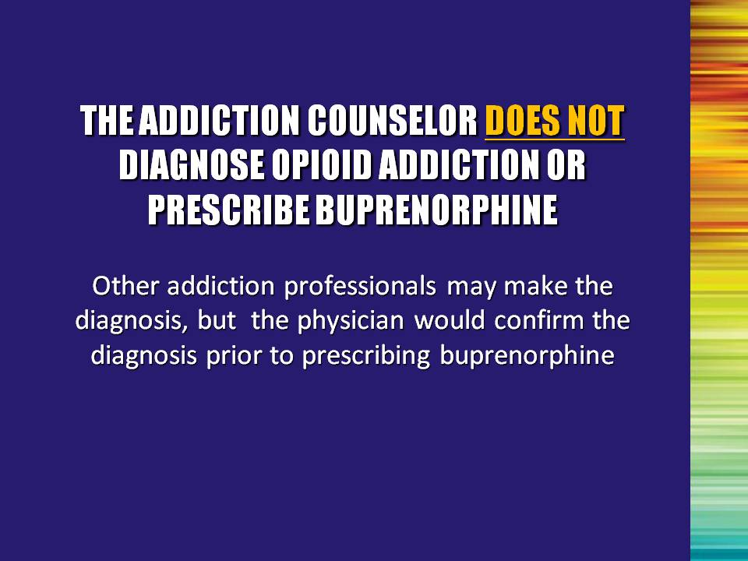 | Slide 11: THE ADDICTION COUNSELOR DOES NOT DIAGNOSE OPIOID ADDICTION OR PRESCRIBE BUPRENORPHINE (OPTIONAL SLIDE)  Read slide aloud.  Note to the Trainer(s): It is important to review licensing and/or certification criteria to determine if an addiction counselor is allowed to diagnose opioid addiction prior to the training. The scope of work of licensed and/or certified addiction counselors varies in accordance to the state in which they practice. | Slide 11
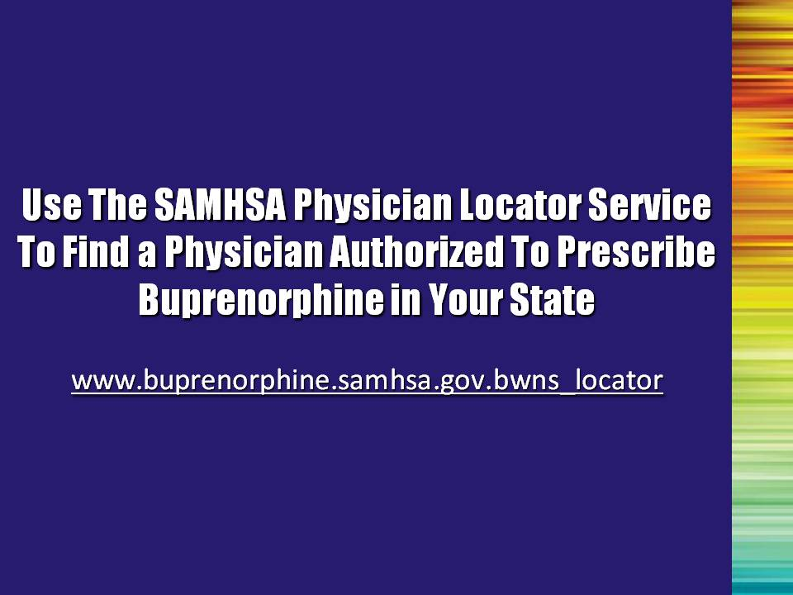 | Slide 12: Use the SAMHSA Physician Locator Service to Find a Physician Authorized to Prescribe Buprenorphine in Your State  The Substance Abuse and Mental Health Services Administration (SAMHSA) provides a registry of physicians who have received a waiver that authorizes them to prescribe buprenorphine. Community treatment providers can locate physicians in their local area by checking out this web site.  If there are no physicians within a local community, the community treatment provider may attempt to recruit a physician who is willing to pursue the waiver process if there will be a sufficient number of patients to warrant the effort. Also note that some physicians who are authorized to prescribe buprenorphine may choose not to be listed in the SAMHSA directory. So the number of physicians included in the directory may be an underestimate of the actual number authorized to prescribe buprenorphine. | Slide 12
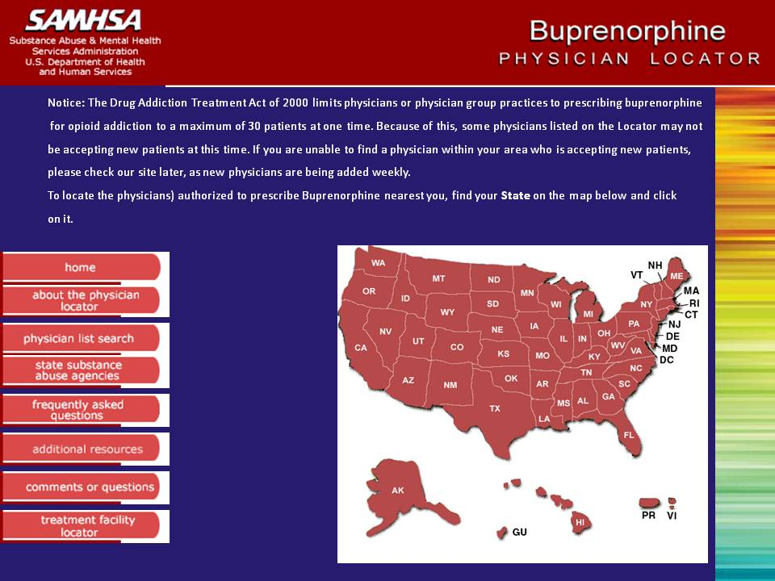 | Slide 13: SAMHSA’s Buprenorphine Physician Locator  Review each feature of the Physician Locator website.  Note to the Trainer(s): It is recommended that an additional slide be created that lists the names and locations of prescribing physicians for the local area identified from the Physician Locator prior to the training. | Slide 13
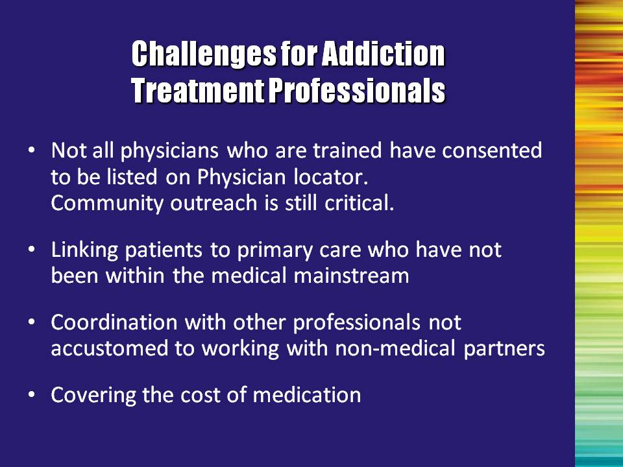 | Slide 14: Challenges for Addiction Treatment Professionals  Accumulated research on the effectiveness of treatment for alcohol and other drug abuse documents the efficacy of treatment strategies in alleviating substance abuse disorders and their related consequences. Successful treatment will have economic, health, and human benefits for individuals and society. Effective drug abuse treatment positively impacts the economic and health care burden of this major public health crisis (Primm, 1992).  Drug abuse treatment is not yet mainstreamed into the public health care delivery system and is often not part of routine primary care. Drug users are often not engaged in coordinated primary care within the mainstream medical care system and often rely instead on episodic care or acute/emergency room settings. In this environment, treatment providers are charged with the responsibility of coordinating comprehensive, community-based service delivery systems where clients receive a full range of medical, social, and psychological services.  The advent of buprenorphine treatment mandates a level of collaboration between physicians and community treatment programs that is more extensive than that required for more traditional opioid treatment programs, where the patient receives his or her medication in the treatment setting.  Many insurance programs will not provide reimbursement for buprenorphine. Physicians and community treatment providers must work in partnership to find creative ways to support buprenorphine treatment so that this effective medication is available to those patients that may benefit from its use.  Reference:  Primm, B.J. (1992). Future outlook: Treatment improvement. In J.H. Lowinson, P. Ruiz, R.B. Millman & J.G. Langrod (Eds.), Substance abuse: A comprehensive textbook. Baltimore: Williams & Wilkins. | Slide 14
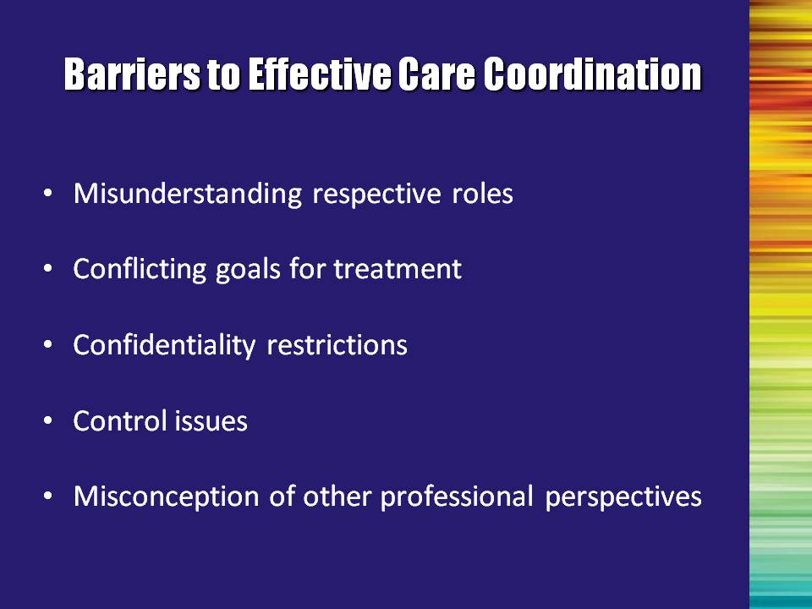 | Slide 15: Barriers to Effective Care Coordination  There are several barriers to effective communication within the substance abuse treatment system.  Read the barriers aloud. | Slide 15
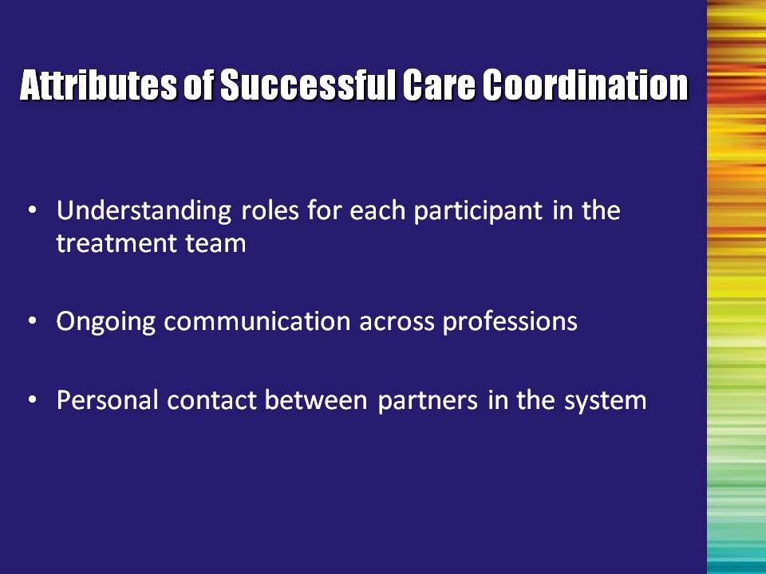 | Slide 16: Attributes of Successful Care Coordination  Familiarization with the roles, procedures, and organization of the other participants’ agencies/offices allows participants to anticipate the effect of their actions on the other team members.  Maintain ongoing communication: Groups involved in collaborative efforts need to plan for effective communication. This may involve specifying mechanisms for communication, such as periodic meetings, reports, memoranda, and both formal and informal communication channels. Feedback is vital in communication loops.  Personal contact is important; people are more likely to talk and listen to people they know.  Permanence must be ensured by vesting responsibility for ongoing communication in an office or institution. Intermediaries can help foster communication when certain individuals feel they lack authority to communicate.  Furthermore, it is important to work within the scope of current practices and have linkages to other professionals. There is no wrong door for treatment. | Slide 16
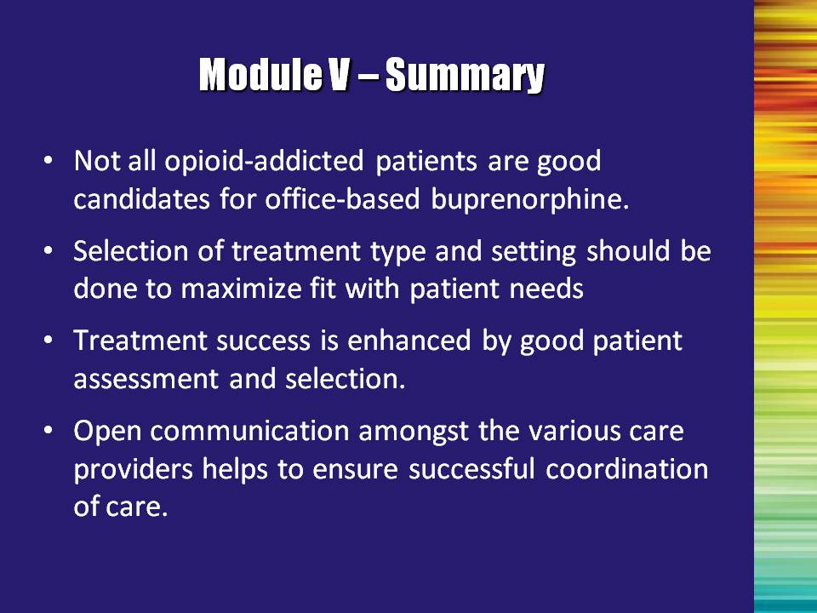 | Slide 17: Module V – Summary  Counselors who develop experience working with buprenorphine patients provide a valuable service to patients, the medical community, and the opioid treatment field. However, many members of the medical community are not aware of the support that addiction professionals can provide physicians who want to provide buprenorphine treatment for opioid addiction. | Slide 17

Module VI

Counseling Buprenorphine Patients
Module VI: Counseling Buprenorphine Patients

This is the final module in the six-module training. The one major issue left to address is a discussion of strategies to treat patients who are taking buprenorphine as part of their opioid treatment.

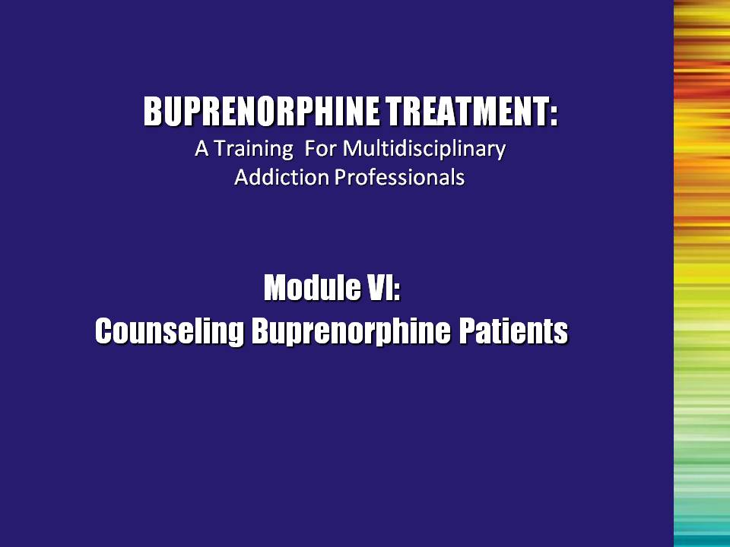 | Slide 1: Title Slide  This final module specifically addresses issues involved with counseling buprenorphine patients, including needs assessment, patient monitoring and management, and counseling strategies to use when providing psychosocial treatment to these individuals. | Slide 1
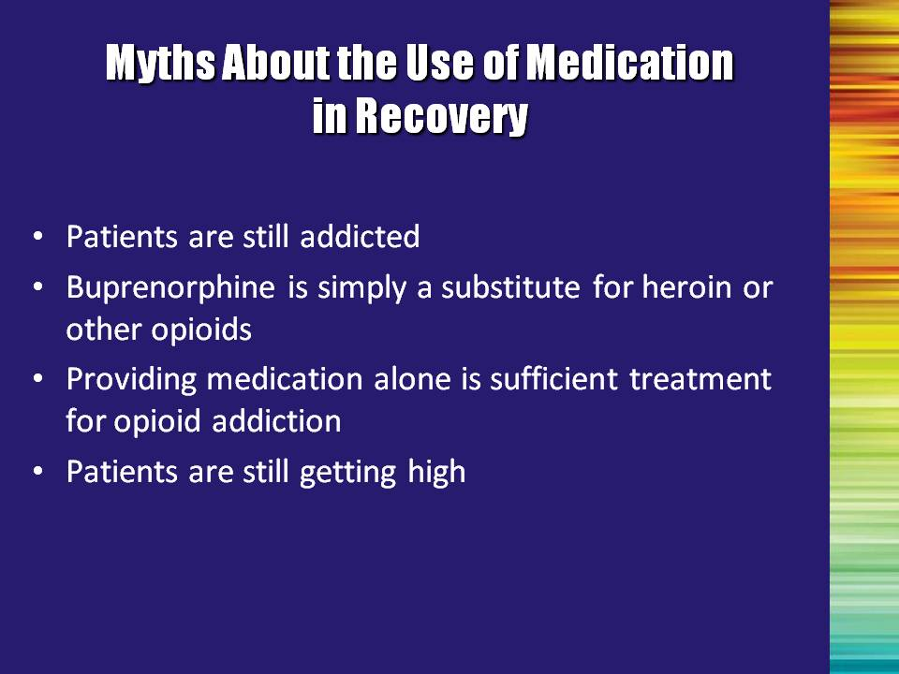 | Slide 2: Myths About the Use of Medication in Recovery  Briefly review the myths that were presented in Module I.  - Myth #1: Patients are still addicted  - Myth #2: Buprenorphine is simply a substitute for heroin or other opioids  - Myth #3: Providing medication alone is sufficient treatment for opioid addiction  - Myth #4: Patients are still getting high | Slide 2
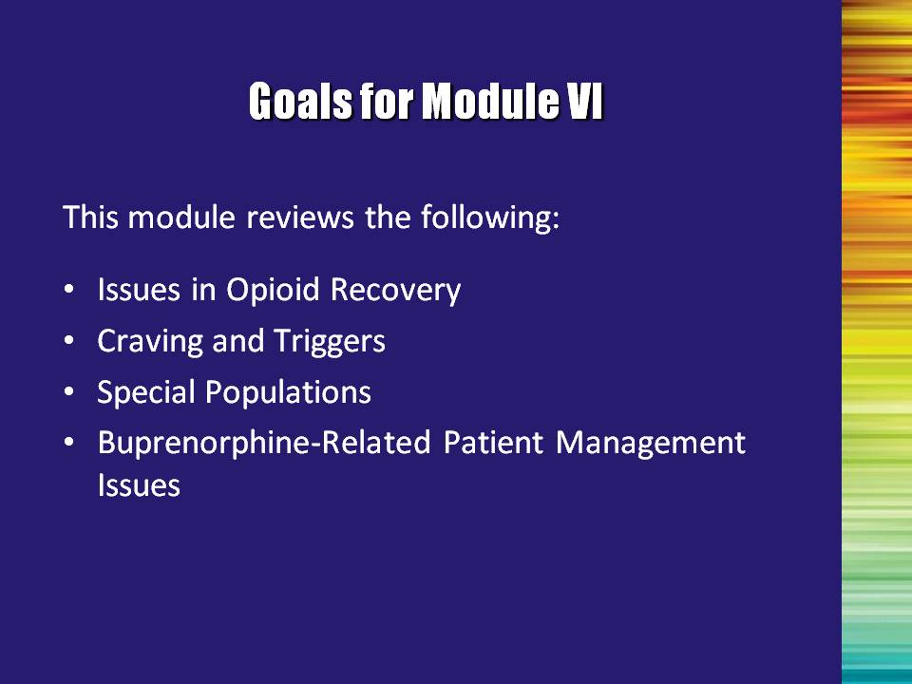 | Slide 3: Goals for Module VI  This module focuses on the various aspects of opioid addiction treatment and the use of buprenorphine in treating opioid addiction.  This module reviews the following:  - Issues in Opioid Recovery  - Cravings and Triggers  - Special Populations  - Buprenorphine-Related Patient Management Issues | Slide 3
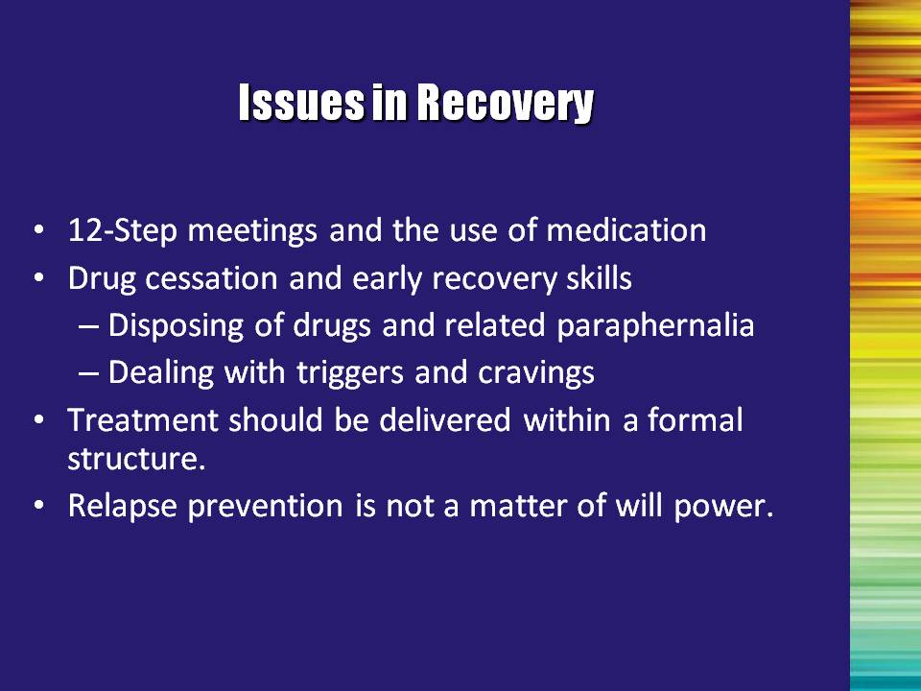 | Slide 4: Issues in Recovery  Bullet #1: Introducing 12-Step meetings to a patient can be considered a coaching process; the addiction professional should discuss potential scenarios the patient may encounter at a 12-Step meeting. The patient should be encouraged to choose a sponsor who is supportive of their use of buprenorphine as part of their overall opioid treatment plan.  Bullet #2: Counselors can assist patients by educating them about the importance of disposing of drugs and related paraphernalia, as well as ways to address triggers and cravings, understand addictive behaviors and thinking, and avoid relapse drift.  Bullet #3: Treatment should be delivered within a formal structure  Bullet #4: Relapse prevention involves a series, or process, of learning the skills necessary to stay away from drugs. Relapse prevention techniques help the patient learn these skills.  Relapse prevention techniques will be covered in more detail later in this module. | Slide 4
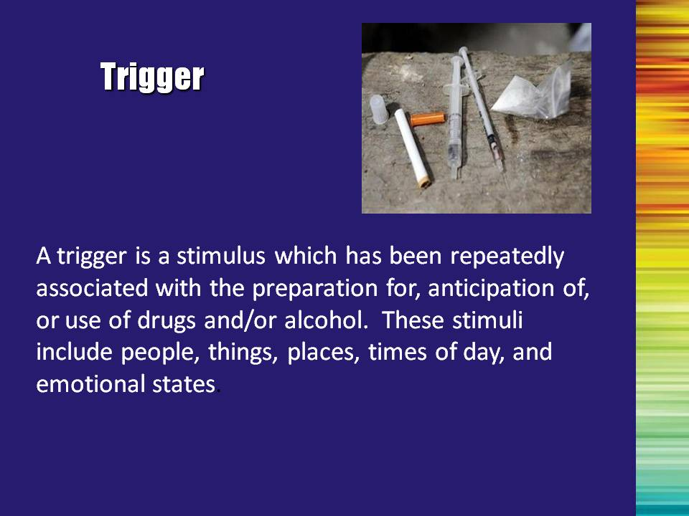 | Slide 5: Trigger  Read the definition of a trigger aloud. You can ask trainees to volunteer to give examples of triggers (places, people, things, times of the day, emotional states, etc.). | Slide 5
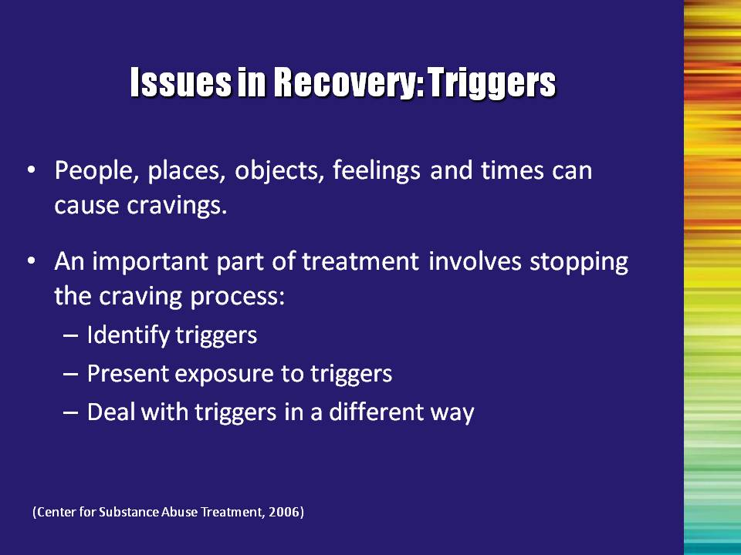 | Slide 6: Issues in Recovery: Triggers  Triggers are people, places, objects, feelings, and times that cause cravings. Your addicted brain associates the triggers with alcohol and drug use. For example, if every Friday night you cash a paycheck, go out with friends, and use drugs, the triggers might be:  - Friday night;  - After work;  - Money;  - Friends who use drugs; or  - The bar or club at which you hang out with your drug-using friends.  It is important to remember that triggers will affect a user’s brain and cause cravings even though the person has decided to stop using alcohol and drugs. An intention to stop using must translate into behavior changes, which will steer the person away from possible triggers.  Reference:  Center for Substance Abuse Treatment. Counselor’s Treatment Manual: Matrix Intensive Outpatient Treatment for People With Stimulant Use Disorders. DHHS Publication No. (SMA) 06-4152. Rockville, MD: Substance Abuse and Mental Health Services Administration, 2006, reprinted 2007. | Slide 6
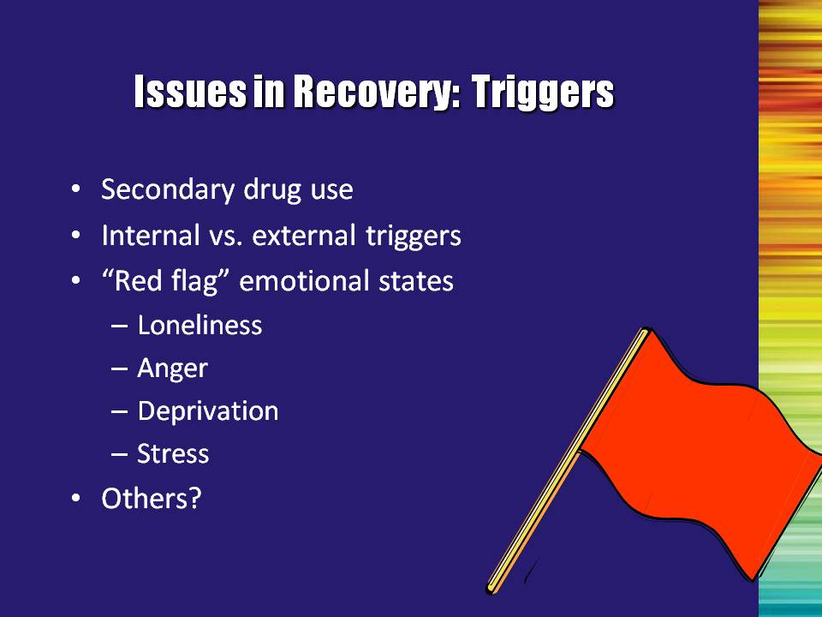 | Slide 7: Issues in Recovery: Triggers, Continued  There are two types of triggers – internal and external.  Internal triggers include:  - Feelings or emotions (afraid, confident, excited, inadequate, lonely, sad, bored, etc.).  External triggers include:  - Parties;  - Liquor stores;  - Driving past a dealer’s house;  - Payday; or  - Time of day.  You can ask trainees to volunteer additional examples of internal and external triggers. | Slide 7
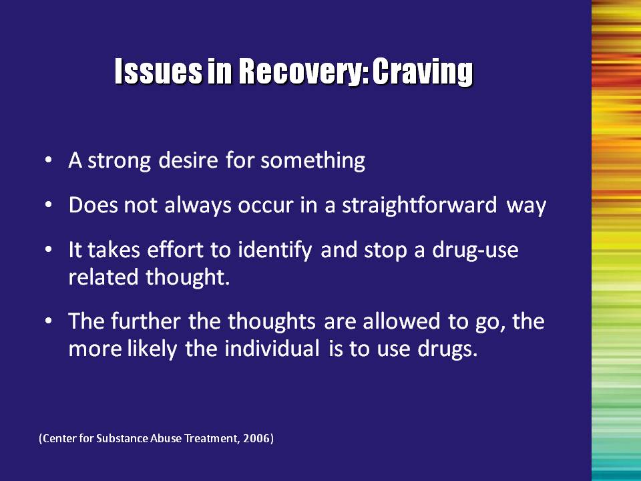 | Slide 8: Issues in Recovery: Craving  An important part of treatment involves stopping the craving process. To do this, the patient must: (1) identify triggers; (2) prevent exposure to triggers whenever possible; and (3) deal with triggers in a different way.  Bullet #1: Read the definition of craving  Bullet #2: Often, drug-using thoughts occur with little or no effort. It takes effort to identify and stop a thought.  Bullet #3: It is necessary to stop a drug-related thought before that thought becomes a full-blown craving. The further the thoughts are allowed to go, the more likely the person is to relapse.  Reference:  Center for Substance Abuse Treatment. Counselor’s Treatment Manual: Matrix Intensive Outpatient Treatment for People With Stimulant Use Disorders. DHHS Publication No. (SMA) 06-4152. Rockville, MD: Substance Abuse and Mental Health Services Administration, 2006, reprinted 2007. | Slide 8
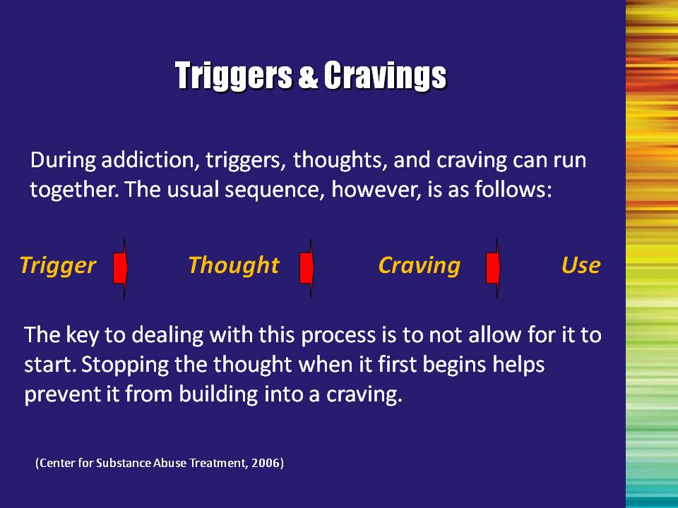 | Slide 9: Triggers and Cravings  This is a process; it is not automatic. Patients need to be told that they can control their thoughts, but it will take time and practice. It helps if the addiction professional finds a constructive way for patients to deconstruct the thought/using process.  To the actively using substance abuser and those in early recovery, the Trigger-Thought-Craving-Use sequence feels as if it happens simultaneously. You feel triggered, and you immediately want to use. Knowing about the specifics of this process can be very helpful to the recovering individual. The successful key in dealing with the process is to avoid it getting started.  It is extremely important to stop the thought when it first begins and to prevent it from building into an overpowering craving. It is vitally important to do this as soon as the patient recognizes the thought is occurring. This can be accomplished by using a number of Thought-Stopping techniques.  Reference:  Center for Substance Abuse Treatment. Counselor’s Treatment Manual: Matrix Intensive Outpatient Treatment for People With Stimulant Use Disorders. DHHS Publication No. (SMA) 06-4152. Rockville, MD: Substance Abuse and Mental Health Services Administration, 2006, reprinted 2007. | Slide 9
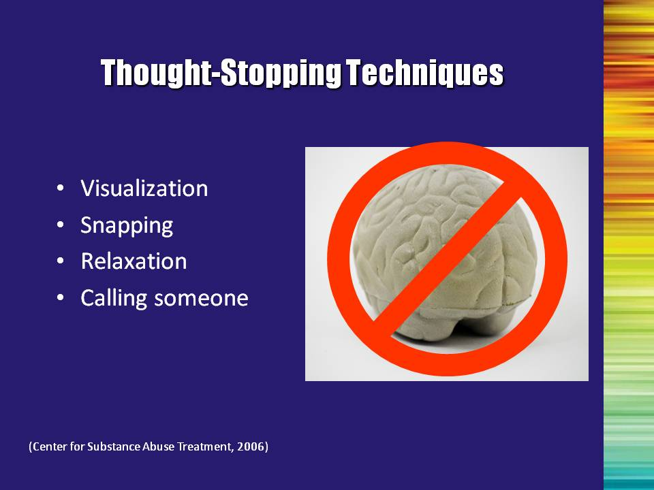 | Slide 10: Thought-Stopping Techniques  It is necessary to interrupt the thought process, by finding something to replace the drug/alcohol the patient uses. Here are examples of thought-stopping techniques:  Visualization: Picture a switch or lever in your mind. Imagine yourself actually moving it from ON to OFF to stop the drug or alcohol thoughts. Have another picture ready to think about in place of those thoughts. You may have to change what you are already doing to make the switch.  Snapping: Wear a rubber band loosely on your wrist. Each time you become aware of drug or alcohol thoughts, snap the band and say “NO” to the thoughts as you make yourself think about another subject.  Relaxation: Feelings of hollowness, heaviness, and cramping in the stomach are cravings. These can often be relieved by breathing in deeply and breathing out slowly.  Call someone: Talking to another person provides an outlet for your feelings and allows you to hear your own thought process. | Slide 10
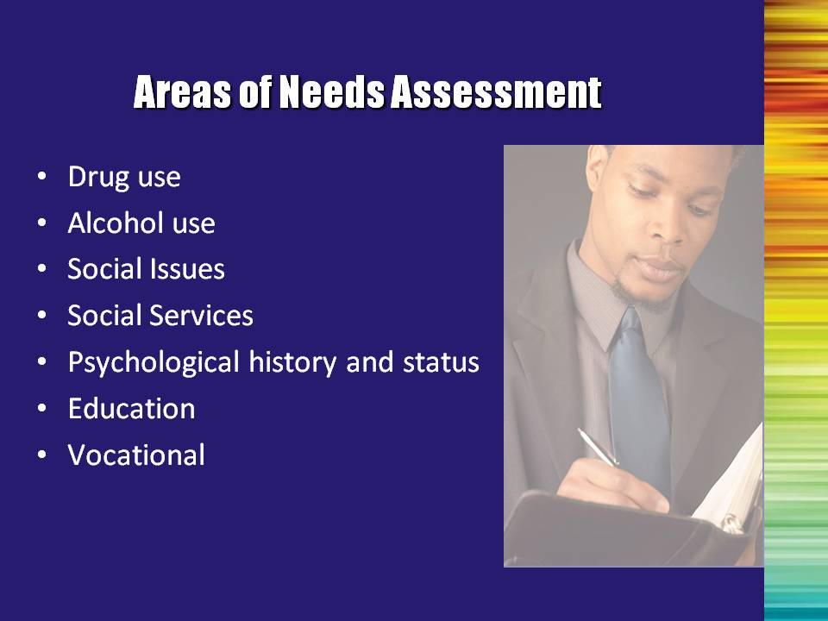 | Slide 11: Areas of Needs Assessment  Many opioid-addicted individuals have complicated lives. They often recognize the physical components of their addiction; however, they may not recognize the breadth of the disorder or the need to make changes in their lives.  A THOROUGH needs assessment is a useful process to help a buprenorphine patient identify problem areas beyond the immediate problem of their opioid addiction, and is an intricate part of the provision of quality care. Issues may come up during the needs assessment that weren’t previously discussed or assessed. The addiction professional should look at previous assessments that may have been done on the patient – this will help to find a balance and fill in any gaps, without being repetitive.  Social issues may include amount of drug and alcohol use in the social environment; unemployment; dependence on illegal sources of income; eligibility for public assistance; need for housing; and legal problems. | Slide 11
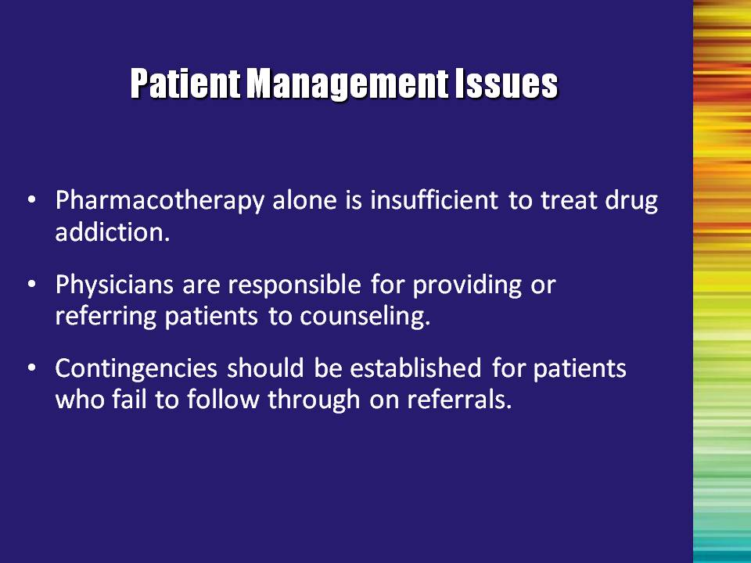 | Slide 12: Patient Management Issues  Bullet #1: Recovery is more than medication. Many buprenorphine patients may feel that once they have dealt with the physical aspect of their opioid addiction and have received a medication, they do not need additional treatment in the form of psychosocial counseling. At the same time, the addiction professional should not diminish the importance of medication compliance.  Bullet #2: Despite the fact that physicians must have the “capacity” to refer their patients for additional counseling, they may not have knowledge of the psychosocial treatment providers in their local community. Therefore, treatment providers may need to perform outreach to inform local physicians of their existence and of their willingness to collaborate in treating patients receiving buprenorphine.  Bullet #3: Contingencies should be established for patients who fail to follow through on referrals. | Slide 12
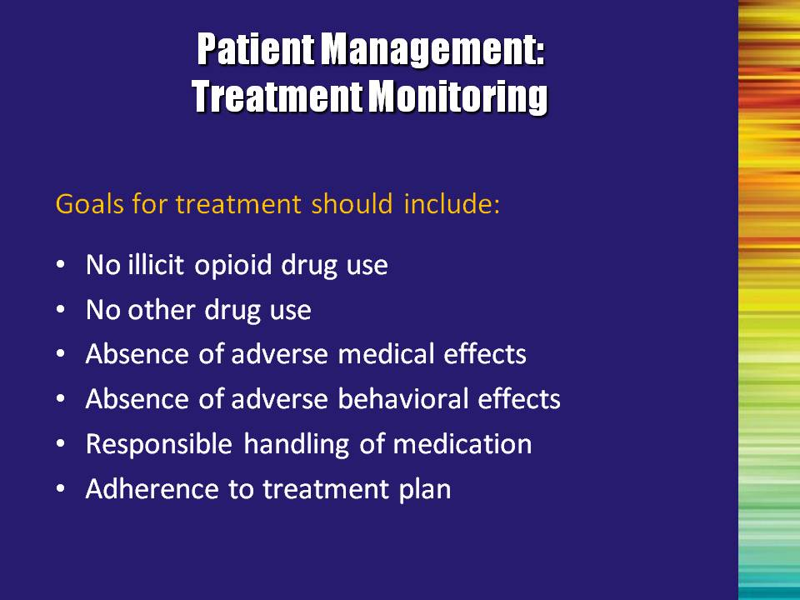 | Slide 13: Patient Management: Treatment Monitoring  Read the goals for treatment aloud. Mention that this list is not exhaustive, and ask the trainees to provide additional components of a comprehensive treatment plan.  Bullet #1: No illicit opioid drug use  Bullet #2: “No other drug use” may also include alcohol use. Different treatment programs handle the issue of alcohol use very differently. The important issue to keep in mind is that possible alcohol use should be assessed and the goals for treatment should be agreed upon by all of the treating professionals (physician, substance abuse counselor, etc.) and the patient.  Bullet #3: Absence of adverse medical effects  Bullet #4: Absence of adverse behavioral effects  Bullet #5: Responsible handling of medication  Bullet #6: Adherence to treatment plan | Slide 13
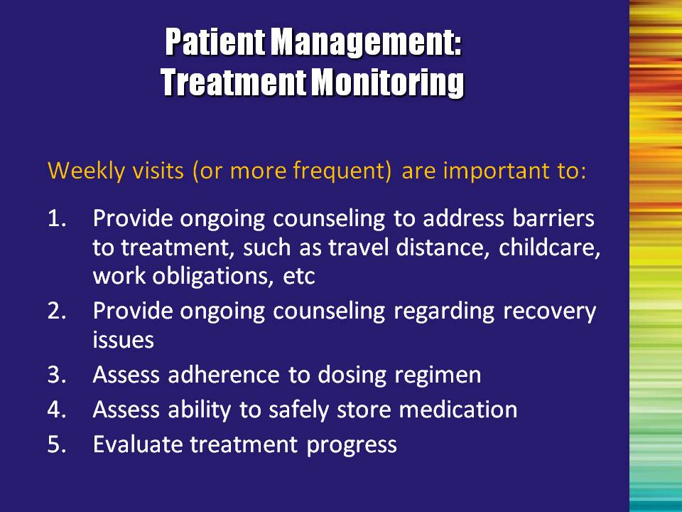 | Slide 14: Patient Management: Treatment Monitoring  Weekly visits are important – at least early on in the treatment and recovery process. During this time, it provides an opportunity for the addiction professional to:  - Provide ongoing counseling to address barriers to treatment, such as travel distance, childcare, work obligations, etc.;  - Provide ongoing counseling regarding recovery issues;  - Assess adherence to dosing regimen;  - Assess ability to safely store medication; and  - Evaluate treatment progress.  If medical issues are identified throughout the course of psychosocial treatment, be sure to refer those questions back to the treating physician. | Slide 14
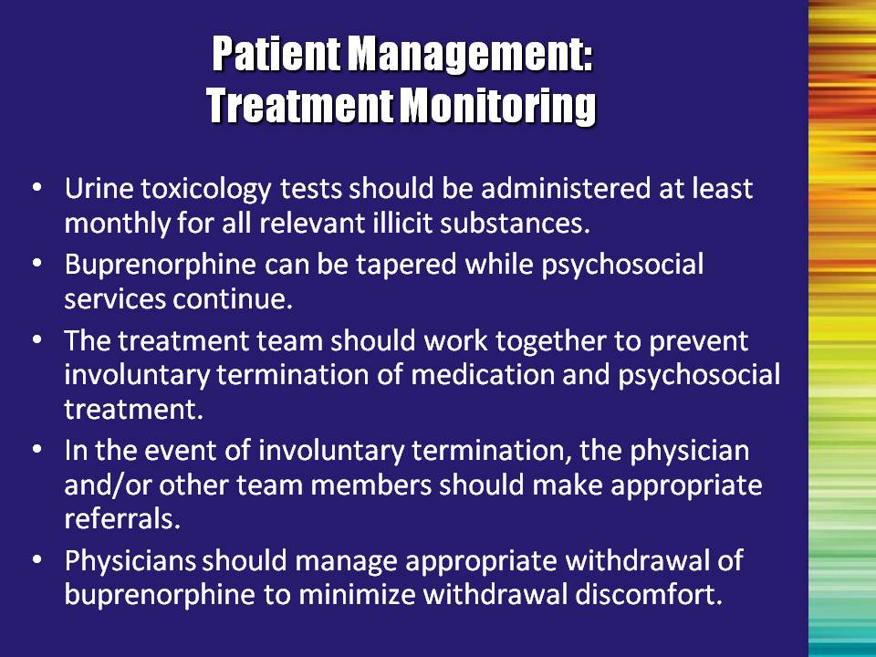 | Slide 15: Patient Management: Treatment Monitoring  Bullet #1: Urine toxicology testing (drug testing) is a common practice and is conducted primarily to assess treatment efficacy. The physician, counselor, and/or other staff may conduct urine testing. Testing provides the patient with an additional tool to prevent drug use. Counselors should stress that testing is a standard procedure that can help their treatment and is not a surveillance tool based on an assumption of patients’ dishonesty.  Bullet #2: It is not up to the addiction counselor to decide whether or not buprenorphine should be discontinued. Tapering off of buprenorphine is a medical decision, and should be reserved for the treating physician and patient to discuss.  Note to the Trainer(s): Bullets #3-5: The message here is that lines of communication between all treatment providers should remain open at all times, to ensure that the patient is receiving high-quality, comprehensive care.  Bullet 3: The treatment team should work together to prevent involuntary termination of medication and psychosocial treatment.  Bullet #4: In the event of involuntary termination, the physician and/or other team members should make appropriate referrals.  Bullet #5: Physicians should manage appropriate withdrawal of buprenorphine to minimize withdrawal discomfort. | Slide 15
 | Slide 16: Special Populations  The following discussion highlights a few of the many special populations, including patients with co-occurring psychiatric disorders, pregnant women, and adolescents. | Slide 16
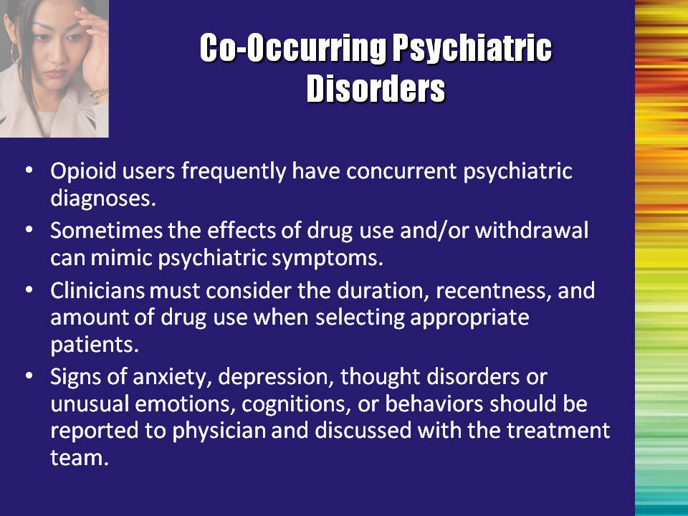 | Slide 17: Co-Occurring Psychiatric Disorders  Opioid users frequently have concurrent psychiatric diagnoses, ranging from anxiety or depressive disorders to antisocial personality disorder. However, drug effects and withdrawal symptoms can sometimes mimic psychiatric symptoms. It is necessary to consider the duration, how recent the drug use, and amount of drug use when making a psychiatric diagnosis.  Counselors should consult with the DSM-IV-TR to review “substance-induced disorders.” It is also necessary to review the patient’s psychiatric history, and consult with the buprenorphine-prescribing physician and other mental health providers.  Any of the following should prompt further action:  - Suicidal thoughts or plans;  - Extreme changes in mood;  - Extreme changes in sleep or activity patterns;  - Hyperactivity;  - Paranoid thinking;  - Hallucinations;  - Unresponsiveness; and/or  - Confusion. | Slide 17
 | Slide 18: Pregnancy-Related Considerations  Bullet #1: Methadone maintenance is the treatment of choice for pregnant opioid-addicted women.  Bullet #2: Pregnancy itself is traumatic to the body (especially if the woman is experiencing “morning sickness”). Generally, it is not recommended for a woman who is already in a vulnerable condition to go through any additional trauma/discomfort of withdrawing from an opioid. If withdrawal is indicated in the treatment plan, most physicians will urge the patient to wait until after delivery. Methadone plus behavioral treatment would then be considered for the immediate treatment plan.  Bullet #3: Buprenorphine may eventually be useful in pregnancy, but is currently not FDA approved.  Reference:  Jones, H. E., Johnson, R. E., Jasinski, D. R., O’Grady, K. E., Chisholm, C. A., Choo, R. E., … & Milio, L. (2005). Buprenorphine versus methadone in the treatment of pregnant opioid-dependent patients: Effects on the neonatal abstinence syndrome. Drug and Alcohol Dependence, 79, 1-10. | Slide 18
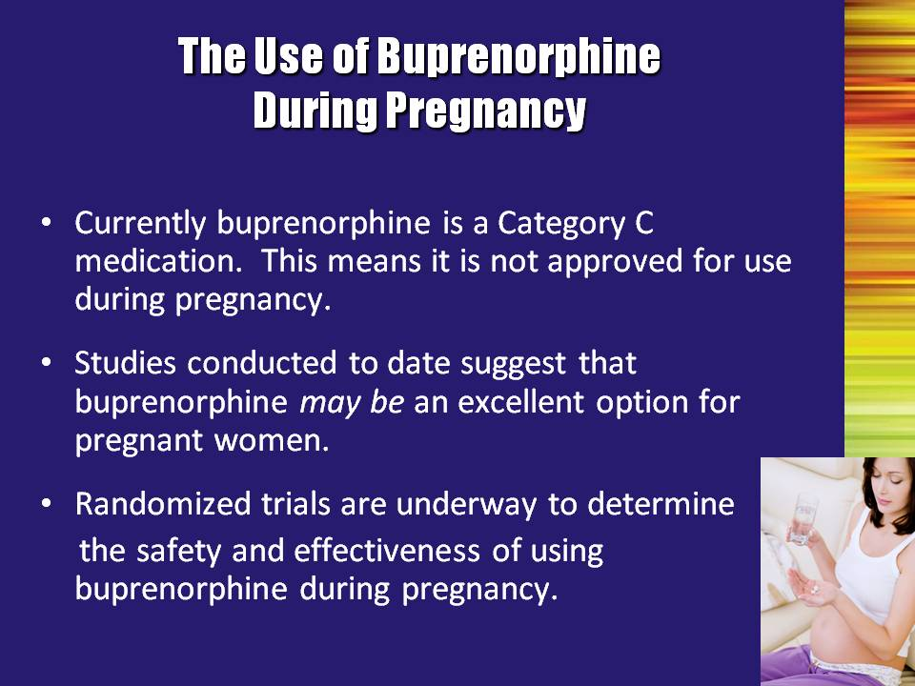 | Slide 19: The Use of Buprenorphine During Pregnancy  There is no evidence of any harmful effects of buprenorphine relative to pregnancy, but in the absence of controlled clinical trials, risk cannot be ruled out.  Bullet #1: Currently buprenorphine is a Category C medication. This means it is not approved for use during pregnancy.  Bullet #2: Studies conducted to date suggest that buprenorphine may be an excellent option for pregnant women.  Bullet #3: Randomized trials are underway to determine the safety and effectiveness of using buprenorphine during pregnancy. | Slide 19
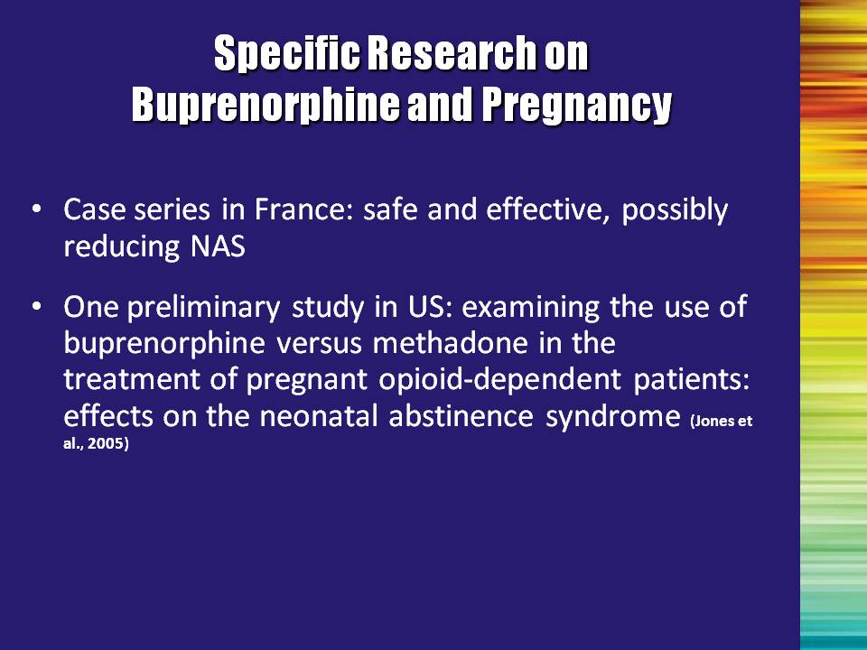 | Slide 20: Specific Research on Buprenorphine and Pregnancy  Research on the use of buprenorphine is limited. In a case series conducted in France, buprenorphine was found to be safe and effective and to possibly reduce neonatal abstinence syndrome (NAS).  There has been one preliminary study conducted in the United States by Jones and colleagues (2005). This study examined the use of buprenorphine versus methadone in the treatment of pregnant opioid-dependent patients and effects on NAS.  Reference:  Jones, H. E., Johnson, R. E., Jasinski, D. R., O’Grady, K. E., Chisholm, C. A., Choo, R. E., … Milio, L. (2005). Buprenorphine versus methadone in the treatment of pregnant opioid-dependent patients: Effects on the neonatal abstinence syndrome. Drug and Alcohol Dependence, 79, 1-10. | Slide 20
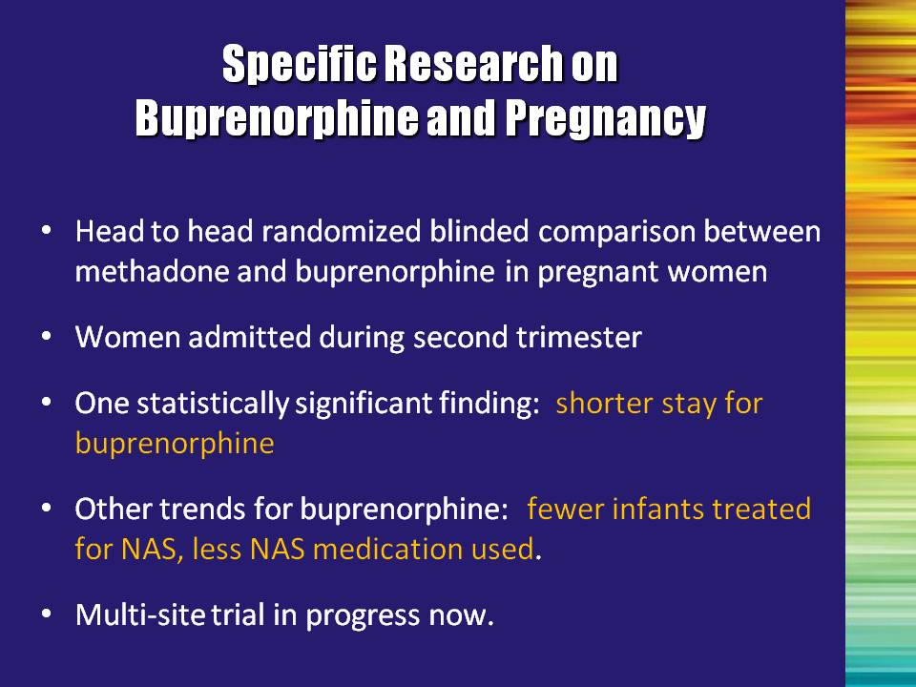 | Slide 21: Specific Research on Buprenorphine and Pregnancy  This research was conducted as a head to head randomized, blinded comparison between methadone and buprenorphine in pregnant women. Women were admitted during their second trimester.  One statistically significant finding was that the length of hospitalization was shorter for buprenorphine-exposed neonates than for methadone-exposed neonates.  Other trends showed that fewer buprenorphine-exposed infants were treated for neonatal abstinence syndrome; of those treated for NAS, less medication was administered.  Results suggest that buprenorphine is not inferior to methadone on outcome measures assessing NAS and maternal and neonatal safety when administered starting in the second trimester of pregnancy.  A multi-site trial is now in progress.  Reference:  Jones, H. E., Johnson, R. E., Jasinski, D. R., O’Grady, K. E., Chisholm, C. A., Choo, R. E., … Milio, L. (2005). Buprenorphine versus methadone in the treatment of pregnant opioid-dependent patients: Effects on the neonatal abstinence syndrome. Drug and Alcohol Dependence, 79, 1-10. | Slide 21
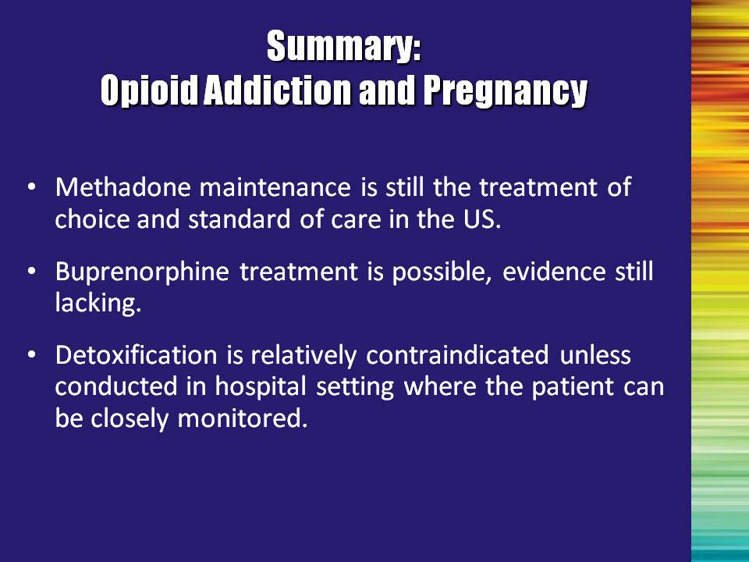 | Slide 22: Summary: Opioid Addiction and Pregnancy  Bullet #1: Methadone maintenance is still the treatment of choice and standard of care in the United States.  Bullet #2: Buprenorphine treatment is possible, evidence still lacking.  More research is needed before buprenorphine is approved for this indication. In the meantime, it can be used off-label if methadone is not available or appropriate AND the benefits of treatment outweigh the risk of using this medication.  Note to the Trainer(s): In cases where it is determined that the benefits of buprenorphine treatment during pregnancy outweigh the risks, it is important to utilize the mono-product to minimize the chance of precipitated withdrawal.  Bullet #3: Detoxification is generally contraindicated unless conducted in a hospital setting where the patient can be closely monitored.  In general, complete withdrawal from opioids is contraindicated. If indicated:  - It should be done in a hospital with careful monitoring.  - Risk of relapse is high and detrimental; ongoing care with monitoring is essential. | Slide 22
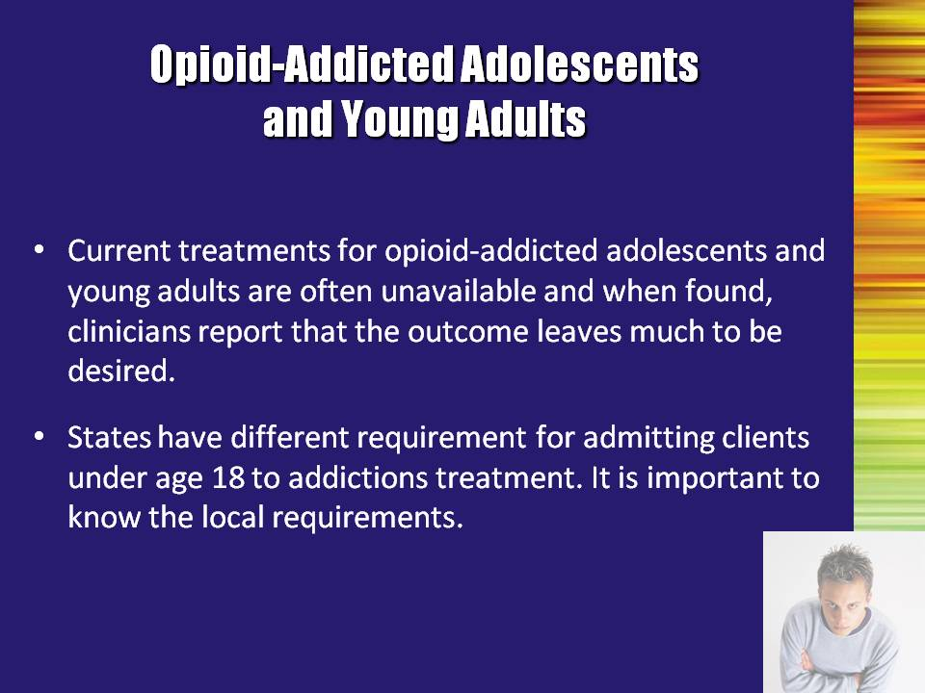 | Slide 23: Opioid-Addicted Adolescents and Young Adults  Reiterate the importance of finding out the local requirements regarding opioid treatment for individuals under age 18. | Slide 23
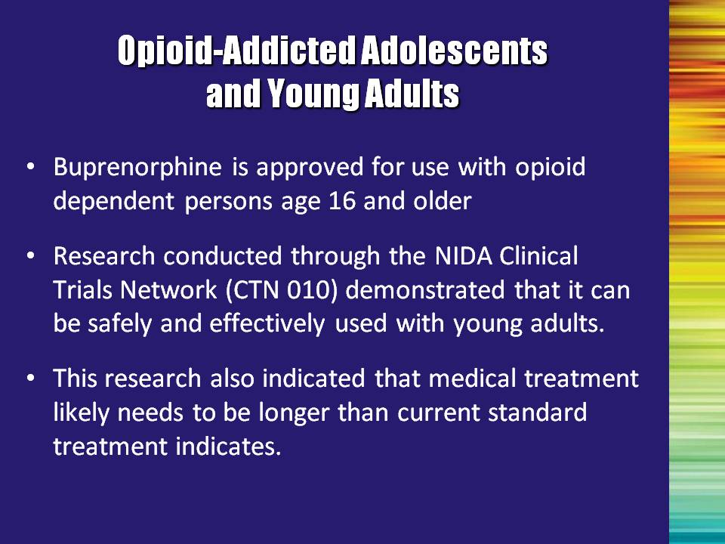 | Slide 24: Opioid-Addicted Adolescents and Young Adults  Buprenorphine is approved for use with opioid dependent persons age 16 and older. Research conducted through the NIDA Clinical Trials Network (CTN) had demonstrated that it can be safely and effectively used with adolescents and young adults.  Note to the Trainer(s): This information is a very brief summary of using buprenorphine with adolescents. For a more detailed explanation including results from the NIDA CTN Study, insert optional Buprenorphine Treatment for Young Adults Module here. | Slide 24
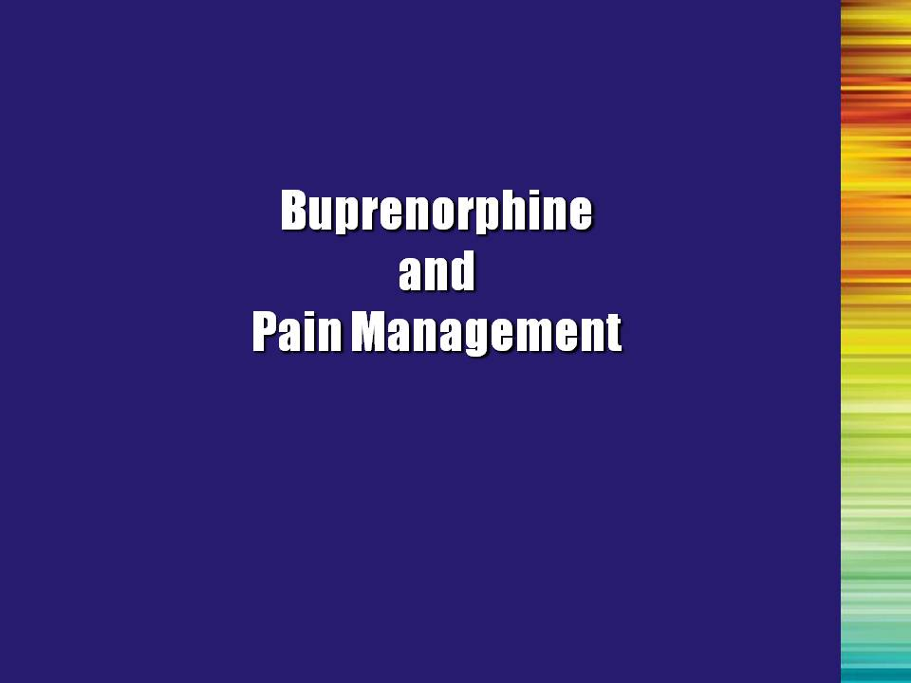 | Slide 25: Buprenorphine and Pain Management  The next two slides will briefly address medication-assisted treatment and pain management | Slide 25
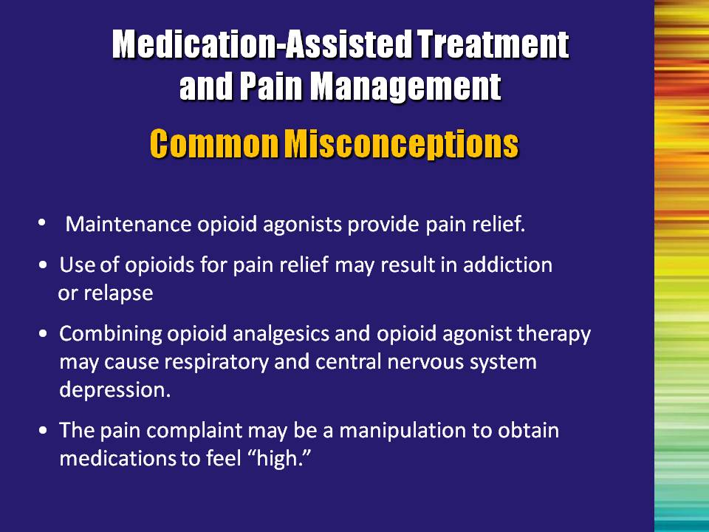 | Slide 26: Medication-Assisted Treatment and Pain Management – Common Misconceptions  Bullet #1: Maintenance opioid agonists (methadone or buprenorphine) provide pain relief.  Pain relief depends on maintaining the established tolerance (i.e., maintenance of the methadone dose) with an opioid agonist and providing additional pain relief.  Note to the Trainer(s): Stress the importance of understanding that long-term use of opioids is associated with neurological changes, thus the analgesic effects of these medications may diminish; and that the treatment profiles of opioid medications differ.  Bullet #2: Use of opioids for pain relief may result in addiction or relapse.  A common concern of primary care providers is that the use of opioids for pain relief in patients receiving opioid agonist therapy may result in relapse to active drug use. However, there is no evidence that relapse rates increase secondary to exposure to opioid analgesics in the presence of acute pain. In fact, relapse prevention theories would suggest that the stress associated with unrelieved pain is more likely to be a trigger for relapse than adequate analgesia  Bullet #3: Combining opioid analgesics and opioid agonist therapy may cause respiratory and central nervous system (CNS) depression.  Primary health care providers are often concerned that combining opioid analgesics and opioid agonist therapy will cause respiratory or CNS depression. This has never been clinically demonstrated. In fact, tolerance to side effects develops quickly, thus allowing doses to be increased as necessary to achieve effective pain relief. | Slide 26
 | Slide 26: Medication-Assisted Treatment and Pain Management – Common Misconceptions, Continued  Bullet #4: The pain complaint may be a manipulation to obtain medications to feel “high.”  It can be difficult to distinguish between a patient’s desire to use opioids for pain relief and their desire to feel “high.” This may be especially true in patients who have become physically dependent secondary to the treatment of a pain condition. A careful assessment will assist in determining the appropriate treatment plan. For additional information regarding the clinical features that distinguish opioid use in patients with pain versus patients who are addicted to opioids, please refer to TIP 40: Clinical Guidelines for the Use of Buprenorphine in the Treatment of Opioid Addiction.  References: Bullet #1  Alford, D. P., Compton, P., & Samet, J. H. (2006). Acute pain management for patients receiving maintenance methadone or buprenorphine therapy. Annals of Internal Medicine, 144, 127-134.  Zweben, J. E.. & Payte, J. T. (1990). Methadone maintenance in the treatment of opioid dependence. A current perspective. Western Journal of Medicine, 152, 588-599.  Reference: Bullet #2  Alford, D. P., Compton, P., & Samet, J. H. (2006). Acute pain management for patients receiving maintenance methadone or buprenorphine therapy. Annals of Internal Medicine, 144, 127-134.  References: Bullet#3  Alford, D. P., Compton, P., & Samet, J. H. (2006). Acute pain management for patients receiving maintenance methadone or buprenorphine therapy. Annals of Internal Medicine, 144, 127-134.  Savage, S. R., Kirsh, K. L., & Passik, S. D. (2008). Challenges in using opioids to treat pain in persons with substance use disorders. Addiction Science & Clinical Practice, 4(2), 4-25.  References: Bullet #4  Alford, D. P., Compton, P., & Samet, J. H. (2006). Acute pain management for patients receiving maintenance methadone or buprenorphine therapy. Annals of Internal Medicine, 144, 127-134.  Center for Substance Abuse Treatment. (2004). Clinical Guidelines for the Use of Buprenorphine in the Treatment of Opioid Addiction. Treatment Improvement Protocol (TIP) Series 40 (DHHS Publication No. (SMA) 04-3939. Rockville, MD: Substance Abuse and Mental Health Services Administration. | Slide 26
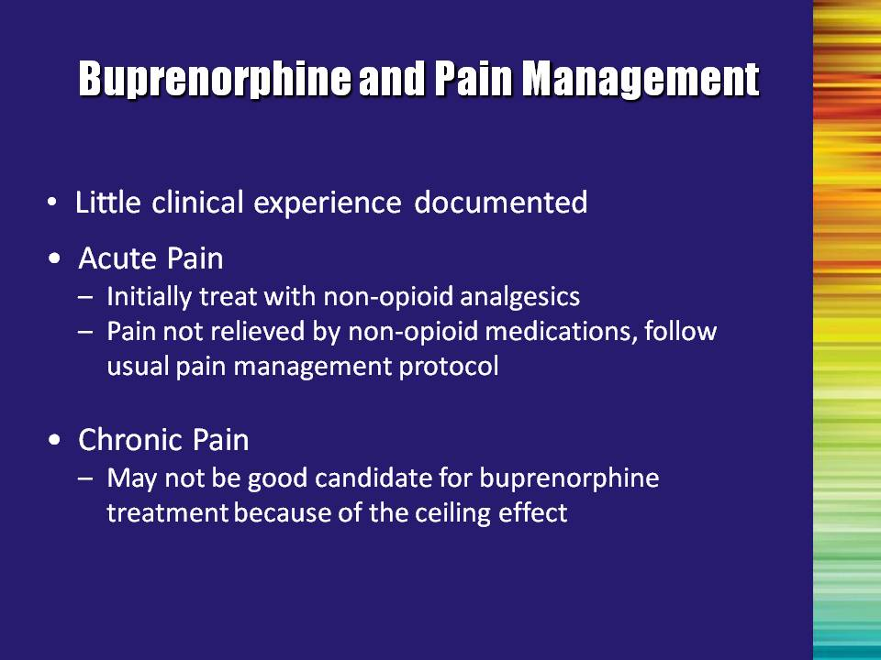 | Slide 27: Buprenorphine and Pain Management  Little clinical experience is documented regarding the treatment of pain in patients receiving buprenorphine. Patients receiving buprenorphine who are experiencing pain should initially be treated with non-opioid analgesics when appropriate.  If acute pain is not relieved by non-opioid medications, patients should receive the usual pain management protocol, which may include the use of short-acting opioid pain relievers. It is important to note that the administration of buprenorphine should be discontinued while patients are receiving opioid pain medications.  As when initially inducting a patient onto buprenorphine, administration should not begin until sufficient time has elapsed for the opioid pain medication to have cleared from the patient’s system, as demonstrated by the onset of early withdrawal symptoms. If buprenorphine is started prior to the opioid pain medication clearing from the patient’s system, acute withdrawal may be precipitated.  Patients receiving long-acting opioids for chronic severe pain may not be good candidates for buprenorphine treatment because of the ceiling effect.  Reference:  Center for Substance Abuse Treatment. (2004). Clinical Guidelines for the Use of Buprenorphine in the Treatment of Opioid Addiction. Treatment Improvement Protocol (TIP) Series 40 (DHHS Publication No. (SMA) 04-3939. Rockville, MD: Substance Abuse and Mental Health Services Administration. | Slide 27
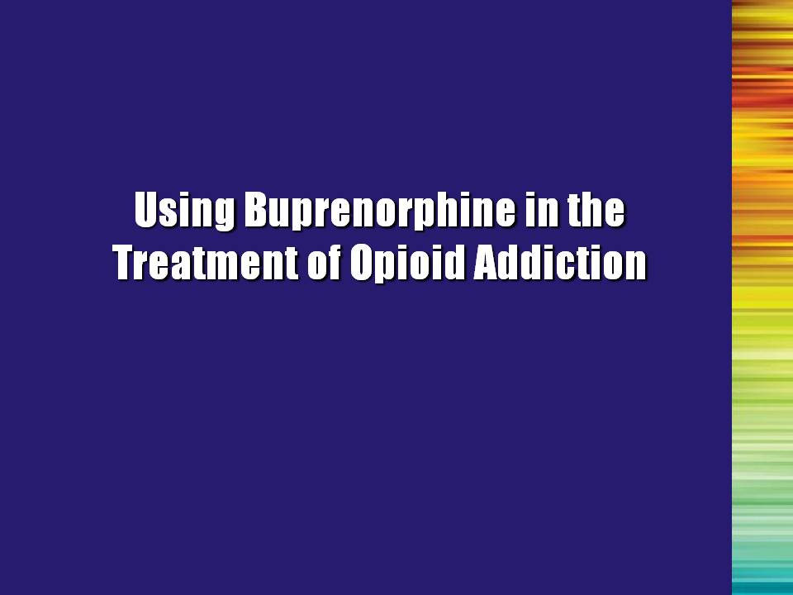 | Slide 28: Buprenorphine in the Treatment of Opioid Addiction (Transition Slide)  We will spend the rest of the training reviewing various approaches used in treating opioid-addicted individuals. | Slide 28
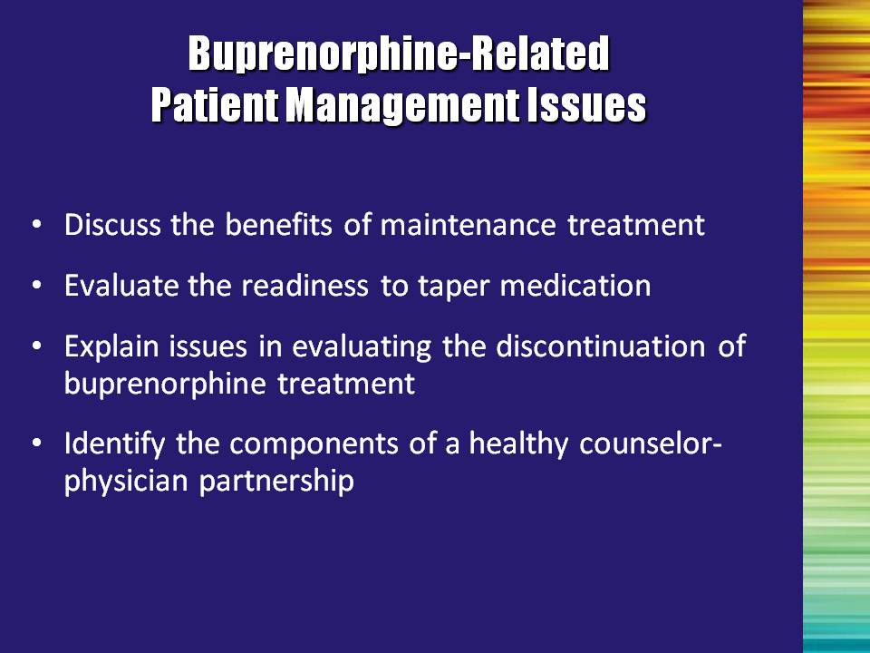 | Slide 29: Buprenorphine-Related Patient Management Issues  Bullet #1: Discuss the benefits of maintenance treatment  Bullet #2: With regards to evaluating readiness to taper medication, ask the patient if:  - He/she has had previous attempts at medically supervised withdrawal. If so, have the attempts been successful or unsuccessful?  - Illicit opioids are avoidable or unavoidable in his/her living or working situation.  - His/her living situation is stable or unstable.  Bullet #3: Explain issues in evaluating the discontinuation of buprenorphine treatment  Bullet #4: When collaborating with a physician, the multidisciplinary addiction professional should:  - Develop open, ongoing lines of communication;  - Avoid manipulation; and  - Support the physician (not work against him/her). | Slide 29
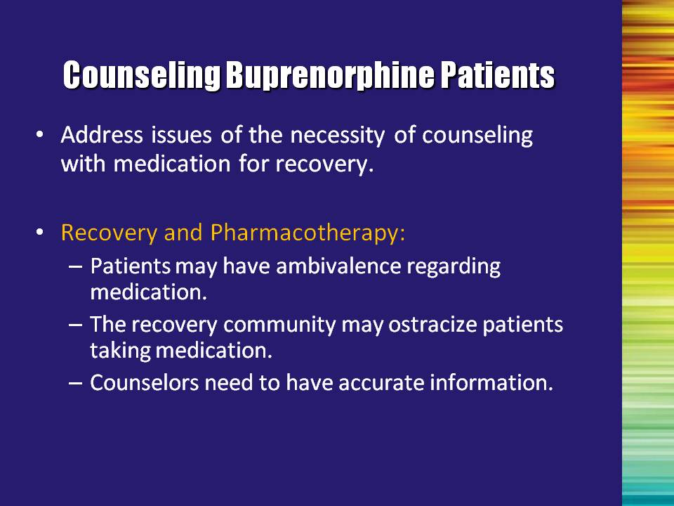 | Slide 30: Counseling Buprenorphine Patients  Note to the Trainer(s): Again, it is important to stress that the multidisciplinary addiction professional should work with, not against, the medication. | Slide 30
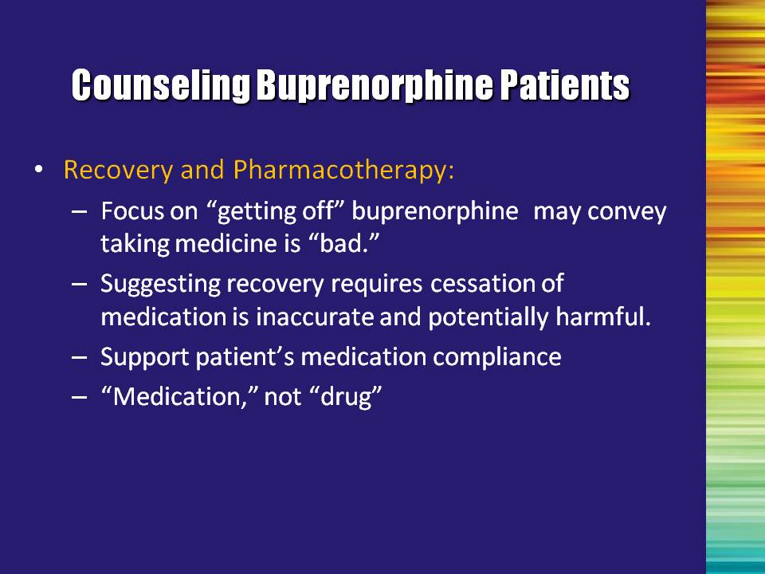 | Slide 31: Counseling Buprenorphine Patients  Suggesting the need to discontinue medication can convey the idea that the medication is a necessary evil and somehow wrong. It is important to refer to buprenorphine as a medication and frame it as one component of the comprehensive opioid treatment plan. | Slide 31
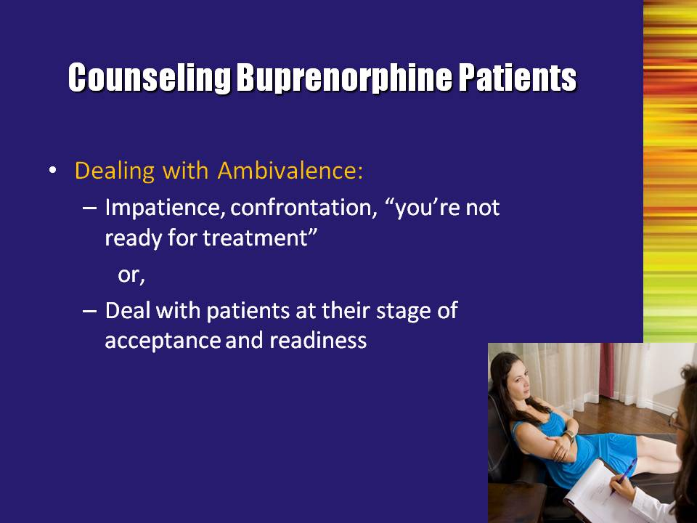 | Slide 32: Counseling Buprenorphine Patients  Some patients are ambivalent about or averse to medication. They may acquire negative attitudes from previous treatment experiences, methadone-related stigma, or from other people in recovery who are using medications.  Medication is not essential to a treatment plan or the recovery process, and in fact, effective treatment and recovery can occur without it. However, it is important to talk with the patient about the realities of withdrawal and the low success rate of people who try it without medical assistance. Counselors can help patients by dispelling myths about buprenorphine and providing accurate information about the use of buprenorphine for treating opioid addiction. | Slide 32
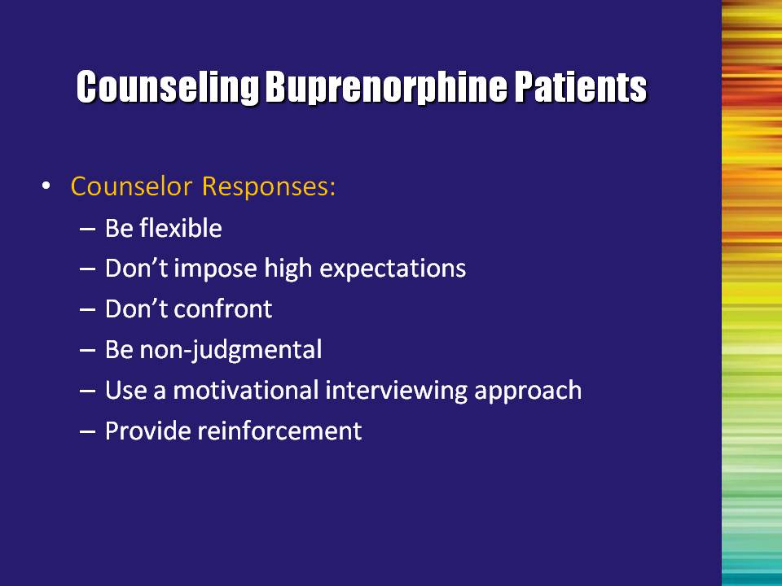 | Slide 33: Counseling Buprenorphine Patients  Be flexible: An opioid-addicted person’s life is often out of control. The transition from active drug use to recovery via buprenorphine treatment is a major lifestyle change. Patients may be late for appointments, reschedule, or fail to show. Applying rigid standards and expressing disapproval may prompt patients to feel negatively about counseling, and they may choose to avoid appointments or discontinue psychosocial treatment altogether.  Don’t impose high expectations: Patients who have taken steps to address their drug addiction have already achieved a significant accomplishment. An immediate major change in the person’s general lifestyle may be an unrealistic expectation.  Don’t confront: Instead of being confrontational, it is better to develop discrepancy (which is a gentler counseling approach). Direct and harsh confrontation is more likely to drive a person out of treatment than to maintain them in treatment.  Non-judgmental acceptance: Drug addiction is associated with many unappealing behaviors, such as lying, stealing, and unreliability. Some of these behaviors may continue during treatment. View these behaviors as symptoms of the drug problem. Do not be critical or judgmental.  Utilize a motivational interviewing approach (this topic is covered in more detail in a few more slides). | Slide 33
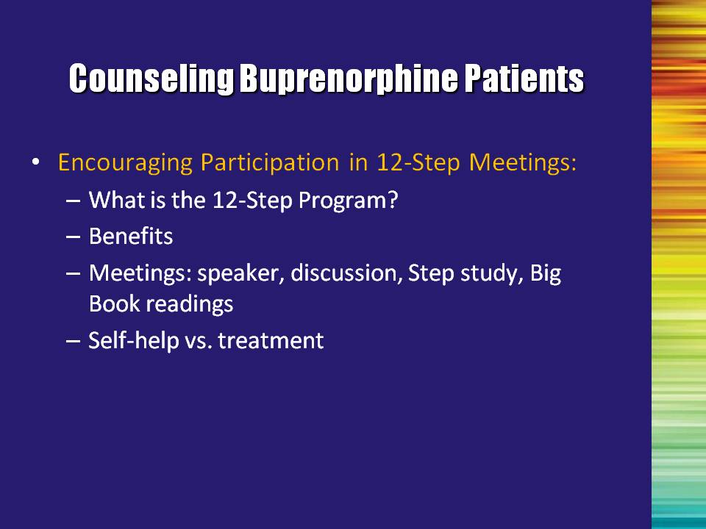 | Slide 34: Counseling Buprenorphine Patients  What is the 12-Step program?: Two men who were unable to deal with their own alcoholism through psychiatry or medicine founded Alcoholics Anonymous (AA) in the 1930s. They discovered several principles that helped people overcome their addictions. They founded AA to introduce alcoholics to these principles of self-help.  The AA principles and concepts have been adapted for addiction to opioids, stimulants, other drugs, and even to compulsive behaviors such as gambling, overeating, and sex.  Benefits of participating in 12-Step meetings: Many treatment providers believe that participating in 12-Step meetings can be an important component of buprenorphine treatment. Individuals addicted to alcohol and drugs have found that other addicted persons in recovery can provide enormous support and help to one another. In addition, meetings are free, and are generally available throughout the day and in the evening. 12-Step meetings can be found throughout the world.  Types of meetings: Speaker meetings (recovering person tells his/her story); topic meetings (discuss a specific topic, such as fellowship, honesty, acceptance, or patience); and step/tradition meetings (the 12 steps and 12 traditions are discussed).  Some people are able to stop using substances through 12-Step participation alone. However, for many, this self-help approach is not enough. In this case, participation in 12-step meetings may be a valuable adjunct to other medical and/or psychosocial treatment. | Slide 34
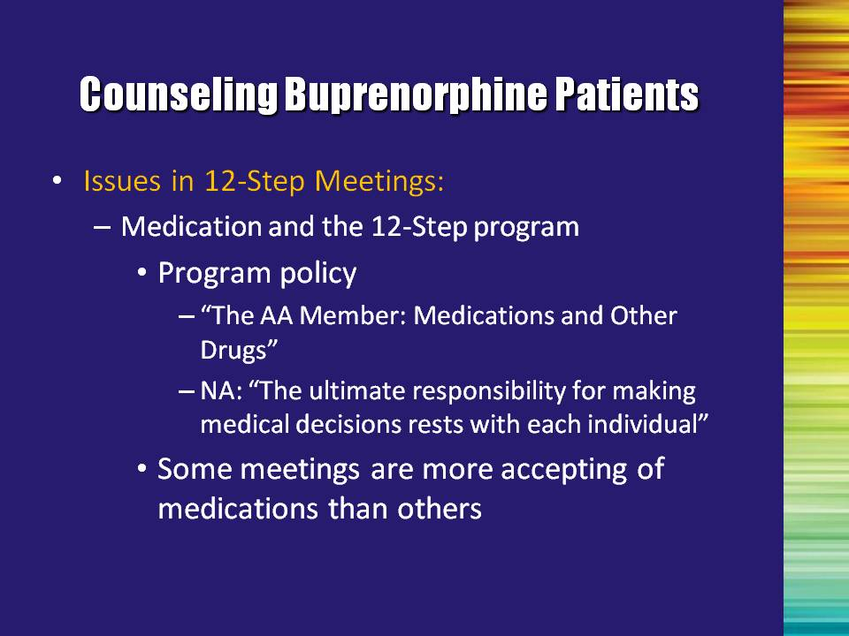 | Slide 35: Counseling Buprenorphine Patients  Some patients may have had negative experiences in the past at 12-Step meetings because they were taking medication for their drug addiction or for psychiatric disorders.  Although 12-Step programs accept people who are taking medications, some 12-Step participants do not discriminate between drugs of abuse and appropriately used medications, and are therefore intolerant of medication-taking individuals.  AA has developed an AA-approved publication called “The AA Member – Medications and Other Drugs.” Addiction professionals should become familiar with this publication.  Addiction professionals can help patients by educating them about the official position of 12-Step programs regarding the use of prescribed medications, describing the benefits of 12-Step programs, and promoting the use of these self-help programs as part of their overall recovery process.  Despite the official views of 12-Step programs, patients may need to seek 12-Step meetings that include members who are accepting of the use of properly prescribed medication.  12-Step Meetings are one source of social support. However, these meetings may not work for everyone. Providers generally recommend to these patients in treatment that they find some source of support to help them in the recovery process (e.g., other self-help meetings, churches, recreational groups, etc.). | Slide 35
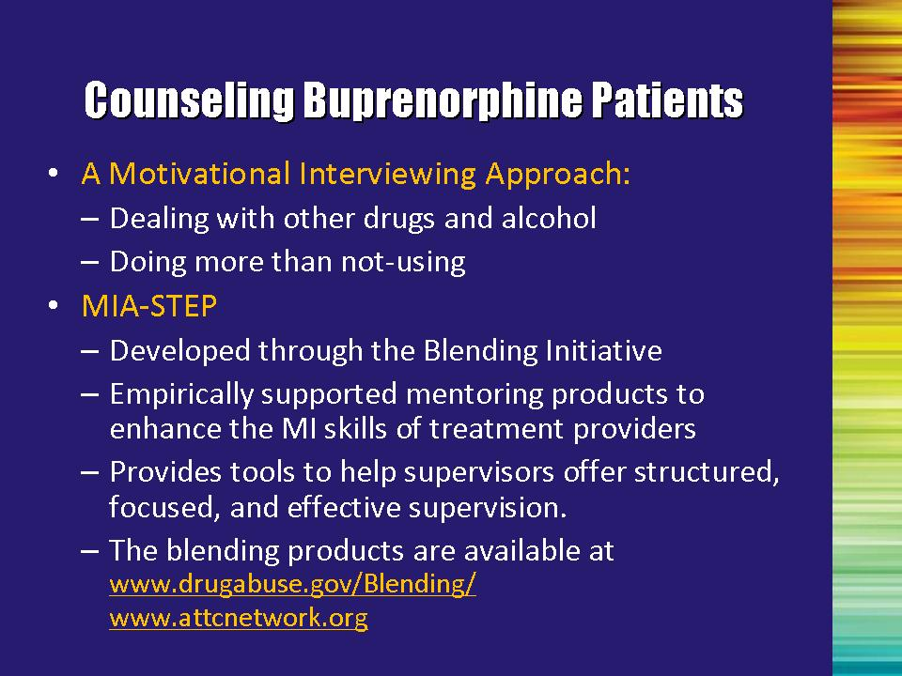 | Slide 36: Counseling Buprenorphine Patients  Patients receiving buprenorphine may not be ready to stop using illicit drugs and alcohol. Even patients expressing the desire to stop using will have ambivalent feelings about the change process. Motivational Interviewing (MI) and Motivational Enhancement Therapy (MET) are therapeutic approaches to help patients move more quickly through the process of change (Prochaska & DiClemente, 1982).  Miller and Rollnick (1995) developed these client-centered, yet directive approaches, which are designed to explore and reduce the inherent ambivalence regarding change. These approaches rely on the Stages of Change model as the theoretical foundation for understanding the change process.  The Motivational Interviewing Assessment: Supervisory Tools for Enhancing Proficiency (MIA:STEP) Blending Product was developed through the Blending Initiative. The MIA:STEP Blending Team designed empirically supported mentoring products to enhance the MI skills of treatment providers, as well as supervisory tools to fortify a supervisor’s ability to provide structured, focused, and effective clinical supervision. MIA: STEP introduces an effective strategy for observation-based clinical supervision, the use of which has potential to improve counselor skills beyond MI.  This Blending Product is available at :  - www.drugabuse.gov/Blending/  - www.attcnetwork.org  Reference:  Prochaska, J. O, & DiClemente, C. C. (1982). Transtheorectical therapy: Toward a more integrative model of change. Psychotherapy: Theory, Research and Practice, 19(3), 161-173.  Rollnick, S., & Miller, W. R. (1995). What is motivational interviewing? Behavioural and Cognitive Psychotherapy, 23, 325-334. | Slide 36
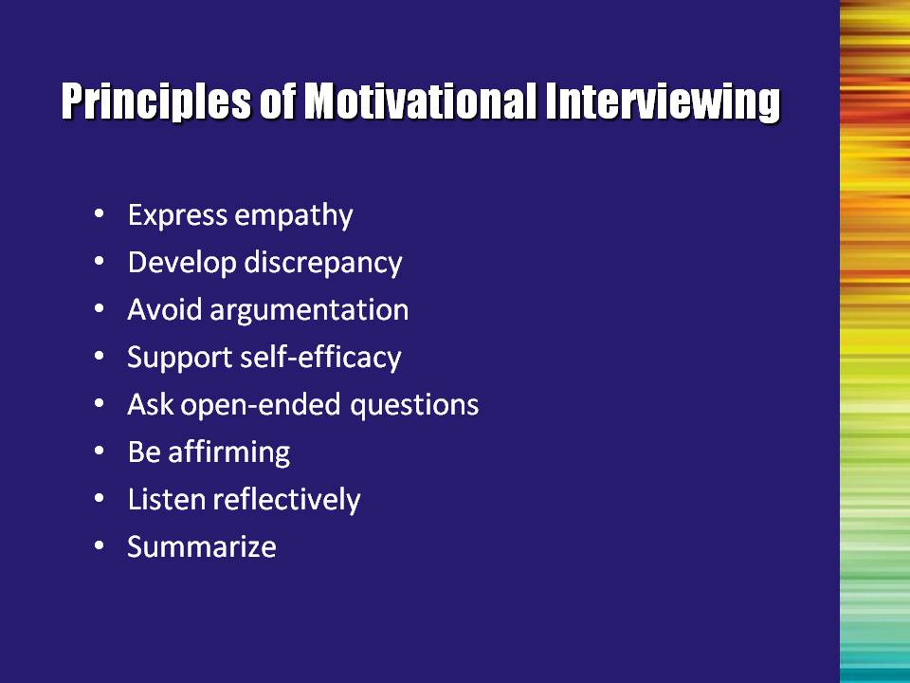 | Slide 37: Principles of Motivational Interviewing  With MI, the counselor has certain goals in mind when conducting patient interviews. These goals are formulated with an awareness of the underlying principles of the approach. When strategizing an intervention, the counselor should try to:  - Express empathy;  - Develop discrepancy;  - Avoid argumentation; and  - Support self-efficacy.  Achieving these goals and helping people to move through the Stages of Change are accomplished by using the microskills of MI. They are:  - Asking open-ended questions;  - Being affirming;  - Listening reflectively; and  - Summarizing.  Becoming adept in the use of MI takes practice. For more information on the use of MI, please refer to TIP 35: Enhancing Motivation for Change in Substance Abuse Treatment.  Reference:  Center for Substance Abuse Treatment. (1999). Enhancing Motivation for Change in Substance Abuse Treatment. Treatment Improvement Protocol (TIP) Series 35. DHHS Publication No. (SMA) 99-3354. Rockville, MD: Substance Abuse and Mental Health Services Administration. | Slide 37
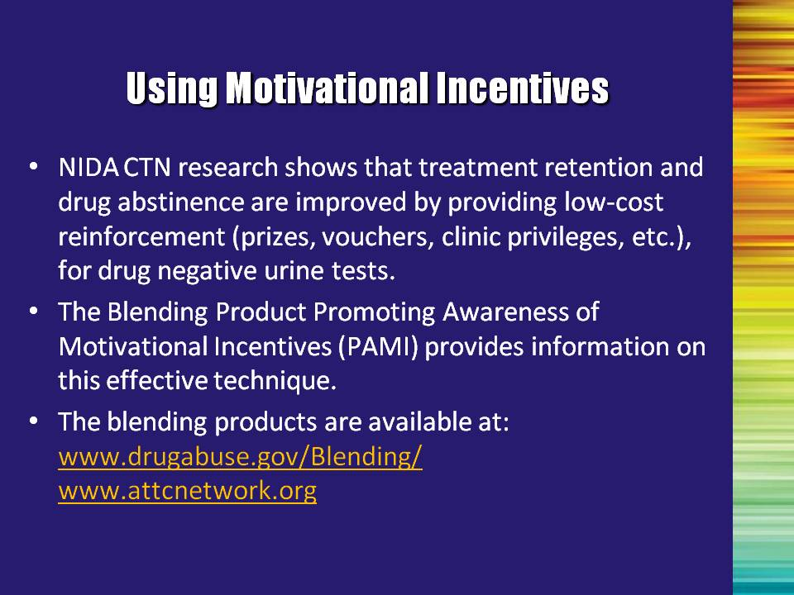 | Slide 38: Using Motivational Incentives  Research has shown that motivational incentive programs that use low-cost reinforcement (prizes, vouchers, clinic privileges, etc.), delivered in conjunction with on-site urine screening promotes higher rates of treatment retention and abstinence from drug abuse.  Promoting Awareness of Motivational Incentives (PAMI) Blending Product, developed through the Blending Initiative is based on the positive research outcomes and lessons learned from the NIDA CTN study, Motivational Incentives for Enhanced Drug Abuse Recovery (MIEDAR). The tools contained in this training package are designed to build awareness of motivational incentives as a research-based therapeutic strategy within the addiction treatment field.  This Blending Product is available at :  www.drugabuse.gov/Blending/  www.attcnetwork.org | Slide 38
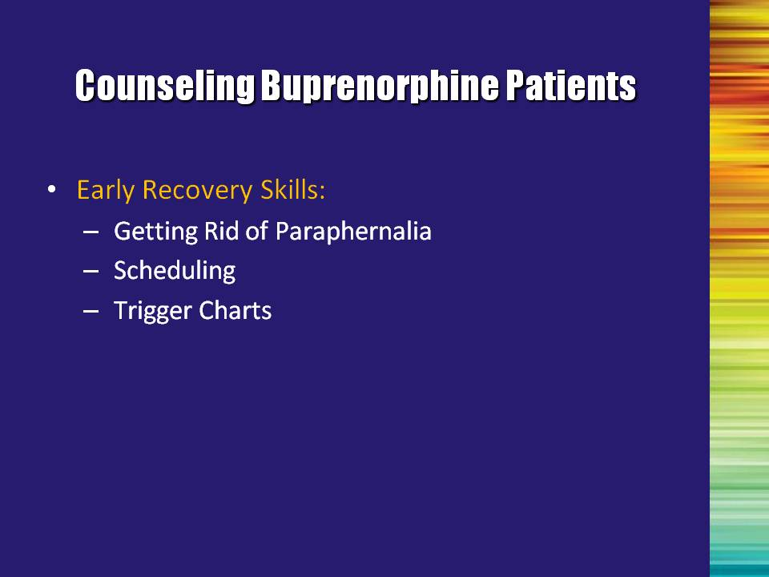 | Slide 39: Counseling Buprenorphine Patients  Early Recovery Skills: Addiction professionals can help patients by educating them about the importance of developing skills related to drug cessation, early recovery, and relapse prevention.  Professionals can help patients through the recovery process by educating them about the need to discard drug paraphernalia, address triggers and cravings, understand addictive behaviors and thinking, avoid relapse drift, not focus on willpower, and address ignored responsibilities. Likewise, addiction professionals have an important role in helping patients to resume optimal health and hygiene, make amends, deal with intense emotions, and engage in healthy recreation activities. | Slide 39
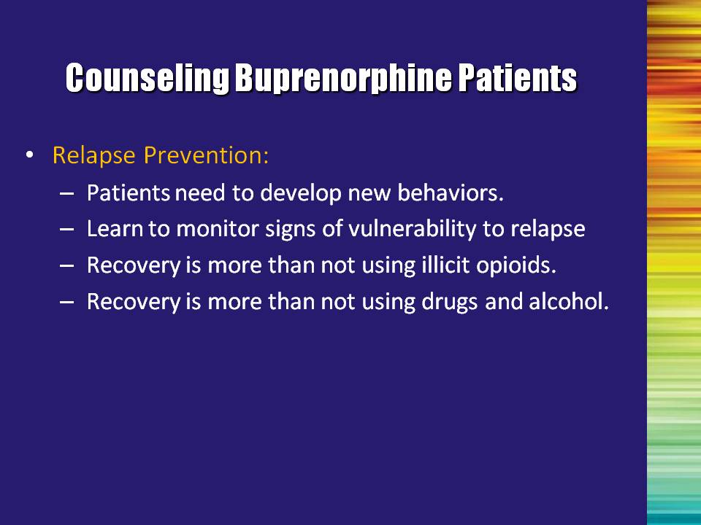 | Slide 40: Counseling Buprenorphine Patients  Relapse does not suddenly occur. It occurs gradually and with warning signs. The gradual movement can be subtle and easily explained away or denied, and therefore, relapse can feel as if it occurred suddenly and without warning.  Relapse prevention involves the following:  Review the bullet points.  Bullet #1: Patients need to develop new behaviors.  Bullet #2: Learn to monitor signs of vulnerability to relapse.  Bullet #3: Recovery is more than not using illicit opioids.  Bullet #4: Recovery is more than not using drugs and alcohol. | Slide 40
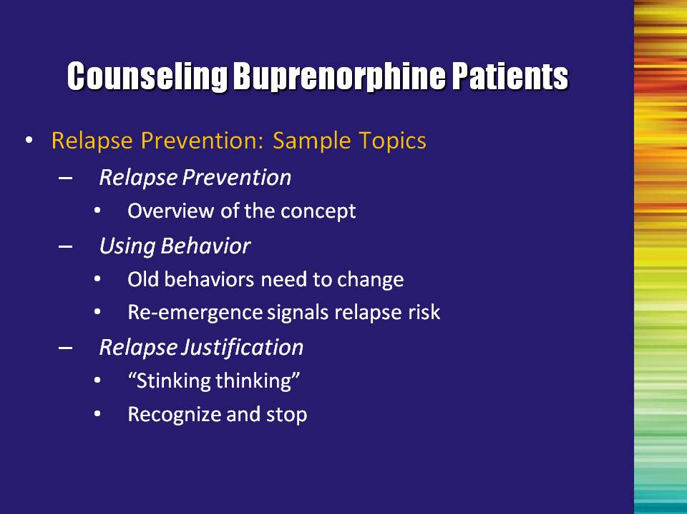 | Slide 41: Counseling Buprenorphine Patients  Because relapse is a common occurrence during the process of substance abuse recovery, it is imperative that it be examined carefully.  Read through the sample topics and move on to the next slide. | Slide 41
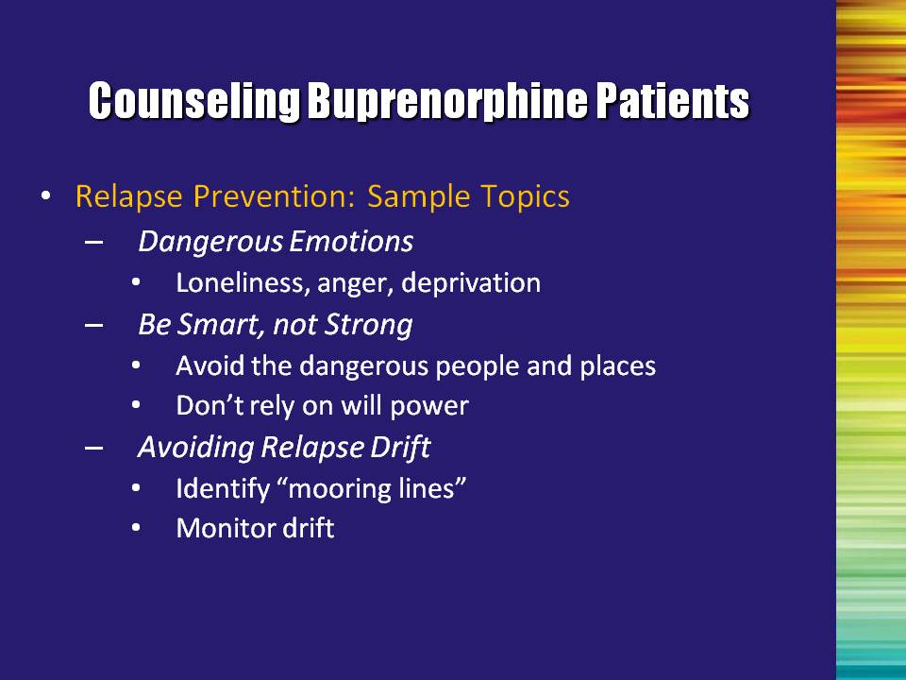 | Slide 42: Counseling Buprenorphine Patients  Read through the sample topics and move on to the next slide. | Slide 42
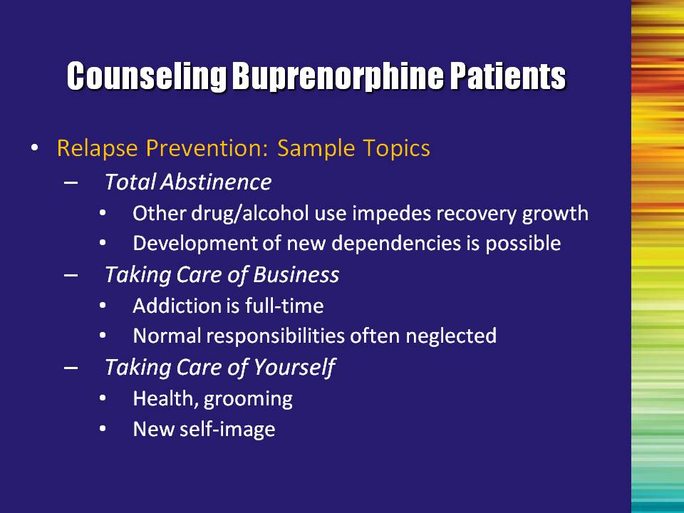 | Slide 43: Counseling Buprenorphine Patients  Read through the sample topics and move on to the next slide. | Slide 43
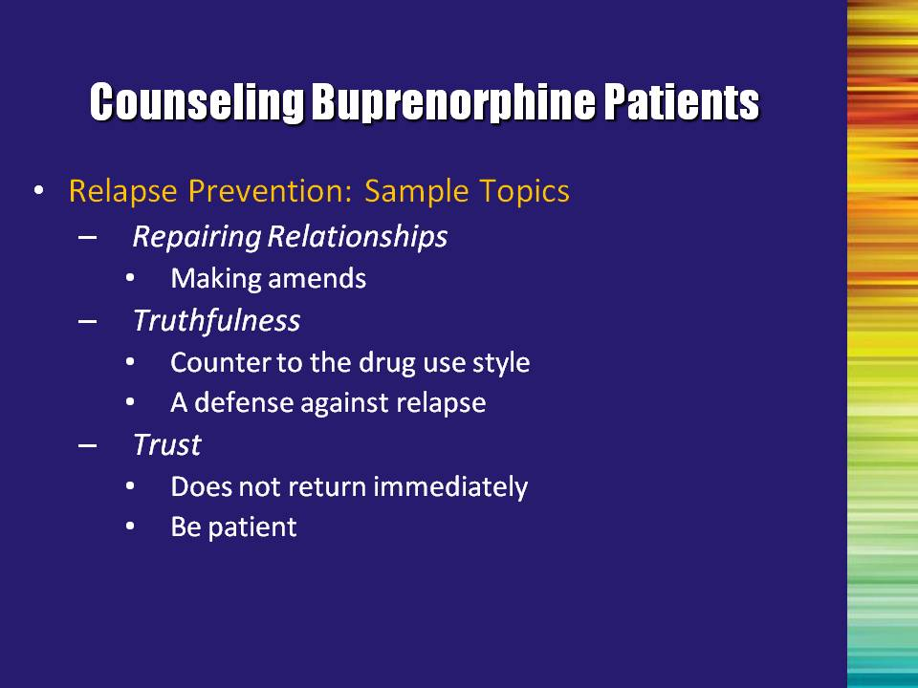 | Slide 44: Counseling Buprenorphine Patients  Read through the sample topics and move on to the next slide. | Slide 44
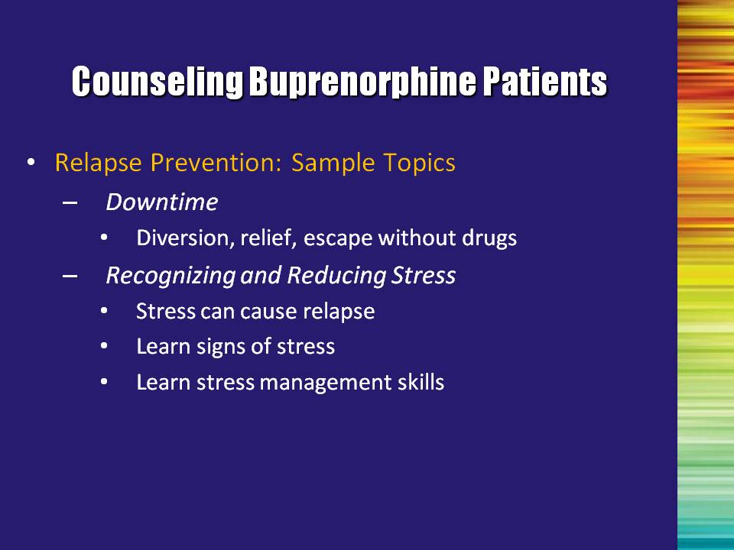 | Slide 45: Counseling Buprenorphine Patients  Read through the sample topics and move on to the next slide. | Slide 45
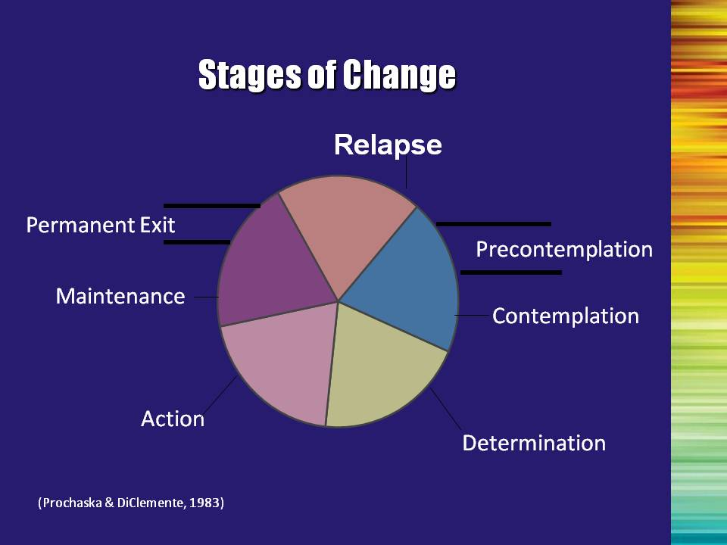 | Slide 46: Stages of Change  As was previously stated, patients receiving buprenorphine treatment may not be ready to stop using all illicit drugs and alcohol. Even patients expressing the desire to stop using will have ambivalent feelings about the change process.  Patients enter treatment at varying stages of readiness for treatment and openness to counseling. Interventions effective at one stage of readiness may not be as effective when used during another stage.  Each stage will be described in greater detail in the following couple of slides.  Reference:  Prochaska, J. O, & DiClemente, C. C. (1982). Transtheorectical therapy: Toward a more integrative model of change. Psychotherapy: Theory, Research and Practice, 19(3), 161-173. | Slide 46
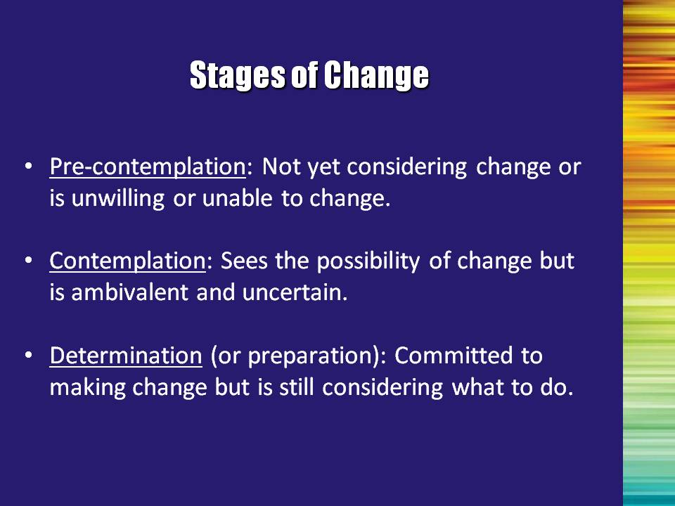 | Slide 47: Stages of Change  Pre-Contemplation: Provide the patient with factual information; explore the meaning of events that brought the patient to treatment and the results of previous treatments; explore the pros and cons of using alcohol and other illicit drugs.  Contemplation: Talk about the patient’s sense of self-efficacy (the belief that you can influence your own thoughts and behavior) and expectations regarding treatment; summarize self-motivational statements; continue exploring pros and cons of substance use.  Determination: Offer a menu of options for change or treatment; negotiate a change (treatment) plan and behavioral contract; identify and lower barriers to change; help patients enlist social support; have patients publicly announce plans to change.  Reference:  Prochaska, J. O, & DIClemente, C. C. (1982). Transtheorectical therapy: Toward a more integrative model of change. Psychotherapy: Theory, Research and Practice, 19(3), 161-173. | Slide 47
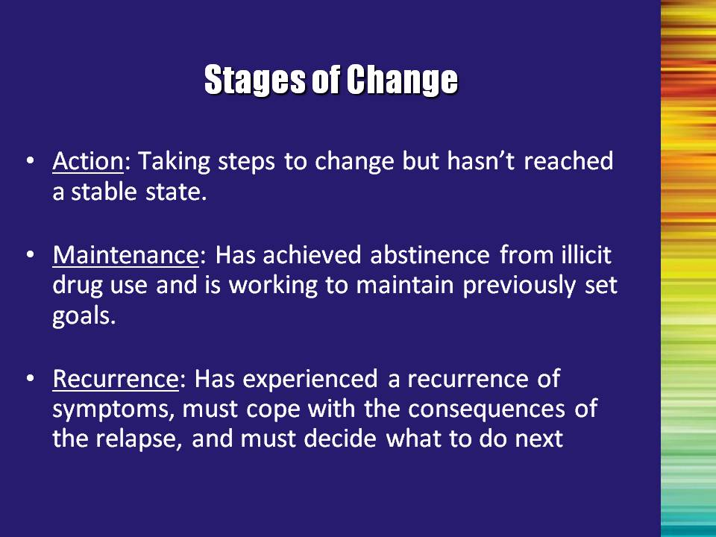 | Slide 48: Stages of Change  Action: Support a realistic view of change through small steps; help patients identify high-risk situations and develop appropriate coping strategies; help patients find new reinforcers of positive change; help patients access family and social support.  Maintenance: Help patients identify and try drug-free sources of pleasure; maintain supportive contact with patients; encourage patients to develop a “fire escape” plan; work with patients to set new short- and long-term goals.  Recurrence: Explore with patients the meaning and reality of recurrence as a learning opportunity; explain the stages of change, and encourage patients to remain engaged in the process; help patients to find alternative coping strategies.  Reference:  Prochaska, J. O, & DiClemente, C. C. (1982). Transtheorectical therapy: Toward a more integrative model of change. Psychotherapy: Theory, Research and Practice, 19(3), 161-173. | Slide 48
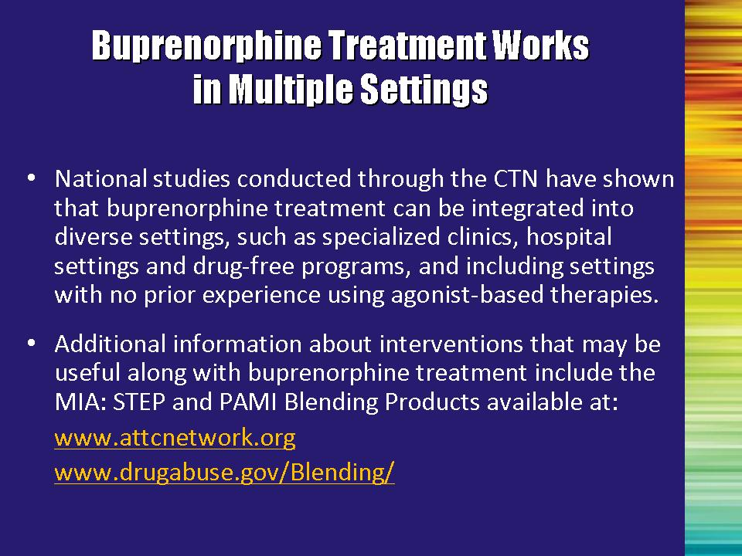 | Slide 49: Buprenorphine Treatment Works in Multiple Settings  Read slide aloud. | Slide 49
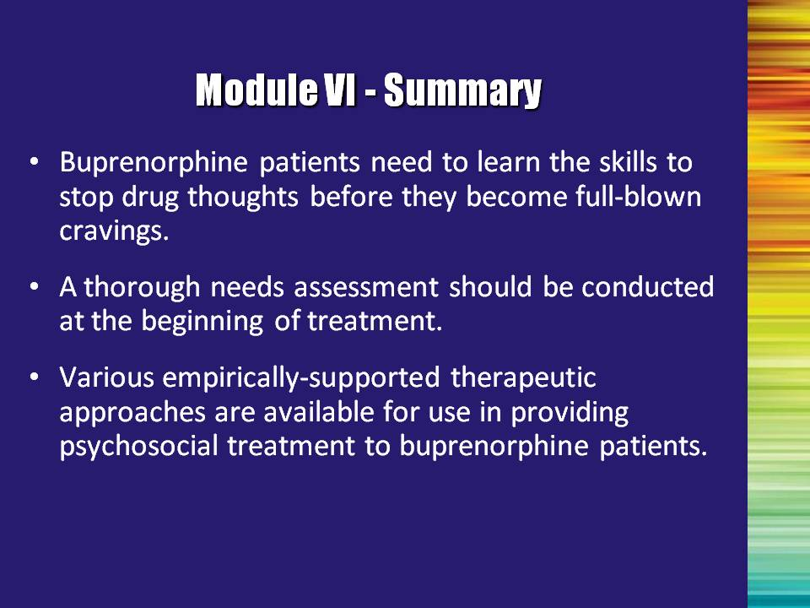 | Slide 50: Module VI – Summary  Bullet #1: Buprenorphine patients need to learn the skills to stop drug thoughts before they become full-blown cravings.  Bullet #2: A thorough needs assessment should be conducted at the beginning of substance abuse treatment.  Bullet #3: Various empirically-supported therapeutic approaches are available for use in providing psychosocial treatment to buprenorphine patients. | Slide 50
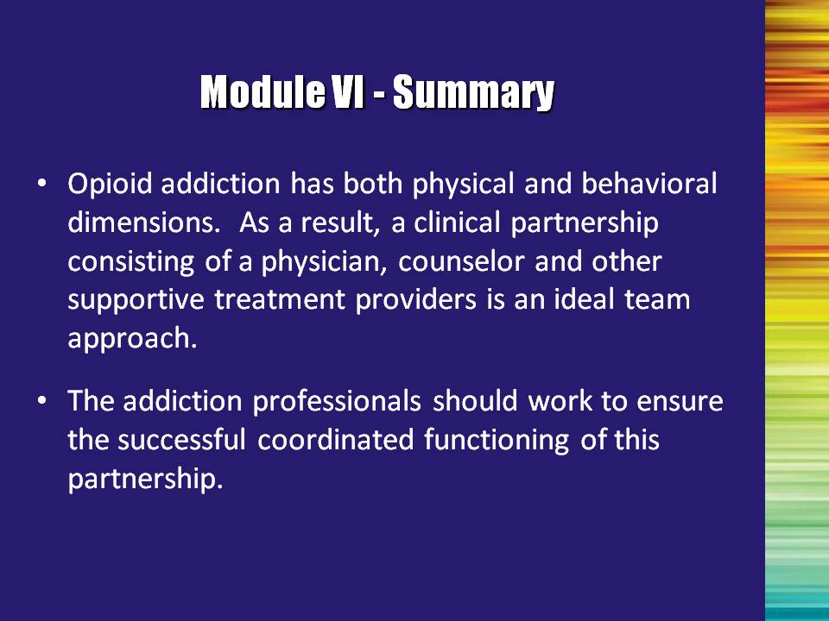 | Slide 51: Module VI – Summary  An ideal buprenorphine treatment team is made up of a physician, substance abuse counselor, and other supportive treatment providers.  Ask the trainees if they have any final questions. | Slide 51

Note to the Trainer(s): This concludes the buprenorphine awareness training. Thank the trainees for taking the time to learn about this new option for the treatment of opioid dependence. Answer any questions and adjourn the training.

Possible Problem Situations and Solutions

1. A physician or other medical personnel in the audience wants to discuss more medical details or starts using unfamiliar terminology.

Solution: Question the trainee about the nature of his/her medical background or credentials and then remind the whole audience that this training is for addiction professionals. Inform the physician that a separate training has been developed specifically for physicians and it may be more appropriate for him/her to attend that training.

2. Training participants are generally hostile to pharmacotherapy.

Solution: Emphasize the disease metaphor (addiction is a disease, just like diabetes and hypertension are diseases), and that people with these other diseases are often given medications to manage their symptoms (insulin for diabetes, etc.).

3. Training participants are concerned about the N.I.M.B.Y. syndrome that plagues/ plagued methadone programs.

Solution: Emphasize that buprenorphine can be prescribed for “take home” use thereby eliminating the loitering problem that sometimes occurs in clinic settings. Buprenorphine patients who are referred to community treatment providers may be scheduled for either individual or group therapy, but do not pose any more “threat” to the neighborhood than any other drug abuse treatment clients.

4. Training participants are concerned that the trainers may be advocating for or marketing buprenorphine.

Solution: State right up front that there is only one manufacturer of this medication (Reckitt Benckiser), a situation similar to new drugs on the market for other medical problems. Their exclusive rights expire in October 2009. This will allow for more widespread adoption and use as the drug becomes more affordable and other manufacturers enter the market.

5. Training participants have a general skepticism about the Clinical Trials Network (CTN) process or questions about the integrity of the research that has been conducted with respect to buprenorphine.

Solution: Emphasize that the National Institute on Drug Abuse, not Reckitt Benckiser, independently funded the clinical trials that are described in this training.

6. Training participants are concerned that the drug is not on Medicaid or other insurance companies’ formularies.

Solution: Emphasize that the appearance of a particular medication on the formularies is largely a result of demand by providers. Physicians and other network providers and patients must ask an insurance company to add medications to the formularies. Once again, this training is a way to ensure that multidisciplinary addiction professionals can be informed enough to engage in appropriate advocacy efforts.

7. The particular region of the country is lacking opioid treatment programs (OTPs)/methadone maintenance.

Solution: Before you would even attempt to conduct this training, you would need to spend time developing marketing materials/messages and meeting with key local stakeholders to get their buy-in to allow you to do the training. It would also involve more intensive basic education about effective treatments currently available for the treatment of opioid addiction. The training itself would need to emphasize the utility of a multi-pronged approach to treating opioid-addicted individuals, including psychosocial treatment, 12-Step meetings/support groups, and pharmacological (medication) treatment.



