Participant Application Form
Application deadline: February 17, 2020
Please read through the accompanying information and consider your willingness to participate in this extended personal leadership development opportunity. The assessment of your talents, accomplishments, needs and potential will be helpful in the selection process and planning additional training opportunities. If you are selected for the Faith Leadership Academy, you will need to mail your one-time $25.00 registration fee in the form of Money Order/Check within 7 business days of notification of acceptance to The Faith Leadership Academy. The SATTC Faith Leadership Academy Selection Committee appreciates the time and care necessary to prepare this application. Please type or print your responses to all the questions on this form.

CONTACT INFORMATION
Name: Click or tap here to enter text. Credentials/Title: Click or tap here to enter text.
Agency/Church: Click or tap here to enter text.
Denomination: Click or tap here to enter text.
Department: Click or tap here to enter text.
Work Mailing Address: Click or tap here to enter text.
City: Click or tap here to enter text. State: Click to enter text. Zip: Click to enter text.
Work Number: Click or tap here to enter text. Fax Number: Click or tap here to enter text.

RELEVANT EXPERIENCE

Lay Leaders must attach 1 Letter of Reference from your Pastor

Lay Leaders must have 1 year of Community Outreach Experience

Lay Leaders must have General knowledge of Substance Use Disorders (SUDs)

ALL APPLICATIONS MUST BE RECEIVED OR POSTMARKED ON OR BEFORE
FEBRUARY 17, 2020

Please describe your experience in the following areas:

- Describe your experience providing Pastoral Care or working with people who have substance use disorder or experiencing life problems related to substance use. Please describe your experience in detail. If you do not have the noted experience, describe how your passion and/or life experience(s) are relevant.
Click or tap here to enter text.
- Describe how you have educated, integrated or infused substance use disorders and/or mental health services in your Church/agency. If you do not have the noted experience, describe how your passion and/ or life experience(s) are relevant. Click or tap here to enter text.
- Describe your reason for desiring to be a participant of the Faith Leadership Academy. Explain what being apart of the academy means to you. Click or tap here to enter text.
- Describe your experience with developing or initiating SUD/mental health activities, events, and/or programs within your community. If you do not have the noted experience, describe how your passion and or/life experience(s) are relevant. Click or tap here to enter text.

- How will you utilize the information gained in your community/agency? Click or tap here to enter text.

PARTICIPANT AGREEMENT
The purpose of the Faith Leadership Academy is to broaden clergy’s awareness about substance abuse issues within their communities and equip them with the skills and tools to be catalyst for change within their communities and congregation; to assist them in preparing their communities/congregation for change.

Objectives of the Faith Leadership Academy:
- Develop individual leadership skills
- Learn more about personal leadership styles
- Meet and network with other new and emerging leaders
- Gain practical experience in engaging and working with individuals dealing with substance use disorders
- Prepare your congregation for organizational change and readiness
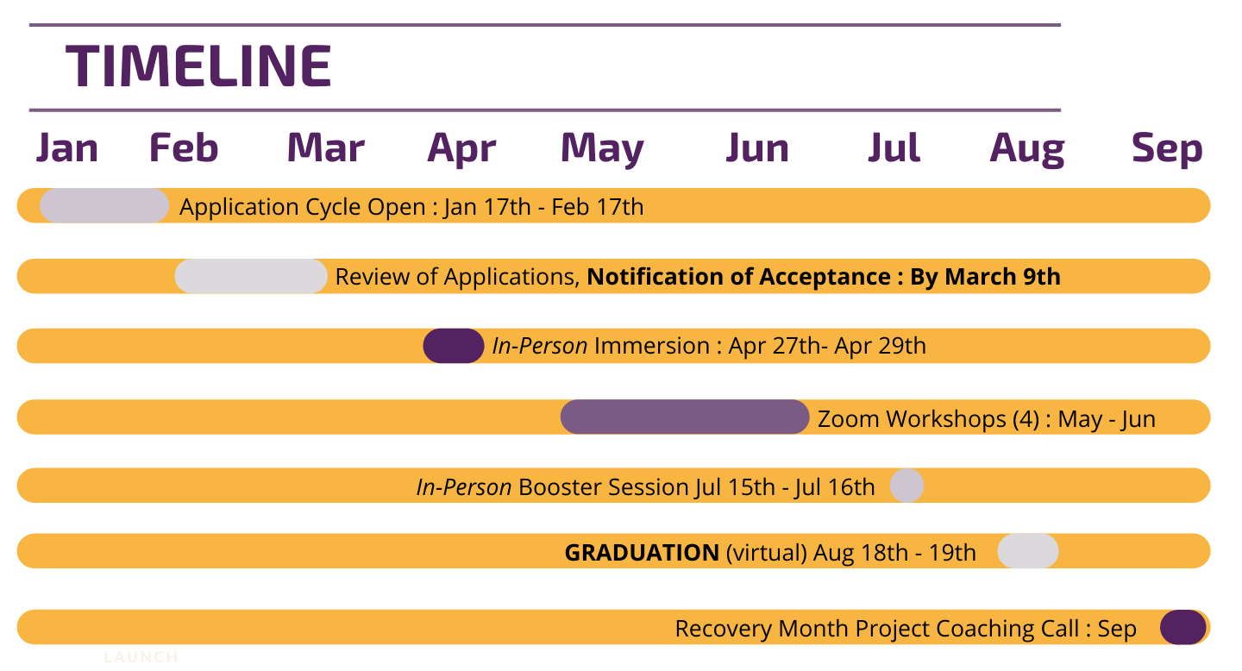

I understand continued department, supervisor, and mentor support is imperative for my successful completion of this six-month process.

- My Supervisor/Department will allow me the time required for full program participation including, but not limited to: the involvement in conference calls, participation in required events, face to face learning opportunities, mentoring, and strategic planning leadership project development.
- The information provided in this application is accurate.
- If selected for The Faith Leadership Academy, I will fully participate
Candidate Signature: Click or tap here to enter text. Date: Click to enter a date.
Submit Complete Application by February 17, 2020 to:
Pamela Lee, Administrative Assistant
SATTC: Region IV | Morehouse School of Medicine
720 Westview Drive Suite 249 Atlanta, GA 30310
Email: plee@msm.edu

The $25.00 one-time registration fee is due within 7 business days of notification of acceptance to The Faith Leadership Academy. The only acceptable form of payment is Check/Money Order made payable to SATTC.

