Providing Peer Based Recovery Support Services for Pregnant and Parenting Families
FREE Training & Technical Assistance | September 9, 2021 -December 2021

The Mid-America Addiction Technology Transfer Center (Mid-America ATTC) along with the Missouri Credentialing Board, Inc. are sponsoring a 2-part training for peer specialists/recovery coaches or supervisors of peer specialists who want to develop expertise in serving pregnant and parenting families impacted by substance use and/or opioid dependence. Registration is limited to 30 total participants.

Eligibility – I am eligible to apply if . . .
- I currently provide peer-based recovery support services in Iowa, Kansas, Missouri, or Nebraska and 1) am recognized as someone qualified to provide peer support services in my state or 2) someone who provides supervision to peers. AND
- I work in one or more of the following settings: 1) a substance use disorder treatment service; 2) a recovery care organization (RCO); 3) a child welfare or home visiting program; 4) a healthcare or emergency crisis service; and/or 5) provide supervision to peers who serve pregnant and parenting families with SUD.

Participant Commitment – What will be expected of me?
- Participate in a four-month intensive learning experience to include:
  - Join and actively participate in two full-day virtual training sessions, September 9 and September 10, 2021, for a total of 13 hours
  - Join six 1.5-hour virtual Peer-to-Peer earning Collaborative sessions to be held twice monthly
  - Given the interactive nature of this training experience, I agree to turn on my smart devise or computer camera

Sponsoring Organization Commitment – What will be expected of my employer?
- Provide computer and internet access during daytime hours
- Allow time for you to participate in all trainings and extended Learning Collaborative sessions fully.

ATTC Commitment – How will Mid-America ATTC invest in my professional development?
- Provide all virtual trainings and Learning Collaborative sessions at no cost to the participant or participant’s organization
- Offer Certificates of Completion

Go to Next Page to Learn More→

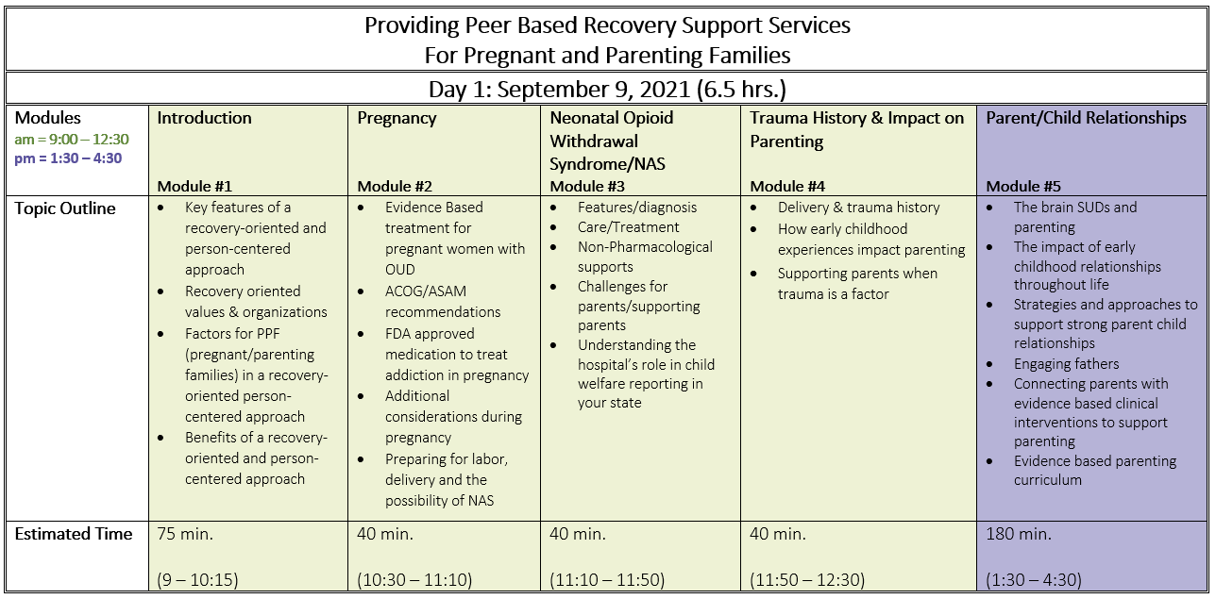

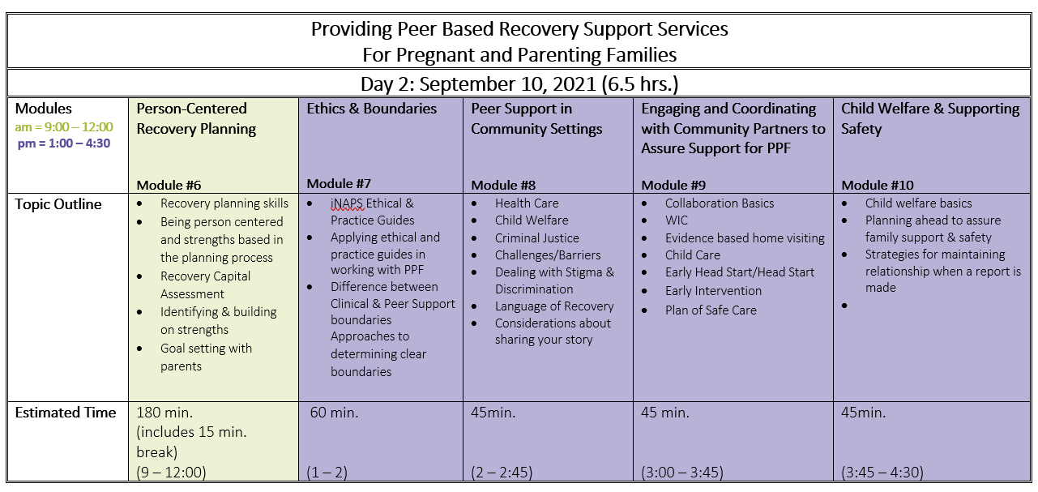

Part 1: Learning Objectives
By the end of the 2-day training, participants will:
- Be able to list and describe 2-3 practices at their organization that they plan to change or adjust as a result of what they learned from the training surrounding assisting clients with pregnancy and parenting family needs.
- Be able to explain their perspectives around how peers can implement positive parenting education and skills in their work with clients.
- Be able to discuss at least three skills or values they gained from the training.

Beginning in September through December 2021, each participant will join in a Learning Collaborative that meets for 90 minutes every other week for six sessions (12 weeks). Facilitated Peer-to-Peer Learning Collaborative sessions provide an opportunity to take a deeper dive into the application of practices and concepts presented in the training through short presentations, literature reviews, and case presentations. The overarching goal of this Peer-to-Peer Learning Collaborative is to engage in a process of higher-level thinking associated with the challenges peers face in their day-to-day work.

Part 2: Learning Objectives

By the end of the Peer-to-Peer Learning Collaborative, participants will:
  - Identify at least three concrete ideas of how peers or peers at their organization will better address issues around pregnancy and parenting.
  - List at least one potential community organization their workplace would like to collaborate with or strengthen collaboration to serve the needs of their families with young children.

By 6-months post-training, participants will be able to:
1. Explain how they have started to implement pregnancy and positive parenting skills and education in their work with clients.

SAMPLE SCHEDULE

Peer-to-Peer Group 1 |  |  | Peer-to-Peer Group 2
Week of | Topic | Facilitator | Week of | Topic | Facilitator
September 12 |  | Sharon Hesseltine | September 19 |  | Lonnetta Albright
September 26  Example |  | Lonnetta Albright | October 3 | Example | Sharon Hesseltine
October 10 |  | Sharon Hesseltine | October 17 |  | Lonnetta Albright
October 24 |  | Lonnetta Albright | October 31 |  | Sharon Hesseltine
November 7 |  | Sharon Hesseltine | November 14 |  | Lonnetta Albright
November 28 |  | Lonnetta Albright | December 5 |  | Sharon Hesseltine

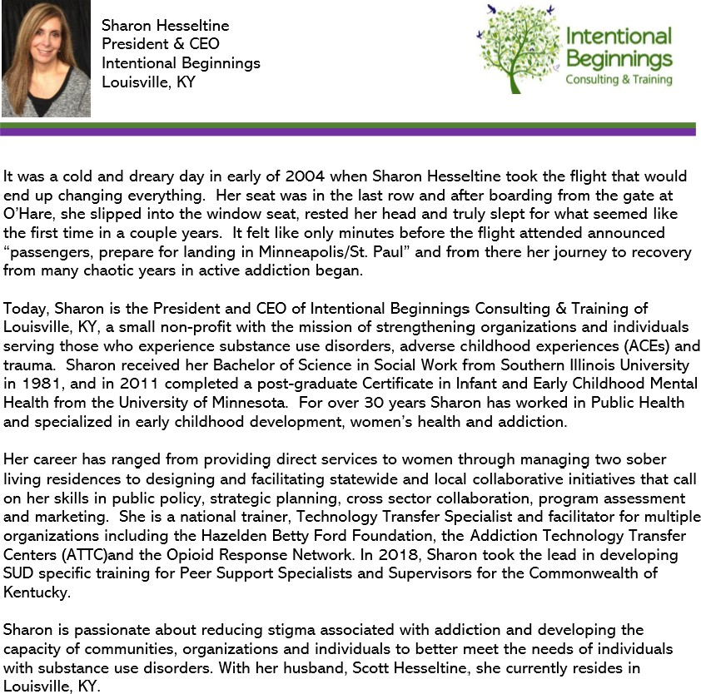

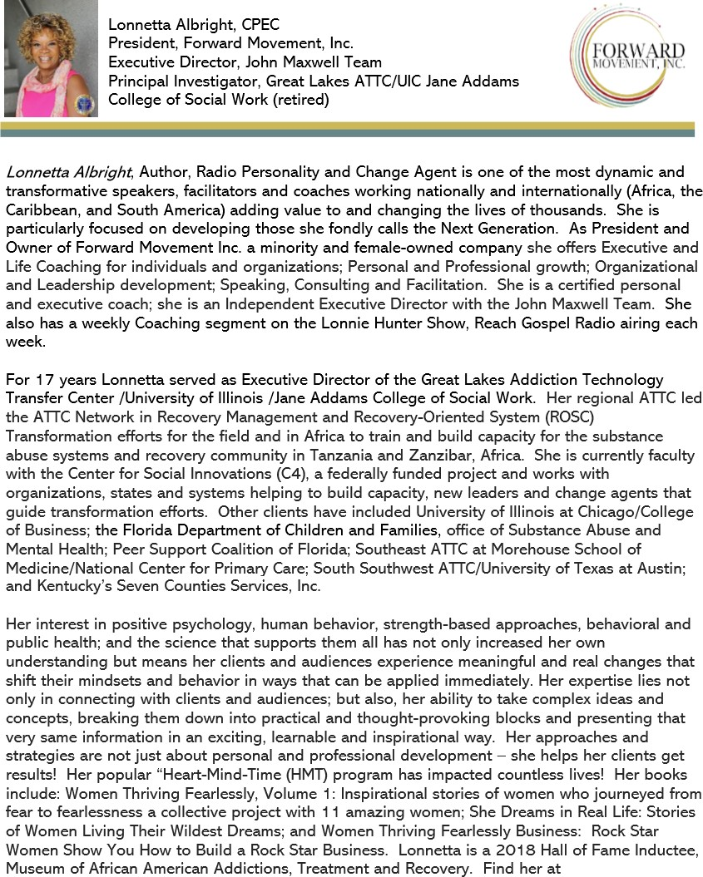

Instructions:
- Enrollment will be limited to 30 eligible participants on a first-come, first-served basis.
- Limit of three registrations per organization.

How to Register:
- Complete Registration Form (pp. 7 - 8)
- Read and sign Participant and Sponsoring Organization agreements
- Email completed registration pages 7 - 8 to Erika Holliday hollidaye@umkc.edu by Friday, August 27, 2021
- Mid-America ATTC will confirm receipt of registration

Organization Contact Information
Organization
Organizational Agent/Representative
Address
City / State / Zip
Main Phone #
Email Address
Participant Contact Information
Participant Name
Work Address | (if different than above)
City / State / Zip | (if different than above)
Work Phone #
Mobile Phone #
Email Address
Briefly describe your role and why you believe this training would benefit your professional development:

If you or your place of employment is affiliated with one or more of these groups, please check here:
Kansas City Perinatal Recovery Collaborative Missouri Credentialing Board
Missouri Hospital Association
State Government (IA, KS, MO, or NE)

Sponsoring Organization
Role & Responsibilities:
- Our organization agrees to provide the participant a computer and internet access during daytime hours
- Our organization agrees to provide the participant time to complete: a) two full-day virtual trainings, September 9th and September 10th, 2021, and 6 virtual 1.5 hour Learning Collaborative Meetings/coaching sessions twice monthly* during October, November, and December 2021. *No meetings scheduled week of Thanksgiving
Name
Signature

Participant
Role & Responsibilities:
I agree to actively participate in a four-month training and learning experience to include:
- Two-day, virtual training (9:00 am – 4:30 pm), September 9th and September 10th, 2021
- Six virtual 1.5-hour Learning Community sessions twice monthly during October, November, and December 2021.
- Given the interactive nature of this training experience, I agree to turn on my smart devise or computer camera
Name
Signature

Registration Confirmation Process:
Mid-America ATTC will document and date the receipt of each agreement and ensure all required contact information and signatures are completed. In addition, we will notify each participant and Sponsoring Organization Representative via email.

Questions?
Contact Erika Holliday hollidaye@umkc.edu

