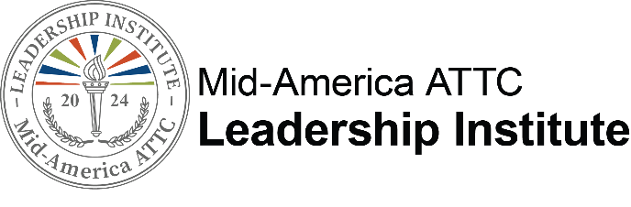

A Unique Leadership Development Program for
Mid- to Upper-Level Behavioral Health, Mental Health, or Recovery Professionals

Agency Information & Nomination Form How to Nominate

The 2024 Leadership Institute presented by the Mid-America Addiction Technology Transfer Center (ATTC) is open to persons who work in behavioral health, mental health, or recovery agencies in Iowa, Kansas, Missouri, and Nebraska.

Potential candidates must:

Be nominated by the agency CEO, Director, etc. using the attached Nomination Form
- Complete the Candidate Application Form

Applications and Nomination Forms should be e-mailed to Bree at sherryb@umkc.edu by Friday, February 16, 2024. Participants will be selected by the Leadership Institute Selection Committee based on the criteria described later in this document. Selected candidates will be notified by March 6, 2024. Strength of the candidate’s application as well as timely receipt of nomination/application will also be considered. Space is limited and early submissions are encouraged.

What does the program cost?
The 2024 Leadership Institute will provide:

- Four-day training focusing on personal development in Kansas City, MO (April 29th- May 3rd )
- Monthly Virtual Coaching Circles (Date 5/24 @ 9:30, 6/21 @9:30, 7/19 @ 9:30, 8/23@ 9:30 )
- Access to LinkedIn Leadership Institute group for networking, resources, and support
- Participants will receive the book It's the Manager which includes access to CliftonStrengths.
- Lodging during Immersion Trainings in Kansas City
- Breakfast provided by the hotel
- Catered lunch provided 3 of the 5 days.
- Social reception provided on April 29
- Group dinner May 2
- Lodging and select meals during the Commencement celebration September 26-27 in Kansas City, MO

The sponsoring agency will be responsible for:

- $650 registration fee due during online registration process after notification of acceptance
- Reimbursement of travel to and from Kansas City for Immersion Training and Commencement Celebration in Kansas City, MO
- Reimbursement of meals incurred during travel (except those included during the training)
- Supporting development of individual leadership skills as identified from assessment and participation in the series.
- Allowing time for the participant to participate fully in the program.

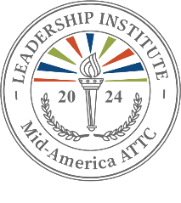

Nomination Criteria
The Leadership Institute is a developmental program and is NOT designed or intended to serve as an employee corrective action measure. Candidates for the program must be employed in a behavioral health, mental health, or recovery agency in Iowa, Kansas, Missouri, or Nebraska, and be nominated by their CEO or Director. It is critical that the agency agree to and allow for time necessary to complete all requirements and provide candidate with opportunities to test new skills.

Following the consideration of nomination and application forms by the Leadership Institute Selection Committee, candidates are selected for the program.

The Committee will select Candidates for the program who:

- Exhibit professional commitment to the behavioral health, mental health, or recovery field.
- Are currently employed in a supervisory or management position in a behavioral health, mental health, or recovery agency. Preference will be given to applicants with at least three years’ experience as a manager or supervisor.
- Make a commitment to participate fully in all training activities, including completion of the StrengthsFinder Assessment.
- Have received employer’s commitment to fully support participation and allow for the time required to learn and apply the leadership model. Commitment of the employer is demonstrated by submission of a nomination form.

Time commitment needed to complete the program involves:

Dates | Program Elements | Location
April 29 – May 3, 2024 | Immersion Training focuses on  - Learning about you  - Developing others  - Embracing equity & inclusion  - Understanding the behavioral health industry  - Leadership self-care | Kansas City, MO
May 24, 2024 | Monthly Virtual Coaching Circle | Virtual
June 21, 2024 | Monthly Virtual Coaching Circle | Virtual
July 19, 2024 | Monthly Virtual Coaching Circle | Virtual
August 23, 2024 | Monthly Virtual Coaching Circle | Virtual
September 26 – 27, 2024 | Commencement Celebration | Kansas City, MO

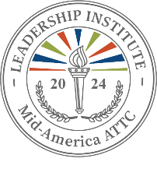

Leadership Institute Nomination Form
(to be completed by agency CEO, Director, etc.)

Please notify the individual you are nominating and provide them with the Leadership Institute Candidate Application. The candidate should submit the Application on their own, separately from the Nomination Form below.
- It is important for the candidate to be aware of and committed to this extended training and development process.
- This program is designed for persons who are performing at or above performance expectations and who have exhibited leadership potential. Please note that this is not a program for persons who require corrective action.

It is important to nominate an individual who currently holds a supervisory/management position, has realistic leadership development potential, and is committed to your agency and the behavioral health field. Preference will be given to candidates with 3 or more years’ experience as a manager or supervisor.

Your assessment of the candidate’s talents, accomplishments, needs and potential will be very helpful. Your comments are confidential and are not shared with the candidate. The Selection Committee appreciates the time and care necessary to prepare this form. Please type your answers to all questions.

Name of candidate: Agency:

Nomination forms and Applications Due on or before February 16, 2024 (Space is limited. Early submissions are encouraged.)

Department: Position:

Agency address:

City: State: Zip:

Candidate’s work telephone number:

Candidate’s work e-mail address:

How long has candidate been in a leadership/supervisory role?
(Preference will be given to applicants with at least 3 years’ experience as a manager or supervisor.)

How long has candidate been in his/her current leadership/supervisory role?

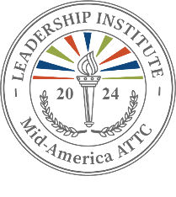

Please respond to the following questions.

- How long have you known the candidate and in what capacity?

- What leadership qualities led you to recommend this candidate?

- Provide examples that illustrate the candidate’s leadership skills and/or potential.

- What type of leadership development do you believe would be of benefit to the candidate?

- Does this candidate use a computer effectively in the workplace? (double-click on box to check)

No opinion /  unknown | No | Sometimes | Often

- Does the candidate have access to an e-mail address solely dedicated to him/her while at work that can be used for communication about and involvement in the Leadership Institute?
Yes No

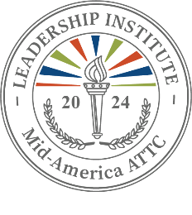

- What plans, if any, do you have for promotion or enhanced responsibility for the person you are nominating?

- Please rate the effectiveness of the nominee, to the best of your ability, in the following areas of leadership. Check your responses by double clicking the shaded box and choosing the “checked” option. These responses, along with results from assessments provided in the program, can help identify your candidate’s areas of development.

Managing people and tasks: Demonstrates such skills as coordinating, teamwork, leadership/influence, managing conflict, and planning/organizing.

Not Effective | Sometimes Effective | Often Effective | Effective | Highly Effective

Problem solving and decision making: Demonstrates skills through problem identification, insight, seeing things from new angles, recognizing trade-offs, decisiveness, and action.

Not Effective | Sometimes Effective | Often Effective | Effective | Highly Effective

Communicating: Demonstrates effective oral and written communication skills and active listening.

Not Effective | Sometimes Effective | Often Effective | Effective | Highly Effective

Building and maintaining relationships: Demonstrates skills that build interpersonal relationships, negotiating, putting people at ease, and showing compassion and sensitivity.

Not Effective | Sometimes Effective | Often Effective | Effective | Highly Effective

Mobilizing innovation and change: Demonstrates the ability to conceptualize, inspire, act creatively to mobilize innovation and change, risk-taking and visioning.

Not Effective | Sometimes Effective | Often Effective | Effective | Highly Effective

Managing self: Demonstrates self-directed learning, personal organization/time management, personal strengths, and problem solving/analytical skills.

Not Effective | Sometimes Effective | Often Effective | Effective | Highly Effective

Personal professional demeanor: Demonstrates integrity, projecting a professional image, and ethical practice.

Not Effective | Sometimes Effective | Often Effective | Effective | Highly Effective

OPTIONAL - Is there additional information you would like to provide that would assist the Selection Committee in making a decision about your nominee? You may attach supplemental information limited to two (2) pages or include in an email when you submit the nomination.

Agency Agreement Page
Nominator name (Type): Title:
Agency:

Agency address:

City: State: Zip:

E-mail: Telephone:

The purpose of this program is to enhance the knowledge and skill of a diverse group of promising leaders at an optimal point in their careers. The program is designed to help Leadership Institute participants prepare for greater responsibility and to contribute more to their agency in a changing healthcare environment, and ultimately, the behavioral health treatment and recovery field.
I understand that continued agency support is imperative for the candidate’s successful completion of this six-month process. I understand and agree that if the nominee is accepted as a candidate for the 2024 Leadership Institute, I will support the candidate in the following ways:

Check all that apply
I will encourage this participant’s leadership development through the Leadership Institute and allow the time required for full program participation, including time to attend the Immersion Training (April 29th- May 3rd, 2024), Monthly Coaching Circles (May-August 2024), StrengthsFinder Assessment, and Commencement Celebration (September 26-27, 2024).
Provide travel and meal expense during travel to Immersion Training and Commencement Celebration plus any meals not provided during the training.
We will provide a dedicated e-mail address which is accessible during work hours. We will pay a registration fee of $650 after candidate is selected for the program.
I certify that the information included in this nomination form is correct and that I will support this candidate if selected to participate in the 2024 Leadership Institute.

Nominator Signature: Date:

Submit Nomination by February 16, 2024, to:
Email: Sherryb@umkc.edu
NOTE: If you do not directly supervise the person you are nominating, the nominee’s direct supervisor should complete the following page. This page ensures that the supervisor understands the program and is prepared to support your candidate through the process if he/she is selected to participate.

Supervisor Agreement Page
(to be completed only if person on the previous page is not the nominee’s supervisor)

Supervisor name (Type):
Title:
Agency:
Agency address:
City: | State: | Zip:
E-mail: |  | Telephone:

A person you supervise is being nominated to participate in the 2024 Leadership Institute. The purpose of the 2024 Leadership Institute is to enhance the knowledge and skill of a diverse group of promising leaders at an optimal point in their careers. The program is designed to help Leadership Institute participants prepare for greater responsibility and to contribute more to their agency in a changing healthcare environment, and ultimately, the behavioral health treatment and recovery field.
I understand that continued agency support is imperative for the candidate’s successful completion of this six-month process. I understand and agree that if the nominee is accepted as a candidate for the 2024 Leadership Institute, my agency agrees to support the candidate in the following ways:

Check all that apply
I will encourage this participant’s leadership development through the Leadership Institute and allow the time required for full program participation.
I understand that the Leadership Institute will only cover breakfast, lunch 3 of the 5 days, and 1 dinner during the Immersion Training.
I understand that our agency will provide a dedicated e-mail address which is accessible during work hours.
I understand that our agency will pay a registration fee of $650 after candidate is selected for the program.

I certify that the information included in this nomination form is correct and that I will support this candidate if selected to participate in the 2024 Leadership Institute.

Supervisor Signature: Date:

Submit Nomination by February 16, 2024, to sherryb@umkc.edu

