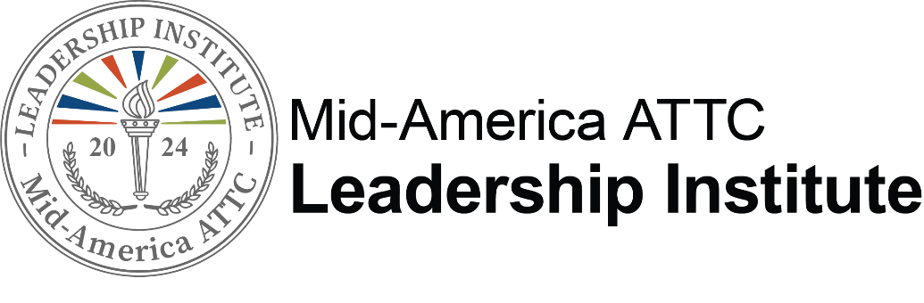

A Unique Leadership Development Program for Mid- to Upper-Level Behavioral Health, Mental Health, and Recovery Professionals

Candidate Information & Application

Application Process
The 2024 Leadership Institute presented by the Mid-America Addiction Technology Transfer Center (MATTC) is open to persons who work in behavioral health, mental health, or recovery agencies in Iowa, Kansas, Missouri, and Nebraska. Candidates must be nominated by leadership within their agency. If you have received this application from within your agency, your leadership plans to nominate you! If you are interested in participating, submit an application form, current resume, and 3–5-minute video by Friday, February 16, 2024. Agency nomination forms and candidate applications can be e-mailed to Bree at sherryb@umkc.edu. The 2024 Leadership Institute Selection Committee will review applications and select participants based on the criteria described later in this document. Strength of the candidate’s application and video as well as timely receipt of nomination/application will also be considered. Space is limited to participants and early submissions are encouraged. Selected candidates will be notified by March 8, 2024.

*Please note that multiple applications from a single organization are allowed, however selections will be based on creating a diverse pool of participants

Program Cost
2024 Leadership Institute will provide:
- Four-day training focusing on personal development in Kansas City, MO (April 29th – May 3, 2024)
- Monthly Virtual Coaching Circles (May – August)
- Access to Leadership Institute Alumni group for networking, resource sharing, and support
- Participants will receive the book It's the Manager which includes access to CliftonStrengths.
- Lodging during Immersion Trainings in Kansas City
- Breakfast provided by the hotel.
- Catered lunch provided 3 of the 5 days of the Immersion Training
- Social reception provided on April 29
- Group dinner May 2
- Lodging and select meals during the Commencement celebration September 26-27 in Kansas City, MO

The sponsoring agency will be responsible for:
- $650 registration fee due during online registration process after notification of acceptance
- Reimbursement of travel to and from Kansas City for Immersion Training and Commencement Celebration in Kansas City, MO
- Reimbursement of meals incurred during travel (except those included during the training)
- Supporting development of individual leadership skills as identified from assessment and participation in the series.
- Allowing time for the candidate to participate fully in the program.

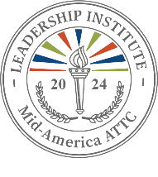

Application Criteria

Candidates for the program must be employed in a behavioral health, mental health, or recovery agency in Iowa, Kansas, Missouri, or Nebraska, and be nominated by their CEO or director. It is critical that the agency agree to and allow for the time necessary to complete all requirements and provide the protégé with opportunities to test new skills.

Following the consideration of nominations and application forms by the Leadership Institute Selection Committee, candidates are selected for the program.

The Selection Committee will select Candidates for the program who:

- Exhibit professional commitment to the behavioral health, mental health, or recovery field.
- Are currently employed in a supervisory or management position in a behavioral health, mental health, or recovery agency. Preference will be given to applicants with at least three years’ experience as a manager or supervisor.
- Make a commitment to participate fully in all training activities, including completion of the
StrengthsFinder Assessment.
- Have received employer’s commitment to fully support participation and allow for the time required to learn and apply the leadership model. Commitment of the employer is demonstrated by submission of a nomination form.

Time commitment needed to complete the program involves:

Dates | Program Elements | Location
April 29 – May 3, 2024 | Immersion Training focuses on  - Learning about you  - Developing others  - Embracing equity & inclusion  - Understanding the behavioral health industry  - Leadership self-care | Kansas City, MO
May 24, 2024 | Monthly Virtual Coaching Circle | Virtual
June 21, 2024 | Monthly Virtual Coaching Circle | Virtual
July 19, 2024 | Monthly Virtual Coaching Circle | Virtual
August 23, 2024 | Monthly Virtual Coaching Circle | Virtual
September 26 – 27, 2024 | Commencement Celebration | Kansas City, MO

*All Monthly Virtual Coaching Circles take place from 9:30 am – 11 am (CST)

Application Form
(to be completed & submitted by candidate)

Your agency is submitting your name as a candidate for the 2024 Leadership Institute. Please read through the accompanying information and consider your willingness to participate in this extended professional leadership development opportunity. If you do NOT want to participate in the Leadership Institute, please inform your agency now.

If you are interested in pursuing this unique opportunity, please complete the application and essay. Your information and responses will be kept confidential. The Selection Committee appreciates the time and care necessary to prepare this application. Please fill out the application form electronically.

Name: |  | Credentials:
Position: |  | Department:
Agency:

Agency address:
City: | State: | Zip:

Work phone number: Work e-mail address:

# of employees in agency:
# of people you supervise:
# of peers in agency:

Home address:

City: State: Zip:

Cell phone number:

Alternate e-mail address:

Name of direct supervisor:
Supervisor’s work phone number: Supervisor’s email address: What is the highest degree you have received? (Double click to check a box)
High school diploma or equivalent (GED) Associate’s degree Bachelor’s degree Master’s degree Doctoral Degree

The following two data fields are OPTIONAL. This information is included to help create a balanced protégé group, if possible.

Applications Due
February 16, 2024
(Space is limited. Early submissions are encouraged)

- Preferred Pronouns
She/Her He/Him They/Them
Other

- Race/Ethnicity (Select all that are applicable)
Black or African American Caucasian Hispanic/Latino
Asian
American Indian
Native Hawaiian/Pacific Islander Alaska Native

- Please submit a video (3-5 minutes) which addresses the following:
  - Describe your reasons for interest in this program.
  - Describe the scope of your current leadership roles.
  - Describe your leadership strengths and development needs.
  - Describe the next professional position to which you aspire.
  - Describe your dedication to the behavioral health, mental health, and or recovery field.

- Submit a current resume with your application.

- Rate your effectiveness when using a computer in the workplace. (double-click box to check)

Not Effective | Sometimes Effective | Often Effective | Effective | Highly Effective

- I use e-mail at work:

Don’t use | Occasionally | Weekly | Daily | Many Times a Day

- I have access to the internet:

At Work | At Home

- I have experience using the following computer programs (list programs you are comfortable using – i.e. Microsoft Word, ZOOM, LinkedIn, Box, Google Drive)

- I have worked in the behavioral health/mental health/recovery field for years. You may also describe other work experience you would like the Selection Committee to know about.

- I have supervised and/or been a manager in this field for years. You may also describe leadership roles you have filled in other settings. (Preference will be given to applicants with at least 3 years’ experience as a manager or supervisor.)

- Leadership Competency Dimensions
Please rate your effectiveness in the following areas of leadership. Check your responses
by double clicking the shaded box and choosing the “checked” option.

Managing people and tasks: Demonstrates such skills as coordinating, teamwork, leadership/influence, managing conflict, and planning/organizing.

Not Effective | Sometimes Effective | Often Effective | Effective | Highly Effective

Problem solving and decision making: Demonstrates skills through problem identification, insight, seeing things from new angles, recognizing trade-offs, decisiveness, and action.

Not Effective | Sometimes Effective | Often Effective | Effective | Highly Effective

Communicating: Demonstrates effective oral and written communication skills and active listening.

Not Effective | Sometimes Effective | Often Effective | Effective | Highly Effective

Building and maintaining relationships: Demonstrates skills that build interpersonal relationships, negotiating, putting people at ease and showing compassion and sensitivity.

Not Effective | Sometimes Effective | Often Effective | Effective | Highly Effective

Mobilizing innovation and change: Demonstrates the ability to conceptualize, inspire, act creatively to mobilize innovation and change, risk-taking and visioning.

Not Effective | Sometimes Effective | Often Effective | Effective | Highly Effective

Managing self: Demonstrates self-directed learning, personal organization/time management, personal strengths, and problem solving/analytical skills.

Not Effective | Sometimes Effective | Often Effective | Effective | Highly Effective

Personal professional demeanor: Demonstrates integrity, projecting a professional image, and ethical practice.

Not Effective | Sometimes Effective | Often Effective | Effective | Highly Effective

Certification and Agreement
The purpose of the 2024 Leadership Institute is to enhance the knowledge and skill of a diverse group of promising leaders at an optimal point in their career. The program is designed to help Leadership Institute participants prepare for greater responsibility and contributions to their agency in a changing healthcare environment, and ultimately, the fields of behavioral and mental health, prevention, treatment, and recovery.

My Commitment
I understand that continued agency support is imperative for my successful completion of this six-month process. I understand that if selected to participate in the Leadership Institute, my agency will be responsible for a portion of the expenses incurred in this extended training program.

I understand that my agency agrees to support my successful completion of the Leadership Institute by
(check all that apply):

Allowing me the time required for full program participation including time to participate in
- Immersion Training (April 29th – May 3, 2024)
- Monthly Virtual Coaching Circles (May - August)
- Commencement Celebration (September 26 – 27, 2024)
- StrengthsFinder Assessment

Providing travel and meal expense during travel to and from the three in-person events plus
any meals not provided during the training.
Providing an e-mail address dedicated to me which is accessible during work hours.
$650 registration fee following notification of selection for the program.

In addition, I affirm the following:

The information provided in this application is correct.
If selected for the 2024 Leadership Institute, I will participate fully.
Submission of this application indicates interest in my personal development through the components provided in this program.

Candidate Signature: Date:

Application should include the following. Please send the following to the email listed below:

Application Form

Video or link to video
Applications Due
February 16, 2024
Current Resume

Submit application to: sherryb@umkc.edu

