Celebrate Women’s Recovery and End Addiction Stigma

Dr. Nora Volkow is the Director of the National Institute on Drug Abuse (NIDA) at the National Institutes of Health. Her research sheds light on one of the most important indicators that someone will or will not reach out for support for their substance use: stigma. She states that:
The words we use to describe mental illnesses and substance use disorders (addiction to alcohol and other legal and illegal drugs) can impact the likelihood that people will seek help and the quality of the help they receive. Research indicates that stigma—negative attitudes toward people based on distinguishing characteristics—contributes in multiple ways to poorer health outcomes; consequently, it has been identified as a critical focus for research and interventions.
Addiction, along with mental health challenges, have long been some of the most stigmatized conditions. Countless research studies show that when there are stigmatizing attitudes, fewer people reach out for help. This is especially concerning considering the percentages of people who don’t receive the treatment they need (nearly 90% of the people who need support for their substance use challenges or addiction do not get it).

The Words We Use Matter
How we talk about addiction and recovery matters. Not just because of the words we say, but because of the words we hear—and what our loved ones hear and in turn, can internalize. Research from 2019 shows that nearly 20% of people who needed help didn’t get it because they were concerned about what their neighbors or community would think.
There are things that we can do as loved ones to learn how to talk about addiction and also why this matters—and how it can help end addiction stigma.
Understanding the science of addiction and recovery is a first step. You may be like me (not a neuroscientist) and that’s okay. There’s a way to understand what happens on a physical level when we experience substance use disorder or substance misuse challenges.
Flo Hilliard, MSH, founding member of Faces & Voices of Recovery and expert in the field of addiction science explains it this way:
Many medical conditions, like Type 2 Diabetes and Cardiovascular disease, are linked to not only a genetic predisposition but also to patterns or habits that can lead to "turning on" the gene for that condition. Substance use disorders often follow the same pattern, yet there is often stigma and shame attached to the normal progression of the medical condition.
Understanding the basic brain science of addiction and recovery is a fundamental step in eliminating stigma and treating those suffering from this disorder as respected human beings. Research shows that with the proper treatment and support people can and do recover from addiction to alcohol and other drugs to have successful professional and personal lives.

When we understand that addiction is a normal part of the human experience, it loses its ability to be framed as something requiring punitive measures. Something that causes shame. It lacks the power to divide into “us vs. them.” Addiction or substance use disorders are worthy of our understanding and compassion.
There are some excellent resources out there, including ones through the ATTC network, including their Addiction Science Made Easy Series, that share information about the science of addiction and recovery so we not only understand it but understand how to talk about it.

How We Talk About Addiction Recovery Matters
There are simple ways that you can talk about addiction and recovery that decrease stigma. The National Institute on Drug Abuse or NIDA shares these helpful ways to talk about addiction recovery:,
- Use person-first language
- Promote community education about addiction
- Share recovery stories
- Education programs for folks who work with those of us in or seeking recovery like doctors, nurses, treatment providers, counselors, and church leaders
Here is another helpful resource from SAMHSA: Overcoming Stigma Ending Discrimination.
Check out this helpful chart from NIDA: Words Matter - Terms to Use and Avoid When Talking About Addiction.

Women and Addiction Stigma
Stigma is even more prevalent for women, especially mothers, and women of color, and this has been known for decades.
It's part of why I founded and host the annual event with the SHE RECOVERS foundation that highlights and celebrates women’s recovery during Women’s History Month on International Women’s Day every year. This year, we are focusing on highlighting the next generation and why it’s important to not only share stories of recovery but also share what works in terms of recovery support services.
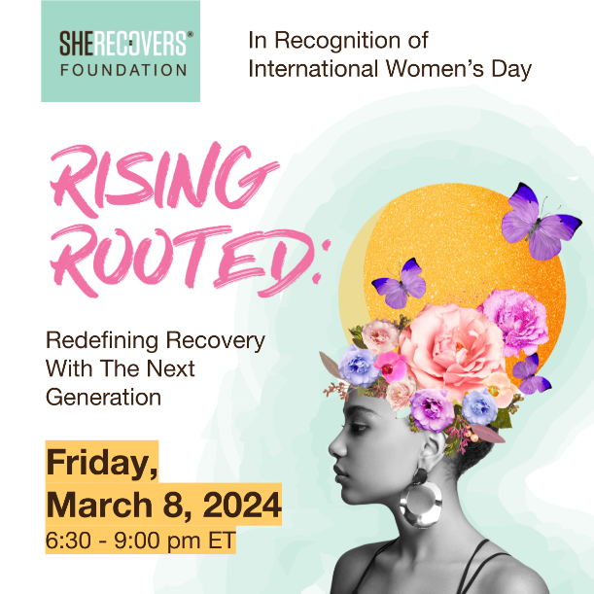
Gathering as a global community of supporters of recovery is not only an incredible experience, it has a purpose: to help reduce the addiction recovery stigma that women face. Since women, especially from under-resourced and underserved communities, experience higher levels of addiction stigma and are thus, less likely to seek support, we all must work to address this issue that impacts millions.
When we share our stories of recovery in the light, it can illuminate hope for others and show that recovery is possible. When we use supportive and hope-filled language, we can be a part of eradicating the stigma and discrimination that has no place in our recovery-oriented world today.
Join us this March and celebrate.
For more information and to register for free visit: https://sherecovers.org/international-womens-day-2024/
Time and date don’t work for you? No problem! Register for a link to watch on demand any time or plan your own watch party.

Caroline Beidler, MSW is an author, recovery advocate, and founder of the storytelling platform Circle of Chairs. With almost 20 years in leadership within social work and ministry, she is currently a consultant with JBS International, along with the founder and host of the annual International Women’s Day Global Recovery Event presented by the SHE RECOVERS Foundation.
Connect with her @carolinebeidler_official and https://www.facebook.com/carolinebeidlermsw

Volkow, N.D., Gordon, J.A. & Koob, G.F. Choosing appropriate language to reduce the stigma around mental illness and substance use disorders. Neuropsychopharmacol. 46, 2230–2232 (2021). https://doi.org/10.1038/s41386-021-01069-4
National Academies of Sciences, Engineering, and Medicine. Ending Discrimination Against People with Mental and Substance Use Disorders: the Evidence for Stigma Change. Washington, DC: The National Academies Press; 2016. https://doi.org/10.17226/23442.
Hammarlund R, Crapanzano KA, Luce L, Mulligan L, Ward KM. Review of the effects of self-stigma and perceived social stigma on the treatment-seeking decisions of individuals with drug- and alcohol-use disorders. Subst Abus Rehabil. 2018;9:115–36. https://doi.org/10.2147/SAR.S183256. Published 2018 Nov 23.
Han B. Key substance use and mental health indicators in the United States: results from the 2019 National Survey on Drug Use and Health (HHS Publication No. PEP20-07-01-001, NSDUH Series H-55). Rockville, MD: Center for Behavioral Health Statistics and Quality, Substance Abuse and Mental Health Services Administration; 2020.
Volkow, N.D., Gordon, J.A. & Koob, G.F. Choosing appropriate language to reduce the stigma around mental illness and substance use disorders. Neuropsychopharmacol. 46, 2230–2232 (2021). https://doi.org/10.1038/s41386-021-01069-4
Livingston, J. D., Milne, T., Fang, M. L., & Amari, E. (2012). The effectiveness of interventions for reducing stigma related to substance use disorders: a systematic review. Addiction (Abingdon, England), 107(1), 39–50. https://doi.org/10.1111/j.1360-0443.2011.03601.x
Radcliffe P. Motherhood, Pregnancy, and the Negotiation of Identity: The Moral Career of Drug Treatment. Social Science & Medicine. 2011;72:984–991.
Page, S., Fedorowicz, S., McCormack, F., Whitehead, S. (2024). Women, Addictions, Mental Health, Dishonesty, and Crime Stigma: Solutions to Reduce the Social Harms of Stigma. International Journal of Environmental Research and Public Health, 21(1):63. https://doi.org/10.3390/ijerph21010063

